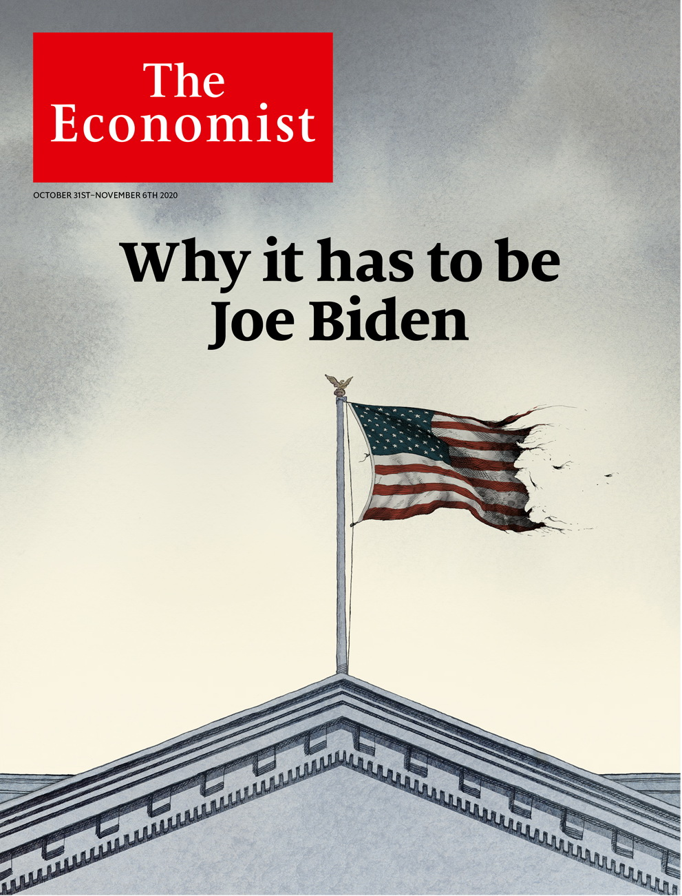

# Table of Contents

The world this week

Politics this week

Business this week

KAL's cartoon

Leaders

America's election: Why it has to be Biden

Green innovation: Breaking through

Furlough schemes: The zombification of Britain

Germany’s Christian Democrats: The long farewell

Letters

Letters to the editor: On Indonesia, Colombia, human rights, Nagorno-Karabakh, CEOs, the Arctic, beer

Briefing

The Trump audit: Four years on

The international stage: Realism and the wrecking ball

United States

Amy Coney Barrett: Against the flow

State legislatures: Flipping houses

Direct democracy: Gentle propositions

Information and elections: Big little lies

Donald Trump and the Latino vote: Better hombres

Corruption and conflicts of interest: The art of the self-deal

Lexington: Battle-hymn of the Never Trumpers

The Americas

Argentina: A harvest of grievance

Brazil: Each race, a new race

Bello: MexiCoke

Asia

Indian politics: Central bark

Street food in Singapore: Out with the new

Climate policy in Japan: Not a carbon copy

Press freedom in Pakistan: News whose printing causes fits

Banyan: Gotabaya, caudillo

China

Leadership succession: Xi’s not going

Demography: Go figure

Chaguan: Chicken and egg

Middle East & Africa

Malaria and covid-19: Masked up, ready to battle bugs

Guinea: Ballots and bloodshed

Sudan: General agreement

Israel’s new airport: Not in my wetland

Europe

Culture: Busking for bail-outs

Italy: Rich pickings

Abortion in Poland: Who is the strictest of them all?

Albania’s royal family: The birth of Baby Zog

Nagorno-Karabakh: The wheel turns, this time

Charlemagne: Macron’s mission

Britain

Data and governance: How the government lost its nerds

Brutalism and beauty: Demolition Derby

Grand houses: Brideshead rebooted

The Tories and race: Black and blue

Prisons: Locked up, locked down

International

Birth rates: Baby bust, baby boom

Business

Climate change and innovation: Greenbacks for greenery

Samsung: The Lee way

Gig companies: Catch 22

Opioids and business: Painkiller wars

Bartleby: Luxury with your laptop

Schumpeter: Jeff Bezos’s final frontier

Finance & economics

Aditya Puri: The world’s best banker?

Cross-border lending: Making inroads

Emerging marketmakers of last resort: Quite encouraging

Europe’s public finances: The fiscal question

The yuan: Caveat victor

Buttonwood: Blitz-coin

Free exchange: The notorious GDP

Science & technology

Lunar exploration: Watermarked

Fishing: Have your hake and eat it

Ecology: Rats, palms and Palmyra Island

Books & arts

Political philosophy: Sylvanian fantasies

Matisse in lockdown: Windows of opportunity

Bumps in the night: Uninvited guests

Kenyan fiction: Magic mountain

Johnson: The riddle of the cucumbers

Economic & financial indicators

Economic data, commodities and markets

Graphic detail

Immunity to covid-19: The valleys of the shadow of death

Obituary

Hawa Abdi: It takes a village



### Friday, October 30, 2020

|  |  |
| --- | --- |
| The world this week | 3 |
| Leaders | 4 |
| Letters | 1 |
| Briefing | 2 |
| United States | 8 |
| The Americas | 3 |
| Asia | 5 |
| China | 3 |
| Middle East & Africa | 4 |
| Europe | 6 |
| Britain | 5 |
| International | 1 |
| Business | 6 |
| Finance & economics | 7 |
| Science & technology | 3 |
| Books & arts | 5 |
| Economic & financial indicators | 1 |
| Graphic detail | 1 |
| Obituary | 1 |

|  |  |  |
| --- | --- | --- |
|  | Sections | Leaders |

The world this week

Politics this week

.

Business this week

.

KAL's cartoon

.

|  |  |  |
| --- | --- | --- |
|  | Sections | Leaders |

|  |  |  |  |
| --- | --- | --- | --- |
|  | Articles | Sections | Next |

# Politics this week

Oct 29th 2020 |

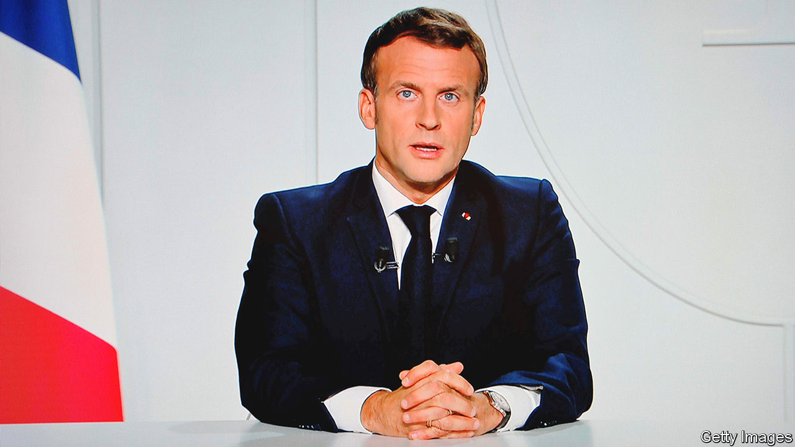

The second wave of covid-19 worsened across Europe, leading a number of countries to impose stricter measures. A second national lockdown was announced in France; Emmanuel Macron, the president, said the country had been “overwhelmed” by the spread of the virus. In Germany restaurants, cafés and bars were ordered to close during November. Spain announced a new state of emergency, and much of Italy has introduced curfews. A study in England suggests that 100,000 people are catching the disease there every day.

A suspected Islamist killed three people at a church in Nice, virtually beheading one of his victims. He was shot, injured and arrested by French police. On the same day police shot dead a man near Avignon who had threatened passersby with a gun. The attacks came soon after the decapitation of a teacher near Paris, after he had shown cartoons of the Prophet Muhammad to his pupils.

Large demonstrations in Poland greeted a decision by the Constitutional Tribunal to make it even harder for women there to have abortions. They will no longer be allowed to cite serious foetal defects as a justification. Abortions are now legal only in cases of rape, or incest, or to protect the mother’s life.

Amy Coney Barrett was sworn in as a justice on America’s Supreme Court. The Senate had voted to confirm her just a week before the presidential election. All Republican senators except Susan Collins of Maine, approved her nomination. The court now has a 6-3 conservative majority.

The number of people who have already voted in America’s election passed 76m as of October 29th. In Florida, a key state, 7m people have voted early, only 2.4m fewer than the total turnout in 2016. Early voting is less prevalent in Pennsylvania and other swing states in the Midwest.

Israel and Sudan agreed to normalise relations in a deal brokered by America. As part of the agreement, Sudan is being taken off an official list of countries sponsoring terrorism. It is the third Arab country to recognise Israel in the past two months.

Libya’s warring factions agreed to cease fire. The UN envoy, Stephanie Williams, said all foreign fighters must leave Libya within three months.

Russian air strikes killed dozens of Turkish-backed fighters in northern Syria. The attack threatens to undo a truce, brokered by Russia and Turkey, in Idlib province, which is partially controlled by rebels.

Police in Nigeria arrested over 800 people in connection with the looting and burning of shops and warehouses. Angry young people targeted government facilities believed to be storing food and other supplies meant to be distributed as covid-19 relief. The unrest follows recent protests against police brutality.

Over 20 people were killed in violence that erupted after a disputed presidential election in Guinea. Alpha Condé won a third term, according to the official results. But his main opponent also claimed victory.

Tanzania’s election was also marred by violence and allegations of vote-rigging. In the semi-autonomous island region of Zanzibar, opposition leaders accused the police of killing at least nine people during protests. John Magufuli, the incumbent, is expected to be declared the winner of the presidential race.

By a large majority, Chileans voted in a referendum to scrap the constitution written under the dictatorship of Augusto Pinochet, who governed Chile from 1973 to 1990. They also voted to summon an elected assembly, half of whose members must be women, to draft a new one. Critics of the current constitution say it gives private firms too big a role in providing public services and concentrates too much power in the presidency.

Leopoldo López, a leader of the opposition to Venezuela’s dictator, Nicolás Maduro, secretly left the residence of the Spanish ambassador in Caracas, where he had taken refuge, and fled to Spain.

A judge in Bolivia annulled the arrest warrant for the former president, Evo Morales, clearing the way for him to return from exile in Argentina. The decision does not end investigations into allegations that Mr Morales committed acts of “sedition and terrorism” by helping to foment unrest a year ago.

Japan pledged to reduce its net emissions of greenhouse gases to zero by 2050, in line with promises made by Britain and the EU. Two days after the announcement, South Korea made a similar pledge.

Sri Lanka’s parliament approved an amendment to the constitution that enormously strengthens the powers of the presidency. The amendment reverses changes made in 2015 to rein in the president.

The king of Malaysia declined the government’s request to declare a state of emergency. That means the government will have to put a budget to parliament, in a vote it might lose, triggering an election.

China tested all 4.7m residents of Kashgar for covid-19 in a matter of days, following a spike in infections. Some 183 people tested positive in the city, which is in China’s autonomous region of Xinjiang.

## Coronavirus briefs

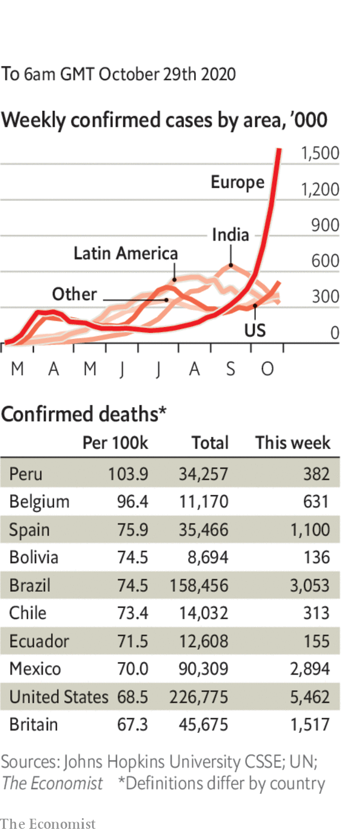

America hit 83,000 new daily infections on two consecutive days, the highest numbers since the pandemic began.

Russia broke records for both the daily number of cases and deaths in the country. Some 27,000 people have officially died in total, though the true figure may be much higher.

Iran said it would extend the closure of schools, mosques, shops, restaurants and other public institutions in Tehran until November 20th. State television reported that a person was dying from the virus every four minutes.

Taiwan went 200 days without any locally transmitted cases. It has had just seven deaths.

Melbourne came out of a lengthy strict lockdown, which has been credited with suppressing the spread of the disease in the Australian city. Its 5m residents had been largely confined to home.

This article was downloaded by calibre from <https://www.economist.com/the-world-this-week/2020/10/29/politics-this-week>

|  |  |  |  |
| --- | --- | --- | --- |
|  | Articles | Sections | Next |

|  |  |  |  |
| --- | --- | --- | --- |
| Previous | Articles | Sections | Next |

# Business this week

Oct 29th 2020 |

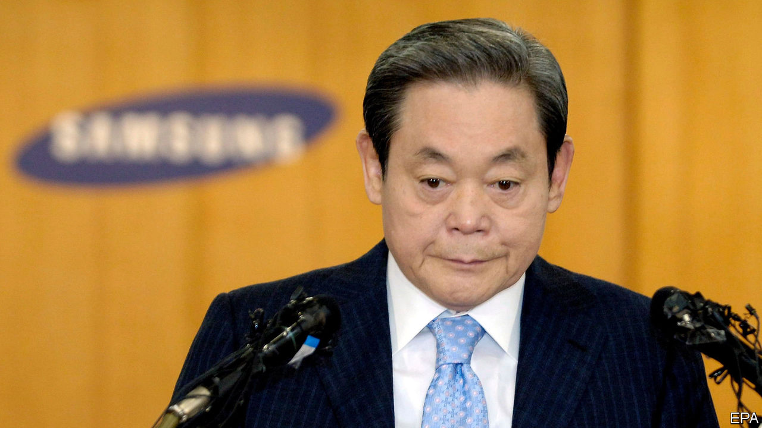

The prospect of a resurgence in covid-19 and new lockdowns made it a rocky week for stockmarkets. On Wall Street the S&P 500 and Dow Jones Industrial Average each fell by 3.5% in a day, the Nasdaq by 3.7%. The FTSE 100 dropped by 2.6%. The sell-off was even sharper in French and German markets. Oil prices also plunged; Brent crude fell to $39 a barrel.

Ant Group set the share prices for its forthcoming dual listing in Hong Kong and on Shanghai’s tech-focused Star market. The Chinese fintech firm’s initial public offering could raise more than $34bn, which would vault it ahead of Saudi Aramco’s debut last year to make it the world’s biggest-ever IPO of stock.

## A spanner in the works

America rejected the candidacy of Ngozi Okonjo-Iweala, a former Nigerian finance minister, as the next head of the World Trade Organisation, instead throwing its weight behind Yoo Myung-hee, South Korea’s trade minister and the only other person running for the job. Both candidates are women. Ms Okonjo-Iweala would also be the first African to lead the WTO and has the backing of its selection committee. But America wants the organisation to be overhauled, and says it “must be led by someone with real, hands-on experience in the field”.

A report from the Intergovernmental Science-Policy Platform on Biodiversity and Ecosystem Services, based in Bonn, warned that future pandemics will do more damage than covid-19 to the world economy unless measures are taken to reduce contact between wildlife, livestock and people, because increasing human activity is driving transmission. It estimates that between 540,000 and 850,000 unknown viruses in nature could still infect people.

HSBC’s net profit declined by half, to $1.4bn, year on year, though it recorded significantly lower credit losses. The bank is considering whether to resume dividends. It cut them in March at the behest of British regulators, causing outrage in Hong Kong, where a third of its shareholders are based.

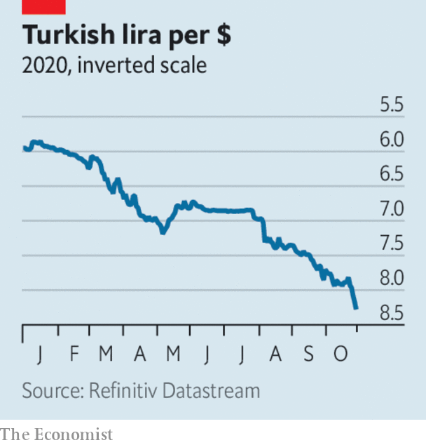

The Turkish lira hit a new low against the dollar, in part because Turkey’s central bank did not raise its main interest rate at its recent meeting, leading to more speculation about the extent of political interference in its decisions. Recep Tayyip Erdogan, the country’s president, is opposed to rate rises. Investors are also nervous about America’s warnings to Turkey about deploying an anti-aircraft missile system it has bought from Russia.

LVMH and Tiffany reportedly negotiated a new deal with a lower price tag for the French luxury-goods group’s takeover of the American jeweller. LVMH had said it wanted to pull out of the acquisition, arguing that Tiffany’s post-pandemic prospects are poor. Both sides are trying to avoid an expensive court case to solve the matter.

Lee Kun-hee, a giant in the world of South Korean business, died at the age of 78. A son of the founder of Samsung, Mr Lee transformed the sprawling group into the world’s biggest manufacturer of smartphones, televisions and memory chips. He was considered to be South Korea’s most powerful man before a heart attack in 2014 confined him to bed. He officially remained chairman of Samsung, though the de facto leadership passed to his son, Lee Jae-yong, who, like his father, has been tarnished by allegations of corruption.

Aston Martin, a struggling British maker of sports cars, announced that Daimler will increase its stake in the company to a maximum of 20% in exchange for access to the German car group’s electric-vehicle technology.

AMD, a chipmaker, announced that it would buy Xilinx, another chip firm, for $35bn. The deal is the latest in a banner year for mergers in the semiconductor industry. AMD hopes its acquisition will help it move into new markets, and to compete with Intel, its arch-rival, in the lucrative market for data-centre chips.

A surge in demand for commercial cloud services helped Microsoft rack up a quarterly profit of $13.9bn, a 30% increase year on year. The company said it expects cloud computing will become ever more important as firms rely less on IT systems physically located in their offices. The number of daily active users of Microsoft’s Team message-and-chat service, a rival to Slack, has risen to 115m, from 32m at the start of the crisis.

## Aloha

Japanese tourists are to be allowed to enter Hawaii, and avoid the American state’s strict two-week quarantine, if they test negative for covid-19 in an approved programme. Japanese visitors, many of whom have family connections with Hawaii, are the islands’ second-biggest source of tourism revenue, after travellers from the American mainland. How many will go is unclear, as they will still have to self-isolate when they return to Japan.

This article was downloaded by calibre from <https://www.economist.com/the-world-this-week/2020/10/29/business-this-week>

|  |  |  |  |
| --- | --- | --- | --- |
| Previous | Articles | Sections | Next |

|  |  |  |  |
| --- | --- | --- | --- |
| Previous | Articles | Sections | Next |

# KAL's cartoon

Oct 29th 2020 |

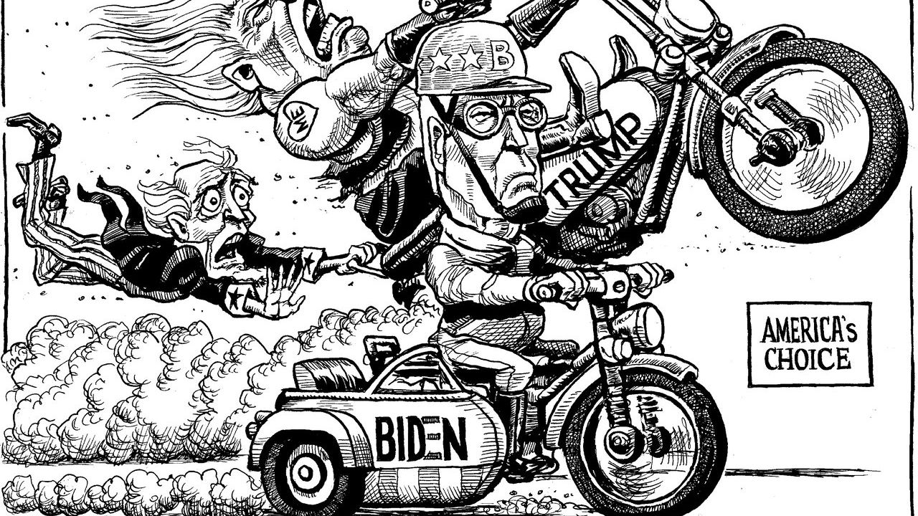

This article was downloaded by calibre from <https://www.economist.com/the-world-this-week/2020/10/29/kals-cartoon>

|  |  |  |  |
| --- | --- | --- | --- |
| Previous | Articles | Sections | Next |

|  |  |  |
| --- | --- | --- |
| The world this week | Sections | Letters |

Leaders

America's election: Why it has to be Biden

.

Green innovation: Breaking through

.

Furlough schemes: The zombification of Britain

.

Germany’s Christian Democrats: The long farewell

.

|  |  |  |
| --- | --- | --- |
| The world this week | Sections | Letters |

|  |  |  |  |
| --- | --- | --- | --- |
|  | Articles | Sections | Next |

#### America’s election

# Why it has to be Biden

Donald Trump has desecrated the values that make America a beacon to the world

Oct 29th 2020 |



THE COUNTRY that elected Donald Trump in 2016 was unhappy and divided. The country he is asking to re-elect him is more unhappy and more divided. After almost four years of his leadership, politics is even angrier than it was and partisanship even less constrained. Daily life is consumed by a pandemic that has registered almost 230,000 deaths amid bickering, buck-passing and lies. Much of that is Mr Trump’s doing, and his victory on November 3rd would endorse it all.

Joe Biden is not a miracle cure for what ails America. But he is a good man who would restore steadiness and civility to the White House. He is equipped to begin the long, difficult task of putting a fractured country back together again. That is why, if we had a vote, it would go to Joe.

King Donald  
Mr Trump has fallen short less in his role as the head of America’s government than as the head of state. He and his administration can claim their share of political wins and losses, just like administrations before them. But as the guardian of America’s values, the conscience of the nation and America’s voice in the world, he has dismally failed to measure up to the task.

Without covid-19, Mr Trump’s policies could well have won him a second term (see first Briefing). His record at home includes tax cuts, deregulation and the appointment of benchloads of conservative judges. Before the pandemic, wages among the poorest quarter of workers were growing by 4.7% a year. Small-business confidence was near a 30-year peak. By restricting immigration, he gave his voters what they wanted. Abroad, his disruptive approach has brought some welcome change (see second Briefing). America has hammered Islamic State and brokered peace deals between Israel and a trio of Muslim countries. Some allies in NATO are at last spending more on defence. China’s government knows that the White House now recognises it as a formidable adversary.

This tally contains plenty to object to. The tax cuts were regressive. Some of the deregulation was harmful, especially to the environment. The attempt at health-care reform has been a debacle. Immigration officials cruelly separated migrant children from their parents and limits on new entrants will drain America’s vitality. On the hard problems—on North Korea and Iran, and on bringing peace to the Middle East—Mr Trump has fared no better than the Washington establishment he loves to ridicule.

However, our bigger dispute with Mr Trump is over something more fundamental. In the past four years he has repeatedly desecrated the values, principles and practices that made America a haven for its own people and a beacon to the world. Those who accuse Mr Biden of the same or worse should stop and think. Those who breezily dismiss Mr Trump’s bullying and lies as so much tweeting are ignoring the harm he has wrought.

It starts with America’s democratic culture. Tribal politics predated Mr Trump. The host of “The Apprentice” exploited it to take himself from the green room to the White House. Yet, whereas most recent presidents have seen toxic partisanship as bad for America, Mr Trump made it central to his office. He has never sought to represent the majority of Americans who did not vote for him. Faced by an outpouring of peaceful protest after the killing of George Floyd, his instinct was not to heal, but to depict it as an orgy of looting and left-wing violence—part of a pattern of stoking racial tension. Today, 40% of the electorate believes the other side is not just misguided, but evil.

The most head-spinning feature of the Trump presidency is his contempt for the truth. All politicians prevaricate, but his administration has given America “alternative facts”. Nothing Mr Trump says can be believed—including his claims that Mr Biden is corrupt. His cheerleaders in the Republican Party feel obliged to defend him regardless, as they did in an impeachment that, bar one vote, went along party lines.

Partisanship and lying undermine norms and institutions. That may sound fussy—Trump voters, after all, like his willingness to offend. But America’s system of checks and balances suffers. This president calls for his opponents to be locked up; he uses the Department of Justice to conduct vendettas; he commutes the sentences of supporters convicted of serious crimes; he gives his family plum jobs in the White House; and he offers foreign governments protection in exchange for dirt on a rival. When a president casts doubt on the integrity of an election just because it might help him win, he undermines the democracy he has sworn to defend.

Partisanship and lying also undermine policy. Look at covid-19. Mr Trump had a chance to unite his country around a well organised response—and win re-election on the back of it, as other leaders have. Instead he saw Democratic governors as rivals or scapegoats. He muzzled and belittled America’s world-class institutions, such as the Centres for Disease Control and Prevention. As so often, he sneered at science, including over masks. And, unable to see beyond his own re-election, he has continued to misrepresent the evident truth about the epidemic and its consequences. America has many of the world’s best scientists. It also has one of world’s highest covid-19 fatality rates.

Mr Trump has treated America’s allies with the same small-mindedness. Alliances magnify America’s influence in the world. The closest ones were forged during wars and, once unmade, cannot easily be put back together in peacetime. When countries that have fought alongside America look on his leadership, they struggle to recognise the place they admire.

That matters. Americans are liable both to over- and to underestimate the influence they have in the world. American military power alone cannot transform foreign countries, as the long wars in Afghanistan and Iraq proved. Yet American ideals really do serve as an example to other democracies, and to people who live in states that persecute their citizens. Mr Trump thinks ideals are for suckers. The governments of China and Russia have always seen American rhetoric about freedom as cynical cover for the belief that might is right. Tragically, under Mr Trump their suspicions have been confirmed.

Four more years of a historically bad president like Mr Trump would deepen all these harms—and more. In 2016 American voters did not know whom they were getting. Now they do. They would be voting for division and lying. They would be endorsing the trampling of norms and the shrinking of national institutions into personal fiefs. They would be ushering in climate change that threatens not only distant lands but Florida, California and America’s heartlands. They would be signalling that the champion of freedom and democracy for all should be just another big country throwing its weight around. Re-election would put a democratic seal on all the harm Mr Trump has done.

President Joe  
The bar to Mr Biden being an improvement is therefore not high. He clears it easily. Much of what the left wing of the Democratic Party disliked about him in the primaries—that he is a centrist, an institutionalist, a consensus-builder—makes him an anti-Trump well-suited to repair some of the damage of the past four years. Mr Biden will not be able to end the bitter animosity that has been mounting for decades in America. But he could begin to lay down a path towards reconciliation.

Although his policies are to the left of previous administrations’, he is no revolutionary. His pledge to “build back better” would be worth $2trn-3trn, part of a boost to annual spending of about 3% of GDP. His tax rises on firms and the wealthy would be significant, but not punitive. He would seek to rebuild America’s decrepit infrastructure, give more to health and education and allow more immigration. His climate-change policy would invest in research and job-boosting technology. He is a competent administrator and a believer in process. He listens to expert advice, even when it is inconvenient. He is a multilateralist: less confrontational than Mr Trump, but more purposeful.

Wavering Republicans worry that Mr Biden, old and weak, would be a Trojan horse for the hard left. It is true that his party’s radical wing is stirring, but he and Kamala Harris, his vice-presidential pick, have both shown in the campaign that they can keep it in check. Ordinarily, voters might be advised to constrain the left by ensuring that the Senate remained in Republican hands. Not this time. A big win for the Democrats there would add to the preponderance of moderate centrists over radicals in Congress by bringing in senators like Steve Bullock in Montana or Barbara Bollier in Kansas. You would not see a lurch to the left from either of them.

A resounding Democratic victory would also benefit the Republicans. That is because a close contest would tempt them into divisive, racially polarising tactics, a dead end in a country that is growing more diverse. As anti-Trump Republicans argue, Trumpism is morally bankrupt (see Lexington). Their party needs a renaissance. Mr Trump must be soundly rejected.

In this election America faces a fateful choice. At stake is the nature of its democracy. One path leads to a fractious, personalised rule, dominated by a head of state who scorns decency and truth. The other leads to something better—something truer to what this newspaper sees as the values that originally made America an inspiration around the world.

In his first term, Mr Trump has been a destructive president. He would start his second affirmed in all his worst instincts. Mr Biden is his antithesis. Were he to be elected, success would not be guaranteed—how could it be? But he would enter the White House with the promise of the most precious gift that democracies can bestow: renewal.

Dig deeper:  
Read the [best of our 2020 campaign coverage](https://www.economist.com/us-election-2020) and explore our [election forecasts](https://projects.economist.com/us-2020-forecast/president), then sign up for Checks and Balance, our [weekly newsletter](https://www.economist.com/checksandbalance/) and [podcast](https://www.economist.com/podcasts/2020/01/24/checks-and-balance-our-new-weekly-podcast-on-american-politics) on American politics.

This article was downloaded by calibre from <https://www.economist.com/leaders/2020/10/29/why-it-has-to-be-biden>

|  |  |  |  |
| --- | --- | --- | --- |
|  | Articles | Sections | Next |

|  |  |  |  |
| --- | --- | --- | --- |
| Previous | Articles | Sections | Next |

#### Green innovation

# Innovation is an essential part of dealing with climate change

More is needed

Oct 31st 2020 |

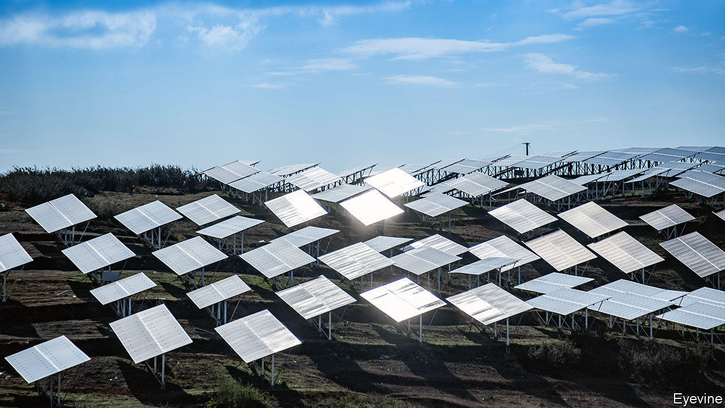

GOVERNMENTS ARE lining up to set new climate targets for the middle of the century. This week Japan said that it would eliminate all greenhouse gases (see article). In the past month or so China and South Korea have declared that their economies will be carbon-neutral, meaning that they will put no more carbon dioxide into the atmosphere than they take out. In March the European Union unveiled a “net-zero” plan of its own. Britain and France have enshrined their targets into law. A victory next week for Joe Biden could put America on a similar path.

Targets are easier set than met. Today around 85% of the world’s industrial energy comes from fossil fuels. Getting consumption to near zero will involve enormous economic shifts. It will require huge changes in how energy is generated and used. And it will also require a sustained barrage of innovations to improve how steel or cement are made, say, or how buildings are designed and managed.

The world’s green-innovation machine likes to make a big noise about its successes. The share prices of firms with climate-sustaining technologies have soared. Tesla’s value has reached $385bn, overtaking the combined total of the next three biggest carmakers. The value of BYD, a Chinese competitor, has more than tripled this year. This month NextEra, a clean-power utility, surpassed ExxonMobil to become America’s biggest energy firm. In the past four years venture-capital (VC) deals have more than doubled (see article).

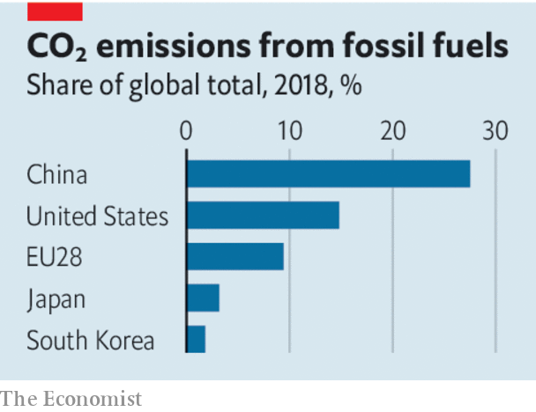

Yet nowhere too little capital is being channelled into innovation. Spending on R&D has three main sources: venture capital, governments and energy companies. Their combined annual investment into technology and innovative companies focused on the climate is over $80bn. For comparison, that is a bit more that twice the R&D spending of a single tech firm, Amazon.

One of the world’s most pressing problems thus receives perhaps just 4% of the global total spent on R&D. Governments are falling short of their targets. VC investment in green startups accounts for about a tenth of all VC investment and firms which sell goods or services that cut emissions made up just five of the top 100 firms in this year’s public-listing bonanza. The private sector’s record on climate innovation has been a hit-and-miss affair, at best. Having boomed in the mid-2000s, green VCs went bust a few years later.

What can be done? The first step is to think clearly about the division of labour between governments and the private sector. Governments need to get involved in several ways, because the market on its own will not do enough to bring about the shift from fossil fuels. It starts with the state funding not just basic research but also some development and the deployment of technologies. Some projects are too risky, too large, or both, to be countenanced by private investors on their own.

In practice that means the government should expect to foot some or all of the bill for new nuclear power plants, new charging grids for electric vehicles, or thorough investigations of new technologies such as geoengineering. Governments also need to enact policies that encourage greener consumption. Pricing carbon is an essential step, forcing firms, and ultimately consumers, to bear the cost of their emissions, and in turn leading investors to allocate capital more efficiently.

The good news is that governments may be at last changing their tune. Carbon taxes are spreading and will soon cover over a fifth of global emissions. A slice of the EU’s €750bn ($880bn) recovery plan is likely to be directed towards R&D that is related to reducing greenhouse-gas emissions and their effects. If he is elected on November 3rd, Mr Biden plans to spend $300bn on R&D over four years, with an emphasis on renewable-energy technology. At the moment, the federal government spends less than $7bn a year on such green R&D.

The private sector still has a crucial role to play. Investors and entrepreneurs are best at commercialising new ideas, from efficient grids to hydrogen-powered forklift trucks. The public markets provide a vast source of capital for more mature firms, helping them scale up fast, as Tesla has demonstrated. Yet so far the asset-management industry has stuck to marketing its green credentials in superficial ways. In the latest quarter the net inflows of cash into “sustainable” funds, which often track the shares of big firms that have little effect on climate change, were twice the size of the annual investments into green VC.

More companies and billionaire-backed funds are eyeing up climate-friendly VC. But institutional investors, who have far larger sums to play with, need to embrace the opportunity, too. The forthcoming energy transition will be one of the biggest business opportunities of the next decades. Instead of piling into Tesla’s shares 17 years after the company was founded, investors should be striving to find the next superstar.■

For more coverage of climate change, register for The Climate Issue, our fortnightly [newsletter](https://www.economist.com/theclimateissue/), or visit our [climate-change hub](https://www.economist.com/news/2020/04/24/the-economists-coverage-of-climate-change)

This article was downloaded by calibre from <https://www.economist.com/leaders/2020/10/31/innovation-is-an-essential-part-of-dealing-with-climate-change>

|  |  |  |  |
| --- | --- | --- | --- |
| Previous | Articles | Sections | Next |

|  |  |  |  |
| --- | --- | --- | --- |
| Previous | Articles | Sections | Next |

#### The zombification of Britain

# Why Rishi got it wrong

Britain’s chancellor should not have extended the furlough scheme

Oct 29th 2020 |

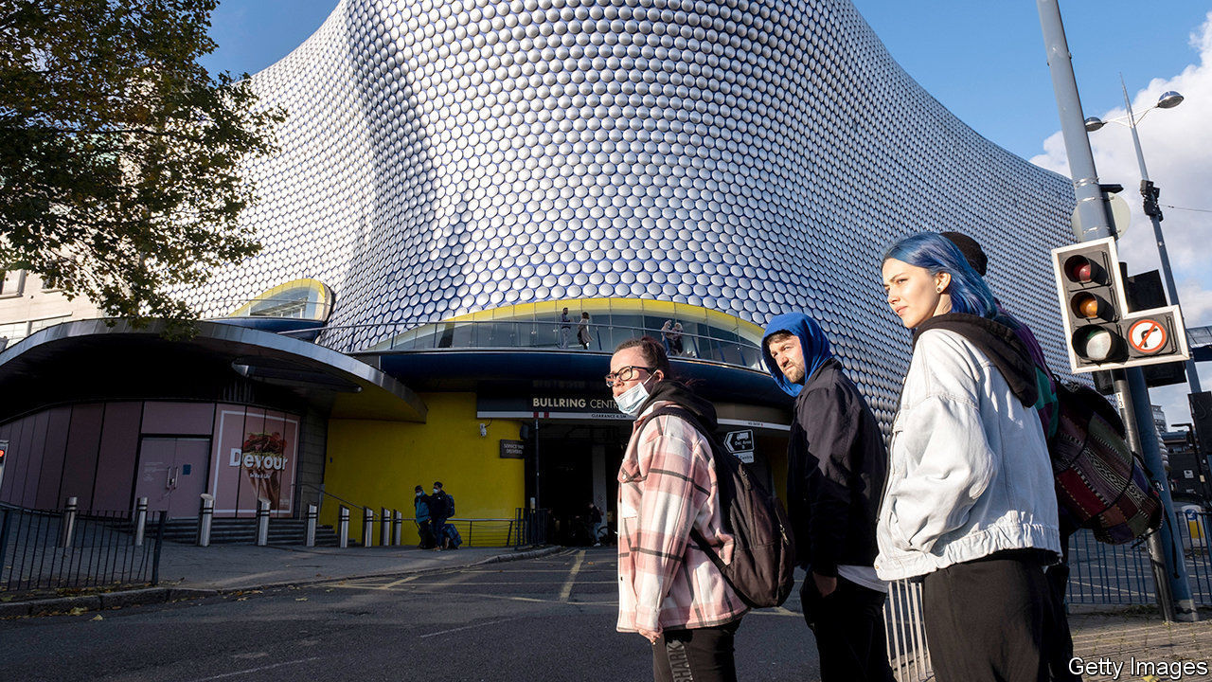

IMAGINE IF, 20 YEARS ago, the British government had vowed to protect every job in the country. Today an extra 30,000 Britons would be working as high-street travel agents, 30,000 or so would earn their crust by repairing fax machines, and 40,000 would still be stacking shelves and ringing the tills in Woolworths, a chain of stores that went bust in 2009.

Allowing obsolete jobs to wither and new ones to blossom is one of the main ways in which capitalist economies get richer and more productive. Governments interfere with this process of creative destruction at their peril. That is why the direction that Britain is taking in its efforts to mitigate the economic effects of the pandemic is so mistaken.

Since March Britain has been shielding workers and their families from the ruinous effects of the pandemic primarily through its furlough scheme, which pays 80% of workers’ salaries. Britain’s approach is similar to that of other European countries, but its scheme is more generous than those elsewhere. In the deepest days of lockdown, close to 10m workers—a third of the labour force—were benefiting from it. More than twice as many Britons remain furloughed as Italians, Germans or French.

Until recently Rishi Sunak, the chancellor of the exchequer, had been planning to introduce a stripped-down replacement for his furlough scheme. But at the last minute, as it became clear that infection rates are rising alarmingly fast across large parts of the country, the chancellor changed his mind and opted instead to continue with an adjusted scheme that is due to start on November 1st and is almost as generous.

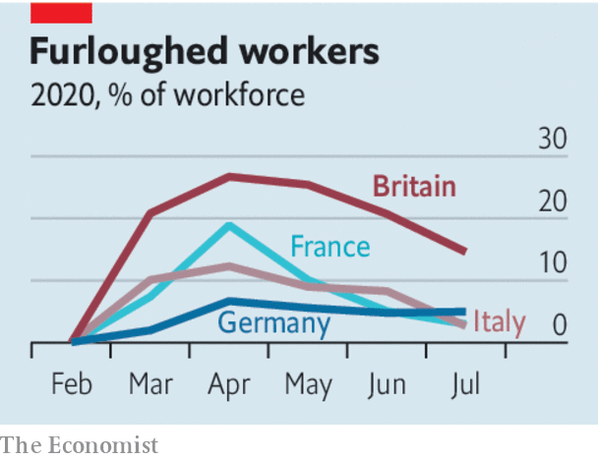

Under the new rules, workers need put in only 20% of their normal scheduled hours, and the government will cover half their normal pay. For companies that have been forced to close by government restrictions, the scheme will pay two-thirds of workers’ salaries.

Politically, Mr Sunak’s move is shrewd. The opposition Labour Party can hardly criticise a policy that it itself had called for. And by making it easier for bosses to keep workers on the books, Britain will for the time being sweep the pent-up rise in unemployment under the carpet. That, in turn, will blunt the criticism coming from those on the right wing of Mr Sunak’s Conservative Party, who worry that restrictions on movement and socialising are strangling the economy.

But the about-turn makes it more likely that the government will protect jobs for which there is no demand. The economy is changing fast. Fewer sandwich-sellers will be needed in city centres in future, since more people will work from home. The growth of online shopping, and the decline of the bricks-and-mortar sort, has accelerated. At least 1m jobs supported by the new furlough scheme, representing about 3% of the workforce, are unlikely to survive in the long run.

The cost of supporting these jobs, which is probably around £1bn a month, is a problem in itself. But in a world in which the budget deficit is that size every day it is a minor one. What is more worrying is the likelihood that the government is retarding economic recovery by discouraging the reallocation of workers from dying industries to growing ones. It is leaving the country stuck with the post-pandemic equivalent of fax-repairmen and Woolies’ sales staff.

America is doing better. Across the Atlantic, politicians have focused less on preserving jobs than on preserving incomes, posting stimulus cheques to households and temporarily bumping up unemployment-insurance payments (these have since lapsed, but after the election Congress will probably decide to reintroduce them). Earlier this year, government top-ups were worth $600 a week, so generous that seven out of ten unemployed Americans earned more from benefits than they had done when they were still in work.

This largesse has given people the financial security to experiment with new ways of earning money. As the economy has reopened, America has seen an explosion of small-business creation, with laid-off workers finding gaps in the market. Europe’s economic recovery is weaker than America’s, and Britain lags still further behind. The furlough scheme, which encourages workers to cling to old jobs rather than looking for new ones, is almost certainly part of the reason.

It is not too late to change course. The government should wind down the furlough scheme, as it had planned to, and follow the American example. It should not just cancel a planned reduction in the value of universal credit, but sharply increase its value, so as to ensure that workers whose jobs disappear earn the same as those who stay on furlough. If so, they would get 85% of their previous earnings in benefits, up from 55% at present. That would allow the necessary reallocation of resources without forcing people into penury.

## Build it to last

In the spring, when it was still unclear how long the pandemic would last, Britain was right to try to hold the economy in suspended animation. Now that the world knows the impact of covid-19 will be deep and enduring, the task for politicians is to protect workers, and leave the market to work its magic. ■

Editor’s note: Some of our covid-19 coverage is free for readers of The Economist Today, our daily [newsletter](https://my.economist.com/user#newsletter). For more stories and our pandemic tracker, see our [hub](https://www.economist.com/news/2020/03/11/the-economists-coverage-of-the-coronavirus)

This article was downloaded by calibre from <https://www.economist.com/leaders/2020/10/29/why-rishi-got-it-wrong>

|  |  |  |  |
| --- | --- | --- | --- |
| Previous | Articles | Sections | Next |

|  |  |  |  |
| --- | --- | --- | --- |
| Previous | Articles | Sections | Next |

#### After Merkel, midgets

# Germany’s ruling party is making a hash of choosing its next leader

The debate between candidates who may end up running Germany has been vacuous

Oct 31st 2020 |

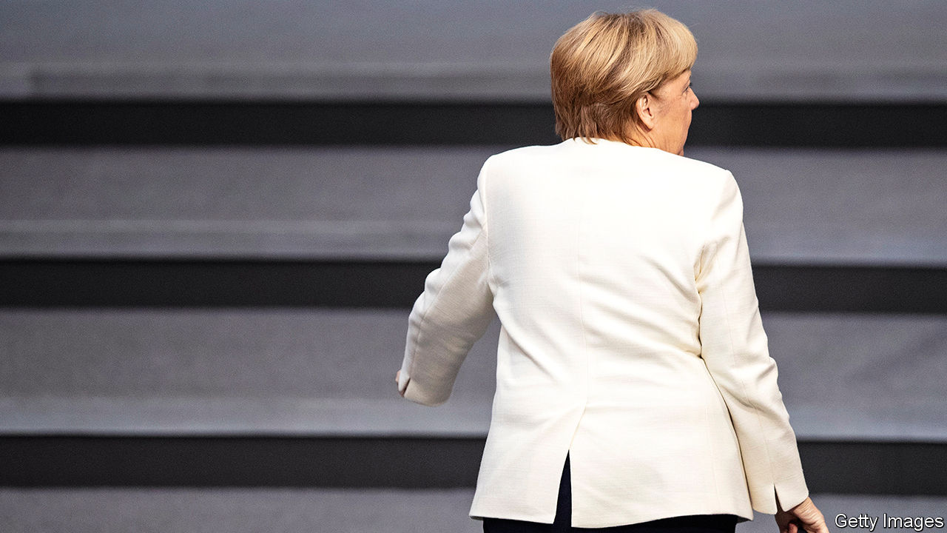

EUROPE’S MOST important election next year will take place in Germany. So will the runner-up. In the autumn of 2021 Germans will elect a new government, and Angela Merkel has promised that she will step down after 16 years as chancellor. Before that, though, Mrs Merkel’s centre-right Christian Democratic Union (CDU) must choose a new leader—and the winner of that vote will be in pole position to succeed her in the chancellery. The CDU’s internal election is therefore crucial for Germany, and beyond. And yet the party is making a monumental hash of it.

The immediate cause is covid-19. The pandemic scuppered the CDU’s first attempt to elect its leader, in April. This week the party scrapped a second party congress, planned for December 4th. Despite a detailed health protocol, including buzzers that would have been triggered whenever those attending got too close to one another, it was considered impossible to organise a mass event just when the virus was rampant. Mrs Merkel has just announced sweeping new restrictions. The CDU now plans either to hold an in-person event early next year, or to conduct a digital congress and ask delegates to vote by post, which will take weeks. (Absurdly, German law appears to rule out an online election.)

Worse, the plan has triggered a bitter party dispute. The chief source of trouble is Friedrich Merz, the leadership candidate with the strongest backing from CDU conservatives. He seems to believe that delay will hurt his chances against his chief rival, Armin Laschet, who is a centrist in the Merkel mould. (A third candidate, Norbert Röttgen, has little chance of victory.) Mr Merz accuses the CDU establishment of using covid-19 as a pretext to damage his candidacy; the party congress was postponed, he says, to help Mr Laschet, who is struggling to gain a following despite his perch as premier of North Rhine-Westphalia, Germany’s largest state.

It is not the first act of political clumsiness by Mr Merz, a former CDU bigwig who quit politics in 2009 only to change his mind and return to the fray two years ago. Party barons are infuriated by his antics as Germany grapples with the steep acceleration in covid-19 caseloads. Mr Merz’s self-pity will not help his case with the 1,001 CDU delegates who must choose their new leader—nor, should he win, with the German electorate.

Yet Mr Merz is right that one of Europe’s most successful parties ought to be able to handle a leadership election without melting down. Postponing the vote could delay other staging-posts before the general election. First, after choosing its leader, the CDU must get together with its Bavarian sister party, the Christian Social Union (CSU), to pick a joint candidate to run for chancellor. Second, that candidate—who will be odds-on to replace Mrs Merkel—will need time to introduce himself to German voters: neither Mr Merz nor Mr Laschet has much of a national profile (unlike Markus Söder, the popular CSU leader, who has an outside chance of taking the candidacy). There are also two crucial state elections to manage in March. No one wants an American-style drawn-out campaign. But next year’s political calendar is starting to look squeezed.

Two years ago Mrs Merkel stepped down as CDU leader, marking the beginning of her long farewell from German politics. The party has since botched its management of her succession at almost every stage. Annegret Kramp-Karrenbauer, Mrs Merkel’s protégée and her successor as leader, resigned earlier this year after failing to stamp her authority on the party. Mrs Merkel’s capable handling of covid-19 has lifted the CDU’s poll ratings. But the contest among the three middle-aged men who are vying to replace her has been dispiritingly dull. At times the party has appeared nervous of allowing too lively a debate for fear of exposing its own divisions.

Yet such splits make debate all the more important. As Mrs Merkel’s reign enters its last year, Germany confronts a fresh set of challenges—immigration, the deepening of euro-zone co-operation, Germany’s policy towards Russia and China, climate change, defence spending and pensions. The CDU urgently needs to talk about the future.

The leadership contest ought to be a chance for the party to thrash out its differences before rallying for a general election that the polls say it is likely to win. But what should be a discussion about vital issues has become a splenetic row over procedure. German voters deserve better. ■

This article was downloaded by calibre from <https://www.economist.com/leaders/2020/10/31/germanys-ruling-party-is-making-a-hash-of-choosing-its-next-leader>

|  |  |  |  |
| --- | --- | --- | --- |
| Previous | Articles | Sections | Next |

|  |  |  |
| --- | --- | --- |
| Leaders | Sections | Briefing |

Letters

Letters to the editor: On Indonesia, Colombia, human rights, Nagorno-Karabakh, CEOs, the Arctic, beer

.

|  |  |  |
| --- | --- | --- |
| Leaders | Sections | Briefing |

|  |  |  |  |
| --- | --- | --- | --- |
|  | Articles | Sections | Next |

#### On Indonesia, Colombia, human rights, Nagorno-Karabakh, CEOs, the Arctic, beer

# Letters to the editor

A selection of correspondence

Oct 31st 2020 |

Letters are welcome via e-mail to letters@economist.com

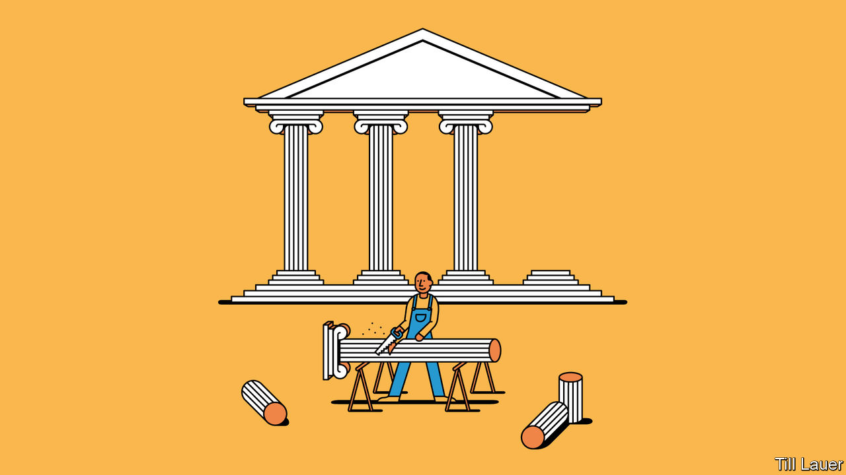

## Indonesia’s politics

It is said that Javanese dynasties rarely last 100 years. This must have been on the mind of President Joko Widodo, or Jokowi, when, as Banyan described, he pandered to the country’s elite to form a grand coalition to govern an unruly country ([October 17th](https://www.economist.com/asia/2020/10/15/how-not-to-reform-indonesia)). In such a fractured country as Indonesia, leaders must contend with entrenched power bases, then cultivate patronage networks of their own if they are to govern at all.

Aspiring reformers who do not play by these rules risk following in the footsteps of Abdurrahman Wahid, toppled as president by a hostile parliament, or of Jokowi’s erstwhile ally, Basuki Tjahaja Purnama (“Ahok”), jailed under a dubious and politically charged sentence for blasphemy. Disgraced reformers are hardly useful to their constituents. Courting the opposition allowed Jokowi to defang the Islamists without jailing anyone, making his job slightly more manageable. Moreover, his economic programmes are not anti-democratic in their own right; they are in line with his campaign promise, which is what the people voted for.

In a region where aspiring despots eliminate term limits or imprison critics, it is rather disingenuous to say that Indonesia is sliding back into authoritarianism. After all, the country is a flawed democracy at best. It is simply remaining one. These point not to Jokowi’s contradictions, but to Indonesia’s.

ELANG ADHYAKSA  
Jakarta

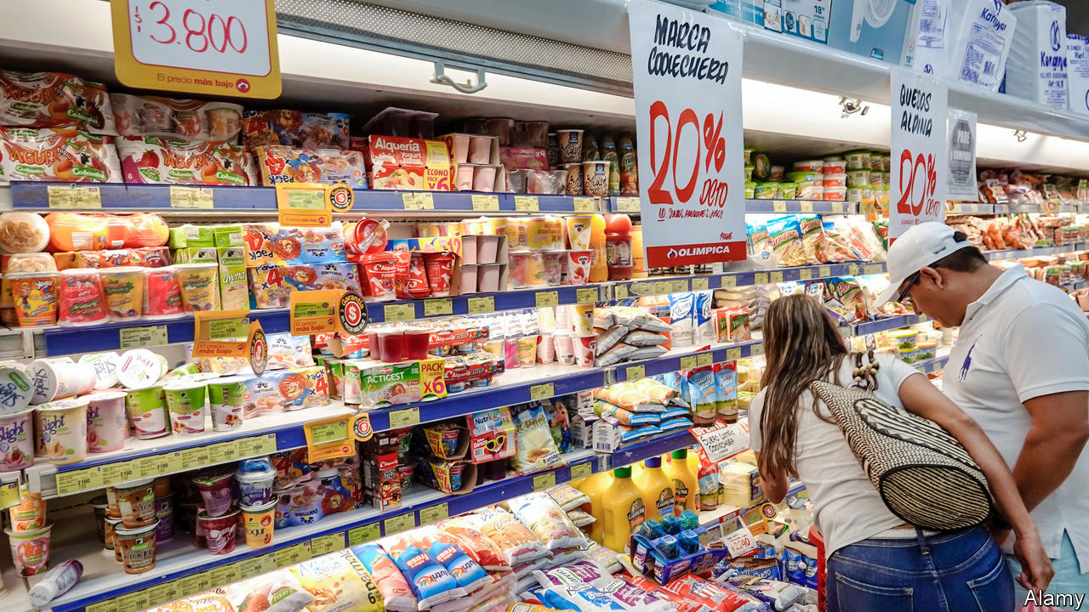

## A tax burden on the poor

Even though Colombia’s value-added tax (VAT) rate has increased over the years, the share of taxes to GDP has stayed about the same, even falling slightly under Alberto Carrasquilla, the finance minister ([“VAT half-empty”](https://www.economist.com/the-americas/2020/10/17/colombia-tries-to-fix-a-messy-and-unfair-tax), October 17th). The reason the list of exempt items is so long is that this is seen as the best way to reduce the impact of the tax on the poorest people (though salmon, for example, is classified as a basic staple). In reality, the payment of VAT does not reach much beyond commerce; the government has not even been able to implement the tax electronically.

The real issue in Colombia is that taxes, especially direct taxes like income tax, are not levied on the richest portions of society and the solution has been to try to increase the number of people, namely the poorest, who pay VAT.

CAMILO BLANCO  
Former economic adviser to the Colombian congress  
Bogotá



## Wither human rights

Sadly, your assertion that human rights are universal feels more like wishful thinking than proven fact (“[Torment of the Uyghurs](https://www.economist.com/leaders/2020/10/17/the-persecution-of-the-uyghurs-is-a-crime-against-humanity)”, October 17th). Certainly there is lots of international human-rights machinery, established at the high point of Western power. But all recent studies show that its grip is weakening. On a huge range of core issues—the death penalty, treatment of gays and women, protection for religious and other minorities, democracy, freedom of speech—the nations of the world are making their own, often illiberal, choices whatever the West may think.

Your demand that the West act against Chinese persecution in Xinjiang spotlights the policy dilemma this poses. The Western view that it has the moral right to interfere in other countries’ often deplorable human-rights practices is running out of political road. Such action is becoming counterproductive (Turkey, Russia, India) even when it is not glaringly inconsistent (Saudi Arabia, Egypt) or simply disastrous (Iraq, Libya, Syria). China is the perfect case in point. We could easily turn a confrontation that at the moment is principally about such issues as trade and technology into something much less negotiable, and so more dangerous, about ideology.

Back in 1648 the powers of the day laid the basis for 250 years of carefully constrained competition by adopting the Westphalian principle under which countries did not interfere in each others’ internal affairs. It wasn’t perfect. But its collapse at the start of the 20th century gave us two catastrophic world wars and 40 precarious years on the nuclear tightrope. Perhaps we should revive it.

TONY BRENTON  
Cambridge

## Nagorno-Karabakh

Thank you for drawing attention to the situation around the Armenia-Azerbaijan Nagorno-Karabakh conflict in “[Heavy metal](https://www.economist.com/europe/2020/10/10/the-azerbaijan-armenia-conflict-hints-at-the-future-of-war)” (October 10th). However, Nagorno-Karabakh is not a disputed territory. It is an integral part of Azerbaijan, together with seven adjacent regions, occupied and ethnically cleansed by Armenia. Various UN Security Council resolutions demand the immediate, unconditional and complete withdrawal of Armenian occupying forces from the territories of Azerbaijan. The map in your article is falsified. The real map of Azerbaijan, showing Nagorno-Karabakh within its internationally recognised borders, can be found on the website of the UN’s cartographic department.

We categorically reject the allegations on the use of Syrian mercenaries. Azerbaijan’s armed forces are ranked 64 according to Global Firepower in terms of military strength and are perfectly capable of providing every protection Azerbaijan needs. Armenia, however, is ranked 111.

We have had no problem rallying our people. On July 15th, amid yet another Armenian aggression against Azerbaijan along the international border, an estimated 30,000 people gathered in Baku’s Azadliq Square demanding mobilisation and war to bring an end to the occupation of Azerbaijan’s territories. The international community should not expect to resolve this conflict by simply calling for a ceasefire, unless it addresses that occupation, and upholds international law.

TAHIR TAGHIZADE  
Ambassador of Azerbaijan  
London

Clear the decks  
* Buttonwood’s keen observations on successful endowment investing ([October 3rd](https://www.economist.com/finance-and-economics/2020/10/03/lessons-from-the-endowment-model)) bring to mind claims of a long-standing Yale Endowment Investment Committee Chair, with whom I worked for many years. He would jokingly state that his most important task in the role was to keep the other members of the committee out of the way of the chief investment officer, David Swensen. Except he wasn’t joking.

JOHN WEBSTER  
Wootton-by-Woodstock, Oxfordshire

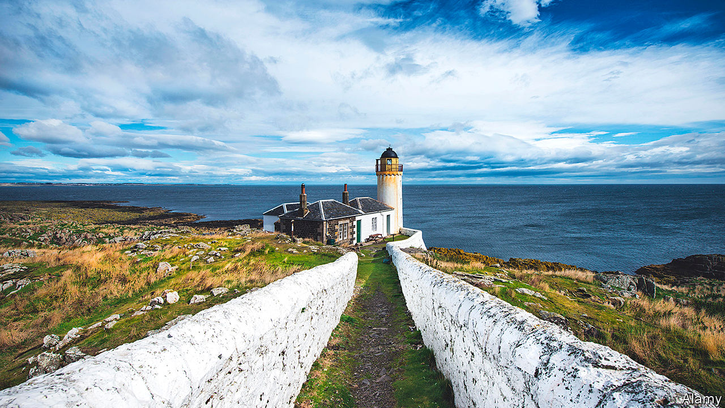

## Where the land runs out

“[Water all around](https://www.economist.com/books-and-arts/2020/10/03/the-magical-allure-of-islands)”, (October 3rd) alas promulgated a challengeable superlative in citing a description of Moffen Island, off Spitsbergen, as being “the last spot before the North Pole”. In so far as the Svalbard archipelago is concerned, that claim more assuredly goes to the island of Rossoya, which lies within a small cluster of seven islands (Sjuoyane) that constitute part of the Nordaust Svalbard nature reserve.

It was among these rocky outcrops that the Royal Navy’s first attempt at reaching the North Pole became beset in ice in 1773. And it was within hailing distance of the four-man party of the British Trans Arctic Expedition that made landfall in 1969 to complete the first crossing of the surface of the Arctic Ocean from the northernmost point of contiguous land in the New World (Point Barrow, Alaska) to the northernmost land of the Old World (the Sjuoyane Islands).

KEN HEDGESSole surviving member of the four-man crossing party of the British Trans Arctic Expedition  
Barrie, Canada

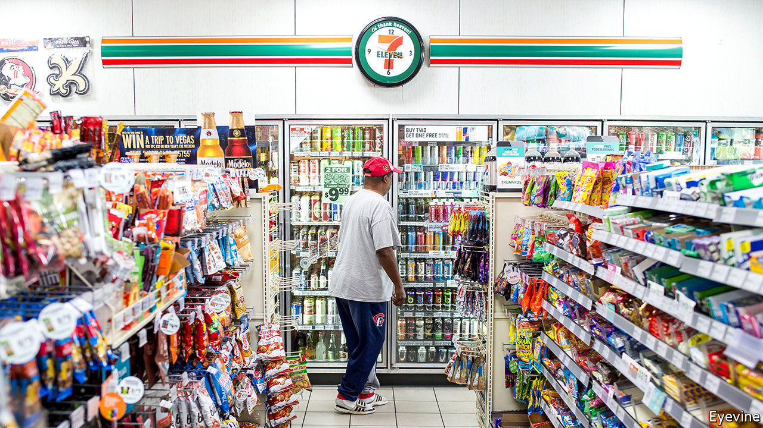

## The beer necessities of life

Milk, beer and sweets were listed as “basic necessities” supplied by corner shops, which are thriving during the pandemic (“[Turning a corner](https://www.economist.com/business/2020/10/17/convenience-stores-may-benefit-from-covid-19-if-they-adapt)”, October 17th). Two of the three can hardly be considered necessities. Sweets are bad for you, and many people live perfectly happily without drinking milk.

COLIN MILLS  
Basel, Switzerland

* Letters appear online only

This article was downloaded by calibre from <https://www.economist.com/letters/2020/10/31/letters-to-the-editor>

|  |  |  |  |
| --- | --- | --- | --- |
|  | Articles | Sections | Next |

|  |  |  |
| --- | --- | --- |
| Letters | Sections | United States |

Briefing

The Trump audit: Four years on

.

The international stage: Realism and the wrecking ball

.

|  |  |  |
| --- | --- | --- |
| Letters | Sections | United States |

|  |  |  |  |
| --- | --- | --- | --- |
|  | Articles | Sections | Next |

#### The Trump audit part I: domestic

# President Trump has had real achievements and a baleful effect

Three judges, a tax cut, an ever-more-divided nation and an undrained swamp

Oct 29th 2020 | WASHINGTON, DC

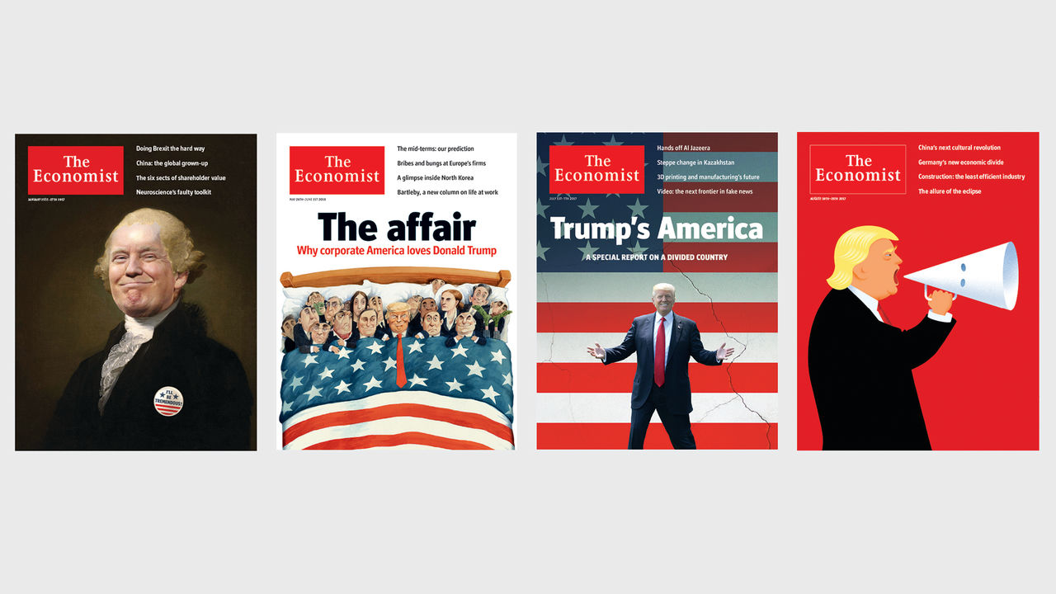

AMERICA HARDLY feels great again. There are 11m fewer people working than in February. Barely more than one-third of pupils are attending school normally. Hunger and poverty have risen; the memories of a turbulent summer of protests and racial unrest are still raw. Official figures show 227,000 people dead due to covid-19; excess-mortality data suggest the true total is over 300,000. And both caseloads and hospitalisations are surging for a third time. On October 23rd America recorded nearly 84,000 new cases, the highest daily tally so far.

The mismanaged epidemic, more than anything else, seems likely to cost President Donald Trump his job. As The Economist went to press our election model gave him less than a 5% chance of winning.

Were it not for the epidemic, though, Mr Trump might be on the brink of re-election. In 2016 he told voters he would keep the economy growing; until the epidemic hit it had done just that. Growth never quite reached the lustrous annual rate of 4% he promised, but it did do better than many had forecast, and his tax cut in 2017 turned out to be a well-timed fiscal stimulus. At the end of last year unemployment was at its lowest level for half a century. The wages of the less well paid were rising swiftly.

What was more, he had made good on other parts of his agenda. Trade deals he disliked had been abandoned or rewritten, tariffs had been slapped on countries accused of stealing jobs and immigration had fallen dramatically. He had appointed two conservative justices to the Supreme Court, a number which he has now brought up to three. “Promises made, promises kept” is one of the slogans of Mr Trump’s re-election campaign. The president tells outright lies with remarkable frequency. But in this he is stretching the truth no further than any politician might.

If Mr Trump does indeed lose the election, it seems likely that his main legacies will be the further polarisation of America’s politics, a guide to how the country’s democratic norms can be subverted and serious damage to its reputation overseas (see article). But the past four years have also seen achievements beyond that sad litany. Some of them are distinctive, not all are bad and some may prove long-lived.

## Give the public a song and dance

In 2016 Mr Trump distinguished himself not just in how he talked but also in what he said. Like all Republicans since Ronald Reagan he was in favour of tax cuts, deregulation, conservative judges, safer streets, stronger armed forces and lower government debt; he was against Obamacare and open borders.

But on many issues he stood out as unorthodox, extreme or both—and in so doing captured voters’ imaginations in a way that his rivals did not. He pledged to deport all 11m undocumented immigrants in the country and build a wall on the border with Mexico. He derided the party’s foreign-policy and free-trade orthodoxies as failures, and held that trade deficits were purely a sign of weakness and poor negotiating—which, as the master of the deal, he could set right. He bashed Wall Street and was against making Social Security and Medicare, the pension and health-insurance programmes for the elderly, less generous. He mocked and disparaged not just his opponents, but also revered Republicans such as the late Senator John McCain (a “loser”).

Given that disparagement it is ironic, if not surprising, that many of his achievements have been those of a generic Republican. His tax cuts, indeed, look modest measured against those of other first-term Republican presidents. According to the Tax Foundation, a think-tank, the Tax Cuts and Jobs Act of 2017 reduces the government’s annual revenue by $150bn, or 0.7% of current GDP, over ten years. They were thus smaller than the tax cuts made under George W. Bush in 2001 (about 1.5% of GDP) or under Reagan in 1981 (2.6%). Mr Trump’s cuts included some welcome reforms, such as a curb on the deduction for mortgage interest and state and local taxes, but no deep rewriting of the tax code.

Mr Trump’s judicial appointments, too, were those that any other Republican might have made, given the chance. That he got that chance was thanks to Mitch McConnell, the Senate majority leader, who held up the confirmation of a number of Barack Obama’s judicial nominations—most notably that of Merrick Garland for the Supreme Court in March 2016. The resultant backlog allowed Mr Trump to follow the recommendations of the Federalist Society, a fraternity of conservative jurists, in appointing about 30% of the federal judiciary. Sandra Day O’Connor, Antonin Scalia and Anthony Kennedy—the three justices whom it took Reagan two terms to put on the bench—shaped the court’s rulings for decades. It is likely that Neil Gorsuch, Brett Kavanaugh and Amy Coney Barrett will do so too.

When it comes to deregulation Mr Trump can credibly claim to have outdone all predecessors. He pledged to eliminate two old regulations for every new one. He now boasts that the ratio he has actually achieved is 22 to one. The list of those scrapped is inflated with some pretty small fry; rules on Uruguayan mutton, Japanese persimmons and the like. But it is undoubtedly true that the pace of new regulation has slowed dramatically. Since Mr Trump’s inauguration, the estimated number of federal rules has grown very slightly, by 0.5%. That is one-twelfth the pace of growth during the Obama and Bush years.

In some areas losing rules was beneficial; in few was it fundamental. In finance, for example, though some rules were streamlined, Dodd-Frank, the sweeping law passed after the Great Recession to rein in banks, was not thrown out (although the Consumer Financial Protection Bureau, a watchdog agency set up by Elizabeth Warren, was effectively neutered). The exception was environmental regulation, which has been thoroughly savaged.

Of the 225 major executive actions in a studiously catalogued list of the Trump administration’s deregulations 70—a clear plurality—are environmental rollbacks. These are rules that will increase the amount of lung-damaging fine-particulate matter belched by coal-fired power plants, methane leaked by oil and gas wells and carbon dioxide emitted from the exhaust pipes of cars with new, less ambitious fuel-economy standards. When the White House claims to have saved $51bn—0.25% of GDP—in regulatory costs it ignores all such debits on the other side of the ledger.

On the signature issues which set the Trump campaign apart from the Republican establishment, the successes look more vulnerable to revocation. Take immigration. Xenophobia was the raison d’être for his campaign in 2016, which he launched with a speech warning that Mexico was sending rapists and drug-dealers across the border; later on, Mr Trump called for a “total and complete shutdown of Muslims entering the United States”. His administration’s aggressive restriction of migration was therefore no surprise, even if the shock of seeing children alone in detention camps because of a policy of family separation caused an outcry

What is perhaps less appreciated is the degree to which it has succeeded. The “Muslim ban” issued in the first days of his presidency ran afoul of the courts and had to be reworked; the border wall Mr Trump promised has not been built, let alone paid for by Mexico. But eligibility criteria for asylum have been tightened, and asylum-seekers at the border must now wait in Mexico while decisions are made. “It may not be the physical wall that Trump initially touted, but there is now a bureaucratic wall that expels every unauthorised immigrant on the southern border,” says Sarah Pierce, an analyst at the Migration Policy Institute. In its revised form the Muslim ban remains in place, with little dissent.

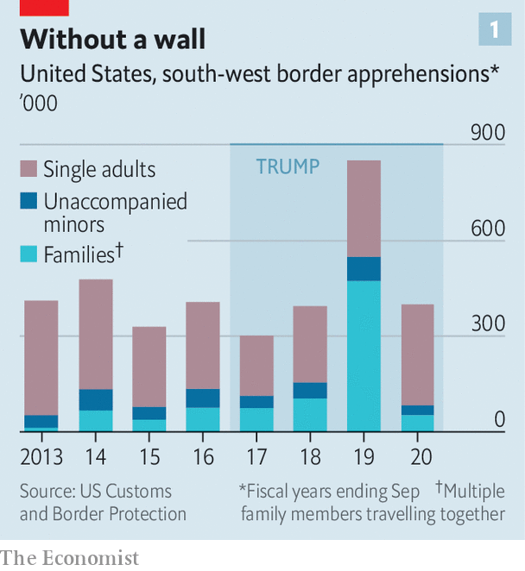

Apprehensions at the border with Mexico have risen to their highest level in 12 years (see chart 1), and in 2019 there were 360,000 deportations. That was not a record—there were 432,000 in 2013—but it was more than there were in 2016, and the share of the deported who had no criminal records, 14% in 2016, had risen to 36%. The administration also increased the bureaucratic hurdles faced by those trying to immigrate legally. Applications for temporary visas and permanent-residency permits have both declined by 17% since 2016. The annual ceiling of refugee admissions has been slashed. The White House recently proposed just 15,000 admissions for 2021, compared with 85,000 admitted in 2016.

## A pile of debris

In the trade arena Mr Trump renegotiated NAFTA, abandoned the nascent Trans-Pacific Partnership, imposed tariffs on aluminium and steel and launched a trade war with China. By his own standards, the benefits were sparse. Though the bilateral trade deficit with China has fallen, America’s trade deficit with the rest of the world was steadily increasing even before covid-19 sent it through the roof. Tariffs have helped some targeted industries, but at great cost. American consumers are reckoned to have paid $900,000 for every steel-industry job saved. Manufacturing employment seemed to slump after tariffs with China went into effect in 2018, though Mr Trump’s advisers insist that in the long term the policy will reverse that.

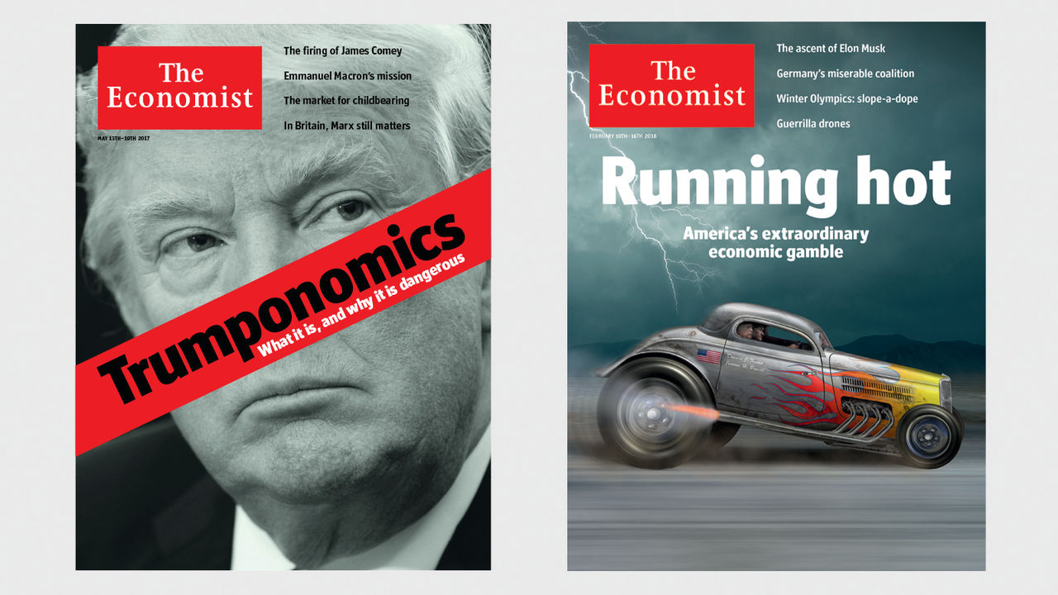

Other promises went unkept, most obviously and predictably the pledge on the debt. Rather than putting America on the path to eliminating its national debt in eight years, as he said he would, Mr Trump saw the budget deficit steadily increase over the first three years of his administration. The rise was not as marked as those seen in the first terms of Reagan and George W. Bush, but the starting point was higher. After covid-19 hit the deficit jumped far further; America’s debt is set to exceed its GDP.

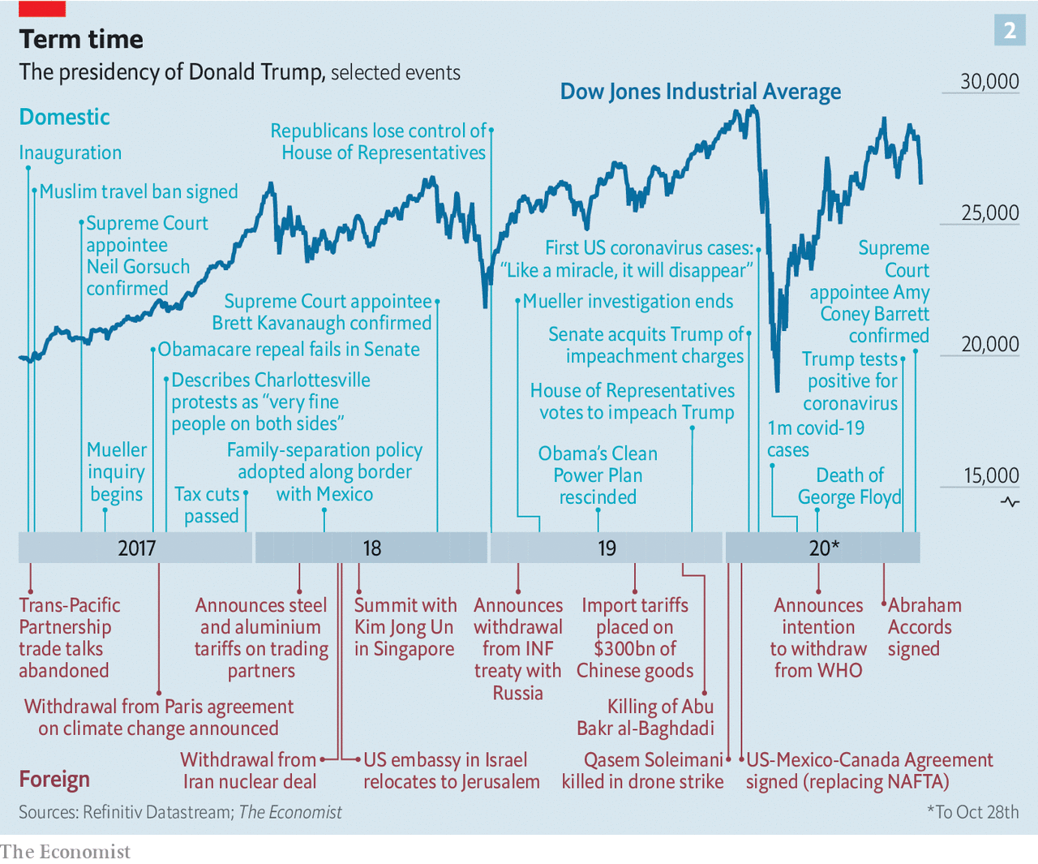

Nor was Obamacare repealed and replaced. Mr Trump has been promising to publish a serious health-care plan imminently for his entire tenure, during which the share of Americans without health insurance rose from 8.6% in 2016 to 9.2% in 2019. He eventually laid out something of a second-term health-care agenda on September 24th, when he declared in an executive order that under an “America-first” plan it will “continue to be the policy of the United States…to ensure that Americans with pre-existing conditions can obtain the insurance of their choice”. If a lawsuit against Obamacare that the Supreme Court will hear on November 10th goes the way the plaintiffs want, though, that coverage guarantee will disappear—and that is the side Mr Trump’s Department of Justice is taking in the case.

Mr Trump also wooed voters with a promise to “restore law and order” to cities that he portrayed in his inaugural address as crippled by “American carnage”. Crime in American cities was actually at a low ebb at the time. But after the tumult of a long summer of protests over racial injustice, some of them violent, they hardly seem safer. Preliminary estimates from the FBI suggest that 2020 will see a 15% increase in the murder rate nationwide. Mr Trump’s most notable legislative achievement in this area was signing the First Step Act, which seeks to reduce incarceration and reform prisons; it was a priority of his son-in-law, Jared Kushner.

And the swamp was not drained. Instead it spread to previously dry land as institutional watchdogs and ethical norms were swept away and new species moved into the murk. It was in these fetid waters that the administration pursued what Steve Bannon, a former senior counsellor to the president, called the “deconstruction of the administrative state”. A weakened and destabilised state apparatus, in which independent inspectors-general are removed or sidelined, the civil service is less independent and personal loyalty paramount is just the sort of government that Mr Trump wants.

How much of that which Mr Trump has done will outlast him should he lose office? The judges and the change in the tone of politics seem the strongest candidates. Beyond his slim legislative record much of what he has done has been accomplished through executive order and changes to regulation which could, in principle, be straightforwardly reversed.

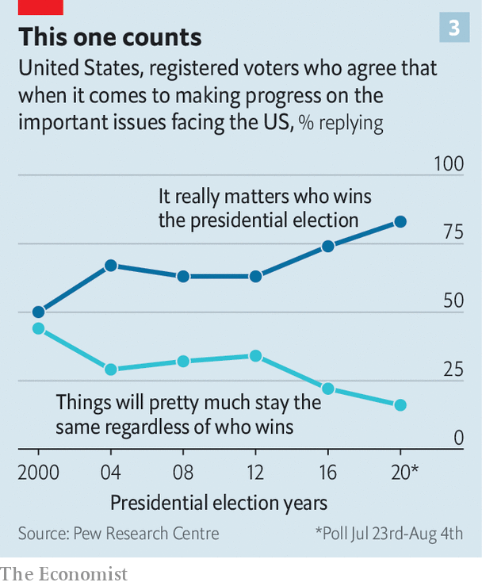

On immigration, for example, the Muslim ban, family separation and the reduced refugee ceiling would be revoked at the very beginning of a Joe Biden administration. But the fact that things can be reversed does not mean that everything will be. It is hard to imagine the Democratic president completely unwinding the new asylum rules on the south-west border, which would undoubtedly invite a new surge of migrants. And there will be other scarring. Prospective immigrants may look elsewhere to study or start businesses even if the country seems welcoming again.

There would be a more thorough attempt to undo loosened environmental protections. But this could be complicated by Mr Trump’s judicial legacy—the courts he leaves behind will probably take a cagier attitude to constraints on business. And as with immigration, there will be scarring that is not easily reversed. People whose lungs were damaged by fine particles will not be cured spontaneously. According to calculations by the Rhodium Group, a research outfit, greenhouse gases equivalent to 1.8bn tonnes of carbon dioxide will be emitted over the coming 15 years solely because of Mr Trump’s deregulations.

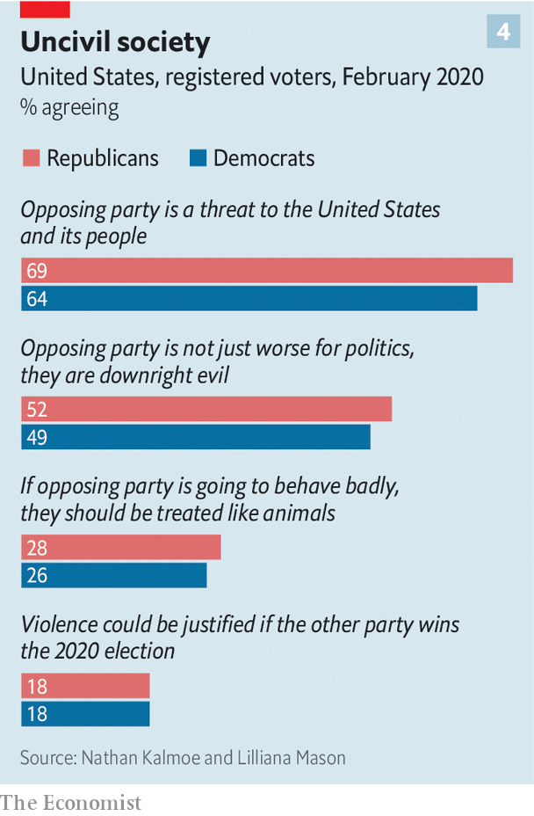

When it comes to the body politic, the scars run deep. The bitterly divided country of the 2016 campaign is more bitterly divided than ever. Voters tell pollsters they see the stakes in this election as greater than those in any before (see chart 3). A remarkable 73% of Americans say Republicans and Democrats cannot agree on basic facts. There is a detectible rise in new strains of extreme partisanship. Data from the Voter Study Group, a research outfit, show one in five Americans saying that violence could be justified if the other party wins the impending election—a minority, but one that has increased markedly since 2017. Surveys by Lilliana Mason and Nathan Kalmoe, two political scientists, reveal disturbing levels of antipathy for fellow Americans: 60% of voters think members of the other party constitute a threat to America, more than 40% would call them evil, and 20% think they are animals (see chart 4).

This trend towards the hyper-partisan predated Mr Trump and went a long way towards explaining his election. He in turn has amplified it—both “a product and an accelerant of the partisan doom loop” in the words of Lee Drutman, a political scientist. In 2016 party affiliation had already come to dominate where Americans live, where they got their news and even whom they married. But to carry that tendency through to what would seem to be basic public-health measures—80% of Biden supporters say they have always worn masks in the previous week compared with just 43% of Trump supporters—took a gift for division unlike any before.

Mr Trump’s decision to rule as the leader of a faction, rather than the whole nation, has been supported by the Republican Party’s base and much of its elected elite. The unconvinced have mostly kept silent on the matter. This has allowed him to trample the norms of politics and good government in any number of ways, from a culpable lack of response to the devastation wrought on Puerto Rico by Hurricane Maria to describing protests against neo-Nazis in Charlottesville, Virginia, as having “very fine people on both sides” to seeing people tear-gassed to enable a photo opportunity. The most pertinent of these outrages at the moment are his attempts to delegitimise the election result. Almost 40% of Republican voters say they do not think the upcoming election will be fair; half of Democrats are worried that there will not be a peaceful transition if Mr Biden wins.

If Mr Trump were to keep his address on Pennsylvania Avenue, what then? There is no real programme for four more years of a Trump presidency. The Republican Party chose to eschew a party platform this year; in its place the campaign released a bombastic list of bullet-pointed aspirations such as “Drain the Globalist Swamp by Taking on International Organisations That Hurt American Citizens”. Without a majority in the House, Mr Trump would be able to pass little if any significant legislation. But the administrative and regulatory changes brought about in the past four years would be taken further, as would the erosion of standards in public life. And the divisions he both embodies and exacerbates would become yet more destructive. ■

Dig deeper:

Read part II of our audit of Donald Trump’s presidency, in which we examine his role in foreign affairs. Although some of his criticisms of the world order have merit, he has left it in worse shape than he found it.

Read the [best of our 2020 campaign coverage](https://www.economist.com/us-election-2020) and explore our [election forecasts](https://projects.economist.com/us-2020-forecast/president), then sign up for Checks and Balance, our [weekly newsletter](https://www.economist.com/checksandbalance/) and [podcast](https://play.acast.com/podcasts/2020/01/24/checks-and-balance-our-new-weekly-podcast-on-american-politics) on American politics.

This article was downloaded by calibre from <https://www.economist.com/briefing/2020/10/29/president-trump-has-had-real-achievements-and-a-baleful-effect>

|  |  |  |  |
| --- | --- | --- | --- |
|  | Articles | Sections | Next |

|  |  |  |  |
| --- | --- | --- | --- |
| Previous | Articles | Sections | Next |

#### The Trump audit: part II

# President Trump’s criticisms of the world order had some merit

But he has left it in worse shape than he found it

Oct 29th 2020 |

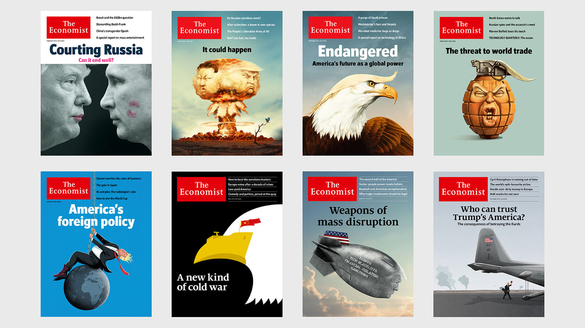

FOREIGN AFFAIRS played an important, and murky, role in Donald Trump’s presidency from before it even began. Russia’s meddling in the election that brought his unexpected victory, and Mr Trump’s happiness in snubbing the findings of his own intelligence services on the subject, set an invidious context for all that followed. His later attempt to inveigle political favours from Volodymyr Zelensky, the president of Ukraine, led to his becoming the first president ever to be impeached over his conduct of foreign policy. Only Republican support in the Senate saved him from losing office.

Such things do not go unnoticed. America’s reputation abroad has plunged during Mr Trump’s presidency. Around the world, judging by a 13-country survey published in September by Pew Research Centre, the share of people with a favourable view of America is in many cases at its lowest since Pew began such polling nearly two decades ago (see chart 5). In Britain America’s approval rating has dropped from 61% in 2016 to 41%; in Japan it has fallen from 72% to 41%.

Confidence in Mr Trump to do the right thing in world affairs is even lower, especially in Europe: a dismal 11% in France and 10% in Germany, compared with a score of 84% and 86%, respectively, for Barack Obama in 2016. European foreign-policy types do not mince their words. “Calamitous, cataclysmic, catastrophic, pathetic,” says François Heisbourg of the Foundation for Strategic Research, a French think-tank, when asked to describe how history will judge Mr Trump’s foreign policy. At home many Republican foreign-policy experts hold similar views; dozens are supporting his Democratic challenger, Joe Biden.

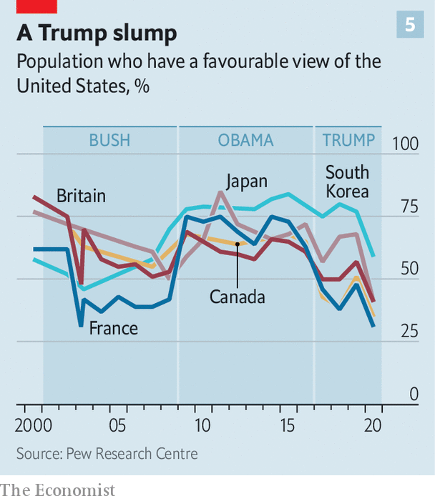

Some who have observed from ringside as Mr Trump has been swayed by flattery and greed feel that to dignify his foreign policy with any sort of conventional analysis is to grant it strategic and ideological heft that it lacks. On this view Mr Trump’s big decisions have been driven by narcissism and a desire for personal gain: Trump First, not America First. But those who stick by him give a different account.

These supporters are consequentialists. They argue that the detractors give too much weight to Mr Trump’s unseemly taunts and tweets; a focus on his actions and their likely results, some not yet felt, will tell a different story, one which will become clearer and look wiser as time goes by but which critics are currently blind to.

As Matt Pottinger, deputy national security adviser, puts it, “a lot is written about the sacred cows Mr Trump has gored, but less about the rabbits he’s pulled out of the hat.” Nadia Schadlow of the Hudson Institute, who served as deputy national security adviser for strategy in 2018, argues in Foreign Affairs that since the end of the cold war American policymakers have been “beguiled by a set of illusions about the world order”; Mr Trump’s “series of long-overdue corrections” has shattered those illusions.

To assess that claim one must first note the degree to which Mr Trump’s course is, in fact, a continuation of that on which the country was already set. The increased preoccupation with Asia (to which Mr Obama “pivoted”); the recognition that America needed to pay more attention to its domestic troubles (“nation-building here at home”, as Mr Obama called it); the weariness with “forever wars”: in all these areas Mr Trump has been following a public mood which has been shaping America’s foreign policy for years.

Despite his alarming bluster Mr Trump has not so far turned out to be a bellicose president. In Afghanistan he is winding down the longest war in American history (if not as fast as he promised to). In the Middle East he continued the fight against Islamic State, hunting down its self-proclaimed caliph, Abu Bakr al-Baghdadi, but he started no new wars. In 2019 he caused some consternation among hawks in his administration when he drew back from a counter-attack against Iran after it downed an American drone.

He makes an exception for trade wars; they provide a form of combat, brash and performative, which he positively relishes. His campaign against China is the most heavyweight fight—one in which he claimed victory with the “phase one” trade deal reached in January. But he was also happy to enter into hostilities with America’s North American neighbours, achieving what one observer called “the rare diplomatic feat of pissing off the Canadians” in order to renegotiate the trade deal that binds the two countries and Mexico. In his attempts to protect America’s steel industry he went as far as to call the European Union—composed almost entirely of NATO allies—a “foe” on trade.

It has not been his only beef with Europe. Presidents from John F. Kennedy onwards have complained about America’s NATO allies failing to carry a fair share of the burden of defending themselves. Mr Trump has done so with particular force—and to significant effect. It is one of the more salutary of the shocks he has administered to the basic assumptions of foreign-policy wonks around the world.

## The fancy and the plush

The “rules-based world order” beloved of those professionals (and this newspaper) was hardly in good shape when Mr Trump came to power. Rivalry with Russia and China had already rendered the UN Security Council largely dysfunctional. Mr Obama had undermined America’s credibility as an ultimate enforcer when he declared that the use of chemical weapons by Syria’s president, Bashar al-Assad, would constitute a “red line” and then administered no retribution when it was crossed.

Mr Trump has undercut that creaky established order in large part by giving new voice to an old strand in American thinking: a belief that America should act beyond its borders only in furtherance of specific short-term interests. From its first decades as superpower until a few years ago America sought to be a power not just in the world, but for the world. It would frequently restrain itself in deference to rules and the concerns of allies. In Mr Trump’s assessment, though, America comes first, might is right, and saying so is fun.

Mr Trump’s brashness has not had all the dire consequences that critics predicted. Witness North Korea. When handing over power Mr Obama is said to have told him that the country’s nuclear weapons would be his most urgent problem. Mr Trump instinctively addressed it with great-man theatre, meeting and corresponding with Kim Jong Un in what he described as a “love affair”. It was an unusual approach, and one many of his advisers disliked. But the usual approaches had yielded nothing. Nicholas Burns of Harvard University, a former NATO ambassador who now advises Mr Biden and gives the president a “failing grade” on foreign policy overall, nevertheless reckons Mr Trump was right to meet Mr Kim. It is true that Mr Kim gained recognition as a peer summiteer while carrying on with his nuclear programme. But there has been no subsequent crisis, and the de facto recognition of North Korea’s nuclear status has put to rest previous talk of pre-emptive military counter-proliferation strikes.

Mr Trump’s bullying of NATO allies has certainly concentrated minds. He claims credit for their increased defence spending, which in 2020 is expected to be 19% higher than it was in 2016, a cumulative extra spend over four years of $130bn (see chart 6). But by failing to express unequivocal support for the mutual-defence guarantee at NATO’s heart he caused real damage, even as his administration increased its defence spending in Europe, deployed forces in front-line states and took part in some of the biggest exercises since the end of the cold war.

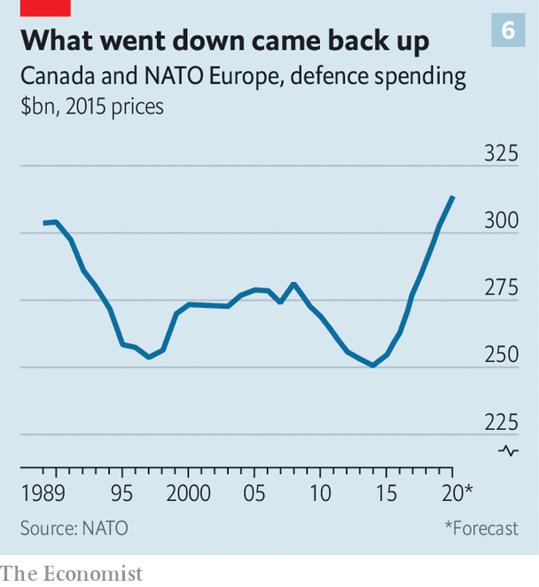

In the Middle East Mr Trump can claim bragging rights for the Abraham accords, a peace agreement between Israel and the United Arab Emirates since joined by Bahrain and, after some American arm-twisting, Sudan. He pleased the Israeli government and many American supporters by moving America’s embassy to Jerusalem. But he has shown no interest in using his influence to press the Saudis to end their brutal war in Yemen—instead, he vetoed a bill that would have helped do so. Rather than punishing Saudi Arabia’s crown prince, Muhammad bin Salman, for his suspected role in the murder of Jamal Khashoggi, a Washington Post columnist critical of the Saudi regime, Mr Trump protected him. “I saved his ass”, he boasted to Bob Woodward, a veteran reporter, who duly recorded the claim in his book “Rage”.

Mr Trump’s decision to pull out of the Iran nuclear deal—a move widely supported within his party—has put America at loggerheads with its allies and eased Iran’s route to becoming a nuclear power. The policy of “maximum pressure” on Iran, lacking any achievable aims, has little to show for itself save the deterrent effect of the uncharacteristically bold action which saw the country’s top general, Qassem Suleimani, killed by a drone. It is a similar story with maximum pressure on Venezuela. That country’s dictator, Nicolás Maduro, remains firmly in place, as does the communist regime of his Cuban backers.

The area where Mr Trump has shaken things up most is in relations with China, the single biggest issue in American foreign policy. Such a rattling may have been coming anyway because of China’s growing aggression. But Trumpists believe the president’s new realism marked a decisive break with the Democrats’ tendency to favour process over outcomes.

According to this narrative, Americans naively thought that opening up to China and letting it join the WTO in 2001 would in time encourage it to become more liberal and democratic. The opposite has happened. China exploited the West’s openness in order to steal its intellectual property. Under its increasingly authoritarian president, Xi Jinping, it has become a fiercer economic rival, as well as a more powerful one. It has continued to build up its armed forces and to bully its neighbours. It was left to Mr Trump to challenge the idea that this was unstoppable.

## Allegiance is ruled by expedience

Toughness towards China has become a rare area of bipartisan consensus in America. The administration has started to shift attitudes elsewhere, too. It successfully urged Britain to shun Huawei, a Chinese telecoms giant, for its 5G telecoms network. More allies are expected to fall into line. Mr Pottinger says that Europe is “18-24 months behind us, but moving at the same speed and direction”. In Asia, America’s embrace of the phrase “a free and open Indo-Pacific”, expressing resistance to Chinese hegemony, has found favour from India to Indonesia, much to China’s annoyance.

There is, though, no evidence that Mr Trump has plans to build any new structure on the ground he has opened up. And he has deprived himself of the tools whereby he might do so. America’s foreign service, skilled in the patient work of erecting institutions and nurturing relationships, has been gutted; functionaries still in place know that anything that they, or indeed the president, have negotiated could be undone at any time in just 280 characters.

The damage wrought by the president’s wrecking ball has mounted up in three particular areas. The first is institutional. For more than half a century the world has run on the basis of a system established amid the ruins of the second world war, led by America. Now that system’s chief architect is undermining it. In some cases—NATO, the WTO, the UN itself—Mr Trump has merely weakened the foundations. In others he has turned tail. His rejection of arms control goes beyond renouncing the Iran deal. When Russia broke the Intermediate Nuclear Forces treaty he scrapped the treaty completely. He flirted with allowing New START, America’s one remaining nuclear treaty with Russia, to expire early next year, though now seems to want a last-ditch deal to save it.

Mr Trump’s response to covid-19 has shown this approach at its worst. In the midst of a global pandemic he chose to attack and abandon the World Health Organisation, the body responsible for tackling such crises. Where the world would normally expect America to take a lead, or at least to try to, it found an administration more interested in blaming others and shunning global efforts. Something similar goes for the greater crisis beyond covid, that of climate change: a repudiation of international efforts and wilful negligence at home. Every such American retreat from the international system is seen in Beijing as a chance to advance China’s claims.

The second area of damage is Mr Trump’s sidelining of his allies, who have frequently had no prior warning of major developments such as America’s abandoning of the Kurds in Syria or its reduction of forces in Germany. America’s alliances can act as a force-multiplier, turning its quarter or so of world GDP into a coalition accounting for some 60% of the world economy, far harder for China or Russia (neither of which has a network of permanent allies) to resist. Yet Mr Trump has taken allies for granted and belittled their leaders while flattering Presidents Putin and Xi. Foreign-policy get-togethers are awash with worries over “Westlessness”.

Encouraged by his inattention, Turkey, under the authoritarian leadership of Recep Tayyip Erdogan, is in the process of unbundling itself from the West. “The Americans have gone AWOL and the Turks have run amok,” says Mr Heisbourg. In Asia, where, as in Europe, Mr Trump has treated mutually advantageous defence relationships like protection rackets, America remains the most powerful country, according to an “Asia Power Index” compiled by the Lowy Institute, an Australian think-tank. But its lead over China has narrowed by half since 2018. Despite having raised the stakes with China, Mr Trump has shown little sense that he knows how to play the subsequent game, or to rally allies to his side.

Allied misgivings about America reflect the third big casualty of Mr Trump’s wrecking ball: the country’s power of example. For much of post-1945 history many have looked to America as a beacon—often flawed, to be sure, but nevertheless a champion of democracy and human rights, and the best hope for the aspirations expressed in its constitution. Now the world sees the workings of America’s own democracy called into question under a president who stokes racial divisions and slams the door on those yearning to breathe free.

Corruption at home makes it harder for American officials to be taken seriously when they preach about kleptocracy. As for human rights Mr Trump has maintained a public silence on abuses from Belarus to Hong Kong. In private, according to John Bolton, his fourth national security adviser, he told Mr Xi that building detention camps for Uyghurs in Xinjiang was “the right thing to do”. An America which can only claim to be stronger than China, not better, is one that has weakened itself.

## Try to stay serene and calm

How permanent is the damage? Some things can be put back together quickly if, as seems likely, Mr Biden wins the election. America would rejoin the Paris agreement on climate change right away. America’s favourability ratings around the world might bounce back, as they did when Mr Obama replaced George W. Bush in the White House. But the fact that America can elect rogue presidents won’t be forgotten. The late Samuel Huntington, a political scientist, suggested that two changes of power were needed before a democracy could be considered firmly entrenched. Perhaps two changes of president will be needed to reassure the world about America.

Mr Trump may have confronted a rising China and created the conditions both for some coalition-building in Asia and for Europe to get serious about its own defence. But the destruction along the way has been enormous. The repair job cannot begin soon enough.■

Dig deeper:

Read part I of our audit of Donald Trump’s presidency, in which we examine his domestic record. Despite some real achievements, his overall effect has been baleful. His mishandling of the pandemic looks likely to cost him his job.

Read the [best of our 2020 campaign coverage](https://www.economist.com/us-election-2020) and explore our [election forecasts](https://projects.economist.com/us-2020-forecast/president), then sign up for Checks and Balance, our [weekly newsletter](https://www.economist.com/checksandbalance/) and [podcast](https://play.acast.com/podcasts/2020/01/24/checks-and-balance-our-new-weekly-podcast-on-american-politics) on American politics.

This article was downloaded by calibre from <https://www.economist.com/briefing/2020/10/29/president-trumps-criticisms-of-the-world-order-had-some-merit>

|  |  |  |  |
| --- | --- | --- | --- |
| Previous | Articles | Sections | Next |

|  |  |  |
| --- | --- | --- |
| Briefing | Sections | The Americas |

United States

Amy Coney Barrett: Against the flow

.

State legislatures: Flipping houses

.

Direct democracy: Gentle propositions

.

Information and elections: Big little lies

.

Donald Trump and the Latino vote: Better hombres

.

Corruption and conflicts of interest: The art of the self-deal

.

Lexington: Battle-hymn of the Never Trumpers

.

|  |  |  |
| --- | --- | --- |
| Briefing | Sections | The Americas |

|  |  |  |  |
| --- | --- | --- | --- |
|  | Articles | Sections | Next |

#### Against the flow

# Amy Coney Barrett will be asked to rule on election disputes and much more

The newest Supreme Court justice cements a conservative majority even as America appears to be moving left

Oct 26th 2020 | NEW YORK

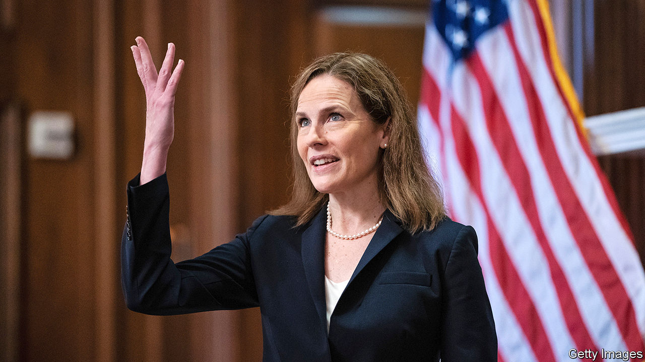

EVERY APPOINTMENT to America’s Supreme Court ushers in “a new court”, observed Byron White, a justice who welcomed 15 new colleagues in his 31 years on the bench. But rarely does the arrival of a justice herald a transformation as dramatic as that promised by the confirmation on October 26th of Amy Coney Barrett, a deeply conservative judge, to take the seat of Ruth Bader Ginsburg, a hero of the progressive legal movement. This watershed moment recalls the rightward shift in 1991 when the arch-conservative Clarence Thomas succeeded a civil-rights icon, Thurgood Marshall. Like Justice Thomas, Justice Barrett could skew the ideological balance on the court for decades.

A mere 38 days after Ms Ginsburg’s death, Justice Barrett took up her seat amid an election tinged by resurgent coronavirus. The Senate voted to confirm her as Donald Trump’s third appointee to America’s highest court by 52-48—a tally mirroring America’s polarisation far outside the Senate chamber. Neil Gorsuch and Brett Kavanaugh had bitter confirmations, too, but they each received crossover votes (three and one, respectively). Justice Barrett had no Democrats on her side and one Republican—Susan Collins of Maine—opposed her confirmation. With a 6-3 conservative majority, the court could dial back liberal victories won during the past few decades. Recent rulings on the rights of gay, lesbian and transgender people appear vulnerable, as are decades-old precedents protecting abortion rights. With a new colleague friendly to gun rights, Justice Thomas may have another partner for his mission to muscle up the Second Amendment.

Now that she has been confirmed, the views Justice Barrett kept shrouded in her confirmation hearing will begin to come to light. On November 4th, the morning after election day, she will join her eight new colleagues to hear a conflict between religious liberty and LGBT rights in Fulton v City of Philadelphia. The case pits a Catholic foster agency that places children only with straight couples against a rule barring discrimination on the basis of sexual orientation. Fulton gives Justice Barrett the chance to reconsider Employment Division v Smith, a precedent written 30 years ago by Antonin Scalia, her mentor and one-time boss, that makes it difficult for plaintiffs to claim laws are unconstitutional if they impinge only incidentally on their religious lives.

Six days later, the court will hear California v Texas, a lawsuit about the Affordable Care Act (ACA), also known as Obamacare. Democrats made much of this case in Justice Barrett’s confirmation hearings because she has spoken ill of Chief Justice John Roberts’s reasoning in two previous challenges to the ACA. Yet the legal claims this time are weaker, despite the full support of the Trump administration, and there is no guarantee they will spur her to jettison a law that provides some 23m Americans with health insurance.

The first potential abortion battle of Justice Barrett’s tenure involves a ban in Mississippi on abortions after 15 weeks’ gestation. An appeals court had blocked this as inconsistent with Supreme Court rulings barring such bans before fetal viability (about 24 weeks). In their latest filing, supporters of the ban point out a split among lower courts on how to read Chief Justice Roberts’s Delphic opinion from June striking down a clinic regulation in Louisiana. The justices seem to have been awaiting Justice Barrett’s arrival to decide whether to take Dobbs v Jackson Women’s Health Organisation: they have put off discussing it three times since Justice Ginsburg’s death. If they opt to hear the case, the core of Roe could soon be on the docket.

Battles also loom involving Mr Trump’s tax returns, “remain-in-Mexico” asylum policy and plans to exclude undocumented immigrants from the census count to determine apportionment in the House of Representatives. But the most immediate questions facing Justice Barrett involve the re-election effort of the president who appointed her. As the gears turned on her confirmation, the justices considered several lawsuits shaping how the torrent of mail-in ballots in several states would be processed and counted. Moments before Justice Barrett was confirmed by the Senate, the court rejected, by a 5-3 vote, Democrats’ call to restore an extended deadline for mail-in ballots in Wisconsin. In dissent, Justice Elena Kagan said the decision “will disenfranchise large numbers of responsible voters in the midst of hazardous pandemic conditions”.

A week earlier, however, Chief Justice Roberts joined his three liberal colleagues in rebuffing a request from Pennsylvania Republicans to block a state-court ruling that extended the deadline for mail-in ballots. Federal courts should not meddle with state elections, he later explained, but neither should the Supreme Court tell state courts how to interpret their own laws. Undeterred, and in apparent hopes that Justice Barrett might tip the balance away from the chief’s position and set the deadline at November 3rd, the same plaintiffs renewed their plea on October 24th.

They were disappointed: on October 28th, the 115th justice sat out the case (she said she did not have time to review the filings) and the court unanimously rejected the Republicans’ last-ditch effort. (In a divided vote, they also turned back a similar request out of North Carolina.) Yet in a move that seems bound to flummox voters, Justice Samuel Alito, joined by Justice Gorsuch, noted that the court might just reconsider the Pennsylvania matter post-election—and hinted it could toss late-arriving ballots then. Would Justice Barrett join in such a Bush v Gore redux? She has not committed herself to sitting out these cases, but now that she is in robes, and given Mr Trump’s insistence that his nominee be seated before the election, she may be swayed by the norm that “appearance of impropriety” is reason enough for recusal.

Once the election is behind her, Justice Barrett’s rightward influence on the court may be more gradual than conservatives hope and progressives fear. Although the court is not shy about reversing itself on occasion, there is no precedent for erasing a constitutional right it has previously recognised. It would be a stunning about-face for the court to tell gay and lesbian couples that their marriages—blessed by a 5-4 majority in 2015—are now null and void. Likewise, fully reneging on abortion rights when half of the country is pro-choice—and tens of millions of women have relied on Roe v Wade, the 1973 ruling that legalised abortion on privacy grounds, over nearly half a century—could ignite a firestorm of protest and calls to rebalance a bench that is far out of step with society.

Still, there is little doubt Justice Barrett and her conservative colleagues will uphold restrictions on abortion, narrow LGBT rights in the name of religious freedom, strengthen the right to bear arms and curtail the autonomy of administrative agencies. With a tenure that could easily stretch past 2050, she has plenty of time for that.■

Editor’s note (October 26th 2020): This article has been updated since it was first published.

Dig deeper:  
Read the [best of our 2020 campaign coverage](https://www.economist.com/us-election-2020) and explore our [election forecasts](https://projects.economist.com/us-2020-forecast/president), then sign up for Checks and Balance, our [weekly newsletter](https://www.economist.com/checksandbalance/) and [podcast](https://play.acast.com/podcasts/2020/01/24/checks-and-balance-our-new-weekly-podcast-on-american-politics) on American politics.

This article was downloaded by calibre from <https://www.economist.com/united-states/2020/10/26/amy-coney-barrett-will-be-asked-to-rule-on-election-disputes-and-much-more>

|  |  |  |  |
| --- | --- | --- | --- |
|  | Articles | Sections | Next |

|  |  |  |  |
| --- | --- | --- | --- |
| Previous | Articles | Sections | Next |

#### Flipping houses

# If a Democratic wave breaks over state elections, its effects will be lasting

Redistricting, police reform and election law all hang on the November 3rd elections

Oct 31st 2020 | LANCASTER, PENNSYLVANIA

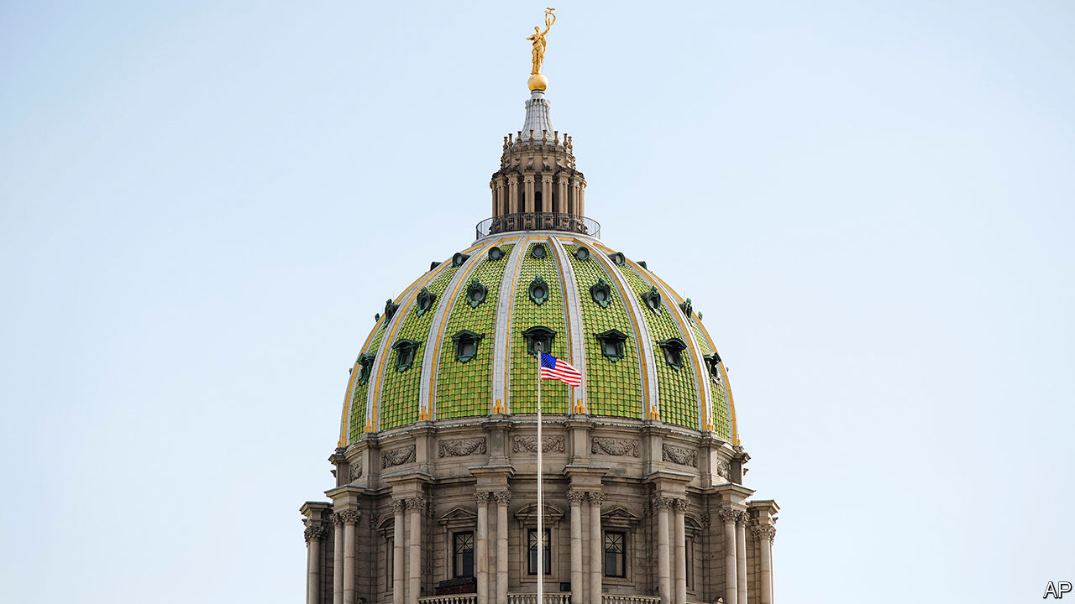

MOST AMERICANS do not know who their state representatives are. Only 12% could correctly name them in a Co-operative Congressional Election Study from Harvard in 2018. But on a recent Saturday when Janet Diaz, who is running for Pennsylvania’s state Senate, knocked on doors belonging to Democratic-leaning households with (her data suggested) patchy voting records, the looks were not as blank as normal. Some even recognised her.

If elected, Ms Diaz would be the first Democrat to win the district since the 1870s. The 13th state Senate district, which stretches from Lancaster and its suburbs to rolling farmland, is probably the most fought-over race in a fought-over state. Our modelling suggests that Pennsylvania is the state most likely to determine who wins the White House. It is also one of the states the Democratic Legislative Campaign Committee (DLCC) is trying to flip.

Democrats need nine seats to win control of Pennsylvania’s state House and have a shot at winning the Senate, too. The DLCC is spending a record $50m in 13 states including Arizona, Michigan, North Carolina, Pennsylvania and Texas. Other left-leaning groups, such as the National Democratic Redistricting Committee, headed by Eric Holder, Barack Obama’s attorney-general, are also spending heavily.

The Democrats have been trying to catch up since 2010, when they were outspent, outsmarted and lost control of 21 chambers. During Mr Obama’s two terms, Democrats lost around 1,000 of the 4,000-odd state seats they held in 2009 (there are 7,383 in all). This cost them not only control of the policy agenda but also, in many states, control of the power to draw congressional-district boundaries.

A decade later Democrats control 39 out of 98 chambers (not counting Nebraska’s unicameral, non-partisan legislature) and have regained 450 of those lost seats. On the watch of Jessica Post, head of the DLCC, they have taken ten state-legislative chambers and made inroads in North Carolina and Texas. They are unlikely to match the Republicans’ success in 2010, but only because they have already won the easiest targets. At stake, once again, is control over redistricting. David Abrams of the Republican State Leadership Committee says this means “there’s a decade of power hanging in the balance” on November 3rd.

In addition to Pennsylvania, other states to watch include Arizona, which has not had a Democratic chamber in more than 40 years and where the party needs only two seats to flip the House and three to take the Senate. The Texas House needs nine seats to change hands. Mark Jones of Rice University judges that Donald Trump’s name at the top of the ticket “has put the Texas House in play”.

It is not just the scale of spending which is unusual. Run for Something, a political-action committee, has recruited 62,000 young Democrats to stand for office, with 500 on the ballot next week. Rita Bosworth, a founder of the Sister District Project, which pairs volunteers with swing districts, points to Colorado as an example of the difference that candidate recruitment can make. Her group helped secure a Democratic clean-sweep there in 2018. In June Colorado’s lawmakers passed broad police reforms. The opportunity for more of that is on the ballot, too.■

Dig deeper:  
Read the [best of our 2020 campaign coverage](https://www.economist.com/us-election-2020) and explore our [election forecasts](https://projects.economist.com/us-2020-forecast/president), then sign up for Checks and Balance, our [weekly newsletter](https://www.economist.com/checksandbalance/) and [podcast](https://play.acast.com/podcasts/2020/01/24/checks-and-balance-our-new-weekly-podcast-on-american-politics) on American politics.

This article was downloaded by calibre from <https://www.economist.com/united-states/2020/10/31/if-a-democratic-wave-breaks-over-state-elections-its-effects-will-be-lasting>

|  |  |  |  |
| --- | --- | --- | --- |
| Previous | Articles | Sections | Next |

|  |  |  |  |
| --- | --- | --- | --- |
| Previous | Articles | Sections | Next |

#### Gentle propositions

# California is in play on November 3rd (sort of)

The state’s voters have big decisions to make on affirmative action, property tax and gig workers

Oct 31st 2020 |



CAMPAIGNS TO BAN affirmative action at state universities and reduce property taxes normally smack of Trumplandia. But after achieving majorities in statewide referendums, both these measures have actually been in effect in deeply Democratic California for decades. The disconnect between this lingering, libertarianish regime and the current left-leaning electorate in the state is the result of the unusually frothy version of direct democracy practised in California, which can bind policy decisions decades into the future. The coming election is interesting less for who will win California’s 55 electoral-college votes—Joe Biden will, barring apocalyptic divine intervention—than for whether its liberal voters will reverse these measures.

Because of a ballot initiative approved in 1996 by 55% of voters, the prestigious University of California system has been unable to deploy affirmative action for minorities for nearly 25 years. Advocates say that without such a scheme, minorities have been and will continue to be perpetually under-represented at the state’s leading universities. They are pushing a new ballot measure, Proposition 16, to repeal the pre-existing one. Hispanics currently make up a majority of the state’s high-school graduates, for example, but just 33% of incoming undergraduates. African-Americans are slightly less under-represented—making up 5% of the state’s graduating high-schoolers but 3% of the university system’s freshmen. Even after two decades and a recent summer of protest over racial injustice, the prospects for repeal look tough. A poll in October from the University of California, Berkeley, found that 38% of voters supported repeal against 49% who want to keep the affirmative-action ban (the rest are still unsure). Even if this deficit is reversed, California may find the policy short-lived: the Supreme Court is likely to revisit affirmative action, and, given its more conservative orientation, may severely limit the use of the practice nationwide or strike it down altogether.

Polls show a better chance of success on the state’s property-tax quagmire. Proposition 13 is perhaps the only state law well-known by number alone across the country. This too is facing a partial repeal. Passed by 65% of voters in 1978, the measure caps property taxes at 1% of real-estate value. As long as a property is not sold, its assessed value may grow only by the rate of inflation rather than the growth in market prices. Since housing prices have surged in the past 40 years, this has meant enormous benefits for incumbent landlords and forgone revenue for counties and schools. A repeal measure, Proposition 15, would link property tax back to reality for commercial plots, but not for residential ones. It is being richly funded by strange bedfellows: the teachers’ union, the SEIU (another big labour union), and Mark Zuckerberg, Facebook co-founder, who has spent around $11m on the campaign.

The expected returns from partial repeal of Proposition 13 are large: just taxing commercial property according to market prices should generate between $6.5bn and $11.5bn in extra funds. The many millionaires benefiting from residential exemptions might be a plum subsequent target. That would exert downward pressure on stratospheric housing prices in the state, which are stifling growth in some of America’s most productive places.

But unless California can kick its addiction to bureaucratic suffocation of new development—through anonymous environmental lawsuits, height limits, parking requirements, land-use committee reviews and zoning rules requiring some apartments to be leased at well below market rates—its housing crisis will continue. Already, it has made bad ideas like rent control more appealing. A state law called the Costa-Hawkins Rental Housing Act exempts cities from many kinds of rent control; advocates are also aiming to revoke this through the ballot box. It would be a good way to restrict rental supply and increase prices for all except the lucky few, and a rather bad way to actually resolve the state housing crisis.

Despite the money at stake over property-tax rules and the free-flowing Zuckerberg dollars, the housing question is not the costliest referendum campaign facing Californians. That distinction instead goes to Proposition 22, which would exempt app-based delivery workers from a recently passed law that would relabel some gig workers as full-time employees requiring paid benefits from companies like Uber, Lyft and DoorDash (see article). The effort is being funded by exactly those companies, which have already spent $190m to escape what they see as a death-knell for their businesses in the state. Uber is so keen on the idea that it took the mildly dystopian step of pushing its political ads directly to the phones of its customers, claiming the measure will “save lives”.■

Dig deeper:  
Read the [best of our 2020 campaign coverage](https://www.economist.com/us-election-2020) and explore our [election forecasts](https://projects.economist.com/us-2020-forecast/president), then sign up for Checks and Balance, our [weekly newsletter](https://www.economist.com/checksandbalance/) and [podcast](https://play.acast.com/podcasts/2020/01/24/checks-and-balance-our-new-weekly-podcast-on-american-politics) on American politics.

This article was downloaded by calibre from <https://www.economist.com/united-states/2020/10/31/california-is-in-play-on-november-3rd-sort-of>

|  |  |  |  |
| --- | --- | --- | --- |
| Previous | Articles | Sections | Next |

|  |  |  |  |
| --- | --- | --- | --- |
| Previous | Articles | Sections | Next |

#### Big little lies

# The story of Hunter Biden and the diminishing returns to disinformation

To work, dumps of hacked email need a juicy target and credulous institutions. This one had neither

Oct 31st 2020 | MARTINSBURG, PENNSYLVANIA



DONALD TRUMP’S rally in Martinsburg—his third of the day in Pennsylvania—felt less like a political gathering than a greatest-hits concert of an ageing rocker. Vendors selling T-shirts, buttons and banners lined the streets leading to the airstrip. The talent trotted out all the golden oldies: “Crooked Hillary”, “They’ll confiscate your guns”, “Mexico is paying for the wall”, and abundant derision of a rival band (“Joe Biden and the Democrat socialists”).

As at many such events, the crowd liked his old stuff better than the new. The mention of Mrs Clinton prompted “Lock her up” chants from the crowd. They booed dutifully when Mr Trump mentioned his latest target, Hunter Biden, his rival’s troubled son. But allegations concerning the younger Mr Biden seem not to have shifted the race in Mr Trump’s favour as those regarding Mrs Clinton did four years ago. The target is less enticing, and American institutions more prepared.

It helps that the allegations concern not the candidate himself, but his son. Rudy Giuliani, Mr Trump’s personal lawyer, gave a cache of emails to the New York Post, a tabloid owned by Rupert Murdoch. They seem to show Hunter exploring a Chinese investment deal in 2017 that included a 10% equity stake “held by H for the Big Guy”. One of Hunter’s former business partners, Tony Bobulinski, stated that “the Big Guy” was the elder Mr Biden, who was aware of his son’s activities.

Another email purports to show Hunter arranging a meeting between his father and an executive at Burisma, a Ukrainian energy firm that paid Hunter a lot of money to occupy a seat on its board. Both Mr Biden’s campaign and Hunter’s lawyer say no such meeting ever happened. Mr Trump’s camp has alleged that as vice-president Mr Biden perverted American foreign policy to benefit his son and Burisma. The opposite appears true: Mr Biden pushed Ukraine to remove a corrupt prosecutor who had scuppered an investigation into Burisma. Mr Biden’s 22 years of tax returns show nothing fishy. He has called the allegations “garbage”, but neither he nor Hunter have denied that the emails were genuine.

Whether they are real or fake is not the main point, argues Marc Polymeropoulos, the CIA’s former acting chief of operations for the Europe and Eurasia Mission Centre—one of more than 50 retired intelligence officials who signed a letter arguing that the email dump “has all the classic earmarks of a Russian intelligence operation”. He notes that “the use of actual material is a hallmark of Russian disinformation campaigns”. In 2017 Russians hacked Emmanuel Macron, then battling Marine LePen for the French presidency, then released false and genuine emails mixed together.

The hack failed to derail Mr Macron’s candidacy; French law bans campaign reporting in the 44 hours before an election, and the emails were released just before that blackout took effect. No such law exists in America, but mainstream media outlets have been much more circumspect than they were in 2016. Lesley Stahl, a prominent news anchor, told Mr Trump that the allegations “can’t be verified”, so her show would not air them. Twitter blocked the New York Post’s account, infuriating many conservatives.

The allegations have been shared widely on Facebook, and Fox News has given them more airtime than they did to the Wikileaks dump four years ago. But they have failed to spread much beyond Trump-friendly echochambers. Other bits of disinformation from Mr Trump’s campaign, such as a deceptively edited video that purports to show Mr Biden referring to Mr Trump as “George”—implying that he confused Mr Trump with George W. Bush, when in fact he was referring to his interviewer, George Lopez—have also flopped.

Mr Trump brought up the allegations during his last debate with Mr Biden, but the references were unclear (nobody not already steeped in the story, for instance, would have known what “the laptop from hell” was). Partisans may cheer disinformation that confirms their views, as the crowd in Pennsylvania showed. But to change minds, disinformation has to catch on with a broader audience, and in this race it has not.■

Dig deeper:  
Read the [best of our 2020 campaign coverage](https://www.economist.com/us-election-2020) and explore our [election forecasts](https://projects.economist.com/us-2020-forecast/president), then sign up for Checks and Balance, our [weekly newsletter](https://www.economist.com/checksandbalance/) and [podcast](https://play.acast.com/podcasts/2020/01/24/checks-and-balance-our-new-weekly-podcast-on-american-politics) on American politics.

This article was downloaded by calibre from <https://www.economist.com/united-states/2020/10/31/the-story-of-hunter-biden-and-the-diminishing-returns-to-disinformation>

|  |  |  |  |
| --- | --- | --- | --- |
| Previous | Articles | Sections | Next |

|  |  |  |  |
| --- | --- | --- | --- |
| Previous | Articles | Sections | Next |

#### Better hombres

# Latino men are a bright spot in Donald Trump’s faltering campaign

If he does hold on in Texas, he may have them to thank

Oct 27th 2020 | HOUSTON



THE LAST Republican presidential candidate to lose the state of Texas, Gerald Ford, choked on a delicious tamale during a campaign stop at the Alamo. He tried to eat the Mexican speciality without removing its corn-husk wrapping. He won 18% of the Latino vote, and the support of 130,000 fewer Texans than Jimmy Carter. Many Republicans still believe that the “Great Tamale Incident” cost him re-election. Almost half a century later, polls suggest a Republican may be on the verge of choking in Texas again.

Donald Trump has found other ways to offend Mexican-Americans. “He’s a bad husband, he doesn’t pay his taxes and he separated lots of children from their parents. How good that we can separate ourselves from him!” says Santiago Ramos García, a retired shoe-seller in Houston who has already cast his vote for Joe Biden. The fast-swelling ranks of Latinos, many of whom feel that the Republican Party would prefer America without them, have transformed Texas from a jewel in the Republican crown to a battleground. Mr Trump’s sagging popularity among white women and the elderly is hastening the change.

If Mr Trump holds Texas he may have Latino men to thank. National polls place Mr Trump about seven percentage points behind his opponent compared with 2016. But his support among Latinos has bucked the trend, even creeping up slightly. His polling in battleground states among men (35%) is much stronger than among women (22%), according to Equis, a political consultancy. Although some pollsters differ, most think the gender gap among Latino voters is wider than those for whites or African-Americans. Latino men have moved further towards him in this cycle than just about any other group. The New York Times/Siena College poll of Texas has Mr Trump down by 46 points with Latino women and up by a point with Latino men.

Gender gaps between left-leaning women and right-leaning men are a staple of voting in America and the rest of the West. But many Latinos have migrated from countries, like Mexico and El Salvador, where women tend to vote more conservatively than the men do. Foreign-born Latinos are less divided by gender than native-born ones, says Rachel Stein, an analyst at Equis. This shows that Mr Trump’s outsize support among Latino men does not spring from some imported macho yearning for a caudillo. Rather, it is a sign that Latinos are succumbing to American electoral quirks as they integrate.

Whereas Latino parents define a social role for girls early on, boys are “left more to their own devices”, says Christina Bejarano of Texas Woman’s University. Latinas are more likely to go to university, vote, volunteer and naturalise as American citizens. Latino men are likely to work in “quasi-partisan” industries such as border patrols, police, construction and oil, says Celeste Montoya of the University of Colorado. But paths to the dignified traditional role of provider have narrowed for Latino working-class men just as they have for whites, creating an opening for Mr Trump. He has stopped referring to Mexican men as “bad hombres” in his rallies, and is more concerned with chasing the shadows of Antifa than with the migration menace.

Conversations with Latino male Trumpers in Houston reveal enthusiasm for Mr Trump’s impenitent style and his business nous. Others see flaws, but also see past them. “You’ve got to look at the big picture,” says Agustin Reyes, an Obama-Trump voter who dislikes the president’s anti-immigration stance but supports him “going after China”. Daniel Reyes Saenz, a fifth-generation Texan with a Led Zeppelin tattoo on each forearm, recalls his journey from young Democrat to middle-aged Republican in a booth at Maga’s, a cosy restaurant named after its Mexican owner, Margarita. Asked about Mr Trump’s description in 2015 of Mexican migrants as “rapists”, he replies: “I didn’t take it personally.”

Latinos, who are now a larger bloc than African-Americans, would have greater clout if they voted more. Some Democrats grumble that the Biden campaign began seriously courting them too late to turn them out. Others hope that the Trump presidency is inducing a long-awaited stampede to the polls. The covid-19 epidemic has hit Latinos particularly hard. Some might wonder if certain misfortunes—a racist mass shooting in El Paso, or the botched response to a hurricane in Puerto Rico—would have happened under a different president. But not all apathetic Latinos deem themselves Mr Trump’s victims. “He can build the fucking wall, I’m already on this side,” says Peter Macedo, a construction worker who has never cast a ballot.

Collecting just under a third of the Latino vote would merely earn Mr Trump a par score for a Republican candidate. A defeat may cause the party to conclude, not for the first time, that settling for this in the 21st century is a recipe for failure. An autopsy after defeat in 2012 called on the party to be warmer towards Latinos and embrace immigration reform. It cited advice on Latino courtship from Dick Armey, a Tea Partier: “You can’t call her ugly all year round and expect her to go to prom with you.” Mr Trump binned that advice and won. But the demographic sands will continue to shift—and faster still if a President Biden were to keep his promise to carve out a path to citizenship for the 11m immigrants living in America illegally.

Inroads should be possible into a group that is no monolith. Earlier this year a survey from Lake Research Partners, a Democratic pollster, asked Latinos to describe their racial identity. Are they “people of colour” like African-Americans, endlessly battling discrimination? Are they, like Italians, “white ethnics” who will blend into society after a rancorous welcome? Or are they “bootstrappers” who rise through hard work like Asian-Americans? Respondents split evenly between the three. The first group is solidly progressive. The second and third groups are up for grabs if treated with respect. Republicans who want to hold Texas might heed the lesson of Ford and his tamale: to entice Latinos properly, first remove the unpalatable parts. ■

Dig deeper:  
Read the [best of our 2020 campaign coverage](https://www.economist.com/us-election-2020) and explore our [election forecasts](https://projects.economist.com/us-2020-forecast/president), then sign up for Checks and Balance, our [weekly newsletter](https://www.economist.com/checksandbalance/) and [podcast](https://play.acast.com/podcasts/2020/01/24/checks-and-balance-our-new-weekly-podcast-on-american-politics) on American politics.

This article was downloaded by calibre from <https://www.economist.com/united-states/2020/10/27/latino-men-are-a-bright-spot-in-donald-trumps-faltering-campaign>

|  |  |  |  |
| --- | --- | --- | --- |
| Previous | Articles | Sections | Next |

|  |  |  |  |
| --- | --- | --- | --- |
| Previous | Articles | Sections | Next |

#### The art of the self-deal

# Donald Trump’s record on corruption and conflicts-of-interest

Plain venality in the Trump administration has been bad; the sleaze that weakens institutions has been worse

Oct 31st 2020 | CHICAGO

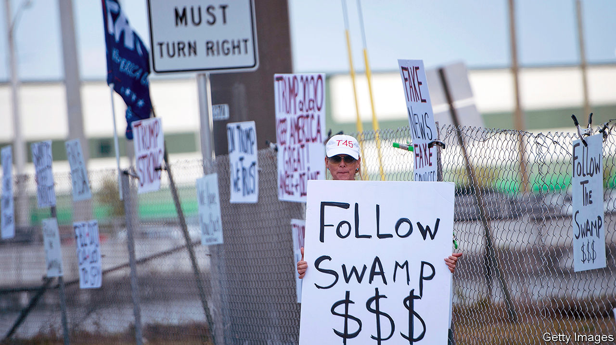

PROMISING TO “drain the swamp” was a popular line in 2016. Four years on some Republicans still cheer, pointing out admiringly that President Donald Trump forgoes his $400,000 salary. Even critics concede that America continues to support sanctions on corrupt foreigners. And despite Mr Trump’s widely reported wish to scrap the Foreign Corrupt Practices Act, his government still energetically applies the law against paying bribes overseas.

Yet concerns about what swamp-draining really meant surfaced early in Mr Trump’s presidency. Federal prosecutors looked into questionable spending around his inauguration. Among his first acts was to scrap a rule requiring oil and other firms to say what they paid foreigners. As for those swamp-dwelling lobbyists, he drained several directly into his cabinet.

Mr Trump’s reluctance to cut ties to his business interests, or to reveal what they were, was unlike anything seen for over a century. He concedes he owes hundreds of millions of dollars, but will not name his creditors. Deutsche Bank, a German bank, is said to have loaned him $2bn over the past two decades. He is due to refinance some of this, but nobody knows how. Unlike presidents since Gerald Ford, he has not released his personal tax returns.

He has continued to receive financial updates on the 100-plus entities—office blocks, hotels, resorts and more—that make up the Trump Organisation, and to promote his brand. He pushed for one of his resorts to host a summit of G7 leaders this year (the idea was scrapped), one of many cases where he tried to steer official business to his own firms. He has spent over 530 days at just one of his other resorts, Mar-a-Lago. As a result, officials, lobbyists, the secret service and others have spent millions there. At his chandelier-heavy hotel in Washington, diplomats, party operatives and businessmen have spent heavily.

Outsiders’ views of America’s tolerance of corruption have shifted as a result. Transparency International said in January that America ranks 23rd-cleanest of 198 countries, down from 18th in 2016. Since then, the sacking of five independent inspectors-general (who look into government corruption) and the forced removal of the top federal prosecutor in New York (who was studying people close to Mr Trump) probably heralds a further drop.

Worse than the venality has been the weakening of institutions meant to keep corruption in check. Take three examples. The first relates to indictments of men—Michael Cohen, Michael Flynn, Rick Gates, Paul Manafort, Roger Stone—who hung close to Mr Trump. All were convicted of crimes. Steve Bannon, another close adviser, was charged with fraud in August. Scandal has embroiled various cabinet officials. A culture of rule-breaking is encouraged by the boss: in July he commuted the sentence of Mr Stone, convicted of seven felonies.

Next are efforts to break those who would resist, such as the whistle-blowers, professional civil servants, who testified against Mr Trump in his impeachment trial. An executive order he signed in mid-October grants him the power to fire such officials. Matthew Stephenson of Harvard Law School says this “threatens to subvert one of the most important bulwarks against corruption in all of US law”.

Last comes the slide of the Justice Department (DOJ) under William Barr. One corruption expert calls it “weaponised”, saying it serves increasingly as a personal defence team for the president, for example in fending off subpoenas for his personal tax returns. More bizarre, the department had tried to replace Mr Trump as defendant in a defamation case, linked to a claim of rape against him in the 1990s. A court this week rejected the manoeuvre.

This sort of creeping damage is disturbing, but can also be reversed. David Cay Johnston, an author who has long studied Mr Trump’s finances, calls this moment an “anomaly”. Mr Trump’s bad behaviour could yet provoke legislative changes, for example by writing the expectation that presidential candidates will disclose their tax returns into law and scrapping a rule that exempts the president from a federal law on conflicts of interest. Such talk is less thrilling than vows of swamp-clearance, but it could have more welcome effects. ■

Dig deeper:  
Read the [best of our 2020 campaign coverage](https://www.economist.com/us-election-2020) and explore our [election forecasts](https://projects.economist.com/us-2020-forecast/president), then sign up for Checks and Balance, our [weekly newsletter](https://www.economist.com/checksandbalance/) and [podcast](https://play.acast.com/podcasts/2020/01/24/checks-and-balance-our-new-weekly-podcast-on-american-politics) on American politics.

This article was downloaded by calibre from <https://www.economist.com/united-states/2020/10/31/donald-trumps-record-on-corruption-and-conflicts-of-interest>

|  |  |  |  |
| --- | --- | --- | --- |
| Previous | Articles | Sections | Next |

|  |  |  |  |
| --- | --- | --- | --- |
| Previous | Articles | Sections | Next |

#### Lexington

# Battle-hymn of the Never Trumpers

Renegade Republicans represent the breadth—and the admirable best—of Joe Biden’s coalition

Oct 29th 2020 |



THE IRONY of the election that unleashed Donald Trump upon America was how normal it was. Contrary to early reports, he was not elevated to the presidency by hordes of aggrieved non-voters and Democrats. He won a similar (if slightly smaller) share of the vote to Mitt Romney in 2012 from much the same Republican voters. The election was decided more by Hillary Clinton’s failure to turn out Democrats in a few midwestern states than by Mr Trump’s success in recruiting them. He won fewer votes in Wisconsin—the state that sealed his victory—than Mr Romney.

This time looks to be different. Joe Biden’s promise to restore normality to the government has found support from an unusually broad swathe of voters. If the polls are right, he is on course to win the biggest share of the vote since Ronald Reagan in 1984. Besides Democrats of all hues, he appears to have the backing of most independent voters (millions of whom plumped for a third-party candidate in 2016) and around 10% of self-described Republicans. Kamala Harris was right to boast in the vice-presidential debate of Mr Biden having assembled “one of the broadest coalitions of folks that you’ve ever seen in a presidential race”.

Notwithstanding the main explanation for this coalescence—the country’s overriding desire to sack Mr Trump—it is dramatic and unpredicted. The Biden coalition stretches from Bernie Sanders and the hard-left to “Never Trump” Republicans, including politicians such as John Kasich and Carly Fiorina and operatives such as George Conway and Bill Kristol. Of all these diverse parts, the role of the Never Trumpers has been most remarkable of all.

Not since Lyndon Johnson crushed Barry Goldwater in 1964 have so many leading lights in one party backed the nominee of the other. And Goldwater was a reviled challenger. By setting themselves against the sitting president of their own party—at a time of more intense polarisation—the Never Trumpers have made themselves heretics on the right while taking on the mantle of truth-tellers, authenticated by a willingness to commit career suicide, to almost everyone else.

This has transformed their reputations. Mr Kristol, formerly known on the left as the warmongering editor of the Weekly Standard, now gets practically mobbed on liberal campuses. Mr Conway, a lawyer and proud former member of the “vast right-wing conspiracy” to bring down Bill Clinton, has become a liberal social-media star. It helps, of course, that the Never Trumpers’ denunciations of Mr Trump and his Republican enablers tend to chime with long-standing Democratic criticisms. Only, given their superior knowledge of the subject-matter, they invariably improve upon them. A current example is “It Was All a Lie: How the Republican Party became Donald Trump”, in which Mr Romney’s former chief strategist, Stuart Stevens, analyses the degree to which the party he served for 30 years is fuelled by racism.

More happily, Never Trumpers, freed of the partisan yoke, have provided most of the laughs in this grim campaign. The irreverent Lincoln Project (in which Messrs Conway and Stevens are involved) is chiefly dedicated to provoking the president to Twitter rage. With a nod to Michelle Obama, its pledge to Democrats is: “We go low so you don’t have to.” In their podcasts and articles—including in the Bulwark, a Never Trump news site—Mike Murphy and Tim Miller of Republican Voters Against Trump (RVAT) have shown themselves to be two of the wittiest people in politics. This has addressed such a conspicuous cultural problem—the fact that American satire is dominated by lefties—that there is talk of the Lincoln Project being repurposed as an entertainment company.

RVAT has focused on the grittier business of moving votes to Mr Biden. Its founder, Sarah Longwell, perhaps the Never Trumper-in-chief, began that task during the Democratic primaries. The group’s signature ad—featuring an angry or sorrowful anti-Trump testimony from an ordinary Republican voter—may be the most memorable of 2020. Having raised $40m, RVAT has blitzed hundreds of such testimonies across the battlegrounds. According to Mr Murphy, who heads the group’s Florida operation (codenamed Orange Crush), its ads have influenced the Biden campaign’s there.

As the election looms, Democrats are having a hushed debate about how long their discipline might outlive a Biden victory. An equally intriguing question concerns the Never Trumpers. Only a couple would find jobs in a Biden administration. They are not trusted by Democratic decision-makers. And there is no way back to the Republican Party, where they are hated, for most. Yet some parts of their operations, including the Bulwark, will remain. And their record of raising millions of dollars for a centrist cause could open up a role operating between the two parties (perhaps within the political constellation of Mike Bloomberg, an RVAT donor).

Their post-partisan insights would make this as desirable as their manifest capabilities. For example, even Never Trumpers who are less critical of their old party than Mr Stevens have a heightened understanding of its flaws. Mr Kristol claims to have shifted little in his politics—except in developing a new appreciation of the threats African-Americans face to their lives and suffrage. Perhaps he might orchestrate a bipartisan drive to reform the country’s chaotic and sometimes exclusionary election laws.

## Never again

Whatever their future holds, the Never Trumpers have played an admirable part. Most followed their consciences into opposition at significant risk to their livelihoods. The predictable Republican slur, that they are in it for the money, is false. If they are now enjoying success, it is because their consciences turned out to be a better predictor of America’s response to Mr Trump than their cynical former colleagues anticipated. John McCain liked to talk about the importance of backing country over party. Never Trumpers have provided an even more resounding demonstration of this than the late senator. They deserve their brief celebrity and more.■

Dig deeper:  
Read the [best of our 2020 campaign coverage](https://www.economist.com/us-election-2020) and explore our [election forecasts](https://projects.economist.com/us-2020-forecast/president), then sign up for Checks and Balance, our [weekly newsletter](https://www.economist.com/checksandbalance/) and [podcast](https://play.acast.com/podcasts/2020/01/24/checks-and-balance-our-new-weekly-podcast-on-american-politics) on American politics.

This article was downloaded by calibre from <https://www.economist.com/united-states/2020/10/29/battle-hymn-of-the-never-trumpers>

|  |  |  |  |
| --- | --- | --- | --- |
| Previous | Articles | Sections | Next |

|  |  |  |
| --- | --- | --- |
| United States | Sections | Asia |

The Americas

Argentina: A harvest of grievance

.

Brazil: Each race, a new race

.

Bello: MexiCoke

.

|  |  |  |
| --- | --- | --- |
| United States | Sections | Asia |

|  |  |  |  |
| --- | --- | --- | --- |
|  | Articles | Sections | Next |

#### A harvest of grievance

# What a drive through Argentina’s breadbasket reveals

Anger at the government is intense in the country’s interior

Oct 29th 2020 | CÓRDOBA

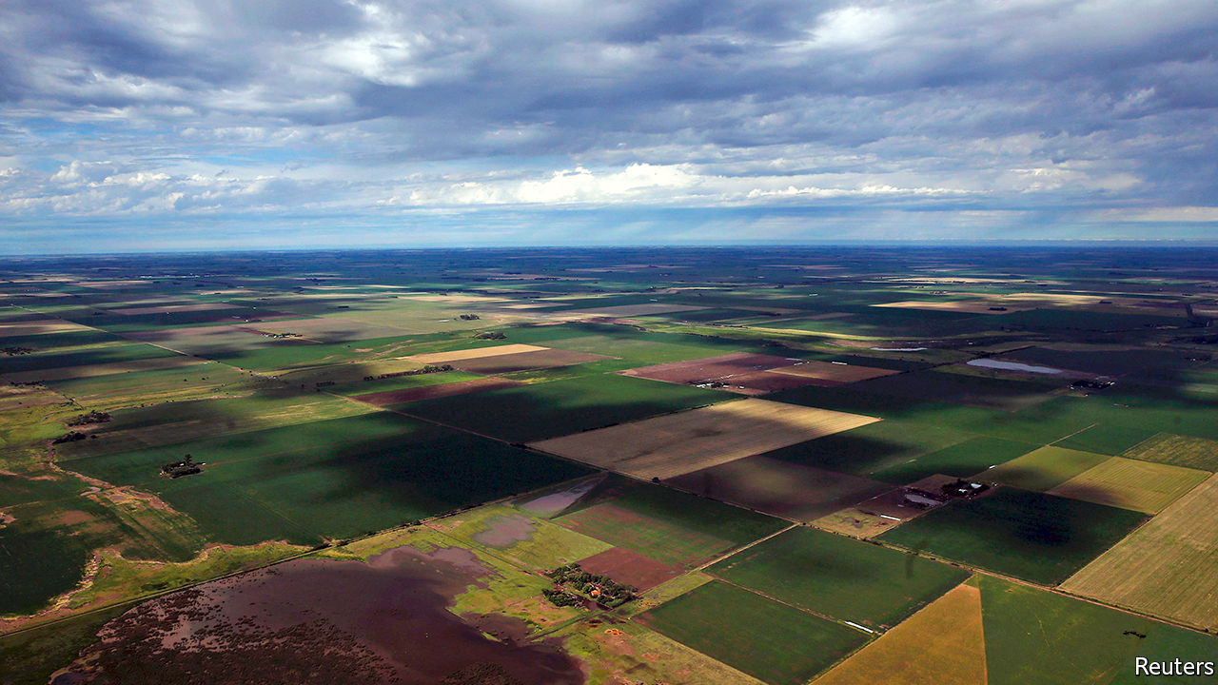

LORRY-DRIVERS at a roadside grill near Vicuña Mackenna, a small town in central Argentina, looked on appreciatively as Jorge Gutiérrez rode up bareback on a young stallion, doffed his blue boina (gaucho hat) and sat down to join them for lunch. “Normally a gaucho has little, or nada, in common with truckers,” he said, wiping sweat from his brow with a red scarf as he tucked into a flame-grilled matambre, or flank steak, so rare that it was almost the hue of that scarf. “But now we agree this pandemic is creating a disaster.” Aldo, a middle-aged trucker with a youthful ponytail and the body of a prize-fighter, interjected: “My friend, all of us will be buried by this crisis if it goes on much longer.”

Discontent is louder in Buenos Aires, the capital, and other big cities, where large protests have taken place since July. But it is just as intense in the agricultural interior. That part of the country was never going to be friendly towards Alberto Fernández, the Peronist president. He was elected a year ago, with Cristina Fernández de Kirchner, a populist former president, as his running-mate. Córdoba, the province where Vicuña Mackenna is located (see map), voted strongly in favour of Mauricio Macri, the conservative incumbent who lost. The province, like most of the others along the route of this correspondent’s road trip in September westwards from the capital, is bound to pose problems for Mr Fernández’s Front for All coalition in crucial mid-term elections due in October next year.

He imposed one of the world’s longest and strictest lockdowns. In addition to shutting borders and shops it impedes internal travel. To drive from Buenos Aires to the campo required permission from the central government. At a roadblock on the border between Santa Fe and Córdoba, police demanded evidence of a negative covid-19 test taken within 48 hours.

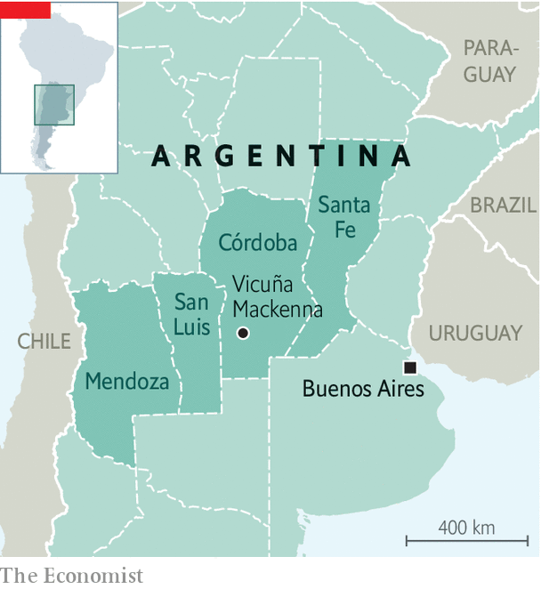

Such measures have not suppressed the disease. On October 19th Argentina recorded its millionth case. It is among the ten countries with the highest cumulative caseloads. In terms of deaths as a share of the population, it ranks just outside the top ten. Whereas early in the pandemic nine-tenths of new cases were in the capital, half are now in the interior. Córdoba, Mendoza and Santa Fe, with a fifth of Argentina’s 45m people, have reported more than a third of new cases in the past fortnight.

The lockdown has weighed heavily on the economy. The IMF expects it to contract by 11.8% this year, compared with 8.1% for South America as a whole. Next year it is expected to grow by just 4.9%. Despite price controls, the inflation rate exceeds 36%. That is partly because the Central Bank is printing money to finance the budget deficit, which is forecast to be higher than 10% of GDP this year. More than half of children are below the official poverty line. “This is an economy imploding,” says Federico Sturzenegger, a former president of the Central Bank. “The pandemic has become an excuse to avoid tough decisions.”

The toughest would be to devalue the peso, which would boost exports, including of the grains that grow in central Argentina, and preserve scarce foreign exchange. But it would drive inflation still higher. The government’s policy is to control the currency’s descent. It is officially valued at 78.3 to the dollar. On the black market the peso has slumped to 181. Rather than devalue to the level set by the market, in September the government introduced fresh currency controls to restrain demand for dollars. These have dismayed businesspeople and failed to stem the decline in the country’s reserves. Economists believe the Central Bank’s net liquid reserves are close to zero.

To hold down domestic prices and fill its coffers, the government has levied punishing taxes on exporters. One landowner, whose family has grown soya, wheat and maize near Vicuña Mackenna for generations, fumes at a 33% tax on farm exports. His goal is to survive the country’s impending “meltdown”. After this conversation the government temporarily reduced export taxes on soyabeans. That seems unlikely to improve the landowner’s mood.

According to a recent opinion poll conducted by Reale Dallatorre, 65% of people in Córdoba and 54% in Santa Fe believe that the national government discriminates against them because they oppose the Peronists. In Córdoba 40% of respondents said they favoured secession, a “stunning” finding, said the pollster. Nationally, the president’s approval rating has dropped from the 80s at the start of the pandemic to 43% by late October.

San Luis, west of Córdoba, is friendlier towards the central government. Its governor, Alberto José Rodríguez Saá, is a scion of a Peronist family. A brother was Argentina’s president for a week during an economic crisis in 2001. San Luis’s 508,000 people are accustomed to support from the federal government, especially when Peronists are in charge, which is most of the time. Yet just outside the capital city Marta, a young mother, sees little to like in its handling of the pandemic. The lockdown cost her her job at a clothes shop. “Our president talks about protecting our jobs, our health, and putting food on the table,” she says as she plays with her three children. “We don’t see any of that.” A police escort hurried visitors out of the province, “to prevent you infecting us”, said an officer.

In wine-growing Mendoza, which requires visitors to present national- and provincial-government permits before entering, attitudes towards the government in Buenos Aires harden. There separatist sentiment has a spokesman in Alfredo Cornejo, a former governor who is now a congressman and leads the opposition Radical Party. In June he called for “Mendoexit”. Mendoza, along with Córdoba and Santa Fe, could be an “economic engine-room”, he says. (Currently they produce a fifth of Argentina’s GDP.) But separation, Mr Cornejo admits, will not happen any time soon. Argentina’s constitution outlaws it.

Mr Fernández’s advisers deny that Argentina’s plight is as dire as people in the breadbasket believe it to be. “Collapse? Out of the question,” says one. The government is striving to boost confidence and attract investment in dollars. It is cutting or capping export taxes for minerals, oil and some industrial goods as well as farm products. It plans to renegotiate its $44bn debt to the IMF, a sequel to its deal on $65bn of debt owed to private bondholders. Mr Fernández has revived the idea of a “social pact” with businesses, trade unions and civil-society groups to reduce inflation and make labour law less rigid.

Reassurances from Buenos Aires mean little in the interior. In Córdoba an old farmhand in a face-mask closes gates on a herd of Aberdeen Angus cows as a young trucker looks on, smoking a cigarette. “Do we need a government to make the most of everything we have, as a country?” the gaucho wonders. His sigh is the answer. The trucker nods. At one in their sense of alienation, they tap elbows.■

This article was downloaded by calibre from <https://www.economist.com/the-americas/2020/10/29/what-a-drive-through-argentinas-breadbasket-reveals>

|  |  |  |  |
| --- | --- | --- | --- |
|  | Articles | Sections | Next |

|  |  |  |  |
| --- | --- | --- | --- |
| Previous | Articles | Sections | Next |

#### Each race, a new race

# Thousands of Brazilian politicians are changing racial identities

Some candidates do so more than once

Oct 29th 2020 | SÃO PAULO

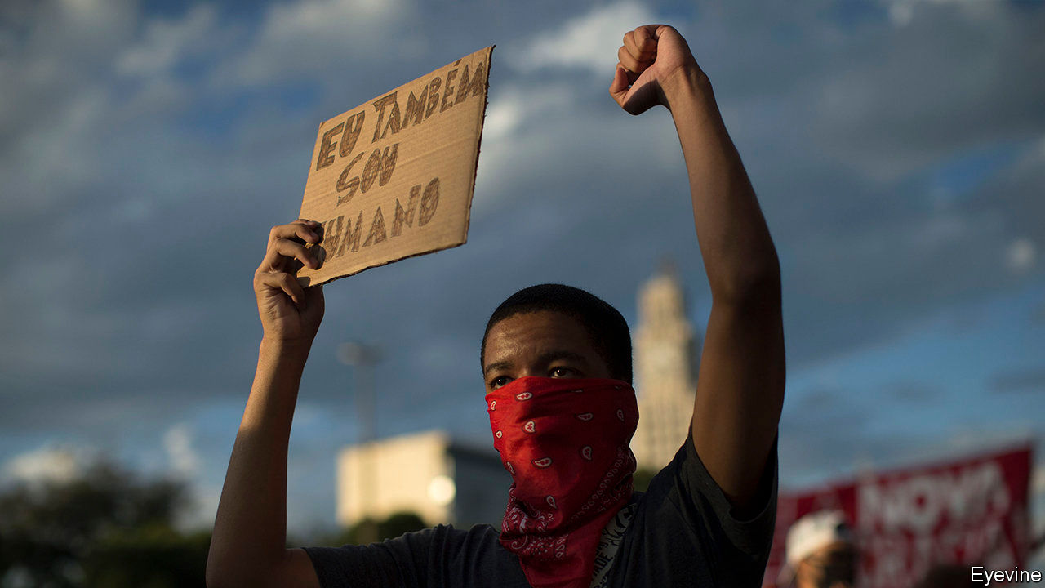

BRAZILIAN POLITICIANS hop like frogs among more than 30 political parties. Like chameleons, some change their skin colour, too. More than 42,000 candidates in local elections scheduled for November 15th are running as members of a different race from the one they declared in 2016. Thirty-six per cent changed from white to brown (pardo, mixed-race, usually with black ancestry); 30% from brown to white; and 22% from brown to black (preto) or vice versa. Fewer switched from white to black, black to white, or to or from the less-common categories of indigenous and Asian (amarelo). Aloisio Gama, a candidate for city council in Guarulhos, in São Paulo state, ran as white in an election in 2014, black in 2016 and brown in 2018. This year, he is running as indigenous.

Racial categories are fluid in Brazil. It was the last country in the Americas to abolish slavery (in 1888), but did not pass segregation laws or bar interracial marriage. Today, a third of unions are across racial lines. Many Brazilians like to think their country is a “racial democracy”, where discrimination is rare. Yet stark disparities persist. Non-whites earn less. They are more likely to be shot by police and less likely to win elections. Nearly half of candidates in national polls in 2018 were black or brown, but they won just 18% of seats.

To close the gap, the Supreme Court ruled last month that parties must award public campaign funding and airtime to black and brown candidates. If 30% of a party’s candidates are black or brown, that share of spending must go to their campaigns. Some crossovers might covet this cash. “Many people who are socially white become pardo when it’s politically advantageous,” says Márcio André dos Santos, a political scientist at Unilab, a university in the north-east. But there are other reasons.

Comparing statewide elections in 2014 with local ones in 2016, Andrew Januscz of the University of Florida found that candidates’ racial changes reflected shifts in their constituencies. Candidates competing in a municipality that is darker than their state were more likely to change from white to black or brown. In whiter municipalities they tended to choose a lighter category. This may explain why nearly a third of this year’s repeat contenders changed to white, despite the possible financial boost to black and brown candidates.

Race-shifting politicians are also responding to the temper of the times. The number of people declaring themselves black or brown in surveys by the government has recently risen much faster than the population. This suggests that millions of Brazilians, including politicians, are changing how they see themselves. Decades of anti-racism campaigning and, more recently, affirmative-action policies helped bring that about.

They brought new challenges. University quotas for brown, black and indigenous students led to arguments. Students reported each other for feigning blackness. Expulsions followed, and some admissions panels started judging applicants on physical features like nose-width and hair type—a method uncomfortably similar to the old South African “pencil test”. (If a pencil placed in your hair stayed there, apartheid officials deemed you black.)

Politicians who change their racial self-description are also facing scrutiny. Some blame paperwork errors. Rodrigo Maia, the speaker of the lower house of Congress, said he didn’t intend to change his race from white to pardo in 2018. Caio Miranda, who is running for re-election as a São Paulo city councilman, says his party listed him as white by mistake in 2016. His grandfather was part-black, and he has come to see himself as non-white. When he ran for congress in 2018, he called himself pardo. The battering he has taken on social media is unfair, he says. He is not taking money from the public fund, and so does not benefit from the Supreme Court’s judgment. “No one has the right to decide who is white and who isn’t,” he says.

Civil-rights activists support the new campaign-financing rules. This year, for the first time since electoral authorities began asking about race in 2014, there are more black and brown candidates than white ones. But the policy may have unintended consequences. One risk is fraud. Another is that a party could spend all the money reserved for non-white candidates on a single person. It could skirt the rule by having no black or brown candidates. The rule is well intended, but may not level the playing field, says Bruno Carazza, the author of a book about campaign finance.

He thinks parties should have to spend a minimum amount on all candidates. That would irk incumbents. Mr Miranda advocates excluding pardos from racial preferences, though many consider themselves to be negro, an unofficial classification whose meaning is akin to “black” as the word is used in the United States. Luiz Augusto Campos, of the State University of Rio de Janeiro, thinks that candidates’ adverts should reveal whether they benefit from race-based funding. Whether a politician is “Afro-convenient” can be hard to determine, he says. “Let the voters decide.”■

This article was downloaded by calibre from <https://www.economist.com/the-americas/2020/10/29/thousands-of-brazilian-politicians-are-changing-racial-identities>

|  |  |  |  |
| --- | --- | --- | --- |
| Previous | Articles | Sections | Next |

|  |  |  |  |
| --- | --- | --- | --- |
| Previous | Articles | Sections | Next |

#### Bello

# Politicians step up the fight against Mexico’s Coca-Cola habit

The pandemic has increased worry about the country’s fondness for fizzy drinks

Oct 29th 2020 |



ON A VISIT in July to Chiapas, a poor southern state, Hugo López-Gatell, Mexico’s covid-19 tsar, condemned an unlikely culprit for deaths from the disease. Fizzy drinks are “bottled poison”. Every year 40,000 Mexicans, the number of recorded covid-19 victims at the time, die from drinking too many, he claimed. The country’s health “would be different had we not been fooled” by a marketing machine that promotes products “as if [they] were happiness”.

The blasé response to the pandemic by President Andrés Manuel López Obrador and his administration is a bigger reason why the official death toll now stands at 90,000. But they are correct to point out that sugary drinks contribute to Mexico’s high rates of obesity and diabetes, which make people more vulnerable to the virus. Three-quarters of Mexicans are overweight, up from a fifth in 1996. Although fizzy drinks are a worthier target than some of Mr López Obrador’s nemeses (suppliers of renewable energy, for example), they are also inescapably part of the country’s culture.

Mr López-Gatell did not single out any brand. He did not need to. Although Coca-Cola is popular across Latin America, it is especially so in Mexico. In 2012, the last time the Coca-Cola Company published data on the popularity of its beverages, Mexicans guzzled 50% more per person than citizens of anywhere else. Drinking Coke “is a ritual, like [drinking] red wine for the French”, says Álvaro Aguilar, who owns burger joints in Jalisco, a western state.

Nowhere is the habit, damned by the left as “Coca-colonisation”, more evident than in San Juan Chamula, a town in the hills of Chiapas. There four-month-olds suck Coke from baby bottles. In the town’s church, indigenous Tzotzil medicine men light rows of candles before spilling Coca-Cola onto the flames to vanquish bad spirits.

Mr López-Gatell has blamed free trade with the United States, which began in 1994, for Mexicans’ poor diets. But Coke mattered a lot before that. Backlashes predate Mr López Obrador’s presidency. Since Mexicans popped open their first bottles in the 1920s, Coke has become the cornerstone of an industry. Bottlers, chiefly Arca and Femsa, get the syrup from Coca-Cola and handle the rest. Bottling and distribution directly employ 100,000 people, says Joan Prats of Coca-Cola Mexico. All told, he claims, the company is responsible for 1m jobs and 1.4% of GDP.

Mr López Obrador often expresses dismay that Coke reaches every village while medicines do not. Vicente Fox, who in 2000 became the first president of Mexico’s democratic era, was Coca-Cola Mexico’s boss in the 1970s. In his memoirs he writes that his early years criss-crossing the country in a delivery lorry were “like those a US presidential candidate spends barnstorming from Iowa to New Hampshire”. He gained a feel for Mexico that his predecessors had lacked.

Only in the 1960s and 1970s, as the dangers of too much sugar became widely known, did Mexicans begin to view Coca-Cola as a foreign brand. “The Secret Formula”, a black-and-white film made in 1965, opens with a shot of Coca-Cola being injected into the veins of a hospital patient from a hanging bottle. That produces “a series of nightmares” about his Mexican identity, in the words of Juan Rulfo, who wrote poetry for the film.

Those who would curb the habit are now motivated more by concern for public health than by anti-yanqui ideology. Mr López Obrador’s market-friendly predecessor, Enrique Peña Nieto—a Diet Coke drinker—imposed a fizzy-drinks tax of one peso (eight cents) per litre in 2013. It seems to have curbed the growth of consumption. In October this year Mr López Obrador’s administration thwacked big black warning labels on Coca-Cola and other foods deemed unhealthy. Oaxaca, a southern state, has banned the sale of packaged junk food to minors. Other states are following.

Coca-Cola is adaptable. According to Mr Fox, the company fended off nationalisation in the 1970s with a promise (never kept) to build a desalination plant. In 2018 it cut a third of the sugar out of its Coke recipe for Mexican consumers. At a meeting with Mr López Obrador in October the company promised to buy more Mexican goods for its other drinks—juicing apples from Chihuahua rather than from Chile, for example—and to support the country’s 1.2m pandemic-ravaged Coca-Cola-sellers. The quintessentially American brand is determined to remain Mexico’s national drink. With a shove from politicians, it may succeed at a lower cost to Mexicans’ health.

This article was downloaded by calibre from <https://www.economist.com/the-americas/2020/10/29/politicians-step-up-the-fight-against-mexicos-coca-cola-habit>

|  |  |  |  |
| --- | --- | --- | --- |
| Previous | Articles | Sections | Next |

|  |  |  |
| --- | --- | --- |
| The Americas | Sections | China |

Asia

Indian politics: Central bark

.

Street food in Singapore: Out with the new

.

Climate policy in Japan: Not a carbon copy

.

Press freedom in Pakistan: News whose printing causes fits

.

Banyan: Gotabaya, caudillo

.

|  |  |  |
| --- | --- | --- |
| The Americas | Sections | China |

|  |  |  |  |
| --- | --- | --- | --- |
|  | Articles | Sections | Next |

#### Central bark

# India’s states and the national government are at growing odds

Money is the main problem

Oct 31st 2020 | DELHI

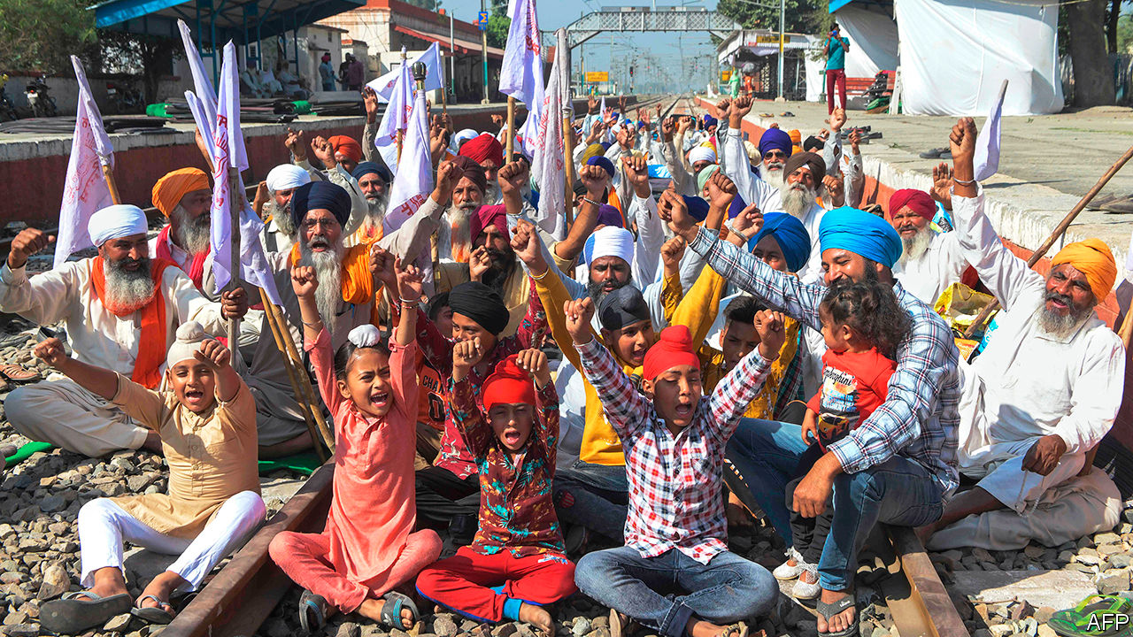

FOR THREE weeks farmers in colourful turbans pitched camp atop the train tracks that stitch the paddies and wheat fields of Punjab. Brewing chai, roasting chapatis, playing cards or simply dozing, the protesters froze traffic across the state’s entire 2,000km rail network. Their rail roko ended on October 21st, after the state legislature voted to resist a barrage of controversial farm reforms that India’s national parliament had passed in September. Yet the trains still did not move. The central government’s rail ministry has held back goods traffic, blocking deliveries of coal to Punjab’s power plants, sprockets to its bicycle factories and fertiliser to its farms.

The centre, as Indians commonly call the federal government in Delhi, cites security as the reason for the stoppage, which began to ease on October 28th. But with tension on a range of issues mounting in recent months between the national capital and India’s 28 states and eight “union territories”, it is not just prickly Punjabis who suspect other forces are at play. Their state happens to be governed by the Indian National Congress, the staunchest foe of prime minister Narendra Modi’s Bharatiya Janata Party (BJP), which rules at the centre as well as in 17 states. Just as Mr Modi has brought a new style of hardball politics to Indian elections, complete with sectarian incitement and online trolling, his government has taken a tougher line with disobedient states. In case Punjabis were in doubt that they were being punished for rejecting the farming reforms, the centre announced it would no longer give the state an annual $135m earmarked for rural development.

In theory, responsibilities are neatly divided between the different levels of government, but in practice there are inevitable, contentious overlaps. Farming is ostensibly a state subject, for example, but in practice Punjab in particular has profited mightily from the centre’s investment in irrigation and subsidies for grain. Hence its farmers are less keen on reforms than others across India, a resentment Congress is happy to stoke.

When provoked by states in earlier decades, the centre frequently responded by invoking a constitutional clause that allows it to declare a state government unable to function properly, and so to disband it and impose direct rule from the centre temporarily. That sort of disruption, typically made following an indecisive election or internal unrest, has grown rarer with time. But with covid-19 deepening an economic slump, frictions have inevitably grown. On issues ranging from taxes to the increased meddling of state governors (who are appointed by the centre but whose role is meant to be largely ceremonial), relations between the two levels of government have soured.

“This is the lowest ebb of federal relations in this country,” asserts Haseeb Drabu, a former state finance minister who once worked closely with the BJP. “Never has the central government been so repressive, never so brazen.” Mr Drabu should know. His state, Jammu & Kashmir, no longer exists. In a series of moves that showed a breathtaking disregard for states’ rights, Mr Modi last year in swift succession imposed direct rule on the state, sliced it into two parts, demoted each half to the status of a union territory, and placed dozens of local politicians under house arrest. On October 27th the centre announced a stunning set of new measures for the rump territory of Jammu & Kashmir, unilaterally revoking a dozen local laws and modifying another 26.

For most states, money is the main bone of contention. The signal achievement of Mr Modi’s first term in office was the replacement of a hodgepodge of local sales taxes with a national goods and services tax (GST). In agreeing to it, states largely gave up their right to impose taxes in exchange for the promise of full compensation from the centre. But as GST revenue has plummeted—the economy shrank by an alarming 24% in the second quarter—the centre has grown reluctant to pay. Meanwhile, because public health and income support are largely state rather than federal responsibilities, it is the states that have had to boost spending the most.

It does not help that the centre has resorted to threats, bluster and parsimony, insisting, for instance, that for every small increase in the limit on what states may borrow from the central bank they must implement a new reform imposed from Delhi. At the same time the centre has pushed states to borrow commercially. The central bank projects that state borrowing is likely to surpass the centre’s this year, leaping from an expected 2.8% of GDP to over 4%.

Money squabbles are bad enough, but several states are also bridling at overbearing political interference from Delhi. After police in the state of Maharashtra launched a probe into the alleged manipulation of ratings by a pro-BJP television channel, the Central Bureau of Investigation, a federal agency, abruptly launched a similar probe in a different state. Fearing its probe would be subsumed, the government of Maharashtra, where the BJP is in opposition, abruptly withdrew consent for the CBI to operate in the state. Four other states have already erected similar barriers, and more are threatening to. Several may also follow Punjab in blocking federal laws, such as the farm reforms, that they don’t like.

Such churn and agitation is part of the normal political back-and-forth in a huge, wildly diverse country. But the BJP’s fondness for subterfuge and coercion, instead of persuasion and consensus-building, is making that process more turbulent than it has been in decades. ■

This article was downloaded by calibre from <https://www.economist.com/asia/2020/10/31/indias-states-and-the-national-government-are-at-growing-odds>

|  |  |  |  |
| --- | --- | --- | --- |
|  | Articles | Sections | Next |

|  |  |  |  |
| --- | --- | --- | --- |
| Previous | Articles | Sections | Next |

#### Out with the new

# Singapore’s government helps old food hawkers but not young ones

The result is a dearth of new recruits to a treasured industry

Oct 31st 2020 | SINGAPORE

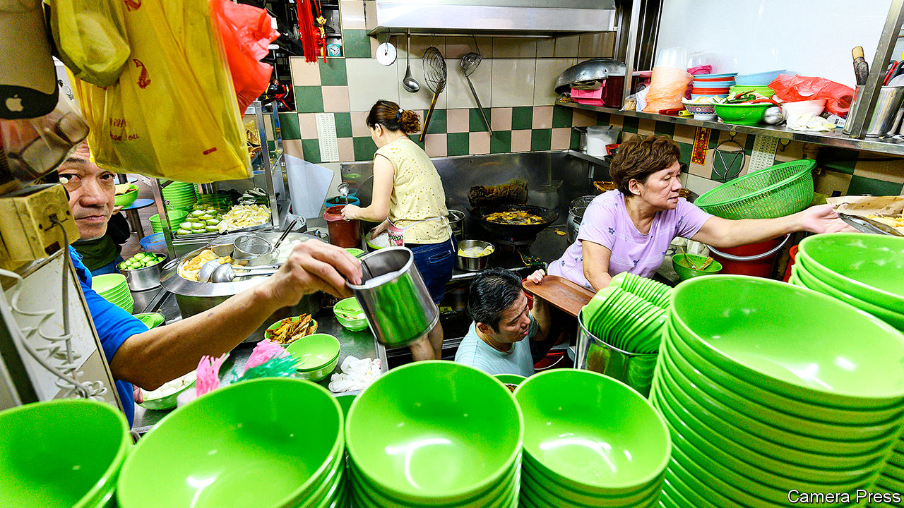

SOME COUNTRIES build palaces or temples as monuments to their greatness. Singapore builds hawker centres. In these open-air food courts lined with stalls and formica tables it is possible to taste Singapore’s history. Dolloped unceremoniously on a plate or banana leaf or scooped steaming into a plastic bowl, dishes such as roti prata and Singapore laksa conjure up the Indian and Chinese migrants whose own cuisines, slowly over centuries, mingled with that of the indigenous Malays. And since one can eat one’s fill at a hawker centre for the price of a flat white, it is no surprise that eight in ten Singaporeans visit such establishments at least once a week, according to a survey conducted by the National Environment Agency in 2018. Singapore is so proud of its street food that it hopes UNESCO will include it in its catalogue of humanity’s most precious arts.

The UN’s heritage inspectors had better tuck in fast. The median age of the chefs is 60. A government report published in 2017 warned that there were “too few [aspiring hawkers] to be able to sustain the hawker trade in the long run”. When old masters die, many take their recipes with them, says K.F. Seetoh, a champion of hawker food. Only Singaporean citizens can work in hawker centres managed by the government, the vast majority. But young Singaporeans have little appetite for toiling in piping-hot stalls for long hours and little pay. “It’s near impossible to get manpower for this trade,” Mr Seetoh wrote in January.

The few young Singaporeans willing to put up with such conditions often live hand-to-mouth. When Yu Ting Gay and Alex Ho opened their Italian-Japanese fusion stall in 2017, they hoped to earn S$2,000 ($1,474) a month each. Most of the time they made half that. “Our pockets were quite tight,” says Ms Yu. “For myself, it’s only going to work and going back home, so we meet up with our friends less than before.”

Older hawkers have an unfair advantage. Many of those who started out in the 1970s and 1980s pay discounted rents: $200 a month on average. They still account for 40% of the 5,500 stalls leased by the government. Younger hawkers must pay market rates: $1,250 a month on average. But a report published by the Ministry of Trade in 2015 found that, even though younger hawkers pay more rent, and have on average 15% higher operating costs, they do not pass those costs on to their customers, probably because of stiff competition.

With classic dishes like Hainanese chicken rice costing just S$3, hawker food is cheaper than chips. The government wants to keep it that way. Singapore’s welfare state is parsimonious, and the authorities have long regarded hawker centres, with their “almost third-world prices”, as “one of our safety-nets”, as Ravi Menon of the central bank has said. The expectation that hawker food will be cheap is shared by consumers. Several months after Douglas Ng opened A Fishball Story in 2013, he decided to increase the price of his S$3 fish-ball soup by 50 cents because his margins were so thin. Sales fell by half, he says.

Many youngsters get noticed and thrive. Mr Ng won an accolade from Michelin in 2016 and received a flood of offers of investment. Others are not so lucky. Just over a year after Ms Yu’s stall opened, her hawker centre closed for renovations. She and Mr Ho had not managed to save enough to weather the three-month hiatus, so were forced to close for good. ■

This article was downloaded by calibre from <https://www.economist.com/asia/2020/10/31/singapores-government-helps-old-food-hawkers-but-not-young-ones>

|  |  |  |  |
| --- | --- | --- | --- |
| Previous | Articles | Sections | Next |

|  |  |  |  |
| --- | --- | --- | --- |
| Previous | Articles | Sections | Next |

#### Not a carbon copy

# Japan promises to be carbon-neutral by 2050

But the government has yet to produce a plan to reach the goal

Oct 29th 2020 | TOKYO

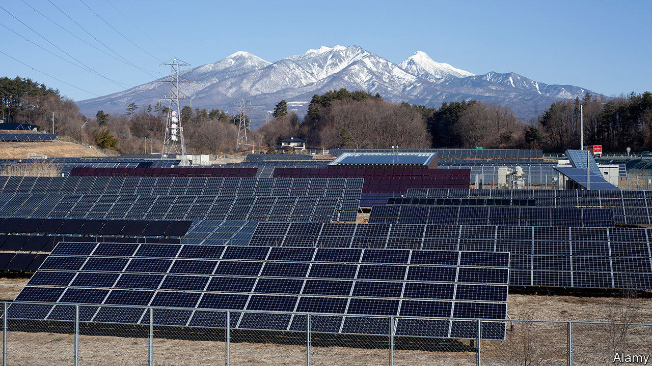

SUGA YOSHIHIDE, Japan’s new prime minister, came to office in September promising continuity with his predecessor, Abe Shinzo. But in one way he has already distinguished himself: during his first speech to the Diet as prime minister, on October 26th, he promised to reduce Japan’s net emissions of greenhouse gases to zero by 2050, breaking with Mr Abe’s foot-dragging on climate change. That brings Japan, the world’s third-biggest economy and fifth-biggest emitter, with a relatively poor record on emissions cuts (see chart), in line with Britain and the European Union and slightly ahead of China, which last month promised zero emissions by 2060.

Japan had previously pledged to be carbon neutral by an unspecified date in the second half of the century. That woolliness had confused bureaucrats and investors alike. The new goal is clearer, but Mr Suga will have to prove it is not just an empty pledge. “The government doesn’t yet have a clear vision as to how to achieve the target, but the target is a way to start the conversation,” says Kameyama Yasuko of the National Institute for Environmental Studies.

There are reasons to be optimistic. By the time of Mr Suga’s speech, more than 160 local governments, representing 62% of the population, had already pledged zero emissions by 2050, up from just four a year ago. Many leading Japanese companies, from consumer brands like Sony and Panasonic to industrial firms like Sumitomo Chemical, have adopted ambitious emissions targets. Even Keidanren, a powerful business lobby that is a bastion of heavy industry, has started talking about decarbonisation. “The energy-intensive industries that oppose climate mitigation have become a minority,” says Ms Kameyama.

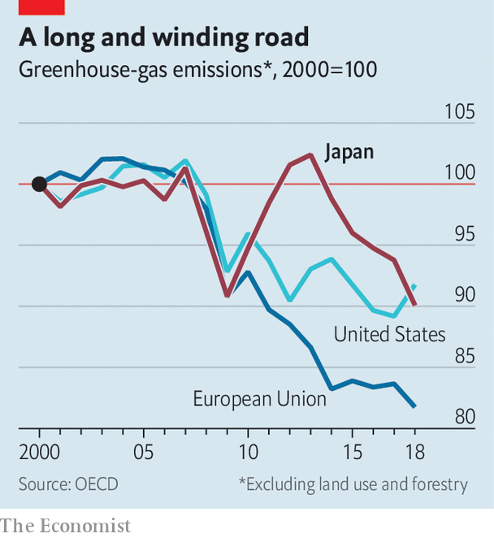

The targets set by other countries seem to have influenced Mr Suga. “It’s kind of shameful for Japan to be lagging behind China,” says Sugiyama Masahiro of the University of Tokyo. Joe Biden has promised to make America carbon-neutral by 2050 if elected president; Japanese officials do not want to be left bucking a global consensus. (Two days after Mr Suga’s announcement, South Korea also pledged to be carbon-neutral by 2050.)

The obvious first step is to raise targets for renewable energy. The government currently projects that 22-24% of electricity will come from renewables in 2030, along with 20-22% from nuclear, 26% from coal and 27% from natural gas. Those benchmarks are set every three years by a committee convened by the Ministry of Economy, Trade and Industry (METI). Discussions on the next iteration began in October; they will conclude by the summer. The assumption is that the target for renewables will jump. “In the past, they developed energy policy first, then thought about climate reduction policy—this time the order is reversed,” says Ms Kameyama.

In the first half of the year, amid decreased demand for power in the covid-19 pandemic, Japan reached the current target for 2030, generating 23% of its power from renewable sources. Pressure groups want the target lifted as high as 50%. Such a rapid shift would require not just huge investments, but also changes in the rules to make it easier to access the grid. Incumbent power companies are sure to resist.

The rest of the energy mix is the subject of similar debate. In July METI, typically a defender of fossil fuels, announced plans to shut 100 inefficient coal plants by 2030. Yet 17 new coal plants are still due to be built in the next five years. Putting a stop to that, as Mr Suga’s goal almost certainly entails, would require the government to stick its oar in. So too would rehabilitating nuclear power. Nuclear plants account for just 6% of electricity generation, down from 25% before the Fukushima disaster in 2011. Restarting plants that have been mothballed since then would be popular with power companies, but not voters, who see nuclear energy as dangerous.

Japan also has ample scope to cut emissions in construction, transport and industry. “It is a myth that Japan is an energy-efficient country,” argues Ohbayashi Mika of the Renewable Energy Institute (REI), a think-tank in Tokyo. Single-pane windows and thin walls are commonplace. A government survey in 2015 found that only 8% of housing met the latest conservation standards, while 35% had no insulation at all. Japanese carmakers pioneered hybrid vehicles, but have been slow to make purely electric cars. The steel industry, which accounts for 48% of industrial emissions, is a laggard: only 24% of its output is made in cleaner electric furnaces, compared to 40% in Europe and 68% in America.

In his speech Mr Suga spoke loftily of the power of innovation. But REI reckons that whereas the EU has directed 30% of its covid-19 stimulus package towards climate-related projects, in Japan the figure is less than 0.2%. Mr Suga reportedly plans to unveil new stimulus measures soon—a chance, perhaps, to prove his concern for the environment. As Mr Sugiyama puts it, “If you’re serious, show us the money.” ■

For more coverage of climate change, register for The Climate Issue, our fortnightly [newsletter](https://www.economist.com/theclimateissue/), or visit our [climate-change hub](https://www.economist.com/news/2020/04/24/the-economists-coverage-of-climate-change)

This article was downloaded by calibre from <https://www.economist.com/asia/2020/10/29/japan-promises-to-be-carbon-neutral-by-2050>

|  |  |  |  |
| --- | --- | --- | --- |
| Previous | Articles | Sections | Next |

|  |  |  |  |
| --- | --- | --- | --- |
| Previous | Articles | Sections | Next |

#### News whose printing causes fits

# Pakistani journalists find ways to get their stories out

But embarrassing the generals who run Pakistan carries big risks

Oct 29th 2020 | ISLAMABAD

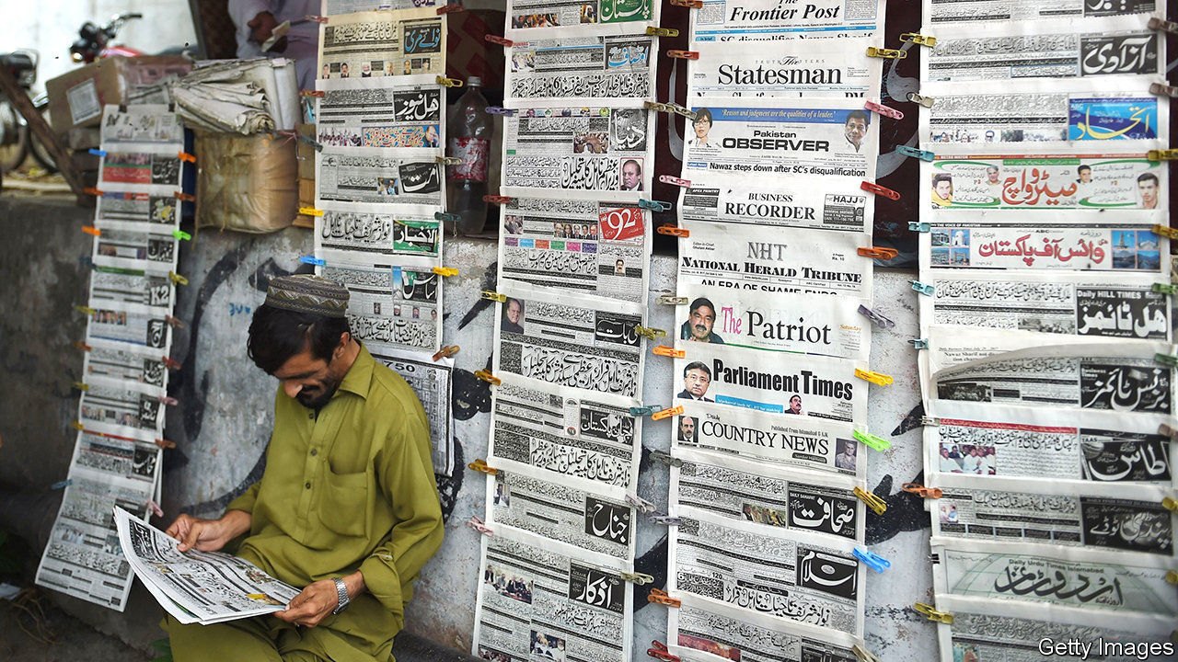

WHEN MATIULLAH JAN was abducted in July outside the school where his wife works, footage from security cameras captured much of what happened. A group of men jumped out of three cars and forced the freelance journalist into one of them before zooming off. At least one of the assailants wore a uniform and carried a gun. What appeared to be a police car and an ambulance drove off with the attackers.

This week the authorities informed a court that they had not been able to ascertain who had kidnapped Mr Jan, who was released unharmed 12 hours later. That, Pakistanis assume, is because Mr Jan was kidnapped by the armed forces, over which the civilian government has little control. The army has lots of ways of discouraging journalists from reporting on awkward topics. Phone calls or WhatsApp messages from unknown numbers will instruct them to let certain subjects be. Colleagues will pass on friendly advice. If all else fails, an abduction or beating by mysterious assailants usually does the trick. Owners of media outlets are also pressed to skirt certain topics and to silence or dismiss pesky reporters. Those who resist find that advertising dries up or, in the case of outspoken broadcasters, their channels are simply taken off the air.

Hearteningly, though, Mr Jan and others have carried on reporting, and have found ways to communicate their findings outside the cowed media. In early October Mr Jan posted an interview on his YouTube channel with Bashir Memon, a former head of the Federal Investigation Agency, Pakistan’s answer to the FBI. Mr Memon alleges that before his retirement last year he was summoned to the “highest office” and instructed to file trumped-up terrorism cases against opposition activists.

By the same token, Ahmad Noorani, a veteran investigative journalist, had to use his own website to publish a report in August on the business empire of the family of Asim Saleem Bajwa, a retired general who now heads the China Pakistan Economic Corridor (CPEC) Authority, a government agency supervising a vast network of infrastructure investments tied to China’s Belt and Road Initiative. At the time of publication, General Bajwa also advised the prime minister, Imran Khan, on matters related to the media.

The report revealed that the general’s brothers, wife and sons had amassed business interests worth tens of millions of dollars as he rose through the ranks. Mr Noorani did not allege any corruption on the general’s part, but did point out that none of the holdings in question had been mentioned in the general’s official declaration of assets.

Newspapers and television channels at first ignored Mr Noorani’s and Mr Jan’s reports, but they spread like wildfire on social media nonetheless. In the end, the mainstream media aired the stories. General Bajwa, who disputes several elements of Mr Noorani’s report, eventually resigned as Mr Khan’s aide, although he remains the head of the CPEC Authority.

The internet and social media are not a panacea for Pakistan’s embattled reporters. Mr Noorani’s website has suffered from cyber-attacks. Allegations that he is an Indian agent have scared off some collaborators and donors. He is hesitant to return from America, where he is on a fellowship, because he has received death threats. In 2017 he was badly beaten. The authorities were not able to identify his attackers. ■

This article was downloaded by calibre from <https://www.economist.com/asia/2020/10/29/pakistani-journalists-find-ways-to-get-their-stories-out>

|  |  |  |  |
| --- | --- | --- | --- |
| Previous | Articles | Sections | Next |

|  |  |  |  |
| --- | --- | --- | --- |
| Previous | Articles | Sections | Next |

#### Banyan

# Sri Lanka’s president is amassing personal power

Constitutional amendments make Gotabaya Rajapaksa’s authority almost absolute

Oct 31st 2020 |



NEVER SAY Gotabaya Rajapaksa leaves things to chance. After decisively winning the presidential election last November, putting family in charge of important government departments, suspending Parliament and finally winning postponed elections in early August in a landslide for his Sri Lanka Podujana Peramuna (SLPP) and supporting parties, still the president insisted that “obstacles” to his authority remained. Changes to the constitution were the only solution. Parliament has granted his wish, creating a near-absolute presidency with the 20th amendment.

As so often in Sri Lanka’s turbulent history, the amendment in effect annuls its predecessor. The 19th amendment was a reaction to the overweening rule of Gotabaya’s brother, Mahinda Rajapaksa, president from 2005 until his surprise defeat in 2015. With Gotabaya, a former army officer, in charge of defence and intelligence, he had prosecuted the even more brutal end to an already bloody 26-year civil war. After the war’s end, triumphalism reigned and critics were intimidated. The amendment limited the president’s powers, expanded those of the prime minister, accountable to Parliament, and strengthened independent oversight of the police and the judiciary. More was promised by President Maithripala Sirisena and his prime minister, Ranil Wickremesinghe, including inter-ethnic reconciliation and devolved government. Yet so dysfunctional became their relationship that intelligence about impending terrorist attacks was ignored. Suicide-bombers struck on Easter Sunday last year, killing 269. Gotabaya’s message of security and competence, along with jabs at the Muslim and Tamil minorities designed to please the Sinhalese Buddhist majority, propelled him to the presidency.

Now the 20th amendment looks intended to cement Rajapaksa rule for years (even though Gotabaya remains bound to two terms). Sri Lankans with dual nationality may now sit in Parliament, or indeed be president. This paves the way for another brother, Basil Rajapaksa, the family’s political strategist, to enter Parliament. Mahinda, currently prime minister, is not in good health, and Basil is his obvious replacement—and eventually perhaps Gotabaya’s. Curiously, several SLPP MPs resented Basil’s grip on the party enough to complain about the provision. (Why not simply renounce American citizenship? A plan B is always advisable.)

As for the president, the amendment now allows him to dissolve Parliament early, hire and fire the prime minister and appoint judges as well as the heads of the election, anti-corruption and other supposedly independent commissions. Although Parliament can opine on these appointments, it cannot block them.

What will Gota’s absolutist presidency mean? He promises brisk, technocratic government and economic development. In dealing with the pandemic, he has indeed introduced sensible measures to help the poor. Yet personalised rule is more the Rajapaksa mark. Recently the president was indignant when, having ordered that one village should have access to another’s clay pit, a local official asked for written instructions—was his verbal command not enough? Meanwhile, he has named 66 ministers. Patronage networks are multiplying like the alimankada, wild-elephant pathways that criss-cross the island. Such networks, writes Asanga Welikala of Edinburgh Law School, undermine “critical separations between state, society, economy, and the private sphere”.

A Gotabaya presidency makes a return to the earlier hounding of critics possible. Out of public view, Mr Rajapaksa’s notorious irascibility—he flies off the handle and bears grudges—is returning. More probably, his martinet notions of a “disciplined society” risk dashing dreams of a plural, devolved Sri Lanka in which the Tamils who form a majority in the north and Muslims who make up a tenth of the population are as much a part of the polity as Sinhalese.

True, Mr Rajapaksa promises a whole new constitution in the coming year that “fulfils the people’s wishes” better. It is possible a new constitution could contain a kinder accommodation for Sri Lanka’s minorities. Yet for now, Mr Rajapaksa has made explicit the link he sees between an all-powerful state and the centrality of Buddhism, whose more chauvinist priests he courts. Of the 66 ministers only three are Tamils and just one is a Muslim (there is only one woman, too). The message is stark: in the ethno-nationalist state, everyone must know their station.

This article was downloaded by calibre from <https://www.economist.com/asia/2020/10/31/sri-lankas-president-is-amassing-personal-power>

|  |  |  |  |
| --- | --- | --- | --- |
| Previous | Articles | Sections | Next |

|  |  |  |
| --- | --- | --- |
| Asia | Sections | Middle East & Africa |

China

Leadership succession: Xi’s not going

.

Demography: Go figure

.

Chaguan: Chicken and egg

.

|  |  |  |
| --- | --- | --- |
| Asia | Sections | Middle East & Africa |

|  |  |  |  |
| --- | --- | --- | --- |
|  | Articles | Sections | Next |

#### The missing successor

# China’s most senior officials endorse economic plans for years ahead

But they left one little thing out

Oct 31st 2020 |

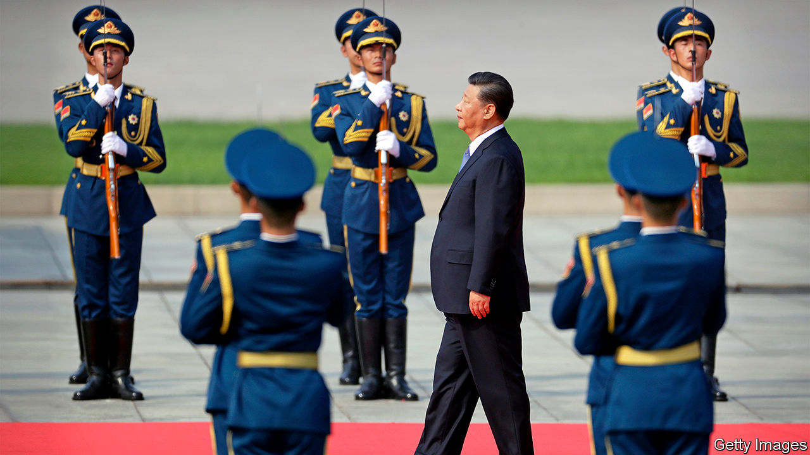

ALMOST EXACTLY ten years ago, in a typically roundabout way, China made clear who its next leader would be. A man who, not long earlier, had been far less famous than his folk-singer wife was made vice-chairman of the Communist Party’s Central Military Commission. Sure enough, two years later, he took charge of the party and the armed forces and became China’s most powerful ruler since Mao Zedong. Were precedent to be followed, a meeting of senior officials in Beijing this week would have provided just such a clue about who would succeed Xi Jinping. It provided nothing of the sort.

That is no surprise. When China’s constitution was revised in 2018 to scrap a limit of two five-year terms for the post of state president, which Mr Xi also holds, it was a clear signal that he did not wish to step down when his ten years were up. As head of the party, he was not bound by any term limit. But his predecessor, Hu Jintao, had given up both party and state roles in quick succession. Mr Xi had been expected to follow Mr Hu’s lead.

For anyone still in doubt about Mr Xi’s intentions, the party’s just-concluded meeting gave a hint as obvious as the one in 2010 that heralded his rise to power. A communiqué issued on October 29th, at the end of the four-day conclave of its roughly 370-strong Central Committee, said the gathering had endorsed “recommendations” for a five-year economic plan and a blueprint for China’s development until 2035 (full details of these had yet to be published when The Economist went to press). But it made no mention of any new civilian appointment to the military commission.

The post of vice-chairman is an important one for any future leader to hold before taking over. Mr Hu got the job three years before he became general secretary. Without experience of how military command works, a party chief may find it hard to assert control over the army. There are still two uniformed vice-chairmen. But the continuing absence of a civilian at that level means China has no leader-in-waiting when time has all but run out to start learning the ropes before the party’s 20th congress in 2022. A civilian vice-chairman would also be a member of the Politburo’s Standing Committee. But a reshuffle of that seven-member body in 2017 did not include anyone of the usual sort of age of someone being groomed for succession.

There are occasional complaints in China about Mr Xi’s seeming determination to hold power indefinitely. In August Cai Xia, a public intellectual, was expelled from the party and stripped of her pension by its most prestigious academy for training leaders, the Central Party School, where she had studied and taught for 20 years before retiring. Among comments that apparently resulted in her punishment was her description of Mr Xi’s scrapping of the two-term limit as something the Central Committee had been forced to swallow “like dog shit”. Ms Cai is now abroad.

But in so far as can be guessed from China’s opaque political workings, Mr Xi remains as powerful as ever and seemingly fit enough to keep going well beyond 2022. He will turn 69 that year—by convention too old to remain in office, but that is not a hard-and-fast rule. While liberals like Ms Cai grumble—as, no doubt, do those who have suffered as a result of his ruthless campaign against corruption and his political purges—there is little sign of strong anti-Xi sentiment among the public.

In some ways this has been a good year for Mr Xi, with many Chinese proud of their country’s success in crushing covid-19 and getting the economy back on track. Party propagandists have been working hard to boost such sentiment. The term “people’s leader”, rarely applied to his post-Mao predecessors, is sometimes used in state media when referring to Mr Xi (the Politburo used it for the first time last December).

It may also, however, be an anxious time behind closed doors. Party congresses rubber-stamp decisions that have been made in secret beforehand. Even though the next one is still two years away, the build-up is a tense time in Chinese politics as leaders bargain over policy and appointments. The party’s 18th congress, at which Mr Xi came to power, followed a protracted political struggle highlighted by the dramatic downfall of Bo Xilai, a contender for highest office. There is no sign that Mr Xi faces another such challenge. But in July the party launched a pilot scheme in a handful of places for a new purge, this time aimed at the judiciary, police and secret police. One stated aim is to root out “two-faced people” who are disloyal to the party. It will be rolled out nationwide next year and wrap up early in 2022, a few months before the 20th congress.

It is not yet clear how Mr Xi intends to exercise his power beyond the congress. He could simply keep his current positions. Another rumoured option is that he might prefer an even grander title than that of general secretary, which has not always indicated that the holder wields supreme power. In the 1980s Deng Xiaoping, whose authority stemmed from his position as chairman of the military commission, sacked two general secretaries; Mr Hu became general secretary in 2002 but remained overshadowed by his predecessor, Jiang Zemin, who held on to the crucial military position until 2004. Mr Xi could revive the title of party chairman (abolished in 1982) and raise himself to the great helmsman’s hallowed level.

He will certainly use the congress to install more of his protégés. By that time the prime minister, Li Keqiang, will have served his constitutionally mandated maximum of two terms. Mr Li was not installed by Mr Xi, who may look forward to appointing someone closer to him. Unusually, there is no obvious person who has the experience (serving as deputy prime minister is usually a prerequisite), is the right kind of age (67 or younger is the norm) and crucially, who is close to Mr Xi. Leaving this choice until closer to the time may not bother him, however. Since Mr Xi became leader, the prime ministership has become less important. He has taken over its core responsibility: directing the economy.

The biggest unknown is who would emerge as China’s paramount leader if Mr Xi suddenly becomes unable to rule, as a result of death or illness. There is no clear line of succession within the party—without Mr Xi, no one in the currently 25-member Politburo would stand head and shoulders above the rest. Younger leaders, such as the party chief of the south-western region of Chongqing, Chen Min’er, who has long been tipped as a forerunner for post-Xi leadership, may lack sufficient seniority to take over in an emergency. Mr Xi’s sudden departure could plunge China into political turmoil.

The Central Committee’s just-concluded meeting may have made Mr Xi’s plan to retain power in 2022 even more certain. It has done nothing to instil confidence in China’s political future. ■

This article was downloaded by calibre from <https://www.economist.com/china/2020/10/31/chinas-most-senior-officials-endorse-economic-plans-for-years-ahead>

|  |  |  |  |
| --- | --- | --- | --- |
|  | Articles | Sections | Next |

|  |  |  |  |
| --- | --- | --- | --- |
| Previous | Articles | Sections | Next |

#### Go figure

# China’s 7m enumerators begin the world’s largest census

Is the population already shrinking?

Oct 31st 2020 |

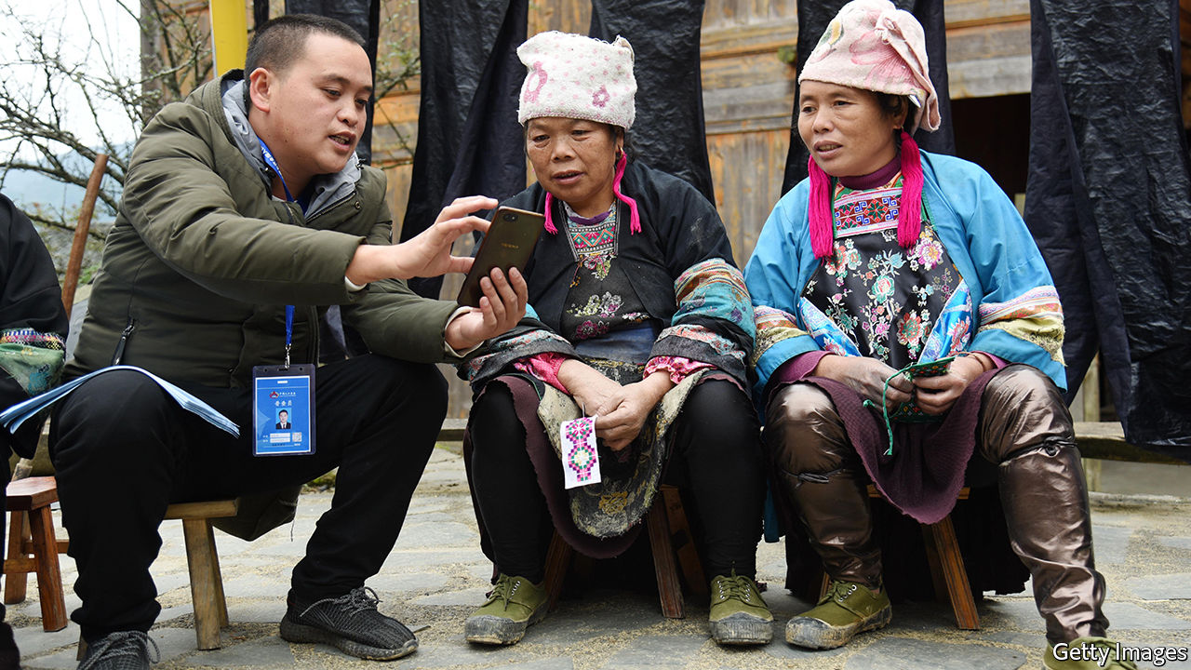

IN THE COMING weeks nearly every Chinese house will receive a knock on the door. On November 1st 7m functionaries will begin carrying out the country’s ten-yearly census, a task that will take them until December 10th. The last such count, in 2010, found that China’s total population was growing only half as swiftly as it did between 1991-2000. This year’s megacount will provide further details about the country’s demographic crunch.

Censuses are difficult everywhere, but China’s is especially fraught. Its hundreds of millions of migrant workers are tricky to count, not least because some fear reprisals for having moved to parts of the country that the Communist Party would like them to leave. Some people do not want officials to find out that they have had more children than family-planning policies allow. Fraudsters and thieves who have posed as census-takers during past counts have given enumerators a bad name. And local governments have sometimes sought to inflate population figures in order to claim more subsidies from Beijing.

This time, says the government, new paperless systems will help to protect people’s information and make it harder for anyone to fiddle the count. There are also plans to substitute door-to-door visits with phone calls and online forms, if census officials in some places have to work around local outbreaks of covid-19. Whereas many Chinese shy from the box-tickers, some are hoping to use this year’s exercise to help make themselves more visible. A gay-rights group in the southern city of Guangzhou is encouraging people in same-sex relationships to make sure census-takers realise they are a couple, and to insist that they write this information into an open field in the census form.

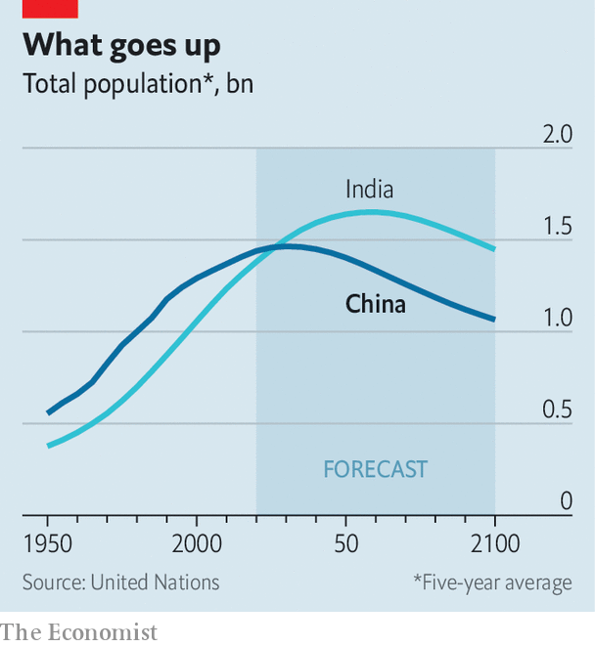

The findings from China’s previous census helped persuade the party that it had to loosen its one-child-per-family policy. Since 2016 Chinese couples risk punishment only if they have more than two. Yet the total number of births is declining even faster than it was before the change. Last year the country produced the fewest babies since 1961, when its population was only half as large. The birth rate, of 10.48 babies per 1,000 people, was the lowest since the party took power in 1949.

The government reckons that China’s working-age population has been shrinking since 2012. The share of people aged 60 and over has risen from 10.4% at the census in 2000 to an estimated 18% last year; this group could make up one-third of the population by 2050. The Chinese Academy of Social Sciences, a government think-tank, guesses that the number of Chinese will peak at 1.44bn in 2029. But some demographers think that the population may already have started to shrink.

Preliminary results from this year’s census will not be released for some months. But it does not require an army of enumerators to see that the coercive regulation of Chinese couples’ fertility is as absurd as it is cruel. In June Chinese journalists reported that a couple in Guangzhou had been fined 320,000 yuan ($48,000) after declining to abort their third child—a sum equal to nearly three years of their household income. Someday, perhaps, Chinese people will be allowed to make their own reproductive choices.■

This article was downloaded by calibre from <https://www.economist.com/china/2020/10/31/chinas-7m-enumerators-begin-the-worlds-largest-census>

|  |  |  |  |
| --- | --- | --- | --- |
| Previous | Articles | Sections | Next |

|  |  |  |  |
| --- | --- | --- | --- |
| Previous | Articles | Sections | Next |

#### Chaguan

# High-tech chickens are a case study of why self-reliance is so hard

For China, rearing the meatiest poultry is surprisingly difficult

Oct 29th 2020 |

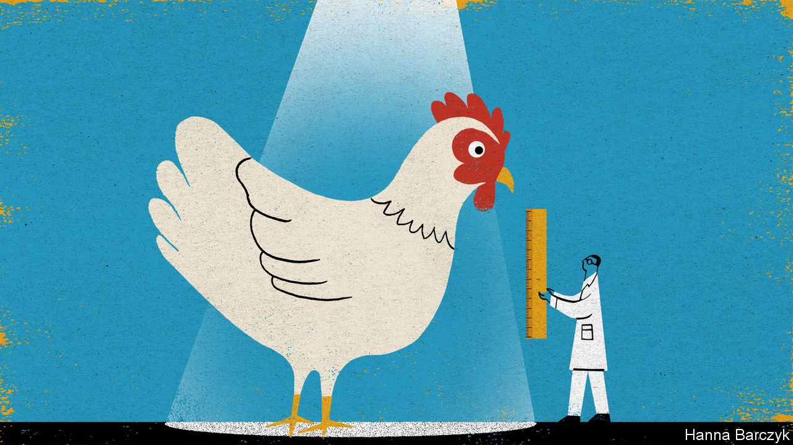

IT TAKES AN effort—a small hardening of the heart—to see day-old Jinghai Poultry chicks for what they are. These, for all their plaintive cheeping and soft, fuzzy plumage, are tiny, high-performance meat factories. The product of decades of genetic research in American and European laboratories, they hatch in China thanks to global supply chains, involving the air-freighting of eggs and chicks between secure breeding sites on five continents.

Those chains are more fragile than once supposed. Animal diseases, the US-China trade war and covid-19 have all disrupted, or threatened to disrupt, industrial chicken supplies. That makes those chicks a window onto something interesting: China’s increasingly complicated relationship with high-tech globalisation, a force that has made the country more prosperous, but also reliant on the outside world in ways that trouble Communist Party bosses.

The unsentimental logic of high-performance poultry-rearing is easy to grasp. Standing this week in the loading bay of a factory farm in the coastal province of Jiangsu, Chaguan heard Jinghai executives explain how “white-feather meat chickens”, as they are known in China, grow to 2.5kg in 40 days. Homegrown varieties of “yellow-feather chicken”, descended from backyard fowl, take twice as long to mature and will only ever weigh half as much. Clients collect cardboard trays holding 102 chicks, peeking through slats in the sides. Four trays can generate a tonne of chicken.

Nor is China’s interest in cheap protein mysterious. Half a century ago meat was a rare luxury. Now, many see it as a daily necessity. In the meantime, the country’s supplies of farmland and clean water have not grown. Agriculture remains blighted by food-safety scandals, the rampant use of fake or illegal animal medicines, and disease outbreaks. Small surprise, then, that Chinese leaders give frequent speeches about food security. A puzzle lurks, though. Leaders also call for self-reliance in key technologies. And in the case of broiler chickens, those two ambitions—rearing meat efficiently and avoiding dependence on imports—are in tension.

The chicks cheeping at Chaguan are the fifth-generation descendants of pedigree birds whose bloodlines represent 80 years of selection for such traits as efficient food-to-meat conversion, rapid growth, strong leg bones and disease resistance. After waves of consolidation, the industry is dominated by two firms, Aviagen (based in Alabama and owned by the EW Group of Germany) and Cobb (owned by Tyson, an American poultry giant).

The most valuable pedigree birds never leave maximum-security farms in America and Britain: a single pedigree hen may generate 4m direct descendants. Their second-generation offspring are flown to breeding sites dispersed between such places as Brazil, Britain and New Zealand, in part to hedge against supply shocks when avian influenzas and other diseases close borders. Day-old third-generation chicks are air-freighted to local partners such as Jinghai, which spend six months growing them and breeding them in climate-controlled, artificially lit indoor facilities. In all, China imports 1.6m third-generation white-feather chicks a year.

Jinghai hatches 8m fourth-generation, “parent stock” chickens annually. The company sells some to other agri-businesses. It breeds from the rest to produce fifth-generation chicks like those cheeping at Chaguan. These are “meat chickens”, consumed in fast-food outlets, schools and factory canteens, or as chicken parts sold in supermarkets. Yellow-feather chickens, deemed tastier by Chinese cooks, account for most whole birds sold in markets.

Chinese breeders have long tried to create local varieties with bloodlines available in-country. Breeding from imported third- or fourth-generation chickens is a bad solution: their genes are less desirable than those of their elite grandparents, making them a poor starting-point for a new variety. In September the State Council, China’s cabinet, issued a paper on livestock-rearing that set self-sufficiency in poultry as a goal, calling meat-chicken breeding a priority. Big foreign firms have resisted appeals from officials to send second-generation stock to China. A poultry firm with 10% of the domestic market, Fujian Sunner, says it has bred all-Chinese broilers: their performance is a source of some debate.

Dependence on foreign bloodlines does carry risks. For several months recently New Zealand was one of the only countries able to send third-generation chicks to China, after other exporters suffered bird-flu outbreaks. Li Jinghui, president of the China Broiler Alliance, an industry association, calls conditions ripe for China’s “brilliant” scientists to develop local birds. Mr Li adds that Chinese diners do not share the West’s love of breast meat and think chicken feet a delicacy, so that Chinese-bred broilers might have bigger thighs and feet. But Mr Li suggests that the government’s aim is diversifying meat supplies, rather than literal self-sufficiency. Let Chinese and foreign chicken breeds compete like Huawei and Apple smartphones, he urges: market forces should decide the result.

## Don’t even ask about animal rights

Wang Hongsheng, a boss at Jinghai, admits to fretting about interruptions to chick supplies, even wondering if President Donald Trump might curb American exports. But to develop a domestic breed from scratch would take years, and if it does not meet market needs, a firm could spend a fortune “without much to show for it”.

High-tech chickens are not as sleek as high-speed trains or as clever as quantum computers. Still, they are a case study of why self-reliance is hard. China’s poultry market has room to grow: Westerners each eat far more chicken than Chinese do. But without a stronger animal-health system and environmental controls, biotechnology alone cannot help China to develop world-class agriculture. Moreover, a long-standing Chinese strategy—bullying foreign firms to hand over intellectual property—is counter-productive now. Western trust in China is low, and official talk of self-sufficiency is one cause. The politics of globalisation get tricky when one side feels it is being readied for the pot.■

This article was downloaded by calibre from <https://www.economist.com/china/2020/10/29/high-tech-chickens-are-a-case-study-of-why-self-reliance-is-so-hard>

|  |  |  |  |
| --- | --- | --- | --- |
| Previous | Articles | Sections | Next |

|  |  |  |
| --- | --- | --- |
| China | Sections | Europe |

Middle East & Africa

Malaria and covid-19: Masked up, ready to battle bugs

.

Guinea: Ballots and bloodshed

.

Sudan: General agreement

.

Israel’s new airport: Not in my wetland

.

|  |  |  |
| --- | --- | --- |
| China | Sections | Europe |

|  |  |  |  |
| --- | --- | --- | --- |
|  | Articles | Sections | Next |

#### The virus and the vector

# How covid-19 hinders the fight against malaria

And how health workers are heroically adapting

Oct 31st 2020 | DAKAR, MAIDUGURI AND THIBA

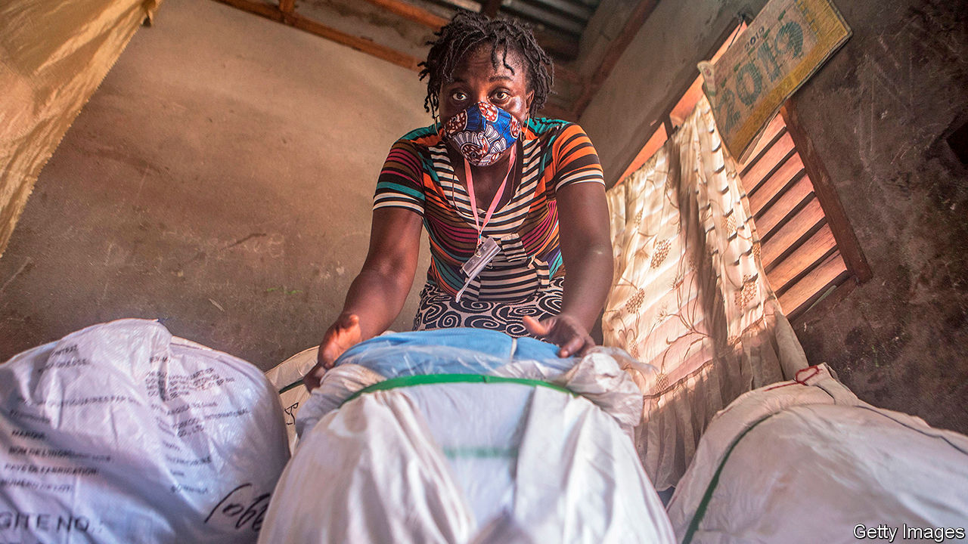

SINCE COVID-19 hit Kenya, Margaret Wanja has accumulated six grandchildren and great-grandchildren. She lives in Thiba, a rice-growing village. Her new brood are all evacuees from Nairobi, the Kenyan capital. Many city-dwellers believe it is safer to send their children to rural relatives. Others hope to save money. The pandemic has destroyed jobs and closed schools, where poor children are often given a free lunch. Dispatching kids to the countryside, where it is easier to live off the land, means fewer mouths to feed.

Yet there are hidden dangers. The irrigation ditches in Thiba’s paddy fields breed mosquitoes, which transmit malarial parasites from human bloodstream to human bloodstream. So even if there is less coronavirus here than in a city, it is far more dangerous for children. Worldwide, 400,000 people died of malaria in 2018, two-thirds of them children under five. Very few children die of covid-19.

To prevent mosquito bites, governments hand out insecticide-treated bednets. Kenya does it every three years; and was scheduled to do it in April. Alas, covid-19 scotched that plan. Kenya was under curfew, movement was restricted and health workers were on pandemic duty.

Belatedly, as the insecticide on Kenyans’ old bednets loses its potency, the government is trying again. On October 24th hundreds of volunteers began a household census in Mwea, the electoral district that includes Thiba, in preparation for a pilot programme handing out 60,000 nets with social distancing. Instead of rolling up with a truckload and letting villagers crowd around to receive one, workers will have multiple distribution points and staggered pickup times. Getting nets to all 15m Kenyans who live in malarial regions will take ages. There is no chance it will be done before the rainy (ie, malarial) season ends in late November.

As covid-19 started to spread around the world in March, malaria-watchers fretted. Supply chains for drugs and insecticide were bound to be disrupted. Pandemic-induced poverty was bound to make people more vulnerable. “All the alarm bells started ringing,” says Pedro Alonso of the World Health Organisation (WHO). In April a WHO study predicted that, in a worst-case scenario, the malarial death toll would nearly double in 2020, to 769,000.

Governments and donors were jolted into action. Supply chains were indeed disrupted, but firms found workarounds, and health workers found ways to fight malaria while avoiding spreading covid-19. Some 90% of malaria-prevention efforts are now back on track, says the RBM Partnership to End Malaria. The worst-case scenario now seems unlikely to come to pass, though conclusive data are not yet available.

Still, huge challenges remain. The global death toll from malaria was falling before covid-19 struck (see chart). It would be a tragedy if progress stalled, especially since, as Philip Welkhoff of the Bill and Melinda Gates Foundation notes, “Every malaria death is avoidable.”

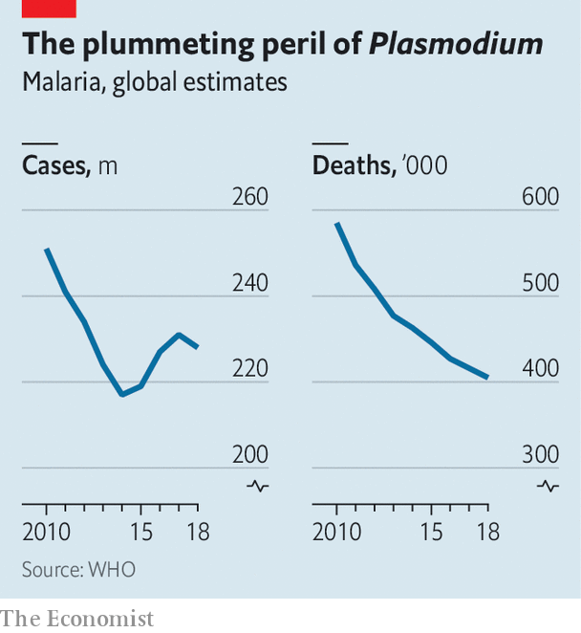

Governments in rich countries have pushed a consistent message for covid-19. If your children have a fever, keep them at home. “That message would be an unmitigated disaster in countries with high malaria transmission, because a child with a fever can die from malaria in 24 hours,” says Melanie Renshaw of the African Leaders Malaria Alliance, an intergovernmental group. Such a child must quickly be tested for malaria and, if the test is positive, be given anti-malarial drugs. In recent years donors have done a good job of distributing rapid diagnostic tests. These plastic devices look like pregnancy tests, only smaller. They can detect malaria within 15 minutes, with just a drop of blood and no need for a doctor. However, each test can be used only once, so donors have to keep supplying millions of them to African villages.

Some of the difficulties health workers face can be seen at El Miskin camp, near Maiduguri in northern Nigeria. Rows of small square houses of thatch and tarpaulin stretch into the distance. Kids mill around. There’s a hand-washing station at the entrance, but no water or soap.

The people in the camp are among the 2m who have fled from Boko Haram, a slave-owning jihadist group. Because they are poor and their camp is puddle-pocked, they are vulnerable to malaria. At one tarpaulin house Nana, a mother, grinds orange pills in water and presses the cup to her son’s lips. Hussein, who is about four years old, grimaces at the bitter taste. The yucky pills were given to his family as part of a campaign of “seasonal malaria chemoprevention”. In the rainy season, when mosquitoes proliferate, children under five who live in the most malarial areas of Africa are given a prophylactic cocktail of drugs once a month. It cuts the likelihood of each child falling sick by 75%. It has helped Nigeria reduce malaria deaths from 153,000 in 2010 to 95,000 in 2018.

Many locals do not believe in covid-19, or dismiss it as a disease only for rich people who fly in planes. Despite numerous warnings, they crowd hazardously around the health workers who come to the camps. Those health workers must haul around bags of masks and sanitisers. This costs a lot; and the masks create a psychological barrier between health workers and ordinary people, frets Ini Nglass, who leads a WHO malaria team in Borno, the state of which Maiduguri is the capital. Masked people at the door look intimidating. And whereas health workers would normally laugh and play with children before dishing out pills, this year they stand a metre away, their reassuring smiles hidden.

This makes it harder to build trust, and that matters in north-eastern Nigeria, where suspicion is rife. Some 1.2m people are trapped in areas controlled by Boko Haram. The jihadists oppose modernity (though they cheerfully brandish modern weapons). In 2018 they murdered two Red Cross midwives, for supposedly betraying Islam by joining a Western charity.

They make it dangerous to save lives. Yet some health workers manage to distribute anti-malarial drugs. They disguise themselves as villagers, sneak into jihadist territory, stay put for weeks or months and only leave when the work is done. The WHO calls them “trapped health workers”.

When it is too risky to sneak in, they try a different ploy. Boko Haram’s subjects are not allowed to leave permanently. But they can make short trips to market towns, so long as they leave something valuable behind. “[Boko Haram] take their children and tell them, ‘If you don’t come back, we will kill them,’” says a local observer. So health workers station themselves at markets and, with the help of local informants, make contact with the villagers for long enough to slip them anti-malarial pills.

It feels odd to work in the shadows, like heroin dealers, but such tactics are effective. In August Africa was declared free of the wild polio virus, despite the efforts of Boko Haram to thwart vaccination campaigns, which its fighters imagine are a plot to sterilise Muslims.

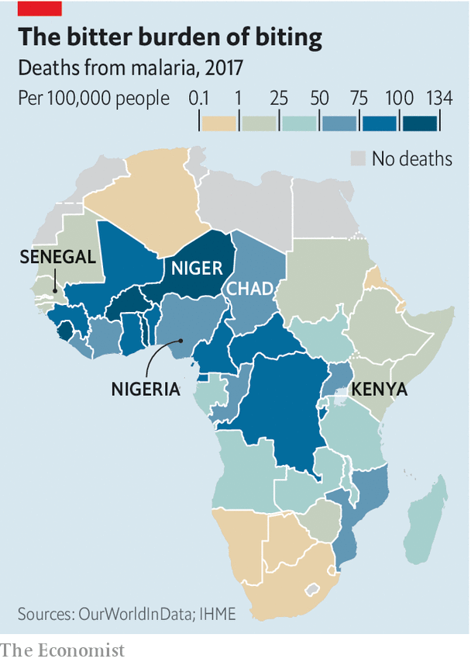

Some places cannot be reached, alas. Of the 27 local government areas in Borno state, two have been struck off the anti-malarial campaign’s list. They are on the borders with Niger and Chad, which the terrorists cross at will, so they are too dangerous. No one knows how many children will die of malaria because the jihadists think science is sinful.

Most Africans disagree with Boko Haram. In a laboratory in Dakar, Senegal’s capital, technicians analyse the malarial parasites found in people’s blood. Genetic information is fed into computers and crunched. “Before genomics arrived, there were questions without answers,” says Daouda Ndiaye, Senegal’s top malaria expert, based at Cheikh Anta Diop University.

There is a correlation between the number of different parasites found in human blood samples and the prevalence of malaria itself. If only one kind of parasite is found in the samples from a given village, there may be only one source of infection. (The villagers are infecting each other.) Multiple different parasites suggests multiple sources of infection: traders crossing a border, migrant workers coming home and so on. People on buses travel much farther than mosquitoes can fly.

## A mix of old and new

Genomics yields precious information. It can show how the disease is being transmitted around the country, and where infection rates are likely to be high. This lets health authorities concentrate resources where they are most needed. It can also show where drug-resistant strains of malaria have popped up, so medics can change the drugs they recommend in those places.

By combining new tools with bednets, pills and spraying, Senegal hopes to eliminate malaria by 2030. Ending it worldwide is further off. The Lancet, a medical journal, said last year that it could be done within a generation, if $6bn a year were spent on prevention instead of $4.3bn. The covid-driven global recession could make it harder to raise such sums.

Anti-malarial campaigns must be sustained. “If you stop holding it down, it goes back up,” says Dr Welkhoff. An Asian species of mosquito, Anopheles stephensi, has found a foothold in Ethiopia and Sudan. Unlike most African species, it thrives in cities, where previously the disease was rare. Since mosquitoes and parasites move and evolve, people must be adaptable. Mosquitoes are being genetically modified to sire offspring that die before they are old enough to start biting. In October the WHO came out in favour of such research. Victory against the vectors is not assured, but nor is it fanciful. ■

Editor’s note: Some of our covid-19 coverage is free for readers of The Economist Today, our daily [newsletter](https://my.economist.com/user#newsletter). For more stories and our pandemic tracker, see our [hub](https://www.economist.com/news/2020/03/11/the-economists-coverage-of-the-coronavirus)

This article was downloaded by calibre from <https://www.economist.com/middle-east-and-africa/2020/10/31/how-covid-19-hinders-the-fight-against-malaria>

|  |  |  |  |
| --- | --- | --- | --- |
|  | Articles | Sections | Next |

|  |  |  |  |
| --- | --- | --- | --- |
| Previous | Articles | Sections | Next |

#### Ballots and bloodshed

# A disputed election leads to violence in Guinea

The president, Alpha Condé, has won a third term—but he has little to celebrate

Oct 31st 2020 | DAKAR

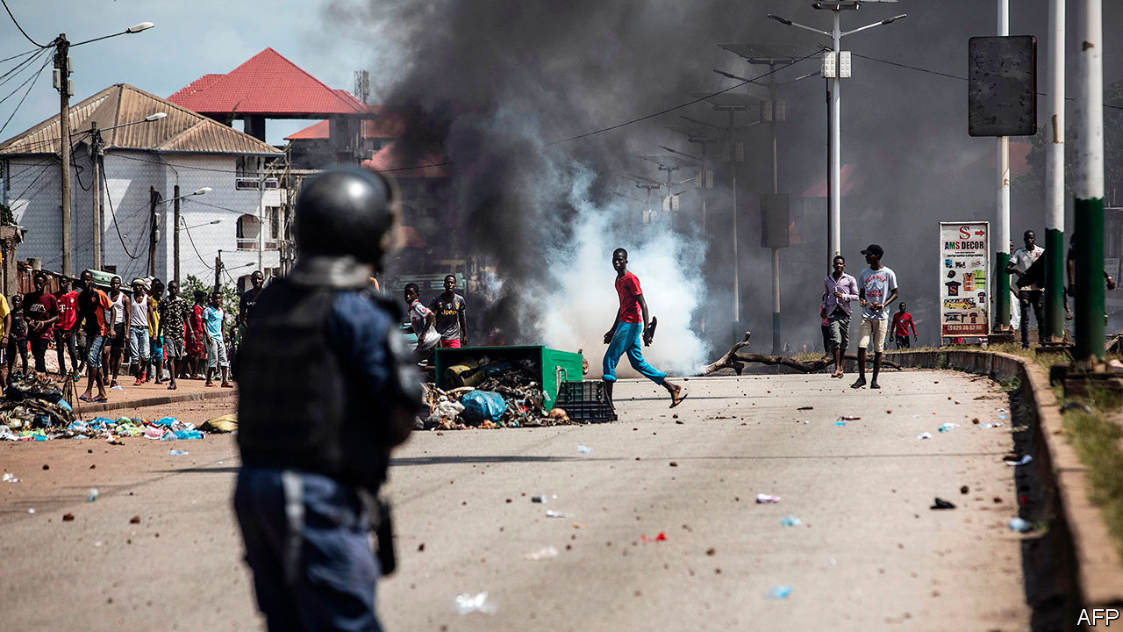

“LONG LIVE democracy, long live peace,” said Kabinet Cissé, the head of Guinea’s electoral commission, as he announced on October 24th that Alpha Condé had won a third term as president. But on the streets of Conakry, the capital, there was little sign of peace—perhaps owing to a lack of democracy. Wounded protesters lay next to charred vehicles. A fleet of police trucks surrounded the house of Mr Condé’s rival, Cellou Dalein Diallo, who was trapped inside for over a week after the vote on October 18th.

This is a crisis many saw coming. In March the 82-year-old Mr Condé, who has ruled for almost a decade, pushed through a new constitution that allowed him to run for two more six-year terms. Dozens of people were killed by security forces during protests about a referendum on the changes. Guineans harbour other grievances, too. Most of the country’s 13m people are poor, despite the presence there of the world’s largest reserves of bauxite, from which aluminium is refined.

The election pitted Mr Condé against Mr Diallo for the third time. Both draw support from their ethnic groups; Mr Condé is Mandinka, Mr Diallo is Fulani. The voting itself was relatively calm. The trouble started the next day, after Mr Diallo claimed victory, citing photos his party had apparently taken of results posted outside polling stations. When his supporters began celebrating in the streets, the authorities cracked down. Soon the parties became protests and the government sent in the army.

The state admits that 21 people died in the days after the vote (including members of the security forces, it says). The opposition claims at least 30 people, including children, have been killed. More than 100 have gunshot wounds. They were not just struck by stray bullets, says Ilaria Allegrozzi of Human Rights Watch, an advocacy group: “Some of them were clearly targeted.” As information trickles in from outside the capital, the death toll could rise.

Fatou Bensouda, the chief prosecutor of the International Criminal Court (ICC), says those perpetrating or inciting violence are “liable to prosecution either by the Guinean courts or the ICC”. But that seems unlikely. For decades Guinea’s security forces have killed with impunity. As the electoral commission prepared to announce the results, the internet was shut down and international phone calls cut off.

It is difficult to say who really won the election. Officially, Mr Condé gained 59% of the vote. But four electoral commissioners (affiliated with the opposition) released a report detailing “serious anomalies”. In one of Mr Condé’s strongholds turnout was listed at over 100%, they say. Elsewhere votes were not counted because of alleged irregularities. The European Union also questioned the result. Mr Diallo claims there has been “massive fraud”. He says he will take his case to the constitutional court, though he doubts its independence.

A delegation from the United Nations, ECOWAS (a regional bloc) and the African Union arrived in Guinea on October 25th hoping to mediate a solution to the crisis. But they lack credibility. ECOWAS said little when Mr Condé changed the constitution, and called the election lawful. “I do not expect much from these emissaries who, in reality, have always sided with Alpha Condé,” tweeted Mr Diallo, after meeting the delegation. “Let us continue our mobilisation in the streets...NO RETREAT!”

As The Economist went to press, things had calmed down—but they could easily heat up again. Guinea has a history of ethnic trouble. Last week in Conakry a man was stoned to death by Condé-supporting youths, says Amnesty International, a watchdog. His apparent crime was being of the wrong ethnicity in a government stronghold. Outside the capital there are reports of score-settling along ethnic lines.

A deal that might keep things calm looks remote—and “will not be enough to prevent another violent political crisis in the years to come”, says Gilles Yabi of the West Africa Think Tank in Senegal. If Mr Condé had just respected the constitution, democracy might have taken root. His decision to run again, says Mr Yabi, may have set the country back decades. ■

This article was downloaded by calibre from <https://www.economist.com/middle-east-and-africa/2020/10/31/a-disputed-election-leads-to-violence-in-guinea>

|  |  |  |  |
| --- | --- | --- | --- |
| Previous | Articles | Sections | Next |

|  |  |  |  |
| --- | --- | --- | --- |
| Previous | Articles | Sections | Next |

#### General agreement

# Sudan joins a wave of Arab states recognising Israel

But the decision may strengthen the generals in a supposedly emerging democracy

Oct 29th 2020 | BEIRUT

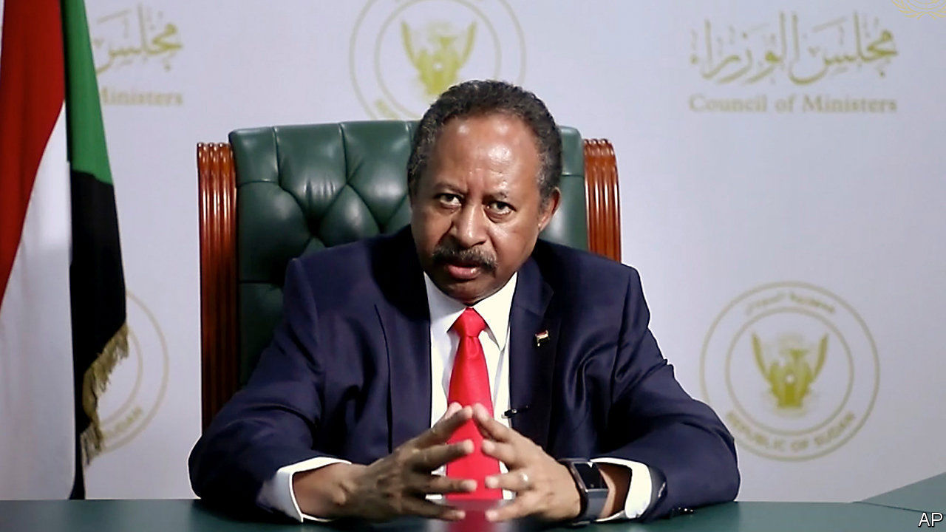

KHARTOUM, THE capital of Sudan, holds a symbolic place in the history of the Arab-Israeli conflict. It was there in 1967 that the Arab League declared their “three nos”: no peace with Israel, no recognition, no negotiations. Unity was short-lived. Egypt said yes to peace in 1978, followed by Jordan in 1994. But for half a century most Arab states refused to recognise Israel.

On October 23rd the government in Khartoum abandoned the Khartoum declaration, agreeing to normalise ties with Israel. It was the third Arab state to do so this year, after the United Arab Emirates (UAE) and Bahrain. They saw a compelling strategic interest: Israel makes a reliable partner against both Iran and an emerging Sunni Islamist axis led by Turkey.

For Sudan’s decision, though, one must credit President Donald Trump’s cynical style of diplomacy. In 1993 America labelled Sudan a state sponsor of terrorism and imposed sanctions. In recent years, as Sudan sought to improve ties with the West, many in Washington argued that it was time to reverse the decision. Their case grew stronger after last year’s popular coup against Omar al-Bashir, the longtime despot. Sanctions seemed to punish the new government for the sins of the old.

But the Trump administration insisted that Sudan must recognise Israel in exchange. In public it has tried to make the quid pro quo less explicit. Sudan agreed to pay $335m into a fund for American victims of terrorism to win removal from the state-sponsors list; the deal with Israel was presented as separate. In private, though, one was a demand for the other. And Sudan had little choice: it desperately needs foreign aid and investment.

The decision puts some of its leaders in an awkward position. Unlike Bahrain and the UAE, Sudan is meant to be a nascent democracy. After the coup the army agreed to a power-sharing arrangement with civilians, meant to culminate in 2022 with an elected government. The transitional prime minister, Abdalla Hamdok, insists that recognition of Israel must wait until then. But the men in uniform want to plough ahead.

Mr Bashir governed in concert with the Islamists who backed his coup in 1989. He also kept close relations with Iran. The Gulf states consequently treated him as a pariah. Around five years ago, however, they spotted an opportunity to flip him. Sudan’s economy was floundering. The south seceded in 2011, taking most of the country’s oil reserves with it. The Sudanese pound lost more than 50% of its value between 2011 and 2015. Iran, an economic omnishambles itself, offered no succour.

So in 2015 Mr Bashir sent troops to join the Saudi-led war in Yemen against the Houthis, an Iranian-backed militia. Saudi Arabia then deposited $1bn in Sudan’s central bank. The UAE invested billions in the country as well. Mr Bashir cut ties with Iran. Breaking with Islamists proved more difficult, though, as he feared alienating powerful allies. In 2017 he refused to join four Arab states (Bahrain, Egypt, Saudi Arabia and the UAE) in imposing an embargo on Qatar. The small Gulf emirate, a supporter of Islamists across the region, was a big investor in Sudan.

When the army tossed out Mr Bashir last year, the UAE was happy to see him go. It is not terribly eager to see democracy emerge in Sudan, though—or any other Arab country. It helped orchestrate the coup in 2013 that toppled Egypt’s only democratic government, led by the Muslim Brotherhood, and replaced it with an authoritarian general, Abdel-Fattah al-Sisi. It has also backed a wannabe Sisi, Khalifa Haftar, in his unsuccessful quest to conquer Libya. If ties with Israel, unpopular with some in Sudan, undermine its transition to democracy, the UAE won’t mind.

For Mr Trump the announcement seemed like a bit of pre-election politics. In a televised phone call he asked Binyamin Netanyahu whether “Sleepy Joe”—his opponent, Joe Biden—could have negotiated a similar deal. (He looked annoyed when the Israeli prime minister gave a diplomatic answer.) The agreement is unlikely to sway voters in Kenosha. But it may help sway the balance of power in Khartoum. ■

This article was downloaded by calibre from <https://www.economist.com/middle-east-and-africa/2020/10/29/sudan-joins-a-wave-of-arab-states-recognising-israel>

|  |  |  |  |
| --- | --- | --- | --- |
| Previous | Articles | Sections | Next |

|  |  |  |  |
| --- | --- | --- | --- |
| Previous | Articles | Sections | Next |

#### Not in my wetland

# The battle over where to put Israel’s new airport

Surprisingly, the air force is losing

Oct 31st 2020 | JERUSALEM



BIRD-WATCHERS in northern Israel are spoiled for choice. Griffon vultures, imperial eagles and long-legged buzzards swoop over the Golan Heights. Cranes, cormorants and kingfishers congregate in the wetlands around the Sea of Galilee. And flying over them all are the biggest birds in the sky, Israel’s F-16 fighter jets, which climb steeply from the runways of Ramat David airbase—in order to avoid sucking any feathered friends into their engines. But the skies in the north may soon look different, if the air force gets its way.

Israel needs a new airport. About 90% of all travel to and from the country moves through Ben-Gurion International Airport, just outside Tel Aviv. It serves the entire population of 9.2m and most of the millions of tourists who visit each year. Before covid-19 the airport was close to full capacity. Nearly everyone agrees that another is essential. They just can’t agree on where to build it. And the fight is making for strange bedfellows.

With land in central Israel scarce, the choice has come down to two air-force bases: Ramat David in the north or the much larger Nevatim in the south. The air force would rather part with Ramat David, which hosts only two F-16 squadrons. Nevatim, by comparison, hosts six squadrons, which include heavy-cargo and tanker-reconnaissance aircraft, as well as F-35 stealth fighters. The location of Nevatim, in the middle of the Negev desert, gives the air force almost exclusive access to airspace over more than half of Israel’s territory. It likes that.

But that site also makes it a good choice for the new airport. Ramat David is surrounded by marshlands, making building expensive. Nevatim, by contrast, already has runways long enough for big passenger and cargo planes. Moreover, it is surrounded by sand, leaving abundant space for terminals and future expansion.

Local officials in the south, most from the conservative Likud party, are clamouring for the project, which they hope will bring jobs and infrastructure. Miri Regev, the transport minister, also from Likud, stymied plans favoured by the fighter-jockeys and is working on new ones that put the airport in the south. In her previous post, as culture minister, Ms Regev was the bane of liberals. But now she has their support. Northern farmers and nature-lovers, many of whom are scions of the old Labour movement, don’t want to see their fields and wildlife sanctuaries paved over.

Israel’s air warriors are not used to such opposition. “They want the Negev to remain their playground, and will try and wait this transport minister out,” says an officer in the army (which sometimes resents the better-equipped air force). Ms Regev, for her part, is talking to the Ministry of Defence before bringing the issue to the prime minister, Binyamin Netanyahu (also of Likud). But she has made a point of saying that it is a “civilian airport”—the implication being that civilians will decide where it goes.

This article was downloaded by calibre from <https://www.economist.com/middle-east-and-africa/2020/10/31/the-battle-over-where-to-put-israels-new-airport>

|  |  |  |  |
| --- | --- | --- | --- |
| Previous | Articles | Sections | Next |

|  |  |  |
| --- | --- | --- |
| Middle East & Africa | Sections | Britain |

Europe

Culture: Busking for bail-outs

.

Italy: Rich pickings

.

Abortion in Poland: Who is the strictest of them all?

.

Albania’s royal family: The birth of Baby Zog

.

Nagorno-Karabakh: The wheel turns, this time

.

Charlemagne: Macron’s mission

.

|  |  |  |
| --- | --- | --- |
| Middle East & Africa | Sections | Britain |

|  |  |  |  |
| --- | --- | --- | --- |
|  | Articles | Sections | Next |

#### Busking for bail-outs

# Covid-19 is forcing the arts in Europe back into the arms of government

As punters stay away, museums and theatres lobby for state aid

Oct 29th 2020 | AMSTERDAM AND CRANS-MONTANA



WEARING A LONG robe and a silver plastic crown, Cameron Burg was dancing on a Swiss mountaintop with a pair of DJs and several hundred ecstatic electronica fans. Behind him, bubble-cars were disgorging men in leather jackets and women in face paint. It was mid-September and Caprices, a dance-music festival in Crans-Montana, had just kicked off after a five-month delay. It had been cancelled by covid-19, along with the rest of Europe’s electronica festivals, and fans were suffering withdrawal. “After a while you miss the PLUR,” said Mr Burg, using a ravers’ shorthand for peace, love, unity and respect.

Chalets and restaurants in Crans-Montana count on Caprices, which usually draws 6,000 festival-goers in April, to fill the gap between the end of the ski season and the start of the golf and mountain-biking ones. When the festival was postponed, local businesses reworked it to satisfy health authorities, limiting it to 1,000 guests divided into three zones. In August they got the go-ahead. They also got more than SFr100,000 ($110,200) in government subsidies and loans.

In Europe, where there is culture, there is government. Orchestras and museums have long relied on state, not private, sponsorship. Theatres and art festivals are often owned or bankrolled by municipalities. Audiovisual ventures benefit from film funds and state broadcasters. Spending on cultural services runs to about 1% of the total government budget in the average EU country. An exact comparison is hard to find, but in America 0.7% of government spending goes to cultural services, recreation and religion; in France and Germany that figure is 2.3%.

Covid-19 hit this cheerful scene like the last act of Götterdämmerung, even before this week’s news of fresh lockdowns on Germany and France. Exhibitions and live events have had to close or restrict admissions. In France output in the culture sector is expected to shrink by 25% in 2020, compared with a drop in overall GDP of 8.7%. Germany expects GDP to fall by 5.8% and cultural output to contract by 13-23%. Governments have responded with emergency spending to keep the arts from collapsing, tying them even closer to the state.

Take Germany. For years its government has pressed cultural institutions to privatise, with only modest results. Covid has pushed in the opposite direction. In June the federal government announced a €1bn “Restart Culture” programme, including €250m to help private institutions like cinemas and theatres with social distancing, €50m for various arts funds and €20m for dance. On top of that, the culture ministry’s budget for 2021 will rise by €120m, or 6.6%. Germany’s states are helping too: North Rhine-Westphalia has set up an €80m covid-19 culture fund, significantly more than its normal annual culture budget.

France’s interventions are even bigger, some €5bn to the end of 2021. Fully €950m goes to shore up a peculiar French institution: intermittents du spectacle, part-time performers and technicians who are the backbone of many shows, and get government pay when they have no work. Since the cancellation of nearly all live events makes it impossible to amass enough hours to qualify, the government has waived the minimums until August 31st 2021. Billions more are budgeted for loans to cultural establishments and reimbursement for projects that cannot be staged.

In the Netherlands, arts institutions have been cutting staff for decades, while liberal governments have provided tax incentives to go freelance. Almost 50% of Dutch in the culture sector are now self-employed, compared with a third in Germany. When covid-19 hit, that caused problems: whereas the Dutch government guaranteed furloughed workers 80% of their salaries, freelancers got only €1,050 per month. Meanwhile drama companies and orchestras faced bankruptcy, which would leave the cities that own the country’s magnificent concert halls and theatres with no tenants to pay the rent. To fend that off, the centre-left D66 party pushed through two spending packages for the culture sector totalling €700m, nearly doubling the ministry’s budget.

Not all the responses to the virus have been defensive. When Italy’s centre-left Democratic Party replaced the hard-right Northern League party in government last year, it revived a scheme to liberate the country’s museums from central control. That persuaded Eike Schmidt, the German director of Florence’s Uffizi Gallery, to stay on rather than returning to Vienna as he had planned. When the pandemic hit, the museum reopened after a few months by redistributing artworks and visitors to smaller museums in towns throughout Tuscany. Ticket revenues have recovered to within 90% of normal.

Mr Schmidt sees this as an opportunity to spread culture around and shift away from the mega-tourism that has blighted European cities. (“Venice, Florence and Barcelona weren’t constructed as theme parks,” he says.) The virus is forcing other countries to think small, too. Hungary, which under Viktor Orban’s populist rule has become the European country that spends the second-largest share of its budget on culture (2.7%), set up a €14.5m fund for small rock concerts, live-streamed to fans. In the Netherlands, a 30-person audience limit has closed the national theatre in Amsterdam. But avant-garde theatres with lower overheads that are happy to perform to an audience of 30 are soldiering on.

With or without the pandemic, the state’s role in culture was always going to be big in Europe. It is hard to imagine private donors preserving the continent’s spectacular architectural heritage. Symphony orchestras lose money everywhere; America’s corporate sponsorships are partly government subsidies disguised as tax deductions. The Dutch practice of having stage productions tour every midsized town would be impossible without state subsidies for local culture. So would the European landscape of high-art festivals such as those in Avignon, Montreux and Salzburg.

When those festivals will have live audiences again is anyone’s guess, the more so as Europe is now deep in a second wave of covid-19. Caprices was not a promising sign. Between mid-September and mid-October the number of daily new cases in Valais, the canton including Crans-Montana, rose from a dozen to 275. A regional hospital said it had found a link between ten of those who tested positive: they had attended Caprices. ■

Editor’s note: Some of our covid-19 coverage is free for readers of The Economist Today, our daily [newsletter](https://my.economist.com/user#newsletter). For more stories and our pandemic tracker, see our [hub](https://www.economist.com/news/2020/03/11/the-economists-coverage-of-the-coronavirus)

This article was downloaded by calibre from <https://www.economist.com/europe/2020/10/29/covid-19-is-forcing-the-arts-in-europe-back-into-the-arms-of-government>

|  |  |  |  |
| --- | --- | --- | --- |
|  | Articles | Sections | Next |

|  |  |  |  |
| --- | --- | --- | --- |
| Previous | Articles | Sections | Next |

#### Rich pickings

# A flat-tax scheme is luring the wealthy to Italy

Many are Britons fleeing Brexit

Oct 31st 2020 | FLORENCE

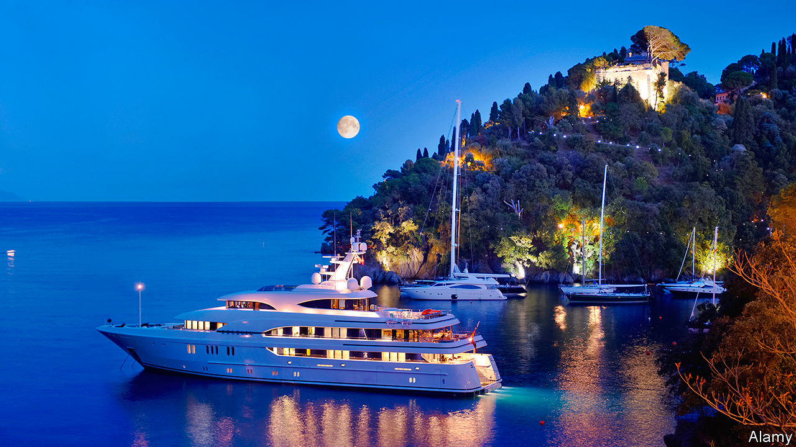

AH, ITALY! “The school as well as the playground of the world,” as one of E.M. Forster’s characters described it: cities packed with the greatest Western art and architecture, ravishing landscapes, delicious food and a sunny climate. What a place to live—but for the tax, levied at 23% from the first euro earned and at progressively higher rates up to 43% on income over €75,000 ($89,000).

But a small number of very rich people—ultra-high-net-worth individuals, in the jargon of private offices and estate agents—are living the Italian dream while paying what, for them, are modest taxes. Several hundred belong to a scheme in which they pay an annual €100,000, plus €25,000 for each member of their family. The flat rates, which apply only to non-Italian income, are valid for 15 years. After that, unless the programme is renewed, its beneficiaries will become subject to Italy’s normal regime. Cristiano Ronaldo, a Portuguese football star, is said to be among those who have made use of the scheme. In 2018, the year after it came into force, he surprised the footballing world by transferring to an Italian side, Juventus.

Introduced by Matteo Renzi’s centre-left administration, the programme is one of several southern European ploys to lure wealthy foreigners. Some have proved intensely controversial. On October 20th, the European Commission opened infringement procedures against Cyprus and Malta over their investor citizenship schemes, after two Cypriot parliamentarians were filmed agreeing to the issue of a passport for a fictitious Chinese person with a money-laundering conviction.

Last year Greece brought in a scheme which, like Italy’s, involves a €100,000 flat tax, but requires applicants to invest €500,000 in Greek assets and spend half the year in the country. Portugal cast its net wider with a ten-year tax holiday on foreign-sourced income aimed at luring retired people. But after protests from some in the EU the government tightened the rules this year, making the unearned income of new arrivals subject to a 10% levy.

Italy also runs programmes for the less well-heeled: incentives to lure back highly qualified Italian expatriates and a 7% tax over six years on the pension and investment income of foreigners who settle in the poorer south of the country in towns of fewer than 20,000 inhabitants.

“The flat-tax scheme is not just an isolated measure, but part of a trend,” says Giulia Cipollini of Withers Studio Legale, a law firm in Milan. In 2019 Italy approved 421 flat-tax applications, against 264 the previous year. “Britain is the jurisdiction from which the largest number of people have relocated,” she says.

Some are Britons fleeing Brexit. Others are citizens of third countries who had been enrolled in Britain’s “non-dom” scheme. Savouring an insalata caprese in a posh restaurant in rural Tuscany, a French citizen cited one of the Italian scheme’s lesser-known provisions: exemption from gift and inheritance taxes. “That, for most of us, is the reason for switching,” he says.

Whether he and others like him will benefit Italy in the long run will depend on how much of their wealth trickles down to the rest of the population. But they are already having an effect: booking private jets for long weekends in Sicily, mooring their super-yachts in Italian marinas, restoring Florentine palazzi to their former glory and hosting inspirational events for young entrepreneurs. As an Italian proverb has it, amor fa molto; il denaro fa tutto—love does much; money does everything. ■

This article was downloaded by calibre from <https://www.economist.com/europe/2020/10/31/a-flat-tax-scheme-is-luring-the-wealthy-to-italy>

|  |  |  |  |
| --- | --- | --- | --- |
| Previous | Articles | Sections | Next |

|  |  |  |  |
| --- | --- | --- | --- |
| Previous | Articles | Sections | Next |

#### Terminal ferocity

# Poland’s abortion rules are now among the strictest in any rich country

A court dominated by the ruling party bans abortions in cases of severe foetal defects

Oct 31st 2020 | WARSAW

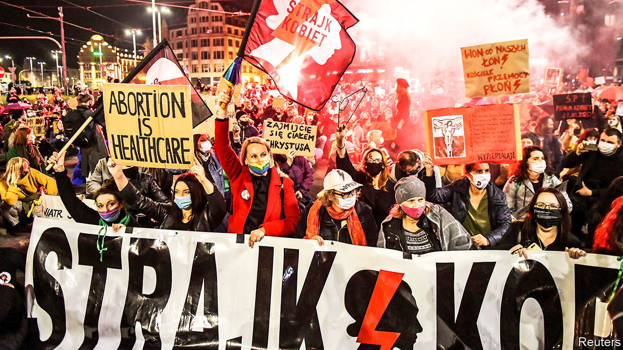

THE LAW AND JUSTICE (PiS) party that has governed Poland since 2015 has firm ideas about how it wants people to live. It champions the traditional family and paints gay people as a threat. Now the country’s restrictions on abortion, already among the tightest Europe, are about to become tighter. In a ruling on October 22nd the PiS-controlled Constitutional Tribunal said that women would no longer be able to cite severe foetal defects as a reason for having an abortion.

Abortion is already banned in Poland. Until now there were three exceptions: when the mother’s life is in danger, in cases of rape or incest, and in cases of severe and irreversible foetal defects. Almost all the 1,000 or so abortions a year performed legally in Poland fall into the third category. In other cases, many women go abroad, often to neighbouring Germany, where terminations are much easier to obtain.

Social conservatives and the Catholic church have long called for Poland’s current rules, in place since 1993, to be made stricter. Jaroslaw Kaczynski, PiS’s veteran leader, said in 2016 that the party would “strive to ensure that even very difficult pregnancies, when the child is condemned to death, is severely deformed, will end in birth, so that the child can be christened, buried, given a name”. However, a bill that year tightening the ban was shelved after it sparked unexpectedly large protests.

The new ruling follows a request last year by lawmakers (mostly from PiS) for the Constitutional Tribunal—of which PiS in effect took control shortly after coming to power in 2015, triggering a protracted dispute with the European Commission over the rule of law—to rule on whether abortion in cases of foetal defects is compatible with the Polish constitution. It will take effect as soon as it is published. Hospitals are unsure how to proceed; one in Warsaw has already advised doctors to stop terminating pregnancies where there is a high probability of severe foetal defects.

The verdict triggered women’s protests across Poland, which continued into this week. Polls suggest little support for the change: in one from 2018, 70% of respondents were against banning abortion in cases of foetal defects (even among PiS voters, the figure was 40%). The decision drew criticism not only for its substance but also for the way it was reached. Adam Bodnar, the country’s commissioner for human rights, suggests that rules about abortion should be made by parliament, potentially with the involvement of a citizens’ assembly modelled on one in Ireland that recommended legalising the procedure.

For Mr Kaczynski, the timing of the verdict is convenient. It offers a distraction from the mounting number of coronavirus cases in Poland (over 18,000 new ones were announced on October 28th) and from the recent crisis in the PiS-led governing coalition. Yet already some politicians in the ruling camp are calling for the restrictions in the ruling to be softened. As Jaroslaw Gowin, another deputy prime minister and the leader of the more moderate of PiS’s two junior coalition partners, put it: “The law must uphold values. But the law cannot force women to be heroic.” ■

This article was downloaded by calibre from <https://www.economist.com/europe/2020/10/31/polands-abortion-rules-are-now-among-the-strictest-in-any-rich-country>

|  |  |  |  |
| --- | --- | --- | --- |
| Previous | Articles | Sections | Next |

|  |  |  |  |
| --- | --- | --- | --- |
| Previous | Articles | Sections | Next |

#### Baby Zog

# A future queen of Albania?

A Ruritanian royal family hasn’t quite given up hope of regaining a throne

Oct 31st 2020 |

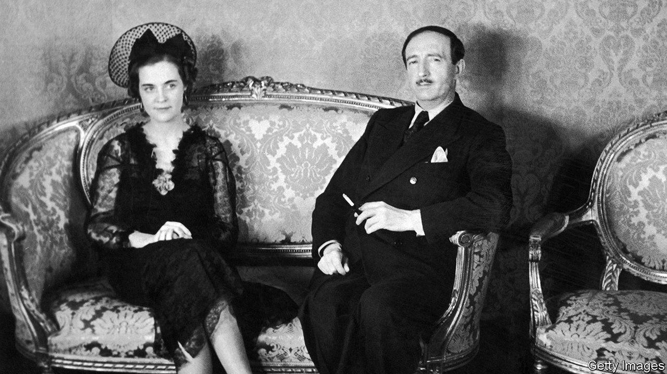

ON OCTOBER 22ND Albania’s royal family was “delighted to announce” the birth of Princess Geraldine. The happy parents are Leka Anwar Zog Reza Baudouin Msiziwe Zogu, or more simply Prince Leka II, who claims the throne, and his wife Princess Elia, an actress. Could the baby one day be queen?

In 1997 Albania was the only former communist state to hold a referendum on restoring a monarchy. A third of voters were in favour. Prince Leka’s father, the self-proclaimed Leka I, who was let back into his homeland in 1993, marched on the electoral commission in Tirana, the capital, to complain of fraud. A man was killed in an ensuing gun battle.

The longest-serving ruler of the state that emerged after centuries of Ottoman Turkish rule was an exceptionally vicious communist, Enver Hoxha, who reigned from the end of the second world war until his death in 1985. But in the interwar years it was Ahmed Zogu, a tribal chieftain, who ran the show. Rising from minister of interior to president, he had himself declared king in 1928. But Mussolini’s Italians invaded in 1939 and chased him out. He died in France in 1961.

King Zog was a rough-hewn moderniser. Some Albanians hark back to his time with nostalgic sentimentality. Tirana, the capital, has a statue of Zog and a Zog Boulevard. But Zog’s son Leka, the current claimant’s late father, though as tall as a basketball player, was less impressive. Born to a half-Hungarian half-American aristocrat (also called Geraldine) a few days before Zog’s flight, he was brought up in England, Egypt and Switzerland. He resided—among other places—in Spain, the then Rhodesia, and South Africa, and married an Australian divorcee. Fascinated by guns, he tirelessly hankered after a royal restoration. In 1979 he was expelled from Spain for flouting arms regulations. His only son was born in South Africa. In 2002 Albania’s post-communist parliament invited the family home, granting them privileges that included diplomatic passports.

Erion Veliaj, Tirana’s mayor, says Leka is “too nice” for Albania’s rough-and-tumble politics. Asked if he would like to be king, the prince says coyly in a lilting South African accent that he “would like to serve in any way that is possible”. In the “theoretical” case of a restoration it would be “very possible”, he says, to imagine the latest Geraldine being crowned Queen of the Albanians.

This article was downloaded by calibre from <https://www.economist.com/europe/2020/10/31/a-future-queen-of-albania>

|  |  |  |  |
| --- | --- | --- | --- |
| Previous | Articles | Sections | Next |

|  |  |  |  |
| --- | --- | --- | --- |
| Previous | Articles | Sections | Next |

#### The wheel turns

# The fighting in Nagorno-Karabakh reflects decades of conflict

The Azerbaijanis are making big gains, but Armenia won’t give up

Oct 29th 2020 | BAKU

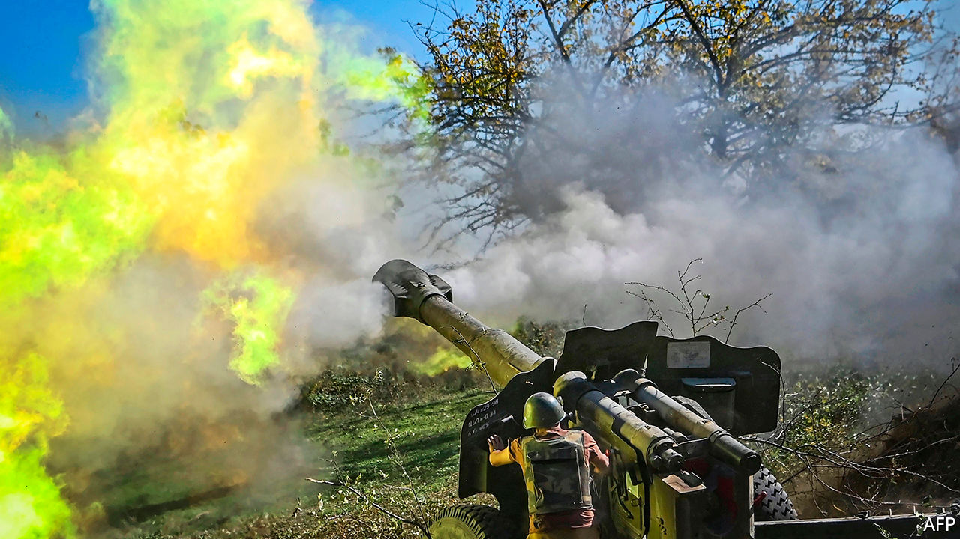

IN A COURTYARD of half a dozen identical apartment blocks in Sumgait, a charmless industrial town near Azerbaijan’s capital, Baku, a group of teenage boys are congregating around Elshan, who is recording a YouTube video. Adopting a “radio voice”, he proclaims the names of villages “liberated” by Azerbaijan’s “glorious army” around Nagorno-Karabakh, an ethnic Armenian enclave inside Azerbaijan that is at the heart of a long and deadly conflict on the edge of Europe. Like most of the residents of the compound, Elshan’s family are refugees displaced from their home in Gubadli, one of the seven districts adjacent to Nagorno-Karabakh that were captured by Armenians during a war in the early 1990s.

It was the first ethnic conflict to accompany the break-up of the Soviet empire. But Elshan and the boys, born after that war ended in an uneasy truce, know little about the Soviet Union. Nor were they ever told that the descent into war began with a horrific pogrom of ethnic Armenians in Sumgait in 1988. What the boys do know is that four years later Armenian militias staged the biggest massacre of that war outside the village of Khojali, within the enclave. The Azerbaijanis say 600 of their kin were murdered. Although the boys have never seen an Armenian in their lives, the talk in their homes is of trauma, hatred and a longing for home. “Armenians are not people,” the adults say. “We cannot live together...They must leave our land...We did nothing wrong.”

Two hours after Elshan has made his video, an announcement comes on Twitter from Azerbaijan’s President Ilham Aliyev: the army has “liberated” three villages in Gubadli district. The compound, along with the rest of Sumgait, erupts in jubilation. People pour out onto the streets dancing and waving the flags of Azerbaijan and its main ally, Turkey. A member of Sumgait’s local council delivers a message to a TV camera: “We are no longer the refugees.”

For a quarter of a century they have been waiting for this moment, since Azerbaijan, an oil-rich country of 10m people, lost the war to Armenia, a poorer and smaller neighbour. At the time Azerbaijan was in a state of turmoil, while Armenia had a better army and received stronger backing from Russia. The war ended in a ceasefire that left Azerbaijan with a loss of territory and pride. “We came back from that war with a sense of deep humiliation,” says Azad Isazade, who fought in that conflict and later served as a spokesman for Azerbaijan’s army. “We failed to defend our land, our children and our mothers.” Back then, he was obliged to announce the loss of Shusha, the citadel of Azeri culture and the highest major town in the Nagorno-Karabakh region. “Azerbaijan’s newsreaders refused to announce it on television news,” he says. Now all the talk is of “taking Shusha back”.

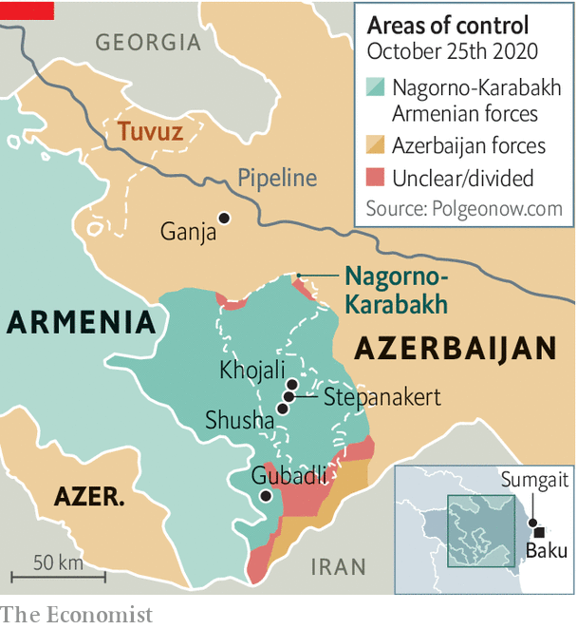

This surge of national confidence is partly the result of an oil and gas bonanza that has fuelled Azerbaijan’s economic growth and paid for vast military spending over the past two decades. Yet while Azerbaijan has gained in strength, its failure to recover land around Nagorno-Karabakh which mediators have said since the mid-1990s should be restored to it has fostered deep frustration.

The trigger for the current all-out offensive occurred in July, when Armenia and Azerbaijan clashed over the border in Tuvuz, more than a hundred miles away from Nagorno-Karabakh but close to a pipeline that carries oil from Azerbaijan to Turkey via Georgia. An Azerbaijani general was killed. Russia began to reinforce Armenian positions, bringing up a mass of military cargo. Turkey sent military planners, troops and jets for a joint drill with Azerbaijan. (Azeris are ethnically close to Turks.)

In Baku tens of thousands took to the streets demanding an end to the lockdown for covid-19—and calling for war. “Commander-in-chief, give us weapons,” they chanted. A small crowd broke into the parliament. Police sprayed tear-gas. Mr Aliyev, an authoritarian leader who inherited his post from his father in 2003, was rattled. If he needed any more excuses to go to war, one was promptly provided by Nikol Pashinyan, Armenia’s populist prime minister, who went to Nagorno-Karabakh to deliver an incendiary message: referring to it by its Armenian name, Artsakh, he called for its unification with Armenia proper. “Artsakh is Armenia, and that’s it,” he declared.

“We came to a logical conclusion that Armenia has no intention of returning the occupied territories or letting the [Azerbaijani] refugees back,” says Hikmet Hajiyev, an adviser to Mr Aliyev. So on September 27th Azerbaijan went to war. “It is not Aliyev’s war. It’s a people’s war,” says Zaur Shiriyev of the International Crisis Group, which seeks to resolve conflicts. “But it could give him lifelong legitimacy.”

Armed with Turkish and Israeli drones, trained to NATO standards by Turkish instructors and fired with nationalist ardour, Azerbaijan’s army has pummelled Armenia’s Russian-made tanks and air-defence systems. Its troops have recaptured chunks of the seven districts, have come within firing-range of the corridor that connects Armenia to Nagorno-Karabakh, and are setting their sights on Shusha. Armenians in the enclave have responded by launching missiles at Azerbaijani towns, the latest one killing 20 civilians in Barda.

What Azerbaijan sees as a war of liberation, Armenians see as one for survival. Two-thirds of the population of Nagorno-Karabakh, some 90,000 people, have fled. “A return to Shusha is essential for restoring Azerbaijan’s sense of justice, but it cannot be achieved by causing injustice to others,” says Mr Shiriyev. Taking Shusha may be a great victory; preventing another spiral of injustice will be harder. But try saying that to the boys in Sumgait. ■

This article was downloaded by calibre from <https://www.economist.com/europe/2020/10/29/the-fighting-in-nagorno-karabakh-reflects-decades-of-conflict>

|  |  |  |  |
| --- | --- | --- | --- |
| Previous | Articles | Sections | Next |

|  |  |  |  |
| --- | --- | --- | --- |
| Previous | Articles | Sections | Next |

#### Charlemagne

# A Biden presidency would offer Emmanuel Macron a tempting opportunity

His Trump-whispering did not work. Can France’s president master Biden-blarneying?

Oct 31st 2020 |

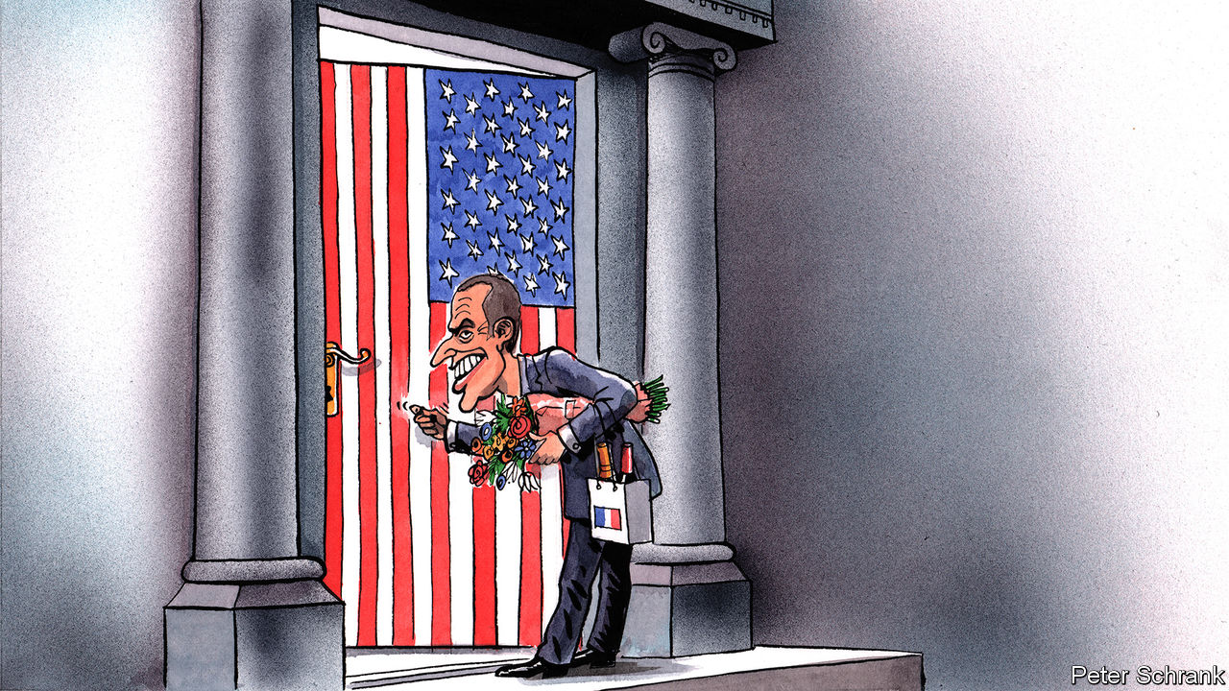

THE SOUND of crunched knuckles was an early alert. There he was, freshly elected and not yet 40, clenching the hand of the leader of the free world with the insouciant confidence of the neophyte. Shortly after his election in 2017, Emmanuel Macron then treated Donald Trump to dinner (up the Eiffel Tower!) and a Bastille Day parade (a military flypast!) as part of a courtship that led some observers to call the French president the “Trump whisperer”. “He’s a great guy…loves holding my hand,” enthused Mr Trump.

In the end, it did not work out so well for Mr Macron. Mr Trump pulled America out of the Paris climate deal, and tore up the nuclear non-proliferation agreement with Iran. Although they still talk regularly, and Mr Macron came tantalisingly close to bringing America and Iran together last year, the pair have clashed over wine, tech, aeroplanes, NATO and more. The American president has proved largely immune to Mr Macron’s charm offensive. If Mr Trump is drawn to a European leader, it is Boris Johnson, whom he once called “Britain Trump”—the highest praise he can imagine.

Yet with the prospect of the Trump years now drawing to a close, a different opening beckons. Mr Macron is nothing if not pragmatic, and should Joe Biden be elected on November 3rd, the French leader could find himself well placed to seize a new opportunity: to establish himself as America’s interlocutor of choice in Europe. The circumstances are favourable. Mr Trump has trampled all over the transatlantic alliance, and left America without a proper working tie to the continent. Brexit has rendered Britain “less useful” to America, in the words of Peter Ricketts, a British former national security adviser. It is also perceived to be less trustworthy. Already Mr Biden, of Irish Catholic stock, has warned Britain not to let the Anglo-Irish agreement become a casualty of Brexit. To be sure, the reflex for a President Biden might well be to turn to Germany instead, not least to fix the damage wrought on that friendship by Mr Trump. As the doyenne of the European Union’s leaders, Angela Merkel would slip effortlessly into the part. But the chancellor is also in her last year in the job. Her successor is unknown, but the choices on offer are not inspiring.

Hence France’s chance. As it happens, Mr Macron has never met Mr Biden—although Barack Obama, just after he left office, called the French candidate before his election to wish him well. For the duration of the campaign, the Biden team has closed the doors to all foreign diplomats, to thwart any future charges of outside interference. But France has some unusually good connections. Antony Blinken, Mr Biden’s top foreign-policy adviser, spent his high-school years at a lycée in Paris, the Ecole Jeannine Manuel. He kept up his links, and was selected for the French-American Foundation “young leaders” programme, a few years before a certain Mr Macron was, too. Emmanuel Bonne, Mr Macron’s diplomatic adviser, knows Mr Blinken from his time at the French mission to the United Nations in New York. Mr Bonne’s predecessor at the Elysée, Philippe Etienne, is now France’s man in Washington. He took over from Gérard Araud, an energetic agent of French soft power, outspoken on Twitter and the host of memorable parties at the residence for le tout Washington.

Berlin and Paris would both welcome an America no longer bent on dividing Europe, committed to curbing climate change, reinforcing multilateralism and re-engaging with Iran. What sets France apart from Germany, though, is its ability to project military force. As it is, France relies on American backing for its counter-terrorist operations in the Sahel, and would welcome the engagement of a fellow internationalist. Mr Macron has often been frustrated by a lack of muscular partners—in dealing with Turkey, Libya, or other Mediterranean crises—and has ended up accused of acting unilaterally. Now he faces an ugly campaign of protests from Turkey to Qatar, following his defence of free speech and the right to caricature in response to the beheading of a schoolteacher who had shown pupils caricatures of Muhammad. He needs all the defenders of liberal democracy he can find.

## Lone ranger

“The scene could be set nicely for Macron,” says Benjamin Haddad of the Atlantic Council in Washington. But there are two big caveats, beyond differences over Russia, China or even trade. One is that Mr Biden might not seek to deal with a single dominant leader, let alone one with a taste for showmanship. “Macron could emerge as a favoured interlocutor,” suggests Mr Araud, “but on the condition that he does this with others, and above all with Germany.”

The other is that a President Biden seeking to revive old alliances through existing structures would swiftly come across the new ones that Mr Macron is trying to forge. The world has shifted since the Obama years. The centrepiece of Mr Macron’s geostrategic thinking—his “operating software”, as a presidential adviser puts it—is “European sovereignty”. The organising principle is that Europeans need to do and make more for themselves, including on defence. Its corollary is that Americans would have to accept that Europeans will act more by, and for, themselves.

This puts Mr Macron on a collision course with the instincts of the American defence establishment. As Michel Duclos, a French ex-diplomat, notes in a paper for the Institut Montaigne, a think-tank, the risk is that a Biden administration might default to “a polite practice of consultation in exchange for unequivocal alignment with American positions”. Mr Macron’s case that he has no intention of undermining NATO remains to be made.

If anything, France may need to dampen expectations. Under Mr Obama, Europe was already fading from American sight. Yet Mr Biden would still need allies. And the chance to supplant Britain is an old instinct. A keen student of history, Mr Macron knows that France is America’s oldest ally—and that at a decisive moment for independence, at Yorktown in 1781, it was the Marquis de Lafayette who helped America to defeat the British. ■

Dig deeper:  
Read the [best of our 2020 campaign coverage](https://www.economist.com/us-election-2020) and explore our [election forecasts](https://projects.economist.com/us-2020-forecast/president), then sign up for Checks and Balance, our [weekly newsletter](https://www.economist.com/checksandbalance/) and [podcast](https://play.acast.com/podcasts/2020/01/24/checks-and-balance-our-new-weekly-podcast-on-american-politics) on American politics.

This article was downloaded by calibre from <https://www.economist.com/europe/2020/10/31/a-biden-presidency-would-offer-emmanuel-macron-a-tempting-opportunity>

|  |  |  |  |
| --- | --- | --- | --- |
| Previous | Articles | Sections | Next |

|  |  |  |
| --- | --- | --- |
| Europe | Sections | International |

Britain

Data and governance: How the government lost its nerds

.

Brutalism and beauty: Demolition Derby

.

Grand houses: Brideshead rebooted

.

The Tories and race: Black and blue

.

Prisons: Locked up, locked down

.

|  |  |  |
| --- | --- | --- |
| Europe | Sections | International |

|  |  |  |  |
| --- | --- | --- | --- |
|  | Articles | Sections | Next |

#### Data and governance

# The sad tale of Britain’s Government Digital Service

How the government lost its nerds

Oct 31st 2020 |

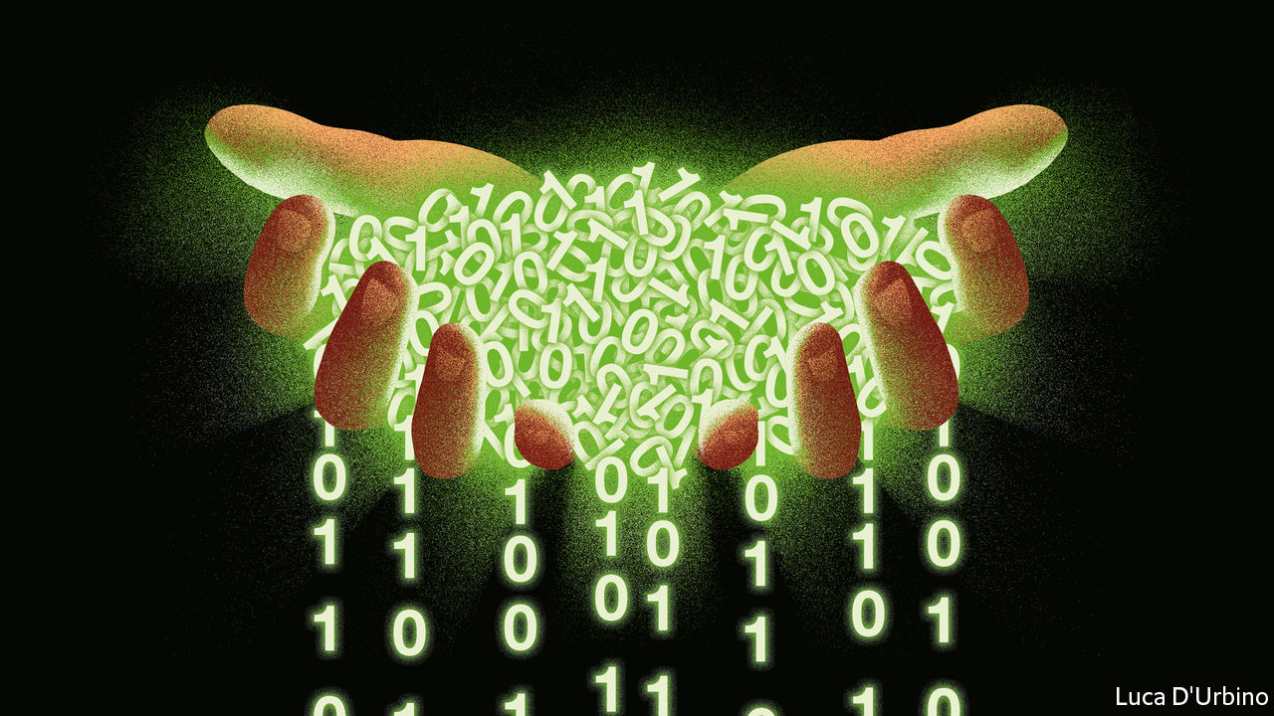

ON NOVEMBER 18th 2015 Barack Obama wrote to Mike Bracken, the boss of the Government Digital Service (GDS), a small part of the Cabinet Office, thanking Mr Bracken for his help in the development of the United States Digital Service, which had been modelled on the GDS. The work that Mr Bracken and GDS had done was “outstanding”, Mr Obama wrote, adding that he trusted Mr Bracken took “pride in the difference you have made thus far”. The following year, Britain rose to the top of the United Nations e-Government Development Index, a measure of how well countries are using information technologies to deliver services.

Four years later, the British government’s reputation as a data manager is not quite what it was. It has slipped to seventh place in the UN league, and there have been mishaps at home. A £495m recruitment system for the army did not work well. An effort to develop a customised contact tracing app for covid-19, ignoring the resources provided by the mobile-phone operating-systems makers, Apple and Google, had to be shut down over the summer. Worst of all, it emerged earlier this month that part of the digital infrastructure for the test-and-trace system, which shuttled data between labs and teams of contact tracers, was relying on—and misusing—Excel spreadsheets. As a consequence of the limitations of that software, not designed for use of this sort, 15,841 positive cases had not been passed on for contact tracing. The system is still struggling to keep up with the rising number of cases. In mid-October, it managed to contact only 80% of those who tested positive, and reached only 60% of their identified contacts.

Managing this sort of data is just what the GDS was created to help the government with. So what went wrong?

Founded in 2010 by Francis (now Lord) Maude at the suggestion of Martha Lane Fox, the government’s “digital champion”, GDS made life easier for citizens in myriad small ways. It enabled Britons to use straightforward, cleanly designed websites to register to vote, pay car tax, sign up for benefits or register for lasting power of attorney. The software written to facilitate this was published under open-source licences, meaning it could be freely reused not just across the British state, but by any government. Other techy democracies like New Zealand and Israel copied the code.

GDS’s early work mostly involved the peripheries of government, but by 2015 it was flushed with success, and dreaming bigger dreams. It wanted to start writing software that could be shared across departments to perform common functions. In the old system, departments had their own HR functions, for instance, running on large, expensive IT systems and reporting to the department’s permanent secretary. Instead, GDS wanted departments to use simple, cheap code to build systems which reported to central government. The concept, which GDS called government-as-a-platform, was that since citizens do not care which department their services come from, just that they work well, the organisational structures ought to reflect that in pursuit of efficient delivery.

## The decline

One important vehicle for GDS’s ambitions was a piece of software called Submit. It was designed, says Mr Bracken, so that “anyone in government could create an online tool in three clicks to send or receive information”. One of its main purposes was to replace shoddy data-management practices. Instead of emailed attachments and forms, different parts of government could send each other data using secure web pages designed for the job.

Submit needed a departmental sponsor, but it never got one. The GDS was not popular with permanent secretaries, the bosses of departments, on whose fiefs it trampled. GDS employees—referred to as “blue-jean kids” by one permanent secretary—would agree on a project with a department, only to find that the department launched its own version of the service soon afterwards. GDS was empowered to restructure the procurement of IT systems across government, relying on its staffers’ technical nous to put better standards in place, but often departments would ignore its advice and buy whatever big, expensive systems they wanted.

Permanent secretaries lobbied the government to deprive GDS of powers over spending and standards of service, arguing that such matters should be under their control. Two attempts were made to persuade David Cameron, then prime minister, to remove Lord Maude.

It was understandable that permanent secretaries should have been hostile to the GDs, for it undermined their autonomy. It also tended, says a civil servant who worked with it at the time, to oversimplify the complex tasks departments have to perform, and its web-only approach terrified ministries that depended on reliable mainframes.

After the 2015 election Lord Maude was replaced by Matt Hancock, now health secretary, and the GDS lost the political backing which was crucial to its ability to work across departmental boundaries. Mr Bracken, who is now a partner at Public Digital, a consultancy, left his job as GDS’s boss soon after. Lord Maude, who has left politics and is now a consultant, says GDS has been “hollowed out” since 2015.

There are still bright spots in Britain’s digital governance. The system which runs universal credit, the main out-of-work benefit, rebuilt by a team led by GDS coders after its initial deployment ended in failure in 2013, has performed well under stress. Notify, a GDS service which makes it easy for any government body to send emails, letters and texts to citizens, has sent 1.88bn messages from thousands of government bodies since it was launched in 2017. There is also widespread praise for the work of the Treasury, which GDS barely touched, and which has managed to distribute money to small businesses across Britain relatively seamlessly, supporting an economy wracked by covid-19.

Now there is new impetus behind the work of centralising and digitising the machinery of government, for it has political backing from Dominic Cummings, Boris Johnson’s chief adviser. The sidelining of GDS lends support to his belief in the civil service’s lethal effect on innovation.

Mr Cummings has established a data-policy unit in Number 10. A dashboard which GDS created to measure the digital performance of different departments died in 2017; Mr Cummings wants to get performance data flowing from departments to central government again. He has told departments that they must embed analytics software into their online services, and funnel those data into GDS, so it can see how services are working.

There have already been standoffs between Mr Cummings and senior civil servants over these data flows, and the control they threaten to wrest from powerful hands. It is a sign that the nerds, sidelined for half a decade, are elbowing their way back to the centre.■

This article was downloaded by calibre from <https://www.economist.com/britain/2020/10/31/the-sad-tale-of-britains-government-digital-service>

|  |  |  |  |
| --- | --- | --- | --- |
|  | Articles | Sections | Next |

|  |  |  |  |
| --- | --- | --- | --- |
| Previous | Articles | Sections | Next |

#### Architecture

# Derby Assembly Rooms and the brutalism battle

Tory notions of beauty do not, by and large, encompass the architectural style

Oct 31st 2020 |

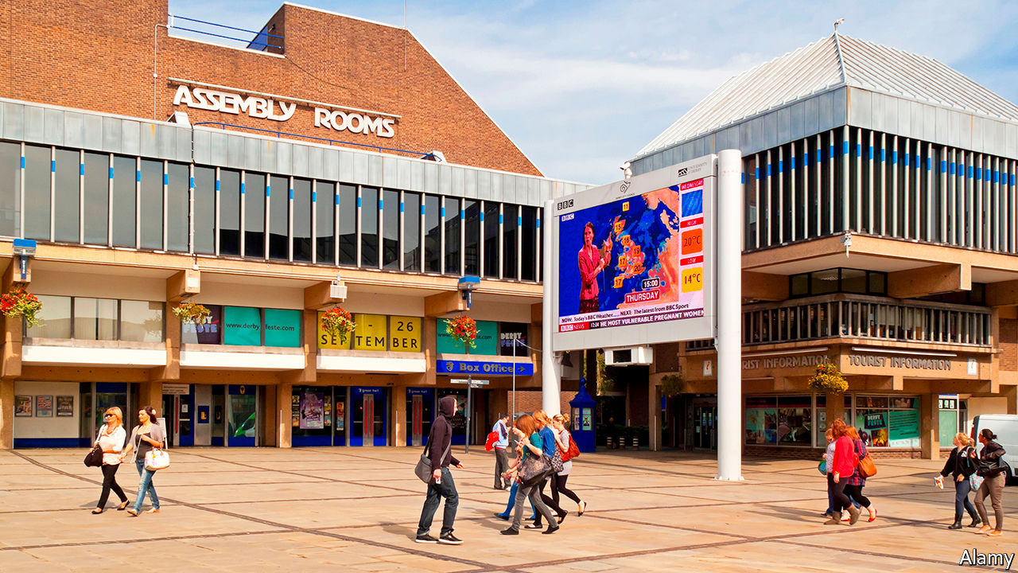

DERBY BUILT the RB211 jet engines, which made Rolls-Royce a global leader in the aerospace industry, and the Advanced Passenger Train, which set a railway speed record of 152.3 miles per hour in 1975. Given the city’s futuristic bent, it seemed appropriate to replace an 18th-century leisure hall that burned down in 1963 with a sleek concrete structure designed by Hugh Casson, then Britain’s foremost architect.

Time has not been kind to the Assembly Rooms, which opened in 1977. The building, a venue for concerts and graduation ceremonies, has sat empty since it was damaged by fire in 2014. The problem is not just that Tory-led Derby City Council is unwilling to foot the £34m ($44m) repair bill; it is that, like many buildings of its era, the Assembly Rooms are unloved. They are “far too big for a Georgian marketplace”, according to a guidebook, “and entirely without grace”. The council agrees, and this month published plans to replace them with green space and a pop-up market.

Many brutalist edifices have been torn down in the past decade, among them Robin Hood Gardens, a London housing estate, and Birmingham Central Library. It is a trend that may soon accelerate. In a recent white paper, the government outlined plans to make it easier for developers to flatten buildings. On October 6th at the Conservative Party conference, Robert Jenrick, the housing secretary, said: “there’s going to be a big opportunity to demolish some of the mistakes of the recent past because you do see quite a lot of empty derelict buildings in town and city centres that were put up, often poorly constructed not within the character of those places, particularly in market towns in the 60s and 70s.”

Beautification is part of the government’s plan to improve morale in depressed places, and Tory notions of beauty do not, by and large, encompass brutalism—a style associated with socialism and Europeans. Conservatives and their traditionalist bedfellows think they have the public on their side. In a poll conducted by Policy Exchange, a right-wing think-tank, in 2018, 85% of respondents said new homes should either fit in with their more traditional surroundings or be identical to homes already there. “It’s true that the 20th century birthed us with a huge range of architectural creativity,” says Ben Southwood, head of housing at Policy Exchange. “But a lot of it is unpopular.”

Brutalism’s friends do not mind being in a minority; indeed, that may be part of the appeal. The style has become fashionable with fastidious types in their 20s, who spend their lunch breaks ogling listings for concrete-clad flats. The Twentieth Century Society (C20), a charity which campaigns for the preservation of post-1914 buildings, criticises Historic England, an official watchdog, for failing to protect modern sites. “We are constantly fighting a battle against people’s preconceived notions that architecture from that period isn’t any good,” says Catherine Croft, C20’s director. Ben Derbyshire, an architect, hears C20’s argument. “The lesson of history”, he says, “is that successive generations are too careless of their immediate heritage, so that it’s important for those in positions of power and influence to heed expert advice capable of distinguishing fashion from quality.”

Derby’s civic society wants the Assembly Rooms to be listed. It is a cause that has even won over sceptics. Maxwell Craven, the civic society’s caseworker and author of the local guidebook, detests brutalist architecture. But he thinks the council, which says it is developing plans for the site’s long-term regeneration, will inevitably build “something much more deleterious to what was originally a medieval marketplace.” Higher-ups at Historic England are also sympathetic to the building’s cause, meaning there is still hope for it. Yet they will not offer protection to every 1970s edifice campaigners want to save. If Mr Jenrick gets his way, Britain’s bulldozers will be busy. ■

Editor's note: This article has been amended to make clear that Ben Derbyshire was not speaking for Historic England.

This article was downloaded by calibre from <https://www.economist.com/britain/2020/10/31/derby-assembly-rooms-and-the-brutalism-battle>

|  |  |  |  |
| --- | --- | --- | --- |
| Previous | Articles | Sections | Next |

|  |  |  |  |
| --- | --- | --- | --- |
| Previous | Articles | Sections | Next |

#### Brideshead rebooted

# Britain’s stately-home boom

In today’s new grand houses, the kitchens have views

Oct 31st 2020 |

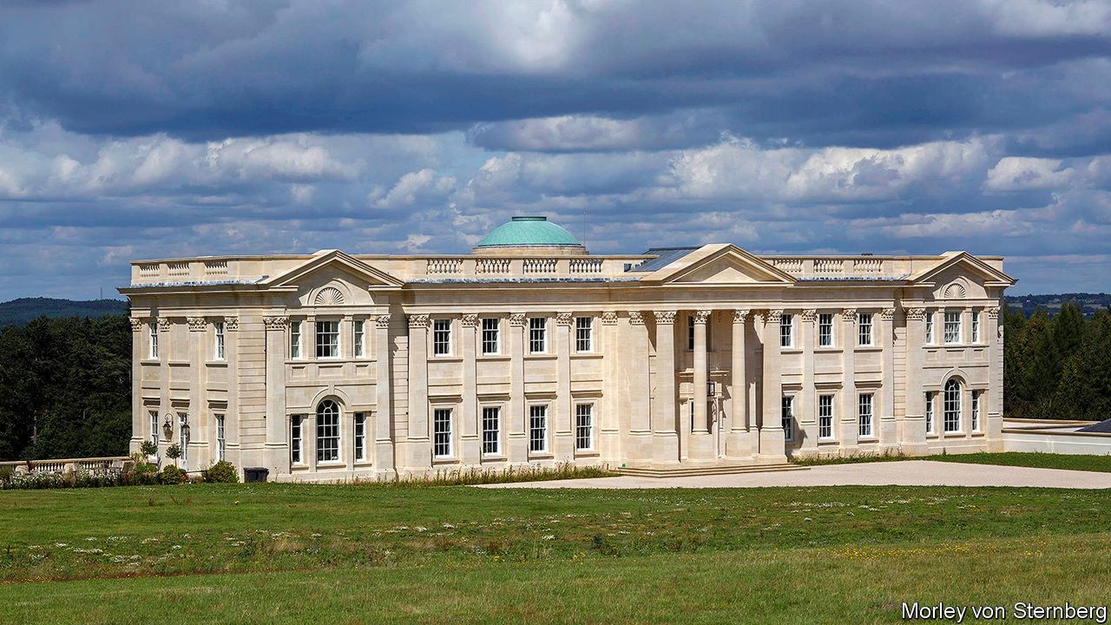

THE TITLE of the exhibition at the Victoria and Albert Museum in 1974 was definitive: “The Destruction of the Country House, 1875-1975”. A gallery was lined with pictures of some of the 1,200 mansions that had been demolished in a century—victims of urbanisation, tax and neglect. One thing was clear: never again would the ruling elite build piles like Trentham, which the Shah of Persia told the future king Edward VII should cost its owner, the Duke of Sutherland, his head on the grounds that it was “too grand for a subject”.

That obituary now requires an epilogue. Stonemasons’ chisels are once again chipping away at the top of long driveways as a new generation of monied Britons commissions its own stately homes. Rebounding demand has prompted a steady supply of architects for whom being a classicist is no longer shameful. “Back in the 1980s if you wanted to build a good-looking classical building…there were about two or three architects in the country who could do that,” says George Saumarez Smith, an architect. “Now there are lots.”

Just as the status symbols of old were often built for that generation’s nouveaux riches, so are today’s new-builds. “The peak of a lot of people’s ambition is to have a country house, and that applies not just to British people, but to people coming to Britain,” says Robert Adam, a classical architect who designed Lea House in Surrey (pictured), is currently building two country houses and has three more on order. His clients include self-made financiers, celebrities and Russians.

Steve Gibson, a welder’s son who made money in logistics and now owns Middlesbrough Football Club, is typical of the new breed. His home in North Yorkshire will be the county’s largest house for 200 years. Christopher Boyle, a lawyer who helps newcomers obtain planning permission, likens them to “the nabobs of the 18th century”, who were keen to show off the riches of empire. They are, he says, “people of extremely fine taste, who have found themselves by good fortune to have lots of cash.”

The paucity of ancient piles on the market, and the hefty heating bills and musty smells they come with, make building from scratch a good option. The new houses’ architecture usually offers more than a nod to that of their forebears. Brutalism is not a style much favoured. Mr Adam likes to lay out several plans for his clients, but “they almost always choose the Palladian one.” Some people regard such houses as mere pastiches, but they are not carbon copies. For instance, whereas previous generations hid their kitchens at the back of the house or below stairs, today’s lords of the manor like to cook and, according to Mr Saumarez Smith, “want the kitchen in the best part of the house, where they will enjoy good views.”

And though such grand designs could hardly be described as modest, their owners still claim to be. “Normally the first thing clients say is ‘we are just an ordinary family and we just want a nice house,’” says Mr Saumarez Smith.■

This article was downloaded by calibre from <https://www.economist.com/britain/2020/10/31/britains-stately-home-boom>

|  |  |  |  |
| --- | --- | --- | --- |
| Previous | Articles | Sections | Next |

|  |  |  |  |
| --- | --- | --- | --- |
| Previous | Articles | Sections | Next |

#### Politics

# The Conservative Party’s changing stance on race

A more diverse party is taking a more assertive line

Oct 31st 2020 |

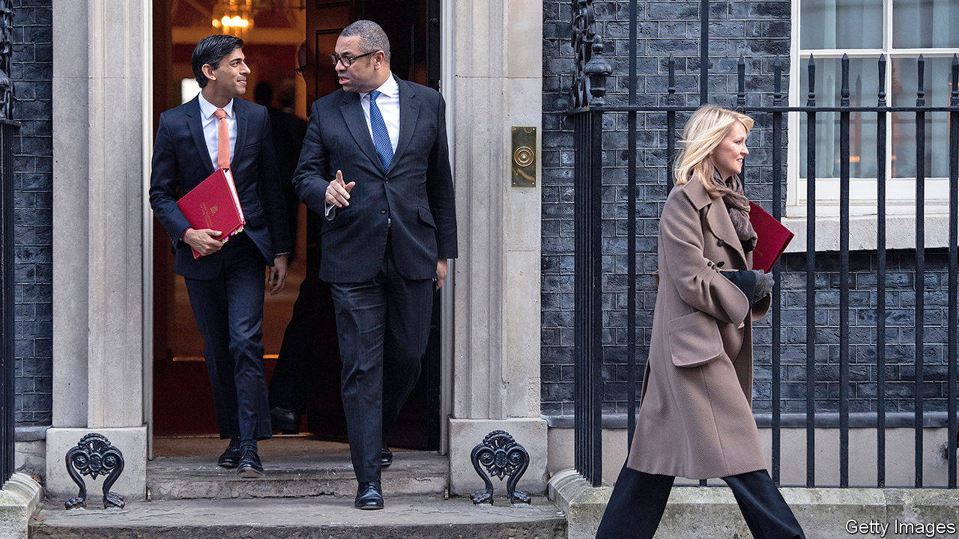

ACCORDING TO HANSARD, the official parliamentary record, the term “critical race theory” had not been uttered in the House of Commons before October 20th. The discipline, which holds racism as a pervasive condition rather than merely as hateful conduct, emerged in American academia in the 1980s, and crossed the Atlantic two decades later. It uses the concept of “white supremacy” to refer not just to hooded Klansmen, but to the everyday advantages afforded to white people. It has shaped the thinking of many in the Black Lives Matter (BLM) movement. Yet it had not much stirred the Conservative Party until Kemi Badenoch, a Treasury minister who also speaks for the government on equalities issues, declared the government to be “unequivocally against critical race theory”, calling it “an ideology that sees my blackness as a victimhood and their whiteness as an oppression”.

Mrs Badenoch’s remarks in a debate on Black History Month, an annual observance marked in Britain since 1987, are evidence of a change in the Conservative Party that has accelerated since the last election. There were just two ethnic-minority Tory MPs when David Cameron became leader in 2005. He sought to fix that by parachuting high-flying ethnic-minority candidates into target seats. There are now 22 non-white Tory MPs out of 365, and 65 altogether in the Commons. (If Parliament reflected Britain’s ethnic make-up, there would be 85.) Boris Johnson’s successor may well be non-white. The family of the chancellor, Rishi Sunak, is from India; the parents of Priti Patel, the home secretary, were Ugandan Asians. Mrs Badenoch, first elected to the safe Tory seat of Saffron Walden in Essex in 2017, has risen swiftly. James Cleverly, a foreign-office minister, was the first black chairman of the Conservative Party.

Superficially, the Conservative and Labour parties talk about race in similar terms. Both celebrate Britain’s increased diversity, take pride in their non-white lawmakers and mark Black History Month. Britain’s model of multiculturalism is no longer contested by any serious politician. Labour heavily outpolls the Tories among non-white voters overall, but this masks broad gaps between groups: black voters are likelier than Indians or Chinese to describe the Tory party as racist.

Yet there are deep differences in the views of MPs from the two parties (see chart). That was evident in the debate on October 20th. Tory speakers emphasised meritocracy and the individual; Labour, what Marsha de Cordova, Mrs Badenoch’s opposite number, called “a systemic problem [which] requires systemic solutions”. Tory speakers said Black History Month should be part of a diverse island story, celebrating the role of black soldiers in British victories. Labour speakers stressed black political struggles and Britain’s complicity in slavery as much as its role in ending it. Labour MPs accused Conservative ones of naivety and evasiveness about inequality; Tories accused Labour of fostering division and grievance.

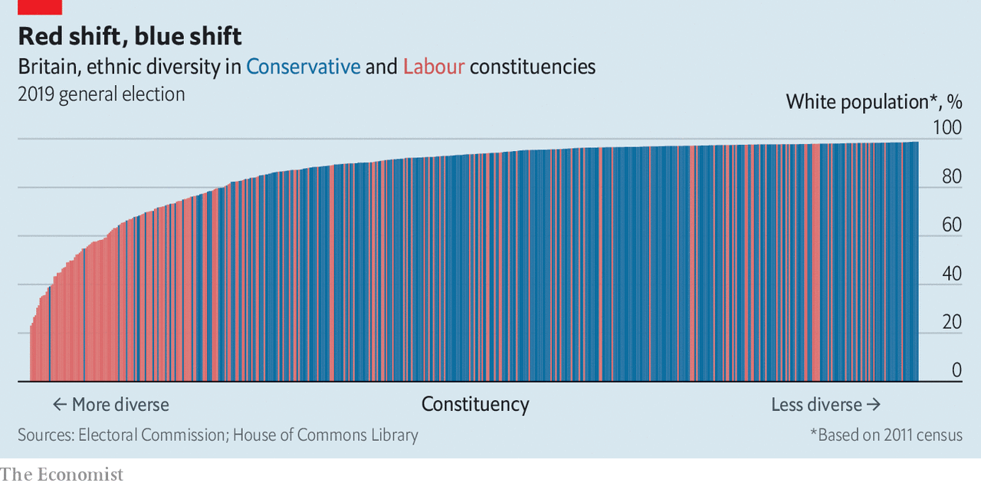

During Mr Cameron’s tenure, the Conservative Party would have hewed closer to Labour’s line in such debates, reckon some black Tories. But the emergence of a “critical mass” of non-white lawmakers has given it the confidence to develop a distinctively conservative line.“We are no longer willing to be pushed around on this by Labour,” says one. Sunder Katwala, director of British Future, a think-tank which specialises in integration, says there’s a new “partisan spikiness” to the debate. Munira Mirza, head of the Number 10 policy unit, is dubious of the concept of “institutional racism”, a mainstay of British policymaking since the 1990s. She accused Theresa May, Mr Johnson’s predecessor, of appeasing a “culture of grievance”.

A second factor is America’s race debate, which has sharpened the parties’ long-held views. Some Labour MPs embrace the global span of the BLM movement. Mrs Badenoch, by contrast, who spent much of her childhood in Nigeria, argues that “an imported, Americanised narrative of slavery, segregation and Jim Crow” would displace Britain’s distinct black history. BLM, she says, is a “political” organisation whose protesters used racial slurs towards cops. Tom Hunt, a young Tory MP, accuses its leaders of promoting “cultural Marxism” and “the abolition of the nuclear family.”

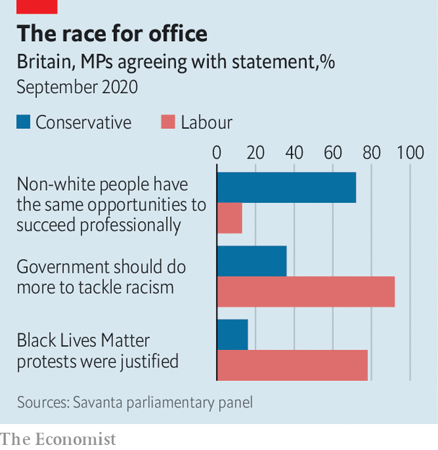

The third factor is the changing composition of the Tory electorate. Labour does well in ethnically diverse seats, Tories in whiter ones (see chart), and the gap is growing. In the 2019 election, the Tories took control of a clutch of Labour’s whitest seats in northern England, including former industrial towns such as Redcar, Blyth Valley, Workington and Sedgefield, whose populations were recorded as more than 98% white in the 2011 census. Despite the Tories’ diverse officer class, their seats remain on average 93% white, compared with 87% for the country at large. Labour’s northern losses made its seats on average more diverse. They dropped from 78% to 75% white.

Mr Johnson wants to shape his party around the values of his new “red wall” voters. They are not necessarily hostile to BLM, says a Tory insider, but they find its cause irrelevant to their lives and its jargon impenetrable. Mr Johnson has stirred the notion that British traditions are under siege from censorious forces, promising to thwart a (never-credible) threat to topple Winston Churchill’s statue from Parliament Square. Some believe they can use these notions as a wedge to keep Labour, which cannot put much distance between itself and BLM, from winning back northern seats.

Some Tory MPs are keen to dabble in their own variety of identity politics, fusing Labour’s class rhetoric with racial identity. Ben Bradley, Tory MP for Mansfield, claims that equality legislation discriminates against white working-class men. He regards the notion of “white privilege” as ridiculous when white working-class boys struggle academically. Matthew Goodwin, a political scientist influential among the new generation of Tories, argues that “if you’re constantly referring to people not as individuals but members of marginalised and victimised racial groups, then it is inevitable that the white working-class kids are going to see themselves in the same lens.” Mr Bradley intends to boycott workplace unconscious-bias training: he says such schemes are “wildly unpopular with what is now the core Conservative vote”.

Mr Johnson is in power thanks to a coalition of people who want a fiscally responsible government and people who want big increases in public spending. Identity politics may provide temporary glue; but it is dangerous stuff. Hotheads like Mr Bradley may damage the Tories in more diverse seats such as Peterborough and Portsmouth, and not just among ethnic-minority voters. Britons may not like imported academic theories, but if ugly nativism becomes a factor in their politics, they may like that even less. ■

This article was downloaded by calibre from <https://www.economist.com/britain/2020/10/31/the-conservative-partys-changing-stance-on-race>

|  |  |  |  |
| --- | --- | --- | --- |
| Previous | Articles | Sections | Next |

|  |  |  |  |
| --- | --- | --- | --- |
| Previous | Articles | Sections | Next |

#### Criminal justice

# Prison visits in the pandemic

The families of prisoners have paid the price of keeping inmates safe

Oct 29th 2020 |

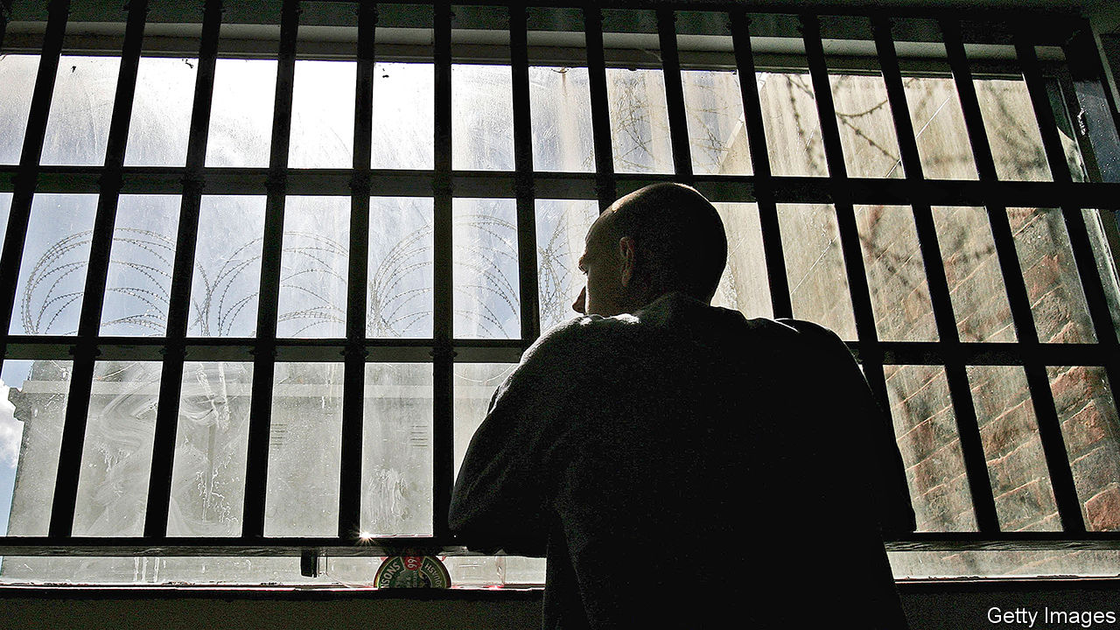

LIFE WAS hardly a doddle for Joanne before covid-19. Her partner has been in prison for two years, so she was bringing up their two little boys—aged two and five—on her own, while trying to hold down a job. But at least they could visit him for one precious hour a week, behind the Victorian gates of HMP Manchester. As the virus began to spread, those gates swung shut, as at all 117 prisons in England and Wales. For half a year, the children did not visit their father at all. They finally squeezed in two visits, but then infections picked up and the ban was reimposed. Her children are growing apart from her partner. “They’re not as close as they used to be,” she says.

As covid-19 leapt around the globe, prisons faced an especially acute version of the familiar trade-off between protection from the virus and broader wellbeing. In Britain, prison-reform charities warned of “loss of life on an unprecedented scale”. Prisoners were reckoned to be especially vulnerable to the virus because they were older and in worse health than the general population. Ministers were spooked by estimates that 2,500-3,500 prisoners could die in English and Welsh jails (out of a total population of about 80,000).

That crisis was averted. Between March and the end of September, covid-19 claimed the lives of 23 inmates, but widespread outbreaks were avoided. That can largely be chalked up to a draconian but effective policy of inmate isolation. Visits were banned on March 24th and activities—like jobs in prison workshops or classes—mostly scrapped. Prisoners stayed in their cells, often for 23 hours a day.

Mark Turnbull of Out There, a charity that supports inmates’ families, says that in the initial stages of the pandemic, his phone was kept busy by relatives worried about how fast the virus might spread in prisons. But the longer covid-19 restrictions went on, the clearer the downside of the trade-off became. Visits resumed over the summer, but have now been banned again at roughly a third of prisons, in areas with the most severe restrictions.

Hardest of all, says Joanne, is not knowing how long it will be before her next visit. “At the start of covid, we said ‘There’s no way on Earth they can stop us seeing each other for more than six weeks’. Then it was seven months.” Her partner calls her on the telephone every day but, confined to his cell, he has “nothing to talk about…There’s no hope for them.” The restrictions will also have a broader social cost. Since strong family ties predict a lower likelihood of re-offending, weakening those bonds could make it harder to get inmates back on the straight and narrow. A government-commissioned report by Michael Farmer, a Tory peer, argued in 2017 that positive interactions between inmates and their families were important in preventing prisoners’ children going on to offend themselves.

In one way, though, the pandemic is bringing prisoners closer to their families. Diane Curry of POPS, another family-support charity, says relatives had been clamouring to have video-calls with prisoners for years. In a matter of months, covid-19 made that happen. Before the pandemic, the prison service had begun a tentative roll-out; now almost every jail has the kit.

Technical glitches abound and the service cannot replace the intimacy of a meeting, but it does offer prisoners a glimpse of normality. “Knowing the nitty-gritty of each other’s lives keeps a relationship going across prison walls,” says Anna Kotova of Birmingham University, who is studying these interactions. “Really small things like ‘I’ve painted that wall’ or ‘Look at the tree you planted, see how it’s growing,’ will help sustain relationships for people serving long sentences.” Inmates may be confined to their cells but—virtually, at least—they can roam farther than ever.■

This article was downloaded by calibre from <https://www.economist.com/britain/2020/10/29/prison-visits-in-the-pandemic>

|  |  |  |  |
| --- | --- | --- | --- |
| Previous | Articles | Sections | Next |

|  |  |  |
| --- | --- | --- |
| Britain | Sections | Business |

International

Birth rates: Baby bust, baby boom

.

|  |  |  |
| --- | --- | --- |
| Britain | Sections | Business |

|  |  |  |  |
| --- | --- | --- | --- |
|  | Articles | Sections | Next |

#### Baby boom, baby bust

# The pandemic may be leading to fewer babies in rich countries

And perhaps more in poor ones

Oct 28th 2020 | NEW YORK, SÃO PAULO AND SINGAPORE



WHEN KAMPALA went into covid-19 lockdown, singletons in the Ugandan capital were looking for “lockdown partners”, says Allan Creed, who works in digital marketing. He and his friends couldn’t get to their local shops to buy contraceptives. Mr Creed has been relying on free condoms doled out by the United Nations Population Fund (UNFPA) via a local motorbike ride-hailing app called SafeBoda. But three of his friends now have unplanned pregnancies in the midst of their university degrees. “We were not moving, we were not working, nothing was happening, so you had a lot of time on your hands,” the 26-year-old explains.

Meanwhile in wealthy Singapore, where contraception is easy to come by, young people who were already reluctant to start a family before the pandemic are even more so during a global recession. The government is trying to coax people into reproducing with a one-off grant of S$3,000 ($2,200) for having a child in the next two years on top of pre-existing payments and savings schemes. For Keith, even that doesn’t make up for the cost of becoming a father. “I know that me and my wife will have a very good time in the next 30, 40 years without kids,” the 36-year-old says. “Do we want to risk that?”

It is too early, by a few months at least, to be sure what the effect of covid-19 will be on fertility rates. But different patterns seem to be emerging in rich and poor countries. Few women want to have a child in a time of uncertainty. In the rich world many are holding off starting a family or adding to it. But in the poorest places, where women often have less choice in the matter, a baby boom may be in the offing. Governments are already trying to adapt. It is not just Singapore trying to boost birth rates. Japan’s new prime minister, Suga Yoshihide, last week called for health insurance to cover in vitro fertility treatment. Japanese government figures showed an 11% fall in new pregnancies in the three months from May relative to last year.

In poor countries mass displacement is adding to sexual activity. In refugee camps, where people rely on informal work that dried up during lockdowns, transactional sex is expected to rise. When India announced an abrupt lockdown in March millions of urban workers lost their jobs and fled to their home villages across the country, and in Nepal, Bangladesh and beyond. They were reunited with lovers they usually see just a few times a year over public holidays. That could be enough to throw off population forecasts, says Vinit Sharma of the UNFPA. “We had not expected so many couples to be together for such a long period of time,” he adds.

More sex doesn’t necessarily mean more babies. But covid-19 has disrupted supply chains for contraception. Poor people rarely buy several months’ worth of contraceptives at once. Even a short break can lead to unwanted pregnancies. Data from health facilities in India show that between December and March the distribution of contraceptive pills and condoms dropped by 15% and 23%, respectively. Insertions of intrauterine devices for long-term birth control also tumbled.

The Guttmacher Institute, a pro-choice think-tank, points out that the strain placed on health-care systems in developing countries by covid-19 is likely to disrupt sexual-health services. It estimates that a fall of 10% in the use of such services in 132 low- and middle-income countries will mean that 50m more women will not get the contraceptives they need this year, leading to 15m unintended pregnancies. It estimates that 28,000 mothers and 170,000 newborns will die, and there will be an extra 3.3m unsafe abortions.

In the rich world, by contrast, women tend to have greater control over family planning. This means that anxiety caused by the pandemic looks likely to cause a sharp decline in birth rates. A survey by the Guttmacher Institute of American women aged 18 to 34 in families earning less than $75,000 found that a third want to get pregnant later or have fewer children because of covid-19 (see chart 1). A paper published by the IZA Institute of Labour Economics predicts a 15% drop in America’s monthly births between November and February, 50% larger than the decline following the 2007-09 financial crisis.

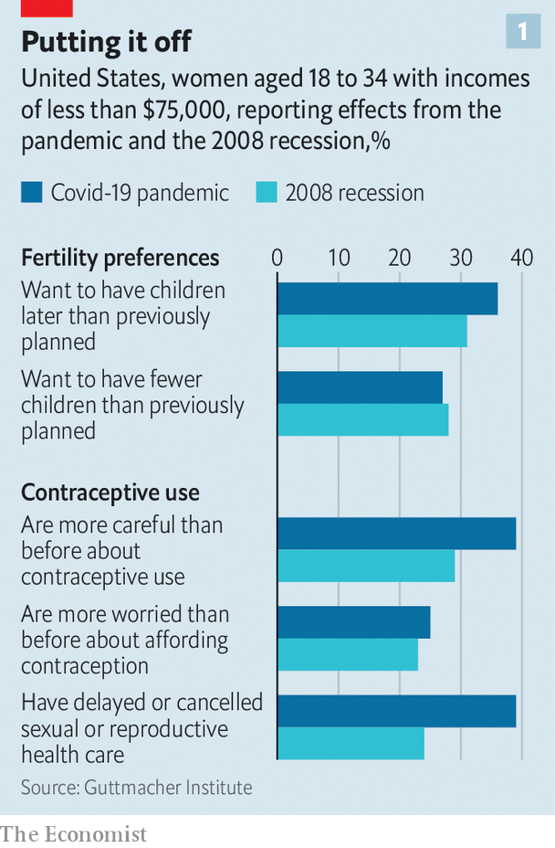

Covid-19 threatens to speed up a decades-old trend towards smaller families in rich countries. In Singapore the fertility rate (ie, the number of children that a woman can expect to have during her lifetime) was 1.14 (far below the replacement rate of 2.1), even before the pandemic. When New York City went into lockdown, many people stopped fertility treatment. Some hospitals did not allow partners into delivery rooms. The prospect of going through birth alone put some women off starting a family, according to Brian Levine, founder and director in New York of CCRM Fertility, a network of fertility clinics in America and Canada. “You’re not going to see a bunch of people being born in December and January because [people] were home and bored and having sex,” he says. “They were home and bored and scared.”

Women are worried about catching covid-19 while pregnant, since medics say it is possible to pass the virus on to an unborn child. Others have found themselves taking on a disproportionate share of housework during the lockdown and can’t face looking after a newborn, too. “It’s not people saying they don’t want kids—it’s them saying they can not and should not,” says Karen Benjamin Guzzo at Bowling Green State University in Ohio.

At Planned Parenthood, the country’s largest provider of abortions and reproductive services, the number of medical abortions has gone up. Gillian Dean, who works in obstetrics and gynaecology for the group in New York, says patients are terminating pregnancies they would have continued in other circumstances. “I’ve had patients who are frontline workers, who are the only people in their homes who are employed, and they feel like they need to do everything they can to not step away from the workforce right now,” Dr Dean says.

Evidence from an outbreak in 2015-16 of Zika, a disease that causes birth defects, suggests covid-19 won’t have a uniform impact across the developing world either. In Brazil, a middle-income country where half of all pregnancies are unintended in normal times, the number of births dropped after Zika hit. This is a sign that many women managed to obtain contraception (or illegal abortions). Births fell furthest in the north-east, where the Zika epidemic struck first and hardest, according to research led by Letícia Marteleto at the University of Texas at Austin. This year, with covid-19, it is black women and other minorities in Brazil who find it hardest to access health care, even after taking account of their poverty.

In May Malu Sícoli, a lawyer in São Paulo, Brazil’s largest city, decided to stop trying for a baby until the pandemic subsided. Days later she found out she was already pregnant. Memories of Zika added to her anxiety about having the child. “The first time I went for a prenatal screening I was sick with nerves,” she says. “I was nervous about being on the street, let alone in a medical clinic, a laboratory, a hospital.”

The big question is how long-lasting the impact on birth rates will be. History suggests the decline in birth rates could be rapidly reversed. Those who conceived unplanned babies during the pandemic might have fewer children later in life. Women in rich countries who put off pregnancy might start trying again once the jitters around covid-19 calm down. Fertility fell after the 2003 Severe Acute Respiratory Syndrome (SARS) outbreak in Hong Kong and Hurricane Katrina in America (see chart 2), but recovered soon after. The 1918 Spanish flu epidemic also led to a baby bust the next year, but birth rates increased again in 1920. The effect held globally, suggesting it was not just the end of war driving the resurgence. Couples were having the babies they put off.

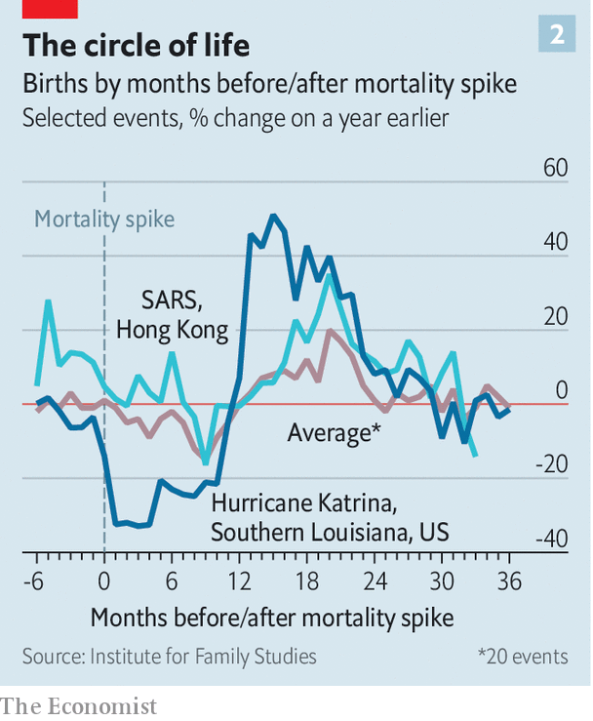

In New York there are already signs that couples are trying for sprogs once again. Edward Nejat, a fertility doctor at Generation Next Fertility in Manhattan, saw a drastic drop-off in patients in March that he puts down to uncertainty. His practice did not close but 95% of his patients chose not to pursue treatment during the first wave. He is now seeing more patients than before the pandemic. “For most people this was a pause,” he says.

But that might not always be possible. In southern Europe the effects of the last economic crisis are still being felt among a generation that reached adulthood then, who have struggled to find stable jobs or buy homes. For those now in their late 30s, biological clocks are ticking, says Francesca Luppi of Università Cattolica del Sacro Cuore in Milan. Recent research by Ms Luppi found 29% of 18- to 34-year-olds in Spain and 37% in Italy who were planning to have a child in 2020 in January had abandoned those plans by March.

Government policy has a role to play here. Besides trying to tackle the pandemic itself, states can seek to ease the economic hardship that covid-19 has caused. They can also subsidise access to contraception, giving women more control of family planning. And they can craft policies for education and child care that make it easier to start a family.

Disasters, like Tolstoy’s unhappy families, are all disastrous in different ways. Comparing covid-19 to past wars, pandemics or natural catastrophes is only so useful. Never before has the world faced such widespread lockdowns for such a long period of time. While people may be more nervous about having children during a crisis, being thrust indoors and banned from mixing with other households might nonetheless make them want them more, suggests Rachel Snow, head of the population and development branch at the UNFPA. “Maybe we’re going to see a new appreciation of family life.” ■

Editor’s note: Some of our covid-19 coverage is free for readers of The Economist Today, our daily [newsletter](https://my.economist.com/user#newsletter). For more stories and our pandemic tracker, see our [hub](https://www.economist.com/news/2020/03/11/the-economists-coverage-of-the-coronavirus)

This article was downloaded by calibre from <https://www.economist.com/international/2020/10/28/the-pandemic-may-be-leading-to-fewer-babies-in-rich-countries>

|  |  |  |  |
| --- | --- | --- | --- |
|  | Articles | Sections | Next |

|  |  |  |
| --- | --- | --- |
| International | Sections | Finance & economics |

Business

Climate change and innovation: Greenbacks for greenery

.

Samsung: The Lee way

.

Gig companies: Catch 22

.

Opioids and business: Painkiller wars

.

Bartleby: Luxury with your laptop

.

Schumpeter: Jeff Bezos’s final frontier

.

|  |  |  |
| --- | --- | --- |
| International | Sections | Finance & economics |

|  |  |  |  |
| --- | --- | --- | --- |
|  | Articles | Sections | Next |

#### Greenbacks for greenery

# Climate-conscious venture capitalists are back

Can they both make money and protect the planet?

Oct 29th 2020 |

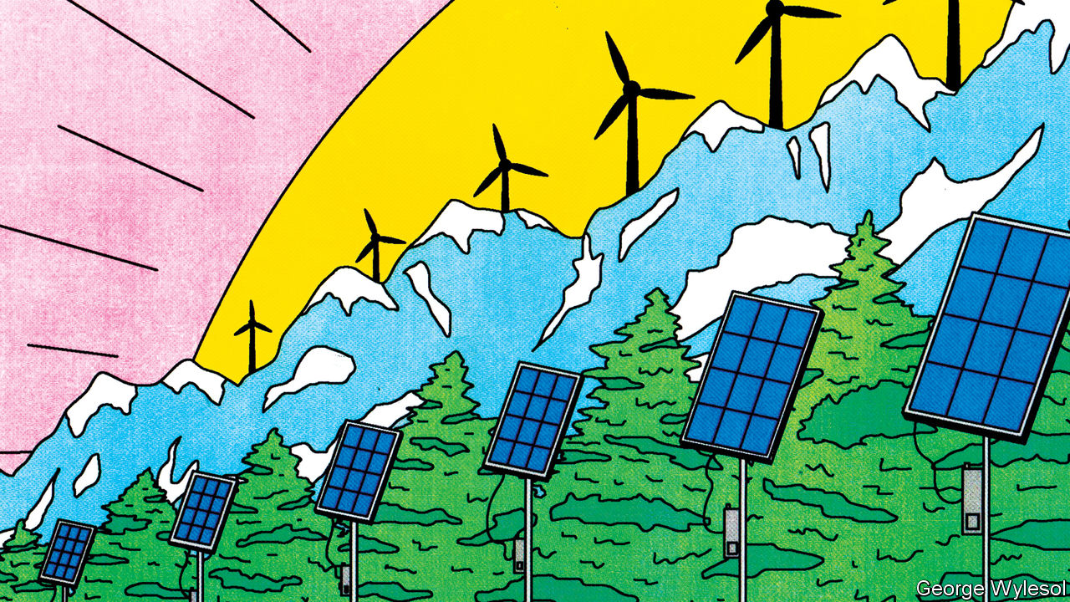

“TO SOME EXTENT, we try to scare off investors,” admits Mateo Jaramillo, co-founder of Form Energy. The startup is trying to solve one of renewables’ knottiest problems. Solar and wind power are intermittent, so green utility firms must store excess energy and release it when no sun shines or breeze blows. Large lithium-ion batteries can discharge energy for up to four hours. Form Energy, founded in 2017, wants to extend that to days with a different, and undisclosed, battery technology. In May it announced a pilot project with Great River Energy, a Minnesotan utility. So star-studded is its team of founders that a rival’s boss calls it “the Travelling Wilburys of energy storage”, in reference to the 1980s supergroup featuring George Harrison and Bob Dylan. Still, Mr Jaramillo does not expect to start scaling up until 2025.

The combination of long wait times and unproven technology would give many venture capital (VC) investors the jitters. Most want to see returns in five to seven years. Form Energy has more patient backers. They include Breakthrough Energy Ventures (BEV), a fund set up by Bill Gates and supported by other billionaires; Eni Next, the Italian oil firm’s VC arm; and The Engine, a fund run by the Massachusetts Institute of Technology. This reflects the evolving nature of the green VC ecosystem, which is teeming again after years in relative hibernation.

In 2019 investors poured a record $36bn into climate-related technology, up from $17bn in 2015, according to Cleantech Group, a research firm. Half the money flowed into North American startups (see chart 1). China accounted for between 15% and 30%, depending on how the sector is defined, and Europe for another 15%. This should spur innovation and, hopefully, lower the relative price of climate-friendly technology even in the absence of regulations making carbon-heavy ones dearer. And it needs to happen across the board, not just in energy and transport. “When we think about decarbonisation we have to remind ourselves that this is the entire industrial economy”, says Mr Gates.

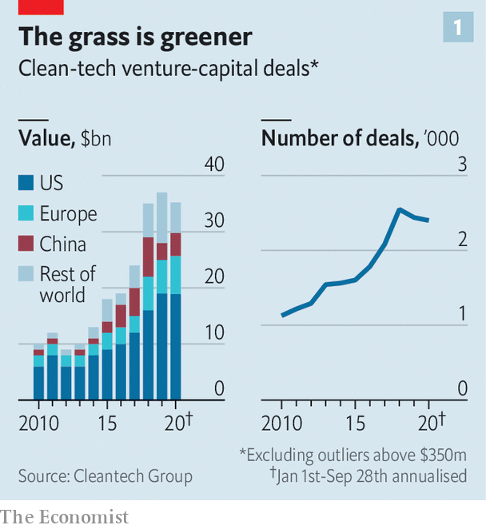

The International Energy Agency (IEA), a global forecaster, predicts that a quarter of the reductions in emissions needed to put Earth’s climate on a sustainable path by 2070 come from mature technologies, such as hydropower. A further 41% come from relatively new technologies with less than 1% of a given market, such as offshore wind in electricity generation. Technology at the demonstration or prototype stages (battery-powered ships or aircraft, respectively) account for 17% apiece. That presents a huge opportunity for investors—so long as they have a strong stomach.

Green VC has a chequered past. In the late-2000s it experienced a boom and bust cycle in America and, to a lesser extent, Europe. VC funds took a financing model designed for software firms and applied it to companies producing physical products, mostly solar panels and biofuels, that take plenty of time and money to generate revenues. Many companies went bust. Their VC backers lost more than half of the $25bn they had bet. Capital dried up.

Now it is flowing again. This time investors are looking at a broader range of clean tech. About half the deals by value go to low-carbon transport, encouraged by Tesla’s credulity-stretching success. In 2004 Elon Musk bought a 14% stake in the electric-car maker for $6.5m. Six years later it went public and is today worth $385bn, more than any other carmaker. Mr Musk’s stake alone is worth perhaps $72bn, just shy of General Motors and Ford combined.

Investments are not confined to Tesla wannabes. Impossible Foods, a $4bn plant-based-protein firm backed by Mr Gates and Google, and Beyond Meat, its listed rival now worth $10bn, have whetted investors’ appetite for agricultural technology. Form Energy and other developers of grid-scale storage are also in demand.

So is software. PwC, a consultancy, estimates that of the biggest 5% of early-stage VC deals between 2013 and 2019, one in ten involved pure software firms. Another six in ten involved startups that integrate clever algorithms with clean hardware. The falling cost and commoditisation of things like solar panels or batteries, the price of which has dropped by 82% and 87%, respectively, between 2010 and 2019, allows such firms to offer auxiliary goods and services. Software innovations make it possible to take this cheaper hardware and push it beyond its previous limits, observes Varun Sivaram of Columbia University. Some startups are, for instance, trying to use clever programming to aggregate distributed energy sources, such as rooftop solar panels or batteries, and provide electricity to the grid like a virtual power plant.

Investors, too, have grown more diverse. VC firms are increasingly rubbing shoulders with governments, corporations, climate-conscious billionaires and private-equity (PE) firms.

In 2015, 24 countries, including America, China and Germany, and the EU pledged to double R&D spending on clean energy over five years. Many will fall short of that goal. But the decline in spending in the mid-2010s appears to have been reversed. Last year taxpayer-funded green-energy R&D around the world rose for the third consecutive year, to a record $25.4bn, accroding to the IEA.

Governments are trying to fill funding gaps at a later stage, too, when deep-pocketed banks are reluctant to hand out $50m for a factory-scale project and less risk-averse VC firms cannot afford to do so, observes Emily Reichert of Greentown Labs, an incubator. Initiatives such as the EU’s long-standing innovation fund and a new scale-up fund within ARPA-E, an American programme for advanced energy technology, aim to help startups escape this “valley of death”.

Corporations, for their part, are on the lookout for new technologies to help them decarbonise or cut energy costs. According to Cleantech Group, big business is involved in about a quarter of deals, up from 16% in 2010. They either invest through their VC arms or by providing capital directly. Oil majors including ExxonMobil have created a clean-investment fund (though it pales in comparison to their oily capital spending). Energy Impact Partners is trying to set one up on behalf of two dozen utilities, such as Southern Company, an American one, and Britain’s National Grid. This year non-energy firms have announced around $5bn-worth of climate VC. Amazon, an e-commerce empire, has backed five firms, including Rivian, an electric-van startup, and Redwood Materials, a battery-recycling firm. Microsoft, a software colossus, Unilever, a consumer-goods giant, and IKEA, a furniture-maker, have also loosened their purse strings.

## High net-zero worth

So have rich individuals, who, like corporate VC funds, tend to represent more patient capital. Family offices participate in around 8-10% of deals, up from 4% in 2010. Many act in concert, as with Mr Gates’s BEV. Launched in 2015, the $1bn vehicle invests only in startups with the potential to cut annual greenhouse-gas emissions by at least the equivalent of half a gigatonne of CO2—some 1% of the world’s total. Mr Gates has enlisted abou 20 fellow plutocrats, among them the richest men in America (Jeff Bezos), China (Jack Ma) and India (Mukesh Ambani). The fund is backing 40 firms and will last for 20 years.

Régine Clément, who heads Clean, Renewable and Environmental Opportunities (CREO), a network of 200 or so family offices, says that many families are trying to be “catalytic”. Some support risky prospects and when a product is established, as is happening with low-carbon protein, they take their capital and move to the next nascent market. The Emerson Collective, a foundation founded by Laurene Powell Jobs, the ex-wife of Steve Jobs, Apple’s late boss, has invested in perhaps a dozen climate-tech startups through an incubator. Mr Gates has separately founded TerraPower, a company developing advanced nuclear reactors, and invested in Carbon Engineering, a firm that builds machines which suck carbon dioxide from the air.

Green innovators are also attracting innovative financing methods. PE firms like Spring Lane Capital and Generate Capital are using new funding models to help startups escape valleys of death. In 2019 Generate lent $100m to Plugpower to install its hydrogen-powered forklift trucks in warehouses of Amazon and Walmart. The retailers pay Plugpower for the service, and it uses the proceeds to repay the loan. Specialised insurance firms, such as New Energy Risk, an affiliate of AXA, a giant insurer, help financiers manage the risk.

In September QuantumScape, a battery startup which counts Mr Gates and Volkswagen among its investors, said it planned to list through a reverse merger with a special-purpose acquisition company (SPAC) of the sort that have been all the rage on Wall Street this year. SPACs allow startups to negotiate the purchase price directly. Deals are faster and more predictable. So are exits, which may encourage climate-tech VCs to support more startups.

Many are already heartened by the rapid rise of green stocks. In the past year the S&P clean-energy index, which tracks around 30 firms, outperformed the S&P 500 index of big American companies (see chart 2). Liqian Ma, of Cambridge Associates, a consultancy, notes that between 2014 and 2018 green VC investments around the world generated annual returns of 20%. That is double what typical VC firms manage, and a vast improvement over the mid-2000s, when the average green VC lost money.

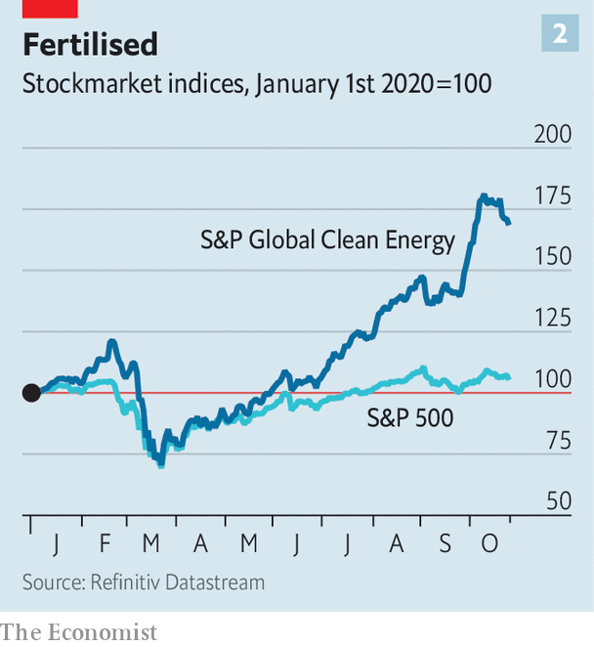

Deep decarbonisation will mean changing heavy industries, too, says Mr Sivaram of Columbia. For that, says Mike Perry, the chief technology officer of VIONX Energy, “You need someone with deep pockets.” His company, which makes large-scale flow batteries and has struggled to get financing to build its fourth plant, is now going through a restructuring process. “This is not-for-the-faint-of-heart investing,” Mr Perry concedes.

Part of the problem is that, as Mr Gates explains, “the demand side for innovation is missing.” That is particularly the case for high-emitting products bought by businesses, such as cement (which accounts for around 8% of global greenhouse-gas emissions) and steel (7-9%). Unlike software, which is easy to differentiate from rivals, “green steel is not going to be any better than steel,” notes Mr Gates. “So there is no market for early innovation.”

Targeted government procurement could boost green products, as happened when the Pentagon enlisted Silicon Valley to make computers. In the private sector Mr Gates is planning a fund that uses auctions to buy clean tech with the lowest price. This, he argues, will stimulate demand and lower costs. With ideas like this the latest green-VC boom may protect the planet—and avoid another bust. ■

For more coverage of climate change, register for The Climate Issue, our fortnightly [newsletter](https://www.economist.com/theclimateissue/), or visit our [climate-change hub](https://www.economist.com/news/2020/04/24/the-economists-coverage-of-climate-change)

This article was downloaded by calibre from <https://www.economist.com/business/2020/10/29/climate-conscious-venture-capitalists-are-back>

|  |  |  |  |
| --- | --- | --- | --- |
|  | Articles | Sections | Next |

|  |  |  |  |
| --- | --- | --- | --- |
| Previous | Articles | Sections | Next |

#### The Lee way

# Samsung after Lee Kun-hee

The death of its patriarch leaves South Korea’s biggest conglomerate with familiar challenges

Oct 29th 2020 | SEOUL

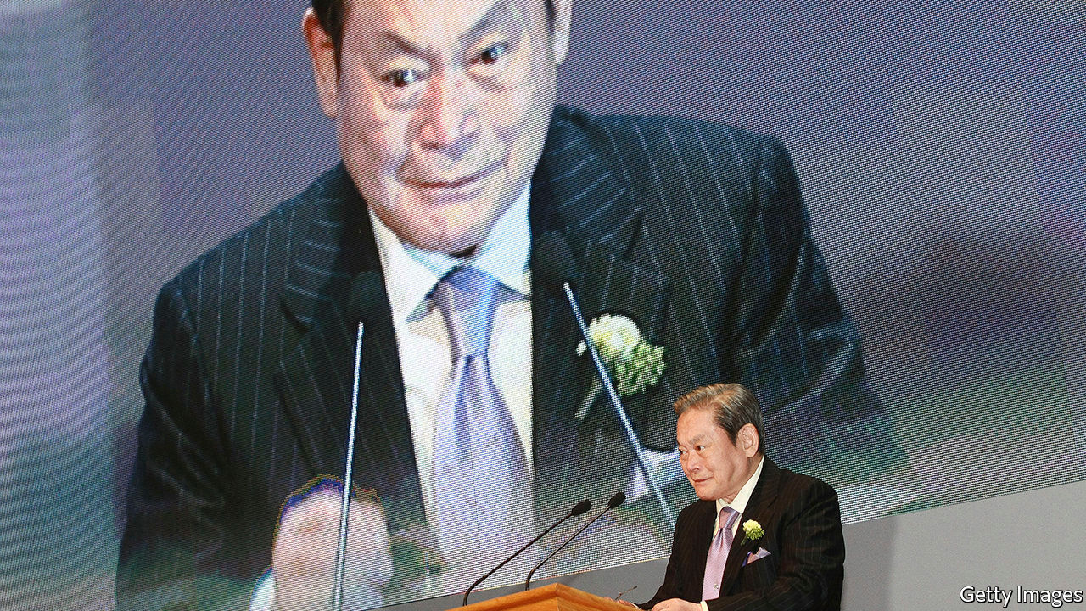

IN THE SPRING of 1995 word got to Lee Kun-hee that a batch of Samsung’s brand-new mobile phones, which it had doled out as new-year gifts, did not work. Incensed, the group’s chairman ordered employees at the factory that had made the offending devices to pile up tens of thousands of them in a courtyard. A cool $45m-worth of equipment then went up in flames.

The episode is emblematic of the way Mr Lee (pictured), who died on October 25th aged 78, turned a South Korean maker of knock-off electronics into a technology powerhouse. He was obsessed with quality and demanded total devotion from executives. Every decade or so he made bold bets. His last one, on smartphones and semiconductors, paid off handsomely. Samsung Electronics, the group’s crown jewel, has a market value of $311bn, more than JPMorgan Chase, America’s biggest bank.

The patriarch’s death was not unexpected—he had been incapacitated since a heart attack in 2014. It will not prompt leadership changes. But it highlights two challenges facing South Korea’s biggest chaebol (conglomerate). The group must find growth beyond maturing smartphone markets. And it has to grapple with Mr Lee’s other legacy: an over-cosy relationship with politics that has embroiled his company, as well as his son and successor, Lee Jae-yong, in corruption cases.

The rise of Samsung mirrors that of South Korea. When Lee père took over from his father in 1987, the country was an emerging economy that had yet to make the transition to democracy. When he fell ill in 2014 it was rich, thriving and democratic. On his watch Samsung abandoned the “fast follow” strategy adopted by South Korean firms since the 1970s and allowed himself “to imagine that his company could be number one in its own right”, says Park Ju-gun of CEO Score, a corporate watchdog. This entailed some mistakes, such as an expensive foray into carmaking. But it mostly brought success.

Although the group maintains businesses from shipbuilding and life insurance to amusement parks, the younger Mr Lee, de facto boss since 2014, has kept a focus on electronics. Today Samsung is the world’s biggest maker of smartphones and its second-biggest of memory chips. It has defended its position in mobile devices against competition from China. Lee fils has forged global partnerships, including with competitors such as Apple, which Samsung Display, a subsidiary, supplies with screens for iPhones. He has also begun to move the company away from producing solid but unsexy hardware towards an emphasis on design and software, which accounts for American big tech firms’ trillion-dollar valuations.

It has not all gone the Lees’ way. Wielding economic influence to preserve a corporate structure that benefits the founding family has landed them in trouble. Lee père was twice convicted for corruption, including bribing the president—and twice pardoned when politicians deemed his continued involvement in Samsung to be in the national interest. His son has already spent time in prison, for bribing a confidante of Park Geun-hye, a former president, to gain approval for a merger, which prosecutors allege helped him consolidate control over the Samsung empire. Ms Park was removed from office and Mr Lee is facing retrial on those charges, plus a fresh one on related accusations of manipulating stock prices to facilitate the merger. Mr Lee and Samsung deny wrongdoing.

If either case lands Mr Lee in prison, his leadership may be in jeopardy. That need not spell doom—the day-to-day running of the company is in the hands of professional managers. But it may make it harder to perform the late patriarch’s occasional, sweeping changes of direction.

Some of his son’s bets seem to be working. Samsung Biologics, the listed biotech subsidiary, is building a new $1.5bn factory. Its share price is up by 50% this year. That of Samsung SDI, a battery affiliate, has nearly doubled (see chart); it has invested $2.1bn since January and is eyeing the electric-car market. It is planning to expand a factory in China and build a new one in Hungary. But at a combined value of $63bn they look small next to Samsung Electronics. And competition in both areas is hot.

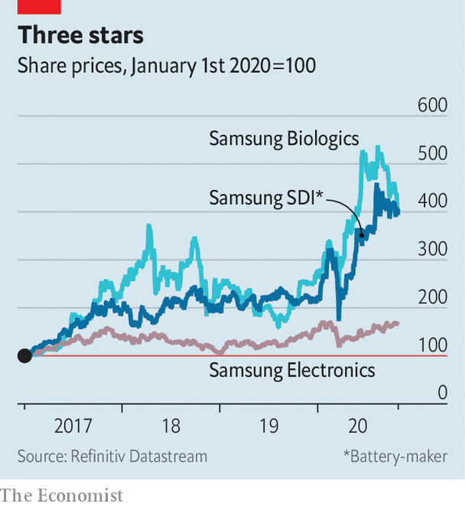

Samsung Electronics’ third-quarter results on October 29th beat forecasts. It plans to spend around $10bn on its contract-manufacturing chip business over the next ten years. American sanctions against Chinese technology firms, which have already hurt its smartphone rivals such as Huawei, may help with that—and with its flagging foray into 5G telecoms. But the firm warned of lower chip demand in the short term. And the market share of its chip “foundries” lags behind Taiwan Semiconductor Manufacturing Company, the industry leader. No new mega-bet in the style of Lee père is on the horizon.

Lee fils has apologised for his group’s run-ins with the law and vowed to break with tradition and not pass control to his own progeny. The Lee family says it plans to pay the full inheritance tax on the patriarch’s $16bn shareholdings. Honouring his positive legacy may prove harder. ■

This article was downloaded by calibre from <https://www.economist.com/business/2020/10/29/samsung-after-lee-kun-hee>

|  |  |  |  |
| --- | --- | --- | --- |
| Previous | Articles | Sections | Next |

|  |  |  |  |
| --- | --- | --- | --- |
| Previous | Articles | Sections | Next |

#### Catch 22

# Californians vote on the future of Uber

If they reject the gig companies’ ballot initiative, a business model will need rethinking

Oct 27th 2020 | SAN FRANCISCO

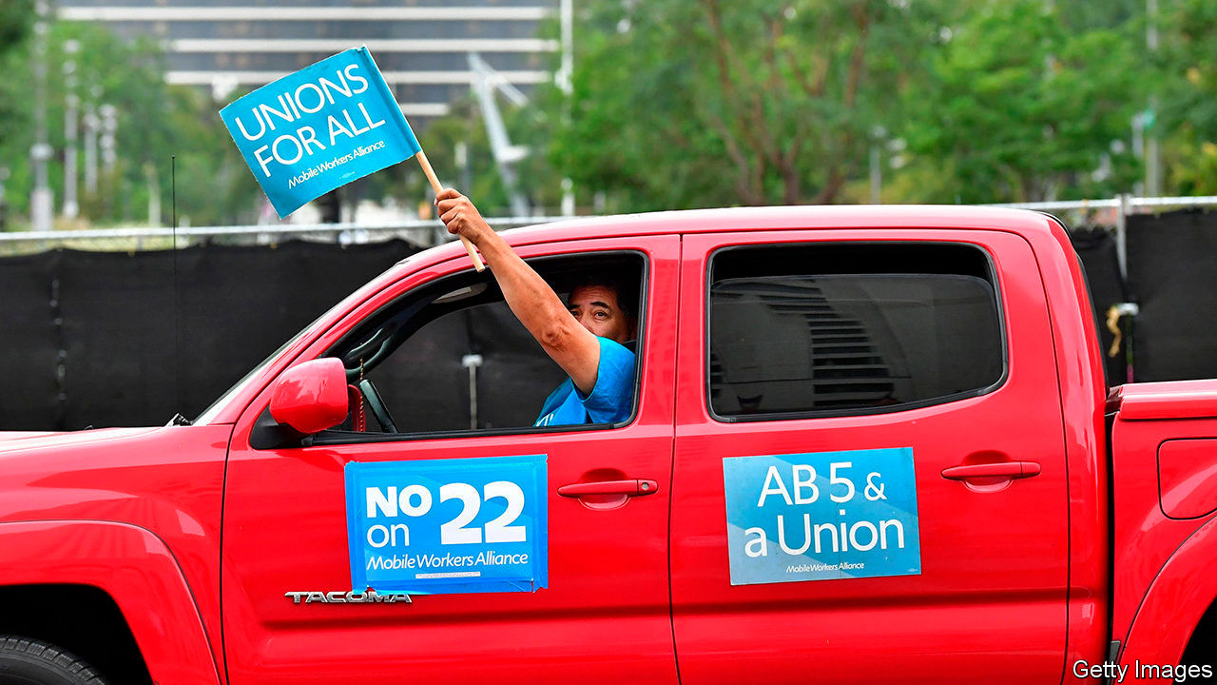

EVEN A HALF-EATEN apple shoved in Dara Khosrowshahi’s face by his young son during a Zoom interview does not ruffle Uber’s boss. “Not now, sweetheart,” was his calm response. Mr Khosrowshahi needs all the unflappability he can muster. Besides picking their president, on November 3rd Californians will vote on a ballot initiative, Proposition 22, that will shape the future of the ride-hailing firm and other gig-economy platforms. The companies have spent nearly $200m promoting the measure, in an effort to preserve their business model.

At issue is whether freelance drivers, couriers and other app-based workers should be treated as employees, entitled to benefits such as unemployment insurance and sick leave. “Prop 22” is a stab at balancing worker protections with the flexibility that lets people work when they want while ensuring that customers never have to wait long for a ride or a meal delivery.

Founded 11 years ago, Uber created the template for the gig economy. Its software matches demand and supply in real time. At first riders and drivers benefited, as Uber and Lyft subsidised rides in a battle for market share. In the past few years the duo began to cut costs, egged on since they went public last year by investors. Uber’s “take rate”, the share of fares it keeps for itself, now averages 26%, up from 20% in 2017, according to New Street, a research firm. Drivers get correspondingly less.

How much they earn per hour is a matter of hot debate. Whatever the pay, though, it comes with no benefits. This may not matter to those who drive to make cash on the side, in addition to other jobs. Uber claims the bulk of its drivers are such part-timers. Critics allege that most rides are provided by full-time drivers. Sharing these concerns, a year ago California passed a law, called AB5, which among other things redefined independent contractors as those who are free from the control and direction of the hirer. Gig firms argue they meet AB5’s criteria. On October 22nd an appeals court ruled they probably do not, pending a full trial next year.

Complying with AB5 would turn Uber from an online marketplace to something like a conventional black-car service, Mr Khosrowshahi says. It would, he adds, have to fire 76% of its 200,000-odd drivers in California. The remainder would work mostly at peak times—and no longer be paid “exactly in proportion to the value that they bring to the system”, he argues, which is “one of the underestimated features of the gig economy”. And, Uber warns, fares would rise by between 25% and 111%.

Nonsense, say Uber’s opponents. Veena Dubal of the University of California’s Hastings College of the Law reckons AB5 would raise cost per driver by a third. But, she says, it would preserve flexibility and protect vulnerable workers. As for fare increases, findings in New York, where ride-hailing firms must pay the city’s minimum wage and respect other rules, suggest that these could be lower than Uber’s estimate.

Enter Prop 22. It would scrap AB5’s narrow definition of independent contractors, while providing such workers with some benefits, including net earnings of at least 120% of the hourly minimum wage and health-care stipends. It could pave the way for portable benefits, which Mr Khosrowshahi has called a “third way” between the status quo and AB5, and which prominent economists, including the late Alan Krueger, have advocated (though it has no provision for collective bargaining, which Krueger also backed). Benefits would be based on “engaged time”; waiting between rides does not count. To qualify for a full health-care stipend, for example, drivers must be “engaged” for 25 hours a week. And any amendments to the proposition would require a seven-eighths supermajority in California’s legislature.

Critics call Prop 22 lopsided. Californians may still back it. They have been bombarded with ads and notifications in their apps warning that a no-vote would doom gig-working. Prop 22 has won the support of influential lobby groups such as Mothers Against Drunk Driving. Polls show the measure winning. If it does, this may bolster Uber’s case in other places, such as Switzerland, where authorities want to classify drivers as employees.

Even if Prop 22 wins, Uber’s business model needs work. It still loses money and investors are getting impatient. Its share price is down by a fifth since it listed. Revenue from rides fell by 75% in the second quarter, year on year, as covid-19 lockdowns sapped demand. Mr Khosrowshahi wants to switch from moving passengers to ferrying everything in cities. Quarterly revenues from its meal-delivery arm doubled as restaurant-goers self-isolated, and now account for nearly 70% of the total. “Just like Facebook built the social graph of connections between friends, we can build the local graph of the connections between people and things,” Mr Khosrowshahi says. Until self-driving cars replace human drivers—don’t hold your breath—that business may not be viable in an AB5 world.■

Clarification (October 28th 2020): An earlier version of this story implied that a court had ruled that gig companies misclassify their workers. In fact it upheld a preliminary ruling that they probably do, pending a full trial. Dara Khosrowshahi, Uber’s boss, also said that California’s labour laws would turn Uber from a digital marketplace to a conventional black-car company, not a taxi company as we suggested.

Dig deeper:  
Read the [best of our 2020 campaign coverage](https://www.economist.com/us-election-2020) and explore our [election forecasts](https://projects.economist.com/us-2020-forecast/president), then sign up for Checks and Balance, our [weekly newsletter](https://www.economist.com/checksandbalance/) and [podcast](https://play.acast.com/podcasts/2020/01/24/checks-and-balance-our-new-weekly-podcast-on-american-politics) on American politics.

This article was downloaded by calibre from <https://www.economist.com/business/2020/10/27/californians-vote-on-the-future-of-uber>

|  |  |  |  |
| --- | --- | --- | --- |
| Previous | Articles | Sections | Next |

|  |  |  |  |
| --- | --- | --- | --- |
| Previous | Articles | Sections | Next |

#### Painkiller wars

# American lawmen are going after Opioids Inc

A grand settlement looks unlikely in the short term

Oct 31st 2020 | NEW YORK



“IN THE SHADOW of their own profound failures, DoJ and DEA now seek to retroactively impose…requirements that are not found in any law.” Unusually strong words to hurl at America’s Department of Justice and its Drug Enforcement Administration. They come from an unusual lawsuit filed by Walmart on October 22nd. It is a pre-emptive strike against the Feds, who are preparing to hammer the giant retailer for allegedly fuelling the opioid crisis.

Opioids Inc is under legal assault on several fronts. Drugmakers were first in the firing line. Last year a judge in Oklahoma ruled that Johnson & Johnson (J&J) had created a “public nuisance” by contributing to opioid abuse and ordered it to pay some $500m; J&J is appealing the verdict. The company also stands accused of wrongdoing, along with other firms, in lawsuits filed in federal courts by thousands of local governments. While insisting it did nothing wrong, J&J signalled this month that it is willing to cough up $5bn if a comprehensive settlement can be agreed.

For the world’s largest drug firm, with annual revenues of $56bn, such a hit would be a publicity nightmare but financially manageable. For smaller fry, litigation can prove fatal. On October 12th Mallinckrodt, a big purveyor of generic opioids, agreed to pay $1.6bn in a settlement as it filed for bankruptcy. On October 21st the DoJ announced that Purdue Pharma, the most prominent opioids producer, which folded last year, had agreed to admit guilt and pay roughly $8bn. A number of state attorneys-general think the settlement lets the Sackler family, which controlled Purdue, keep too much of the $10bn or so they have taken out of the firm since 2008.

As the second phase of opioid litigation begins, “pharmacies are front and centre,” says Andrew Pollis of the Case Western Reserve School of Law. Two counties in Ohio have sued three big chains, CVS, Rite Aid and Walgreens, and Walmart (which has pharmacies inside its big-box stores). The suits will be bellwethers for more than 2,000 similar complaints filed across the country. The plaintiffs allege that the pharmacies knew that opioids were being overprescribed but kept dispensing them. The firms deny wrongdoing.

For firms caught in the mess, the next best thing to exoneration is a speedy resolution. A few months ago rumours swirled of a “big global deal”, in the words of an insider, involving counties and state attorneys-general. To co-ordinate the 2,000-plus lawsuits, Dan Polster, a federal judge overseeing the Ohio cases, promoted a novel legal concept of a “negotiation class”. It would bind all parties to any settlement.

The pandemic has led to big delays, removing the pressure to settle quickly before trial begins. Mr Polster rejected the demand made by plaintiffs’ attorneys that 7% of any settlement go into their pockets, so unhappy lawyers are now threatening to derail the big global deal. A federal appeals court recently rejected Mr Polster’s negotiation class as a jurisprudential innovation too far. Elizabeth Burch of the University of Georgia School of Law, worries that the way forward now “looks like a zigzag”. The end of the legal saga seems as remote as that of the opioid crisis itself. ■

This article was downloaded by calibre from <https://www.economist.com/business/2020/10/31/american-lawmen-are-going-after-opioids-inc>

|  |  |  |  |
| --- | --- | --- | --- |
| Previous | Articles | Sections | Next |

|  |  |  |  |
| --- | --- | --- | --- |
| Previous | Articles | Sections | Next |

#### Bartleby

# How hotels are trying to attract remote workers

Luxury with your laptop

Oct 29th 2020 |



THE BUSY worker looks at the clock on her laptop and discovers that it is nearly 1pm. Time for lunch. So she picks up the phone and asks to speak to room service. A hot meal appears 20 minutes later; no need to bother with the cooking or washing up.

If that vision appeals, you could be a potential customer for one of the many hotel groups that are trying to induce people to rent a room for use as an office. The idea makes a certain amount of sense. Hotel rooms are short of guests during the pandemic; some workers may find it too difficult (or boring) to sit at the kitchen table every day.

The big chains are rushing to test out the size of this market. Hilton has launched a new service called Workspaces in America, Britain and Canada which gives workers the chance to use the gym or swimming pool (where available) and complimentary bicycle hire. The Wyndham chain is offering worker packages at hotels in California, Florida and South Carolina.

Hotels have long made good money out of the business market, catering for business travellers, conferences and team get-togethers. They have also recognised that they need a good Wi-Fi signal to appeal to laptop-toting businesspeople. But renting rooms by the day has traditionally been aimed at a rather different slice of the market from the solitary desk jockey.

Bartleby wrote part of this column in Sofitel St James, a luxury hotel in the heart of London’s West End. This certainly would be an excellent bolthole, for those who can afford it—£299 ($388) a day, with breakfast, lunch and a cocktail available for another £50. Your columnist’s suite offered a lounge with a desk, printer and shredder, plus a four-seater table, two comfy chairs and a sofa. Nice little touches included extra pens, sellotape, scissors and a stapler. All the staff wore masks and kept a safe distance. The place was extremely quiet, which aided concentration.

Nice as these facilities were, they would almost certainly be beyond the budget of an ordinary worker who might be looking to escape the builders or the children during school holidays. A cheaper Sofitel option is available at £199 but that would still require a company’s expense policy to be incredibly generous. If you are fully employed, you can probably retreat to the office for no extra cost. And if you are a freelance worker, you may simply head for the nearest coffee shop, where seating, subject to social distancing, can be obtained for the price of a few cappuccinos.

Another option for British workers is the traditional pub, with some trying to drum up business by offering “hot-desking” packages. One hostelry in Warrington, a town in the north-west of England, is offering a £12 daily package with a meal, unlimited coffee and an internet connection. (Whether a pub would be a great place to concentrate is another matter; an open-plan office looks like a Trappist monastery by comparison.)

Few Britons live far from a pub. By contrast, though Bartleby enjoyed the luxurious accommodation, his visit to St James’s required a lengthy trip. For many workers, the absence of the daily commute has been one of the big bonuses of lockdown. So hotel rooms are most likely to appeal to workers if they are a short distance away, meaning that they need to be in the suburbs rather than the city centres. Suburban hotels will also be a lot cheaper. Hilton offers a work package in a Hampton hotel in west London at a bargain £45 a day.

Even then, the market is likely to be a niche product. Being at home allows workers to have all their chosen comforts (books, snacks, favourite tea) to hand. They will be there if delivery or maintenance men come to call. And sitting alone in a hotel room, good as it may be for concentration, is more likely to increase a sense of isolation than being in the more familiar surroundings of one’s own house.

Still, on occasion a bit of isolation might be welcome, just as authors retreat to a cabin to finish their manuscripts. Workers who have a big project to finish might relish a hotel break, especially if their office does not have the covid-19 protocols in place to ease their fears. Hotels might also be a good place to conduct job interviews, provided that companies respect government social-distancing rules.

For humble drones like Bartleby, however, home will continue to be the office of choice, even if it means doing the washing up. Indeed, time to stop writing and fill the kettle.

Editor’s note: Some of our covid-19 coverage is free for readers of The Economist Today, our daily [newsletter](https://my.economist.com/user#newsletter). For more stories and our pandemic tracker, see our [hub](https://www.economist.com/news/2020/03/11/the-economists-coverage-of-the-coronavirus)

This article was downloaded by calibre from <https://www.economist.com/business/2020/10/29/how-hotels-are-trying-to-attract-remote-workers>

|  |  |  |  |
| --- | --- | --- | --- |
| Previous | Articles | Sections | Next |

|  |  |  |  |
| --- | --- | --- | --- |
| Previous | Articles | Sections | Next |

#### Schumpeter

# Where is Amazon’s Jeff Bezos headed next?

A new book suggests looking up to space

Oct 29th 2020 |

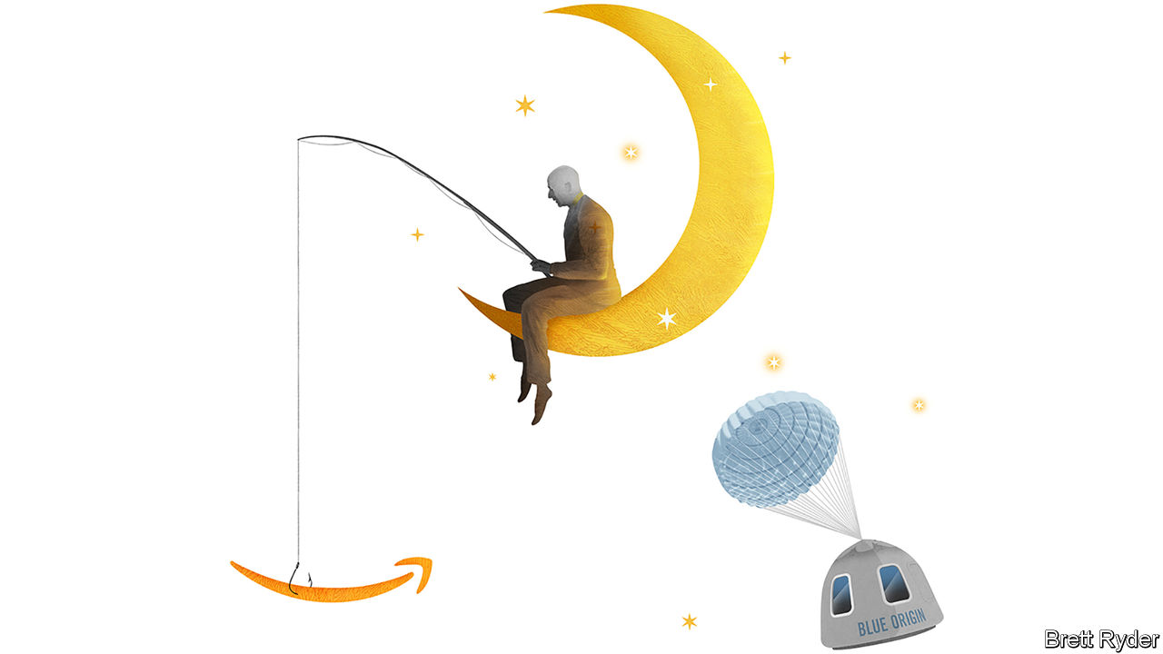

IT HAS THE largest windows in space. Six reclining seats. And blue edges that passengers can grab hold of as they float weightlessly more than 100km (62 miles) above Earth. If that is not rarefied enough, imagine if one of the fellow passengers were Jeff Bezos, gazing down onto a planet that is spanned by his digital conglomerate, Amazon, and of which he is the richest inhabitant. When the time comes for Mr Bezos’s private venture, Blue Origin, to send paying tourists into space, its proprietor will almost certainly be among them. “I suspect that he will be—and is, indeed, eager to be—one of the first private citizens to blast himself into space,” writes Walter Isaacson, a biographer, in an introduction to the collected writings of Mr Bezos. Already you shudder to think of Mr Bezos’s peals of laughter ringing through the heavens.

It is easy to assume that for the 56-year-old man who has (and sells) everything, space tourism is the ultimate vanity project. He launches rockets from his ranch in West Texas. He has a rippling physique. His bald head resembles that of his idol, Captain Jean-Luc Picard in “Star Trek”. He is fulfilling a childhood dream. In 1982 he told his schoolmates: “Space, the final frontier, meet me there!”

Yet dismissing his space quest as a combination of mid-life crisis and money to burn would be underestimating the missionary zeal that drives Mr Bezos, and which “Invent & Wander”, a collection of 23 years of letters to Amazon shareholders and other musings, illustrates. His work on Earth is not yet done. Covid-19 has brought him back squarely to Amazon’s helm. But the book, which is mostly backward-looking, leaves a tantalising hint that you need to peer into the stratosphere to see what comes next. What that means for the future of Amazon is left frustratingly vague.

On the surface, his twin obsessions are a puzzle. It is difficult to imagine more different ventures than retailing and rocketry. Revolutionary as both firms are, there are few more hard-headed ones than Amazon, and few more dreamy-sounding concepts than space colonisation. Amazon is a utilitarian monument to the consumer, worth $1.6trn. It promises relentlessly lower prices, speedier delivery and greater variety—as well as faster cloud computing power in the case of Amazon Web Services (AWS). Blue Origin’s vision, funded by the sale of Mr Bezos’s Amazon stock, is Utopian. It is “to enable a future where millions of people are living and working in space to benefit Earth”. It hopes to achieve this by making launch vehicles that can land and be fully reusable. New Shepard, its suborbital spacecraft, has completed more than a dozen flights. Yet it is years behind schedule for flying tourists to space. For now, Blue Origin’s main customer is the government.

The two companies operate with different degrees of transparency and velocity, too. Amazon has been a public company since it was three years old. Its founding motto was “get big fast” and its obsessive quest to innovate includes a willingness to fail. Blue Origin was kept secret for years after its birth in 2000. It calls itself a tortoise not a hare. Its motto is Gradatim Ferociter, or “Step by step, ferociously”. As Mr Bezos has said, “If you’re building a flying vehicle, you cannot cut any corners.”

Or take their approach to rivals. Amazon, which dominates e-commerce and the cloud, treats them with the haughtiness of a trailblazer. Mr Bezos tells employees to be terrified of customers, not competitors. Blue Origin is a laggard. It is trying to catch up with SpaceX, the rocketry business of Elon Musk, another space-mad plutocrat. Other rivals include Virgin Galactic, the listed venture of Richard Branson, a British tycoon. Aerospace stalwarts such as Lockheed Martin and Northrop Grumman are both collaborators and competitors. Boeing is a mighty incumbent.

Yet at Amazon, Mr Bezos has proved he can run businesses as diverse as one famous for brown boxes, and another for cloud computing. As he wrote in 2015, Amazon and AWS may look different, but they share similar underlying principles on which they act. The same may be true of Amazon and Blue Origin.

## Stairway to heaven

Their visions are communicated by a simple narrative. Amazon’s is a focus on customer satisfaction, behind which employees, suppliers and shareholders fall into line. Blue Origin’s core belief is that reusable rockets will lower costs so that access to space is made possible for many. These mantras are endlessly repeated.

Second, the two businesses share breathtaking ambition. From the Kindle and AWS to Echo smart speakers and Alexa, their soothing machine-learned voice, Amazon has frequently given customers more than they ever thought they needed. With Blue Origin, Mr Bezos hopes that he can unleash entrepreneurial activity allowing others to follow his “road to space” and create a new era for business along the way.

Most important, both firms are imbued with Mr Bezos’s devotion to the long term. In his missives about Amazon, he repeatedly reaffirms his intention to invest to win market leadership in a variety of industries, rather than prioritising short-term profits. Blue Origin’s horizons are measured in decades, if not centuries. Both benefit from Mr Bezos’s knack for burying himself in the day-to-day detail, without losing sight of the big picture.

What his fixation with the heavens says about Mr Bezos’s future at Amazon remains a vexing question. The book does not hint at controversies such as the online empire’s treatment of third-party sellers, the hollowing out of high streets, or its quashing of unionisation efforts. It repeats the cliché that it is “day one” for Amazon, even though it seems late in the day as competitors in e-commerce and the cloud up their game and political heat rises. It gives no sense of whether AWS, its most profitable division, should be spun off, or of when Mr Bezos may step down. But it makes clear that Blue Origin, as Mr Bezos put it last year, is “the most important work I’m doing”. One day it may take him not just into orbit but away from the mother ship. ■

This article was downloaded by calibre from <https://www.economist.com/business/2020/10/29/where-is-amazons-jeff-bezos-headed-next>

|  |  |  |  |
| --- | --- | --- | --- |
| Previous | Articles | Sections | Next |

|  |  |  |
| --- | --- | --- |
| Business | Sections | Science & ... |

Finance & economics

Aditya Puri: The world’s best banker?

.

Cross-border lending: Making inroads

.

Emerging marketmakers of last resort: Quite encouraging

.

Europe’s public finances: The fiscal question

.

The yuan: Caveat victor

.

Buttonwood: Blitz-coin

.

Free exchange: The notorious GDP

.

|  |  |  |
| --- | --- | --- |
| Business | Sections | Science & ... |

|  |  |  |  |
| --- | --- | --- | --- |
|  | Articles | Sections | Next |

#### Star performers

# Who is the world’s best banker?

It may be someone few outside Asia have heard of: Aditya Puri, of India’s HDFC Bank

Oct 29th 2020 |

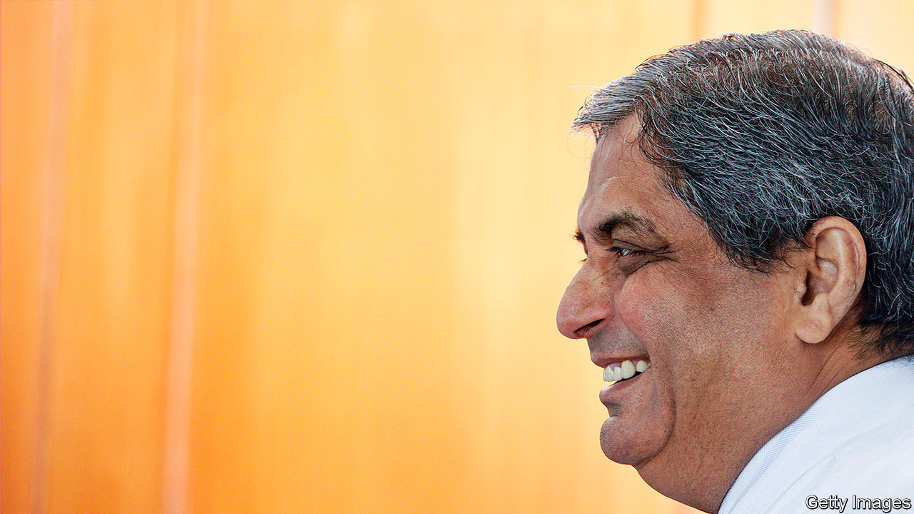

WHO IS THE most impressive banker on the planet? Judged by their swagger and $20m-40m paypackets, the bosses of Wall Street’s big firms are contenders; yet several run firms that have delivered weak returns, been bailed out and left a toxic trail of scandals. Measured by sheer clout, the heads of China’s state lenders are in the running. The boss of Agricultural Bank of China keeps an eye on a mere 23,000 branches and half a million staff. But he is an instrument of the Communist Party.

Measured by the hardest test of all— creating something from nothing and delivering long-term shareholder returns while supporting the economy—the answer is someone of whom few outside Asia and the investment elite would have heard: Aditya Puri, who on October 26th retired from HDFC Bank. Now the world’s tenth-most-valuable bank, it is worth about $90bn, more than Citigroup or HSBC.

HDFC is Indian, headquartered in Mumbai, and has been run by Mr Puri since its creation in 1994. Today it has branches in mega-cities and rural backwaters alike. It serves consumers and firms and eschews the wilder reaches of investment banking and foreign adventures. This unlikely formula has produced spectacular results.

In order to assess Mr Puri’s performance The Economist has compared total shareholder returns during his tenure with those achieved by the chief executives of the world’s top 50 banks, by market value (see chart). Mr Puri has delivered cumulative returns exceeding 16,000% over the quarter-century since his bank went public. That is far more than any other boss in our sample, including Jamie Dimon of JPMorgan Chase, widely viewed as the leading banker of his generation. This is not wholly a function of the length of Mr Puri’s tenure: annualised total returns have been 22%, placing him among the top two. The power of compounding means the absolute value created for shareholders during his tenure is a giant $83bn.

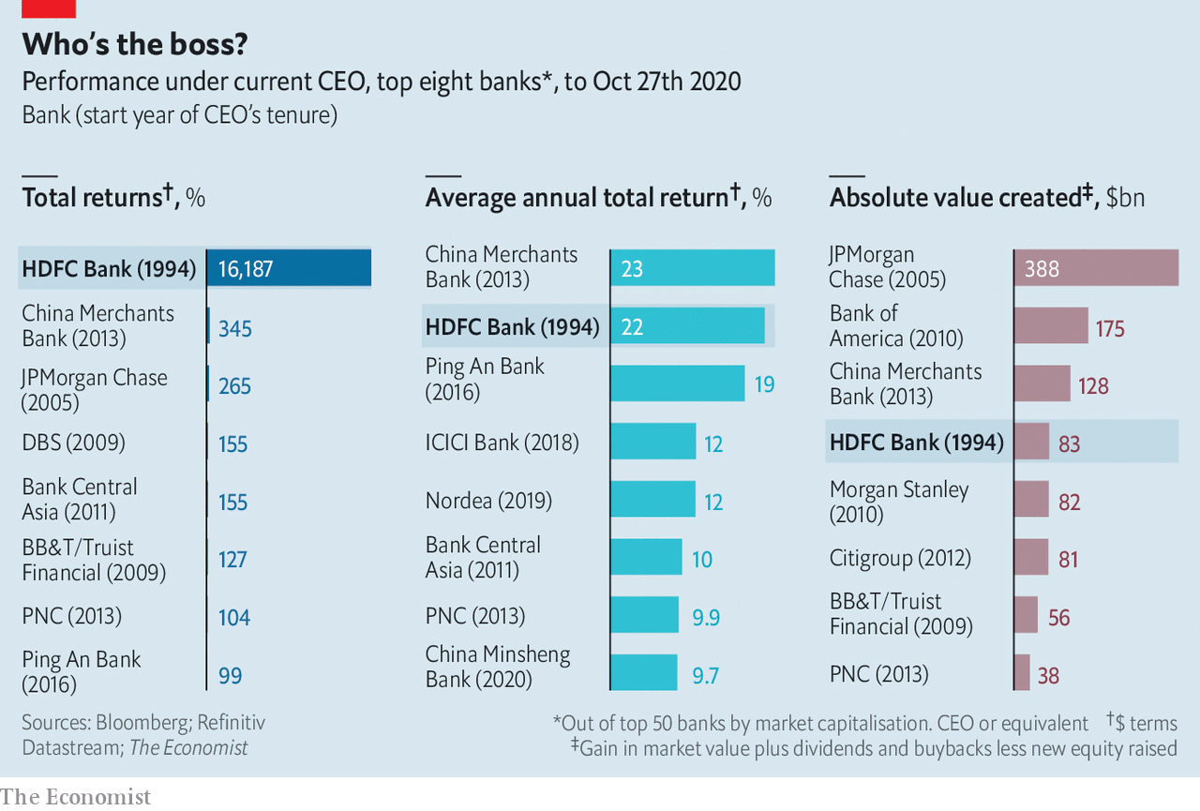

Such returns seemed unimaginable in 1994, when Mr Puri returned to India from Malaysia, where he had worked for Citigroup (Mr Dimon cut his teeth at the bank, too). Back then India’s banks were almost entirely state-owned. Licences began to be issued to private banks in the hope that these would operate without the corruption and inefficiency that had held back the economy. Mr Puri received a call from Deepak Parekh, the head of Housing Development Finance Corporation, a mortgage lender, who offered him less than half his Citi salary to set up a bank. He credits his wife, Anita, for convincing him to say yes.

So what is HDFC’s secret sauce? Being in India is no guarantee of success—the industry still features decrepit state lenders and wild-west chancers and is in the midst of a slump that has only been aggravated by covid-19. Instead three factors stand out. First, Mr Puri’s management style, which features a clear vision, microscopic attention to detail, blunt speaking and a knack for retaining talent. Such was his dedication that, presented with a staggering bill for heart surgery, he sought to encourage the doctor to bank more with HDFC.

The second factor is strategic discipline. Mr Puri intuited that Indian consumers and firms would be a consistent money-maker and has stuck to that view. He took the sophisticated processes used by foreign banks and used them to target local retail and commercial clients. The result is a large branch network, half of which is outside cities. The firm’s cash-machine and credit-card networks are the largest among India’s private banks.

Mr Puri stayed away from foreign ventures and investment projects, avoided lending to India’s indebted oligarchs, and financed HDFC’s balance-sheet through deposits rather than debt. That all has proved prescient. Other banks chased a credit boom in 2004-07, channelling funds into infrastructure projects. Many proved to be bad prospects, or were bogged down by red tape, leaving lenders with a pile of bad loans.HDFC’s ability to take the long view may have been helped by having an anchor shareholder in the form of Housing Development Finance Corporation.

The final element is HDFC’s approach to technology—though not a pioneer, it is a fast follower. Mr Puri famously does not own a mobile phone; Aseem Dhru, a former HDFC executive, recalls meetings in Mr Puri’s office taking place across a desk that had no computer. But HDFC has invested heavily in technology to automate its processes and keep costs low. Loan approvals have gone from days to seconds. Its credit systems are particularly rigorous.

HDFC’s trivial write-offs for poor loans were once attributed to its small size. But it has been the source of as much as a quarter of new credit in India since 2017 without any sign of its standards slipping or bad loans rising, says Ashish Gupta of Credit Suisse, a bank. Figures from Jefferies, an investment bank, suggest that HDFC’s gross non-performing assets were 1.3% of total assets in the year to March, compared with 2.3% for Kotak Mahindra and 6% for ICICI, India’s other big privately owned banks.

Mr Puri leaves behind some question marks. The man many saw as his most likely successor quit in 2018; the bank’s new CEO is Sashidhar Jagdishan, another veteran. Some investors wonder if the bank will eventually merge with its largest shareholder, Mr Parekh’s Housing Development Finance Corporation. The biggest question of all is how Mr Puri got away with working the sort of hours that get you laughed off Wall Street. He tended to take a lunch break, often at home with his wife, and would leave the office at 5.30pm. Perhaps this was the secret of his success. ■

This article was downloaded by calibre from <https://www.economist.com/finance-and-economics/2020/10/29/who-is-the-worlds-best-banker>

|  |  |  |  |
| --- | --- | --- | --- |
|  | Articles | Sections | Next |

|  |  |  |  |
| --- | --- | --- | --- |
| Previous | Articles | Sections | Next |

#### Making inroads

# The overseas activities of Chinese banks shift up a gear

In many emerging economies, they are the chief source of cross-border loans

Oct 28th 2020 |

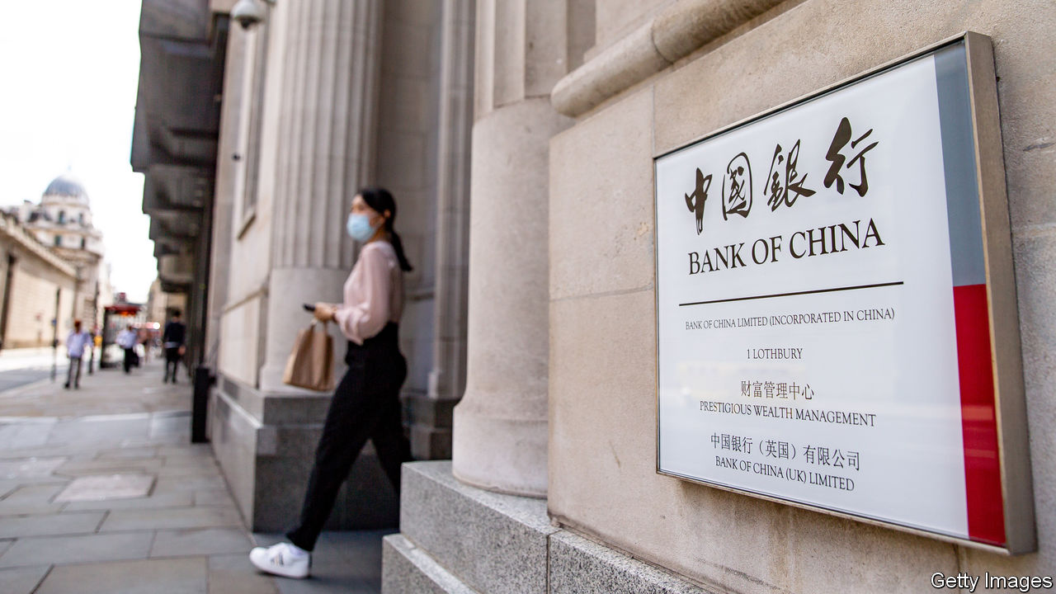

CHINA’S BANKING system, with $35trn in assets, is the world’s largest. Its four biggest lenders, measured by assets, head the global league table. Yet Western banks rarely come up against Chinese peers in foreign climes. That has fed the stereotype that China’s banks are either uninterested in global business or, staffed by staid bureaucrats and stuffed with bad loans, are uncompetitive abroad. A new study suggests that this portrait is wide of the mark.

In fact the global footprint of China’s banks has grown to rival that of Western lenders. In June this year its deposit-takers, including some of its policy banks, accounted for 7% of total cross-border lending flows, up from 5% in 2015, and lent to 196 out of 216 countries. A recent paper by Catherine Koch and Swapan-Kumar Pradhan of the Bank for International Settlements (BIS) and Eugenio Cerutti of the IMF explains why the rich world hasn’t noticed: China’s banks reign in poorer markets that Western lenders either never entered or are now abandoning.

Chinese banks provide 26% of all cross-border loans to developing countries today, most of them in dollars (see chart). That is up from a fifth in 2016, and has risen since the pandemic. (Ms Koch points out that the BIS’s figures cover only countries that report to it, and suspects that the true share could be higher.) China’s share is still lower than that of European banks, which, though retrenching, account for 34% of cross-border lending to poor countries. In half of these places, though, its banks are now the largest cross-border lenders.

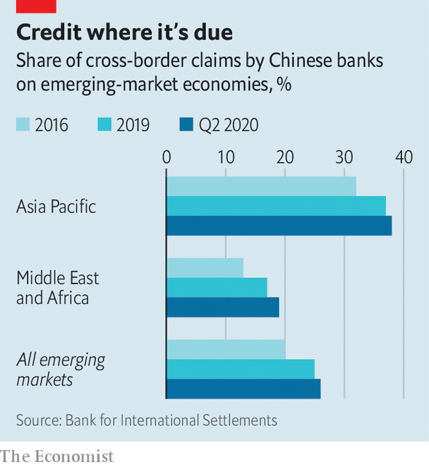

Banks from emerging economies are typically reluctant to lend far away from home, perhaps because their own markets are still growing and the creditworthiness of far-flung borrowers is harder to assess. By looking at loans made by banks from their home base, as well as by their foreign subsidiaries, the researchers show that Chinese lenders are not so put off. In that sense they resemble banks from Europe and America, says Mr Cerutti, even though they are typically state-owned and their overseas expansion is much more recent.

In another respect, however, China’s banks stand out. Cross-border loans tend to be correlated with trade and investment flows, which give lenders more information about foreign borrowers. The link between lending by China’s banks and bilateral trade is especially strong. But lending bears little relation to investment flows. The authors suspect that this reflects China’s capital controls, and the fact that its portfolio investments target rich markets.

What does all this mean for borrowers? The rise of China’s banks brings both risk and reward. One concern has been that the lending has added to some poor countries’ debt woes. In some places China’s banks are now important enough that, if a shock causes them to pull back, then a local credit crunch could ensue. But China could be a source of needed capital too. Strong inflows into the country this year mean that its banks are flush with dollars (see article). If recent form is a guide, a chunk will be recycled into developing countries. ■

This article was downloaded by calibre from <https://www.economist.com/finance-and-economics/2020/10/28/the-overseas-activities-of-chinese-banks-shift-up-a-gear>

|  |  |  |  |
| --- | --- | --- | --- |
| Previous | Articles | Sections | Next |

|  |  |  |  |
| --- | --- | --- | --- |
| Previous | Articles | Sections | Next |

#### Quite encouraging

# Emerging markets’ experiments with QE have not turned out too badly

The IMF blesses emergency bond-buying schemes

Oct 29th 2020 | HONG KONG

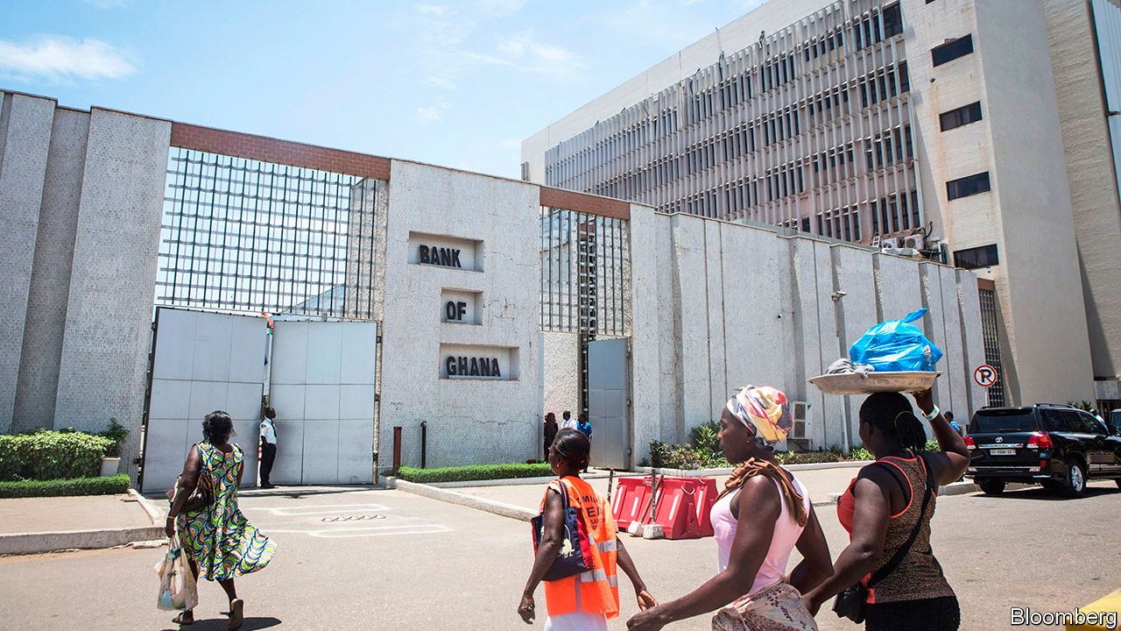

ECONOMIES, UNLIKE people, become more tolerant of excess as they mature. Thus America or Japan can get away with fast-and-loose economic policies that would spell disaster if less mature, “emerging” economies tried them at home. Quantitative easing (QE) is often cited as an example. Buying government bonds with newly created money is surely the kind of indulgence best left to the rich world. Central banks in emerging markets have, after all, spent decades trying to distance themselves from gluttonous governments and prove themselves careful stewards of the money supply.

The emerging-market response to the covid-19 pandemic has, therefore, raised eyebrows. As well as cutting interest rates sharply, many central banks have experimented with their own versions of QE, buying government bonds and other financial assets. Contrary to some fears, this has not so far brought disaster. Indeed the early evidence suggests it has worked quite well.

At least 18 central banks have carried out asset-purchase programmes of some kind, according to the IMF. Policymakers in some countries, such as Chile, Hungary and Poland, resorted to them because they had already lowered interest rates about as far as they could go. Others, however, had different motives. In some countries the authorities admitted that bond-buying had a partly fiscal aim. The central bank’s purchases would help finance the government’s efforts to fight the pandemic. The Bank of Ghana, bought a “covid-19 relief bond” worth 5.5bn cedi ($950m) from the government in May to help fill its financing gap. In the Philippines, Rosalia De Leon, the national treasurer, described the central bank’s purchases as an “extra lifeline” for the government.

A third group of central banks, including those in India and South Africa, bought bonds for a subtler reason: to help make a market for them. Their aim was not simply to lift bond prices, but also to reduce their volatility and narrow a widening gap between the prices demanded by prospective sellers and those offered by potential buyers. In addition, by acting as a buyer of last resort, central bankers hoped to embolden other, private buyers of earlier resort.

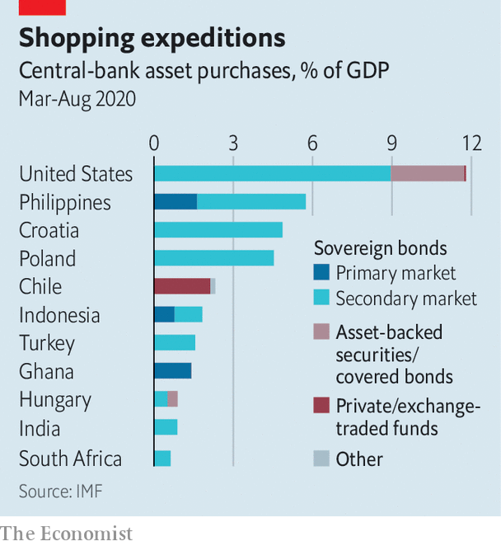

Sure enough, the announcement of these measures helped reduce bond yields, says the IMF’s latest global financial stability report, by about 0.2 to 0.6 percentage points. They also helped to reduce the “term premium”, or the extra yield investors demand to hold a long-term bond rather than a series of short-term ones. More surprisingly, perhaps, these purchases added little, if any, downward pressure to currencies. This was partly because central banks often sold short-term claims even as they bought longer term assets, thereby mopping up the money they had created. It was also because investors seem to have been comforted, not threatened, by the presence of the central bank as a fellow buyer. Their purchases had a “catalysing effect”, the fund says.

If these shopping sprees have been helpful, should central banks make a habit of them? And should they splash out as freely as central banks in the rich world? The IMF urges caution. The pandemic created exceptional circumstances. Investors might react differently to larger, more routine forays into the bond market. Central banks should also consider what private investors can buy instead. If a country’s markets offer few alternatives to government bonds, then the central bank might inadvertently push investors out of the country’s assets altogether.

Unconventional policies help only if central banks are credible. Turkey provides one illustration. Foreigners have halved their holdings of lira-denominated government bonds this year, according to the Institute of International Finance, a bankers’ group, and the currency has plunged to record lows in recent days. Turkey’s president, Recep Tayyip Erdogan, harbours unorthodox views on monetary policy and the central bank manifestly lacks the independence needed to defeat inflation, which exceeds 11%. If Turkey’s central bank were to expand its modest bond-buying scheme, it would only make things worse. You cannot stop a run on a currency by printing more of it and lowering the reward for holding it. The unconventional and the unorthodox are a poor mix. ■

This article was downloaded by calibre from <https://www.economist.com/finance-and-economics/2020/10/29/emerging-markets-experiments-with-qe-have-not-turned-out-too-badly>

|  |  |  |  |
| --- | --- | --- | --- |
| Previous | Articles | Sections | Next |

|  |  |  |  |
| --- | --- | --- | --- |
| Previous | Articles | Sections | Next |

#### The fiscal question

# What next for the EU’s fiscal rules?

The suspension of its rule book could offer space for a wider rethink

Oct 31st 2020 | BERLIN

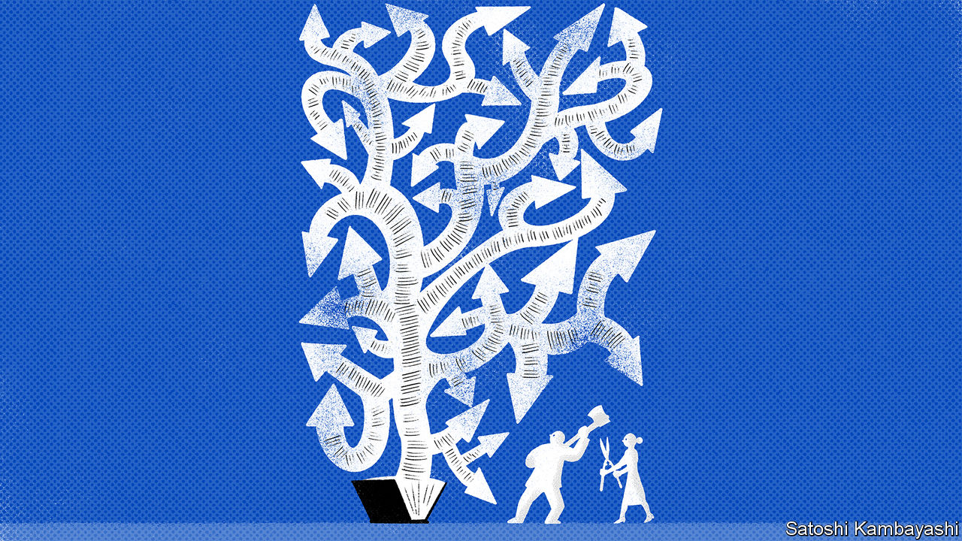

THE SCHLESWIG-HOLSTEIN question, a 19th-century diplomatic teaser, was said to be so complicated that of the three people who had ever understood it, one had forgotten it all, another was dead and the third driven mad. Readers of the European Commission’s 108-page “Vade Mecum” on the Stability and Growth Pact (SGP), the European Union’s fiscal rule book, might sympathise. Over the years the rules have sprouted a head-spinning array of exceptions, interpretative possibilities and get-out clauses. No finance minister in Europe fully understands them, says a Brussels insider.

Yet at the heart of the EU’s rules lie two simple figures, anchored in the Maastricht treaty of 1992: governments should aim to run budget deficits no higher than 3% of GDP and to cap the public-debt stock at 60% of GDP. As countries prepared to enter a monetary union without a central fiscal authority, rules were needed to bind the hands of the spendthrift. The quid pro quo for strict rules was a politicised process of enforcement. In 2003 France and Germany exceeded the deficit threshold and then cowed the rest of the EU into letting them escape unpunished; an early blow to the rule book’s credibility from which some say it never recovered. No country has ever faced the fines that notionally apply to serious miscreants.

The fiscal rules have been periodically tweaked over the years. Brussels shifted away from headline targets to focus on “structural” deficits that sought to strip out the effect of the business cycle. But conjuring reliable estimates in real time has been impossible—often forcing governments to tighten prematurely. In 2011 members agreed that debt levels over the 60% limit should be cut by one-twentieth each year. The “fiscal compact”, passed at the urging of Germany in 2012, obliges governments to try to keep structural deficits close to zero. In 2015 the commission clarified the cases in which exemptions could be granted, including structural reforms with up-front costs, and public investment.

All this gave birth to the monster Europe knows today. This proliferation of rules has enabled more nuanced negotiations between the commission and governments, argues Gregory Claeys of Bruegel, a think-tank in Brussels. The price is a loss of accountability and transparency. The commission might instruct a finance minister, accountable to a national parliament, to shave a few points off their deficit while dangling the prospect of later invoking an escape clause—and a few months later, when the cyclically adjusted deficit has been recalculated, say something different. “That’s when you start debating, should I tell the prime minister or should I just ignore the blighters?” says Thomas Wieser, a former euro-zone official. Mistrust is further fostered by governments that often find it easier to blame slow growth on the constraints of Brussels rather than their unwillingness to reform.

In February the European Commission announced another review of the rules. Covid-19 put it on ice, but could also affect its outcome. The SGP is suspended until the end of 2021, in order to allow governments facing plummeting revenues and huge social bills to run large deficits. That offers space for a broader debate. Italy’s government, with a debt load nearing 160% of GDP (see chart), will hardly be expected to cut it by five percentage points a year. And with monetary policy running out of ammunition, fiscal policy will have to do more for the recovery.

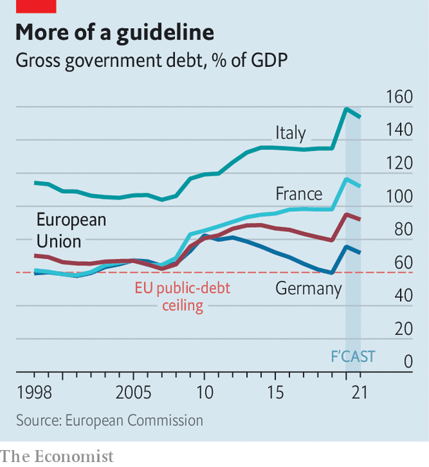

For some, the rules have wholly outlived their usefulness. In a new paper Olivier Blanchard, a former chief economist of the IMF, and two co-authors say that in a world in which nominal growth is likely to exceed interest rates for a long time, debt burdens can be sustainable at levels far higher than could have been imagined when the Maastricht treaty was being written. The authors suggest replacing the tangle of rules with looser “standards”, and applying a debt-sustainability test to countries’ budgetary plans.

Such far-reaching schemes stand no chance of becoming reality—and not only because they would mean reopening the EU’s treaties. A more moderate proposal, advanced among others by the European Fiscal Board, an advisory body to the commission, calls for a simpler framework: a debt “anchor” (which some suggest could be higher than 60%), and a spending rule that would cut excessive debt but adjust the pace of belt-tightening when growth is slow. The commission itself wants to distinguish better between investment and current spending.

France in particular is pressing for changes. But few matters are as divisive among the EU’s members as fiscal policy. And the debate will only begin in earnest next year. For now the EU is focused on implementing a €750bn ($880bn) recovery plan it agreed in July. Some hope this fund could prove a stepping stone to the sort of permanent European fiscal capacity that would render rules for national governments less relevant. But that is an argument for another day. ■

This article was downloaded by calibre from <https://www.economist.com/finance-and-economics/2020/10/31/what-next-for-the-eus-fiscal-rules>

|  |  |  |  |
| --- | --- | --- | --- |
| Previous | Articles | Sections | Next |

|  |  |  |  |
| --- | --- | --- | --- |
| Previous | Articles | Sections | Next |

#### Caveat victor

# If China’s economy is so strong, why isn’t its currency stronger?

The government may be using commercial banks as proxies to suppress the yuan

Oct 31st 2020 | SHANGHAI

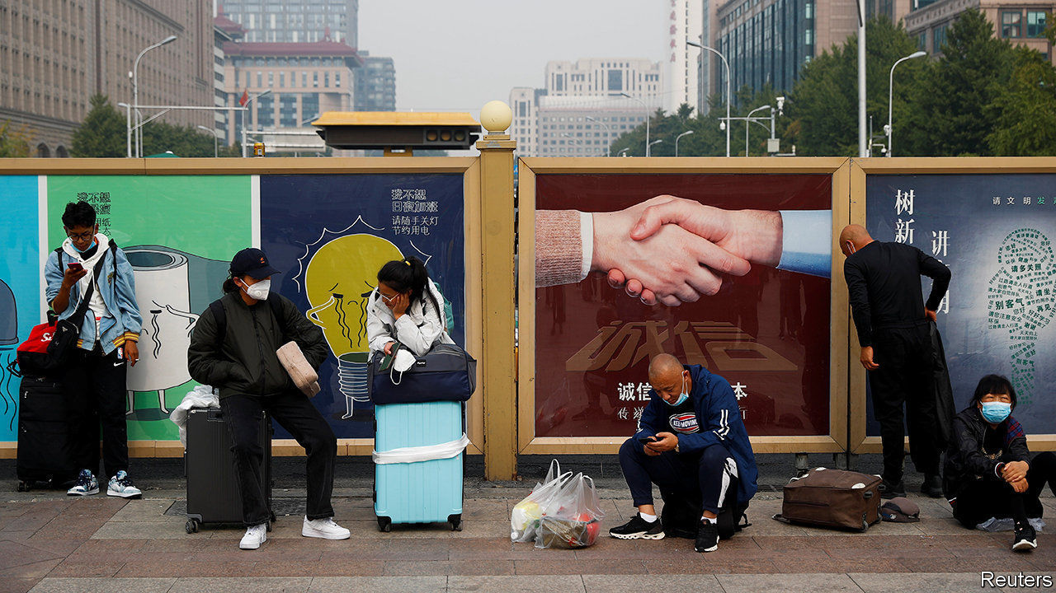

CHINA, AS ITS leaders like to observe, has fared better than any other big country this year. It has all but halted the covid-19 pandemic, got its economy back on track and, to top it off, reaped a cash windfall from abroad. The last has stemmed from a surge in its trade surplus, thanks in part to its factories running at full tilt, and a rush of money into its bonds, thanks in part to its growth outlook. Victors do, it seems, get the spoils. In economic terms, victors should also have a much stronger currency. But that has not happened. The yuan’s recent appreciation against the dollar has merely kept it in line with the yen and the euro. This raises the question, sure to rankle with officials in Beijing, of whether China is again manipulating its currency.

It is much harder to answer than in the past. For two decades until mid-2014 China’s prodigious accumulation of foreign-exchange reserves was the clear by-product of actions to restrain the yuan, as the central bank bought up cash flowing into the country. A sharp drop in reserves in 2015-16 was evidence of its intervention on the other side, propping up the yuan when investors rushed out. Since then, China’s reserves have been uncannily steady. This year they have risen by just 1%. Taken at face value, the central bank seems to have refrained from intervening. That is certainly what it wants to convey, regularly describing supply and demand for the yuan as “basically balanced”.

The past half-year therefore presents a puzzle. Given that China has racked up big inflows, how can the yuan have remained stable without an offsetting increase in foreign-exchange reserves? One possible explanation lies on the balance-sheets of its commercial banks. Their foreign assets, net of liabilities, have soared by $125bn since April. China’s big banks are all state-owned, so it is conceivable that the government has used them as proxies. Adding their foreign holdings to official reserves paints a picture more suggestive of intervention to suppress the yuan (see chart).

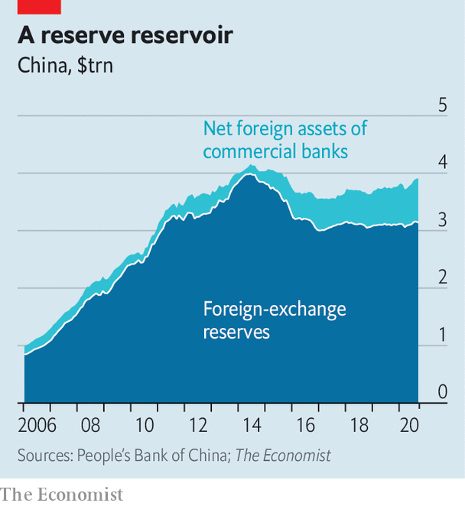

Several currency traders sense the hand of the state, albeit more discreet than in the past. “My guess is that the central bank now has special trading accounts at the state banks,” says one. Yet it is not an open-and-shut case. Exporters themselves have wanted to keep a large portion of their revenues in dollars, worried that friction with America could end up hurting the yuan.

China also has many tools for influencing the exchange rate beyond direct intervention. On October 12th the central bank made it cheaper to short the yuan in forward trades, a signal that it wanted to limit appreciation. Then on October 23rd a currency regulator said that a “smart market” would always consider upside and downside risks, a reminder that China wants the yuan to be volatile but within a fairly tight range. “Chinese officials have perfected the game of telling American officials that they are not intervening while persuading market participants that they will intervene if necessary,” says Brad Setser of the Council on Foreign Relations, a think-tank, who also advises Joe Biden’s team.

If China is intervening, the most charitable defence is that it views its big lead in GDP growth as transient. A big jump in the yuan when other countries are hobbled would set it up for a potentially destabilising fall when they recover. Leaning against appreciation helps prevent that. But if China’s outperformance endures without being reflected in the yuan, charitable feelings will quickly evaporate. ■

This article was downloaded by calibre from <https://www.economist.com/finance-and-economics/2020/10/31/if-chinas-economy-is-so-strong-why-isnt-its-currency-stronger>

|  |  |  |  |
| --- | --- | --- | --- |
| Previous | Articles | Sections | Next |

|  |  |  |  |
| --- | --- | --- | --- |
| Previous | Articles | Sections | Next |

#### Blitz-coin

# Getting down with the cool kids on bitcoin

How investors might learn to stop worrying and love crypto

Oct 29th 2020 |

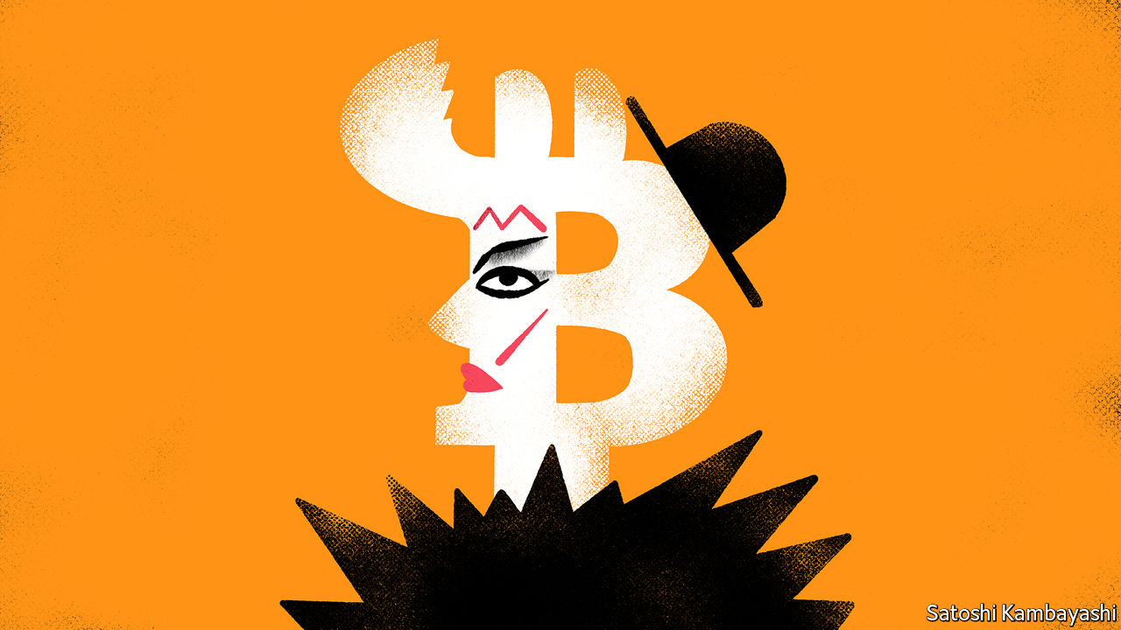

EVERY TUESDAY for most of 1979-80, the Blitz wine bar in Covent Garden was host to an influential club-night. London was then a run-down city. The Blitz was a seedy spot. What made it remarkable were the Blitz Kids, the extravagantly dressed Tuesday-night regulars. A teenage Boy George worked in the cloakroom. The door policy was strict. To get in, said Steve Strange, who ran the club-night, you had to look “like a walking piece of art”. Mick Jagger was once refused entry.

This all seemed shallow and transient. The make-up, the get-ups and the evident disdain for people who were not walking pieces of art were marks of unseriousness. Yet the Blitz Kids, a mix of art students and urchins, would go on to shape popular culture, according to “Sweet Dreams: The Story of the New Romantics”, a new book by Dylan Jones. This brings us to another hangout for oddballs, fantasists and drop-outs: bitcoin. To most people it seems at best a fad, at worst a con-job. But it refuses to disappear. And its price in dollars is up by around 150% since March.

It is hard to have a sensible conversation about bitcoin. To show interest is to invite contempt from sceptics and an inbox stuffed with get-rich-quick proposals from boosters. But a nagging thought will not go away. What if these crypto-kids are on to something just as the much-derided Blitz Kids were? After all, as well as notoriety, bitcoin has ingenuity and scarcity on its side.

Start with the ingenuity. Even people who are hostile to bitcoin will concede that its technology is fiendishly clever. It is essentially a way of accounting for who has spent what. Instead of a central exchange to keep score, and to verify payments and receipts, it uses an electronic ledger that is distributed across the entire system of bitcoin users. The system’s dispersed nature means that tampering with the accounts would require gaining control over a majority of the network’s computers. That is an important source of trust in bitcoin.

A big part of its appeal to users is that no one official entity—no government, bank or tech firm—is in charge. (This is also what a lot of people dislike about it.) The system is self-regulating. It is also self-limiting. Bitcoins are “mined” when a computer solves a very time-consuming maths problem. It must identify a large number encrypted in the system’s code. Over time the remaining numbers become harder to find. Eventually the mine will be exhausted. Bitcoin’s supply protocol is as restrictive as the Blitz’s door policy. Only 21m bitcoins will ever be produced.

Millennial techies are at home with all this. The older technophobic crowd tends to be hostile. So be it. “That most people still hate bitcoin isn’t a bad thing,” writes Dylan Grice of Calderwood Capital, an alternative-investment boutique, in a recent letter to clients. This is to say that it is difficult to make a lot of money buying an asset that everybody likes. And as with the Blitz, the infamy and outrage is part of the allure. Older visitors might grumble that the music played there was unremarkable or that the venue was a dump. It didn’t matter. The club acted as a focal point for like-minded people. That is an underrated virtue. Thomas Schelling, a Nobel prize-winning economist and game theorist, contended that people gravitate towards focal points without formally agreeing to do so. His insight extends to asset markets. Gold bars—or bitcoins—have value if enough people tacitly agree that they do.

What precisely might that value be? An honest answer is: “Who knows?” Bitcoin has no intrinsic worth. As with gold, there is no stream of future dividends to build a valuation around. Yet people have become comfortable with gold as an asset because it has been around for so long. Bitcoin is a newcomer, but its use is growing. So if you believe it has a future, you may want to own some, says Mr Grice. Indeed if you like gold as a hedge against a revival in inflation or some other calamity, you might consider transferring some of your gold allocation to bitcoin. It has advantages over the precious metal: it can be more easily stored and transferred, for instance. In some places, you can actually use it.

Bitcoin is a pretty tiny club. Beside it, gold looks as capacious as Wembley Stadium. The market value of all bitcoin is just 1-2% of the value of all the gold above ground. Scarcity is a trait of many things that are perceived to have value. Steve Strange, who sadly died in 2015, understood this fully. “The best move I ever made was turning Mick Jagger away at the door,” he said.

This article was downloaded by calibre from <https://www.economist.com/finance-and-economics/2020/10/29/getting-down-with-the-cool-kids-on-bitcoin>

|  |  |  |  |
| --- | --- | --- | --- |
| Previous | Articles | Sections | Next |

|  |  |  |  |
| --- | --- | --- | --- |
| Previous | Articles | Sections | Next |

#### The notorious GDP

# What GDP can and cannot tell you about the post-pandemic economy

Third-quarter figures are dramatic, but need careful interpretation

Oct 29th 2020 |

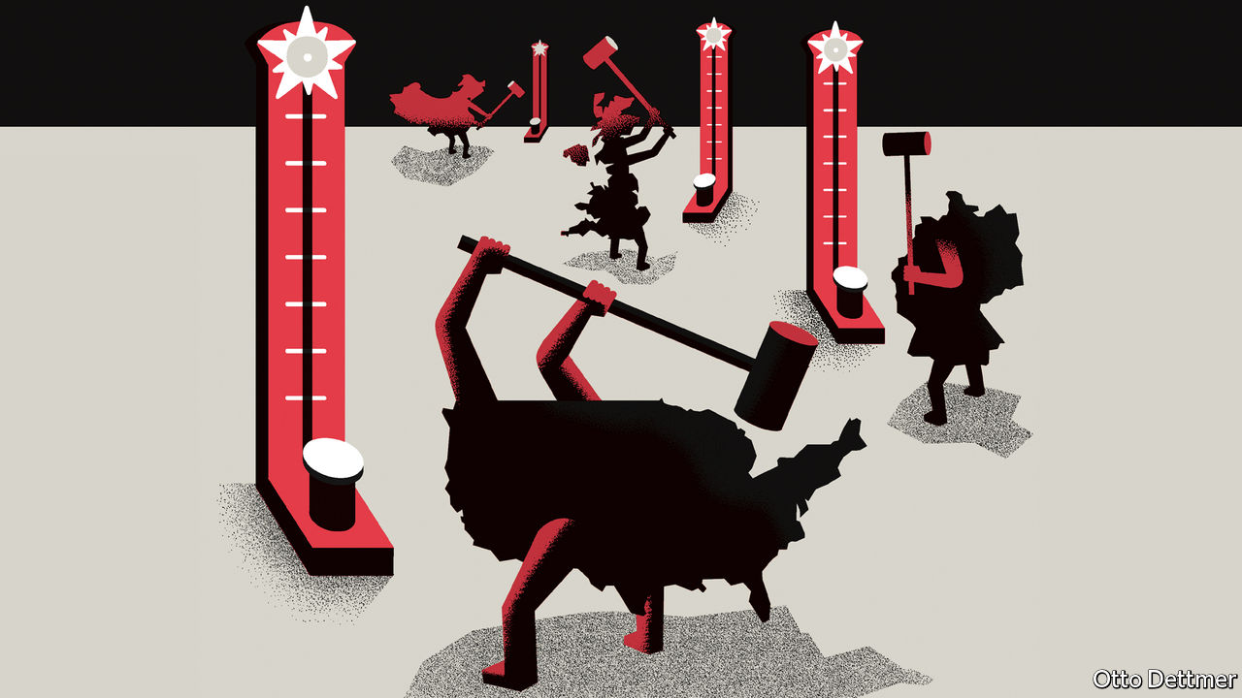

PITY THE world’s chartmakers. For years, normal economic fluctuations will be dwarfed by the extraordinary gyrations of 2020, such as the third-quarter GDP figures that are now rolling in. These data are informative—measures of output today are in part a reflection of governments’ success or failure in controlling the spread of covid-19. Yet they can easily mislead, and should be treated with care.

This year’s GDP figures pose a number of interpretative challenges. In America and Japan, for instance, statisticians present GDP growth compared with the previous quarter as an annualised rate, indicating how much an economy would shrink or expand if its performance in the relevant quarter were sustained for an entire year. As economies have swung into and out of lockdowns the practice has yielded numbers that are astonishing and misleading in equal parts. Real GDP in America shrank at a reported annualised pace of 31% in the second quarter, seeming to suggest that covid-19 swallowed nearly a third of America’s economic output. In fact, production in the second quarter was 9% below that in the first—still staggering, but quite a lot less dramatic.

Simple mathematics adds to confusion. On October 29th the Bureau of Economic Analysis reported that American GDP rose at an annual pace of 33% in the third quarter, compared with the second. The rate in this case is doubly misleading. Output rose by just 7.4% from the second quarter to the third. Though the third-quarter rise is larger, in absolute terms, than the second-quarter fall, the fact that the third-quarter growth rate took place from a pandemic-diminished base of output means that American GDP will still be nearly 3% lower than it was a year ago.

A similar year-on-year drop is expected for the world economy; the IMF expects global output to shrink by 4.4% this year. Exceptions—like China, where GDP in the third quarter stood about 5% above its level in the third quarter of 2019—look not only to have managed the crisis better than others but to have stolen a march on the rest of the world. Looks, though, can be deceiving. GDP is what economists call a “flow” variable: an estimate of how much is produced (or, equivalently, how much is spent or earned) in a period of time. If the economy is a hose conveying a stream of water, covid-19 is a kink constricting the torrent. Because of the pandemic, many normal activities—meals out, holidays, trips to the dentist—have gone unrealised. The kink has been more obstructive in some places than in others; Germany’s economy is forecast to shrink by 6% this year, whereas Spain’s may contract by 13%. The question is whether kinks today cause lingering damage to the hose, affecting its long-run capacity—ie, whether there will be what economists call “hysteresis”. The extent of such scarring is not clear-cut.

Hysteresis is a serious worry. IMF forecasts suggest that many large economies—Brazil, Britain, France and Japan among them—will produce less in 2022 than they did in 2019, in real terms. In Italy the shortfall may persist through 2025. But the depth and persistence of these effects is only loosely related to how much output flows through the hose this year. Consider the potential sources of long-run damage. Lost income for firms and households could mean loan defaults and bankruptcies, all of which stand to impair recovery as the threat from covid-19 recedes. Company shutdowns that sever job ties could delay a return to full employment and extend the period during which jobless workers’ skills and networks erode. A shortfall in investment has also checked the flow of GDP this year in ways that might depress long-run growth, by reducing levels of capital per worker and undercutting productivity growth. Tumbling private investment accounted for roughly a quarter of the dramatic decline in America’s GDP in the second quarter.

Yet the risk of scarring can be mitigated. Generous government stimulus could help break the link between households’ consumption today and their ability to consume tomorrow. Such relief may not have boosted GDP by much so far: recipients may have chosen to save their handouts, rather than spending them, or may have been forced to do so, because of lockdowns. Although stimulus cheques pushed up disposable incomes in the second quarter in America, for instance, households still saved 26% of their income, up from 7% in the second quarter of 2019. But healthy household balance-sheets prime the economy for a boom after the pandemic. This is why allowing some relief to lapse over the summer will be damaging. (The failure to renew stimulus is also a symptom of lawmakers’ mistaken emphasis on the short run. More borrowing today is likely to be better for long-run fiscal sustainability than a stingy response that depresses incomes for years to come.)

## Got a story to tell

The extent to which investment today affects tomorrow’s capacity to grow is also harder to assess than you might suppose. When firms explore ways to make use of new technologies, as many have been forced to do this year, they are spending on “intangible capital”, which may improve long-run growth without being recorded in today’s GDP. China’s expansion this year, by contrast, has been powered by investment in housing and infrastructure. Capital spending accounted for all of its economic growth in the second quarter, compared with the previous year, offsetting a steep drop in consumption, and for more than half of the rise in GDP in the third quarter. If these projects were well chosen, then they should contribute to future growth. If they were not, however, then an impressive GDP figure in 2020 may have bought little more than short-term bragging rights for the Chinese government.

No statistical measure is perfect. GDP is a crude proxy for a country’s economic health at the best of times, the sterling efforts of government data-gatherers notwithstanding. Tempting as it is to compare flows, sound economic management demands a different focus in the face of a deadly pandemic. ■

Editor’s note: Some of our covid-19 coverage is free for readers of The Economist Today, our daily [newsletter](https://my.economist.com/user#newsletter). For more stories and our pandemic tracker, see our [hub](https://www.economist.com/news/2020/03/11/the-economists-coverage-of-the-coronavirus)

This article was downloaded by calibre from <https://www.economist.com/finance-and-economics/2020/10/29/what-gdp-can-and-cannot-tell-you-about-the-post-pandemic-economy>

|  |  |  |  |
| --- | --- | --- | --- |
| Previous | Articles | Sections | Next |

|  |  |  |
| --- | --- | --- |
| Finance & economics | Sections | Books & arts |

Science & technology

Lunar exploration: Watermarked

.

Fishing: Have your hake and eat it

.

Ecology: Rats, palms and Palmyra Island

.

|  |  |  |
| --- | --- | --- |
| Finance & economics | Sections | Books & arts |

|  |  |  |  |
| --- | --- | --- | --- |
|  | Articles | Sections | Next |

#### Lunar exploration

# There is now cast-iron evidence for water on the Moon

And it may be more widespread than previously suspected

Oct 26th 2020 |

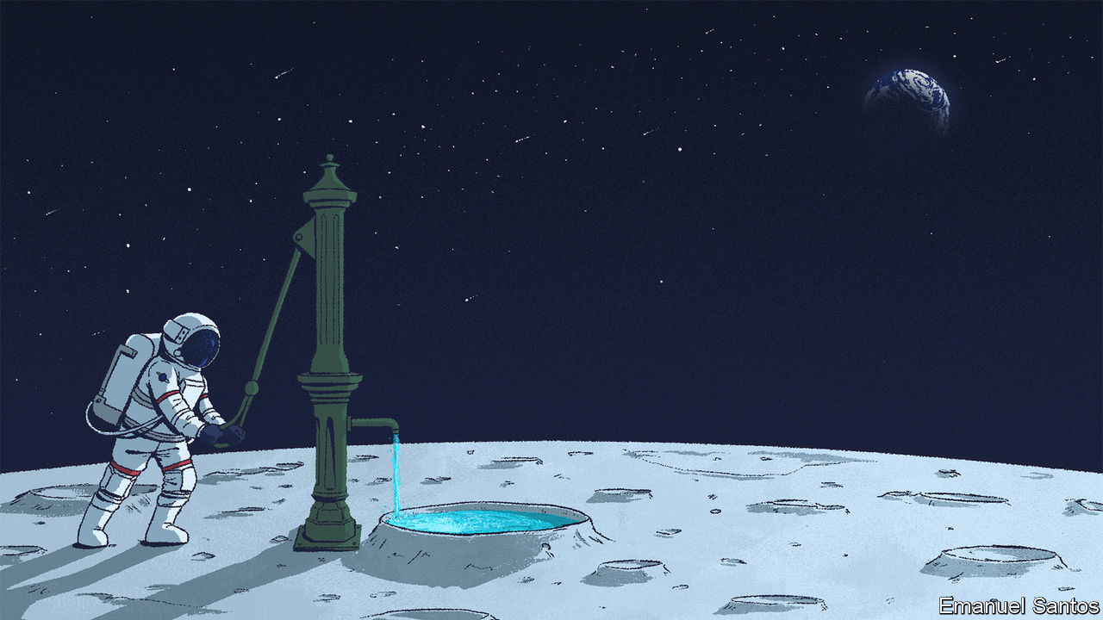

IF HUMAN BEINGS should ever wish to build bases on the Moon, those bases will need water. Residents will require it not only for their own sustenance but also as a raw material for rocket fuel to power adventures farther afield—Mars, for example. Given the cost of blasting things off the surface of Earth, however, such a base would be best served by finding its water locally. A pair of studies published on October 26th, in Nature Astronomy, will therefore raise the hopes of would-be lunar settlers.

One, led by Paul Hayne of the University of Colorado, Boulder, shows that more of the Moon’s surface is in perpetual shadow than was previously believed. This matters because ice—the form in which any lunar water is likely to exist—would be stable and long-lived in such cold, shaded regions. Most of the lunar surface is bathed in harsh ionising radiation from the sun, so any water molecules present would swiftly be torn apart or disappear into space. But Dr Hayne’s work calculates that there are around 40,000 square kilometres of these ice-preserving “cold traps” on the Moon.

The other investigation, led by Casey Honniball of the Goddard Space Flight Centre in Maryland, a branch of NASA, America’s space agency, confirms the presence of water molecules (H2O) on the Moon’s surface. Previous evidence could not distinguish such molecules from hydroxyl radicals (OH), which are subunits of water that are normally chemically bonded to other substances. Intriguingly, these water molecules are on sunlit parts of the surface, away from any cold traps.

## Sea of showers

Despite the Moon being Earth’s closest and most studied celestial neighbour, the presence of water there was confirmed only recently, by a gradual accumulation of evidence. In 1999 a NASA craft called Cassini detected hints of the stuff as it flew past on its way to Saturn. The hints became stronger a decade later when Chandrayaan 1, an Indian probe, flew to the Moon. An American instrument on board, the Moon Mineralogy Mapper (M3), employed a spectrometer to examine sunlight reflected back from the lunar surface. M3 found that infrared light of a specific wavelength—three microns—was being absorbed by the surface. This is an absorption pattern shown by water, but also by hydroxyl.

In October 2009, a few months after the results from M3 had been published, NASA crash-landed the spent stage of an Atlas V rocket into Cabeus, a crater near the Moon’s south pole. They chose Cabeus because it was known to have areas in perpetual shadow. The impact was followed minutes later by LCROSS, the Lunar Crater Observation and Sensing Satellite, its cameras trained on the site taking pictures and measurements of the resulting cloud of debris.

Previous scans of the Moon’s south pole in the 1990s, by NASA missions called Clementine and Lunar Prospector, had indicated large amounts of hydrogen were present in the region, though it was unclear what form this hydrogen took. LCROSS was designed to find out. The crash excavated 350 tonnes of lunar regolith, creating within Cabeus a crater 20 metres wide and generating a plume that rose 10km from the surface. Among the ejecta, LCROSS detected the characteristic three-micron spectroscopic signal, but still could not distinguish whether the cause was water or hydroxyl.

One way to tell the difference is to look for missing light at six microns, too—for only water molecules absorb at this wavelength. So that was what Dr Honniball set out to do. In 2018 she commandeered the only instrument capable of making the relevant measurement—the 2.5-metre-wide Stratospheric Observatory for Infrared Astronomy (SOFIA) telescope, which sits on board a modified Boeing 747 that can fly it to an altitude of 13km. This is above 99.9% of the water vapour in Earth’s atmosphere, which would otherwise obscure any infrared signal reflected from the Moon.

SOFIA normally observes distant celestial objects, such as black holes. Instead, Dr Honniball pointed it towards Clavius, a crater about 75° south of the Moon’s equator, and which, perhaps coincidentally, was the fictional site of an American Moonbase in “2001: A Space Odyssey”. She found an absorption line at six microns in the reflected sunlight. This confirmed that, here at least, between one and four parts in 10,000 of the material of the lunar surface is water.

How useful such water would be for future missions depends, though, not only on how much of it there is but also on how it is stored in the regolith. One possibility is that it exists as ice crystals in microscopic voids between regolithic grains. If that is true, lunar settlers could simply heat the regolith up to liberate its water. Dr Honniball thinks, however, that the water she has found is more likely to be trapped in tiny glassy beads that form when the lunar surface is hit by micrometeorites.

The theory behind this idea is that the solar wind, which is composed largely of protons, the nuclei of hydrogen atoms, continuously deposits that element into the regolith. Some of this hydrogen then reacts with oxygen atoms present as part of lunar minerals. That leads to the creation of hydroxyl radicals. When a micrometeorite hits the Moon, the impact vaporises the regolith. Everything is lifted into space, where the hydroxyls combine to form water molecules. These molecules are then encapsulated within drops of rapidly cooling regolith as it falls back to the surface.

## Sea of cold

Extracting water from such beads would not be straightforward. A more promising source is the ice thought to exist in cold traps. Dr Hayne’s team used high-resolution images from NASA’s Lunar Reconnaissance Orbiter to identify potential cold traps all across the Moon’s surface. There are more than had been hoped for, and they range in size from several kilometres to a few centimetres across. Most, as expected, are found near the poles, where the sun, when visible, remains near the horizon and shadows are consequently long. But a small number also exist at lower latitudes, created by craters or other surface variations that might be small but nevertheless maintain shadows where the temperatures stay low enough to accumulate ice.

Just because cold traps exist, however, does not mean they have trapped anything. Finding out if they have, and also answering the questions left open by Dr Honniball’s work, requires further examination of the regolith itself. In November 2023 NASA hopes to launch a mission called VIPER (Volatiles Investigating Polar Exploration Rover) to the Moon’s south pole. This craft will be armed with instruments designed to prospect the landing area for minerals and ice.

Both Dr Honniball’s and Dr Hayne’s results, then, give mission planners something to think about—not least those involved in NASA’s Artemis project to land people on the Moon some time this decade. Deciding where to site a base, should one ever be built, has always been a balance between the availability of water for food and fuel, and of sunlight for power. The idea of doing so at the south pole, to provide the water, would have come at the cost of astronauts having to work and live in pitch-dark conditions where temperatures rarely exceed -160°C. The possibility that better-lit and marginally less hostile parts of the lunar surface might have water as well will be a welcome prospect.■

This article was downloaded by calibre from <https://www.economist.com/science-and-technology/2020/10/26/there-is-now-cast-iron-evidence-for-water-on-the-moon>

|  |  |  |  |
| --- | --- | --- | --- |
|  | Articles | Sections | Next |

|  |  |  |  |
| --- | --- | --- | --- |
| Previous | Articles | Sections | Next |

#### Fishing

# Stopping some fishing would increase overall catches

You can have your hake and eat it

Oct 31st 2020 |

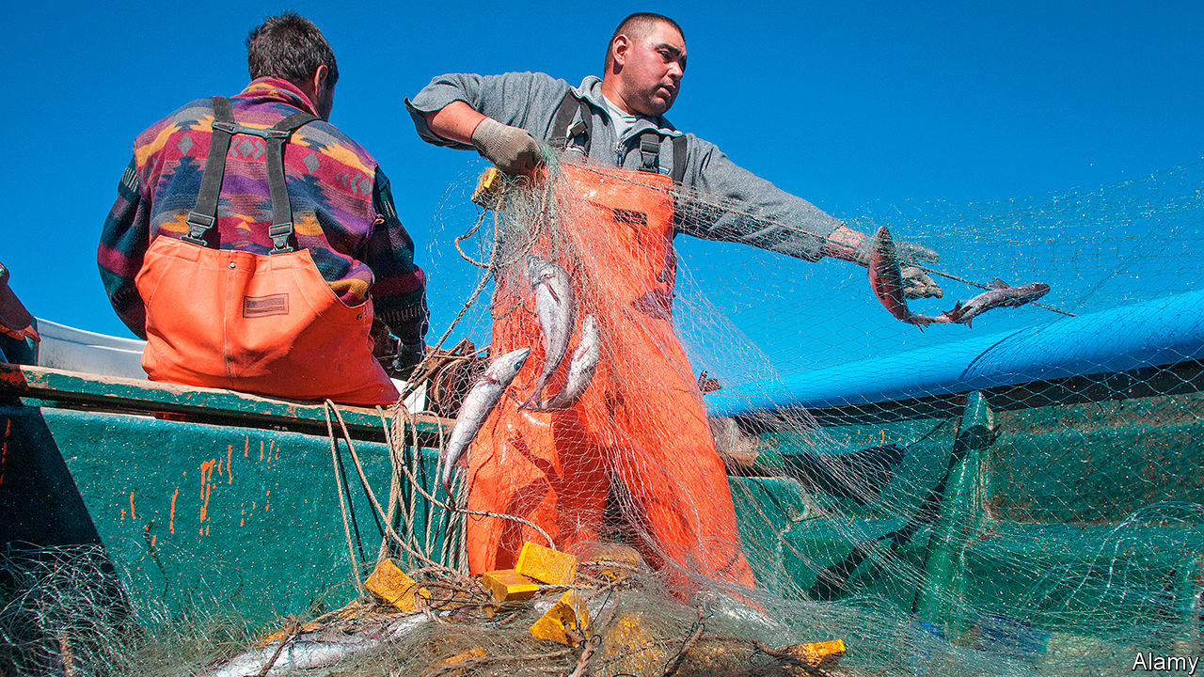

IN 2018, THE most recent year for which relevant data are available, people consumed more fish than they did either pork or beef or poultry. Humanity’s appetite for the sea’s bounty has more than doubled since 1990. Fish, whether wild caught or farmed, now make up nearly a fifth of the animal protein that human beings eat.

In this context, running the world’s fisheries efficiently might seem a sensible idea. In practice, that rarely happens. Even well-governed coastal countries often pander to their fishing lobbies by setting quotas which give little respite to battered piscine populations. Those with weak or corrupt governments may not even bother with this. Deals abound that permit outsiders legal but often badly monitored access to such countries’ waters. And many rogue vessels simply enter other people’s fishing grounds and steal their contents.

The demand side of the equation, then, has many problems. But there may be a way to improve the supply side: increase the area where fishing is forbidden altogether.

This paradoxical approach, which involves the creation of so-called marine protected areas (MPAs), has already been demonstrated on several occasions to work locally. Valuable fish stocks off Apo island in the Philippines increased significantly after a no-take reserve was created in 1982, and similar results have been forthcoming off the coasts of Florida, South Africa and St Lucia. Extrapolating from these examples, Reniel Cabral of the University of California, Santa Barbara and his colleagues have, as they describe in the Proceedings of the National Academy of Sciences, built a model which explores the idea of extending MPAs elsewhere. If the right extensions are picked, their model suggests, designating a mere 5% more of the world’s oceans as MPAs—which would triple the area protected—could increase the future global catch of the 811 species they looked at by more than 20%. That corresponds to an extra 10m tonnes of food a year.

The idea that restricting fishing would permit more fish to be caught may seem counterintuitive, but the logic is simple. Fish in MPAs can grow larger than those at constant risk of being pulled from the ocean. Larger fish produce more eggs. More eggs mean more fry. Many of these youngsters then grow up and move out of the safe zone, thus becoming available to catch in adjoining areas where fishing is permitted.

Dr Cabral and his team based their calculations on data they compiled for 1,338 stocks of fish and marine invertebrates. For each they mapped the geographical range, mobility and population growth of the local species, and assessed the sustainability of present-day fishing levels. That let them create a model of the ocean from which the impact of changes in fishable area could be assessed. Working at a fairly coarse resolution—each pixel corresponding to a square of ocean 55km across—they discovered that a small, well-aimed increase in the size of MPAs brought substantial benefit.

## Less is more

Though MPAs work their magic on all sorts of fishing grounds, Dr Cabral’s model suggests they are especially beneficial for the worst-managed areas, most of which are tropical—and in particular for overfished species such as Atlantic horse mackerels, Japanese anchovies and Argentine hake (the catch pictured on the previous page).

They also have the virtue of simplicity. The setting of quotas is open to pressure to overestimate of how many fish can safely be caught. And different species need different arrangements, making management harder. The breeding habits of the fish concerned must be monitored, and good estimates made of their numbers. This is difficult enough for countries with well-developed fisheries-research establishments. For those without such it is little more than guesswork. And the problem is made yet more complicated by the fact that tropical ecosystems are more speciose and thus harder to understand and manage than those in temperate climes.

Setting the rules for an MPA is, by contrast, easy. You stick up a metaphorical sign that says, “No fishing”. Knowing who is breaking the rules is easy, too. If your gear is in the water, you are fishing illegally.

There are, Dr Cabral and his team readily admit, limitations to their model. Not all fish stocks are equally well recorded, meaning many pertinent species escaped the analysis. Including these would more than double the underlying tonnage of catch being looked at, and might reasonably be presumed to add to the increase in yield that the model already predicts. Also, though good data exist about the movement of fish around the world’s oceans, where they spawn is less well understood. As spawning grounds are prime sites for MPAs, this uncertainty muddies the waters.

The researchers’ hope, though, is that—perhaps inspired by this study—some governments will now think it worthwhile to conduct more detailed investigations of their own. If a bit more protection results in a lot more fish, everybody wins.■

This article was downloaded by calibre from <https://www.economist.com/science-and-technology/2020/10/31/stopping-some-fishing-would-increase-overall-catches>

|  |  |  |  |
| --- | --- | --- | --- |
| Previous | Articles | Sections | Next |

|  |  |  |  |
| --- | --- | --- | --- |
| Previous | Articles | Sections | Next |

#### Ecology

# Kill one unwanted species and another arises

A tale of rats and palms on an atoll in the Pacific

Oct 31st 2020 |



IN THE HIERARCHY of conservationists’ concerns, animals often seem to trump plants. For example, feral rats that live on islands after having been introduced accidentally by passing ships are excoriated because of the damage they do to local wildlife. More than 100 island-based animals have been exterminated or are imperilled by these rodents—birds being at particular risk through loss of eggs and nestlings. The effects of the interlopers on the local flora are, however, less well investigated.

Rats’ main source of nutrition being seeds and fruit, this is a surprising omission. But it has been rectified in part by a project undertaken by Ana Miller-ter Kuile of the University of California, Santa Barbara. The object of Ms Miller-ter Kuile’s attention was Palmyra, an atoll that is one of the most remote specks of land in the Pacific Ocean. And, as she describes in Biotropica, by focusing on the atoll’s plants she showed just how extensive an effect rats can have on an isolated island’s ecology. She also showed, though, that restoring matters to the status quo ante bellum is not as easy as might be hoped.

Palmyra, an American territory, is the northernmost of the Line Islands. At the moment it has no permanent human residents. But it does host a scientific base that is home, at any given time, to a couple of dozen researchers. During the second world war, however, it was the site of a naval airbase—and along with the ships, planes and personnel that serviced this base came rats.

Because of the damage these rodents cause, the elimination of rats from small islands like this one has become something of a cottage industry in recent years. More than 400 have been thus cleared of their infestations. Palmyra’s turn was scheduled for 2011, and Ms Miller-ter Kuile saw this as an opportunity to observe how the local plants would respond.

In 2007 she and her colleagues established seven vegetation-monitoring plots on the atoll, each 300 square metres in area. They observed the plants in these plots until the moment, four years later, when doom for Palmyra’s rats rained down from the skies in the form of bait stations loaded with poison. That this bombardment did for the rats successfully was confirmed the following year, by the setting up of further bait stations. Not a single station was touched. The animals were gone. Ms Miller-ter Kuile and her colleagues waited a further three years for things to settle down, and then got back to the task of monitoring their plots. They did so for four more years.

## No good deed goes unpunished

The difference this second time around was palpable. During both periods of examination, the researchers concentrated their efforts on juvenile trees. Between 2007 and 2011 they found that the mass of such trees remained unchanged. Between 2014 and 2017 it rose 14-fold. Ironically, however, the main beneficiary of this expansion was the coconut palm.

Though coconut palms do grow wild on Pacific islands, those on Palmyra are, like the rats which once inhabited it, aliens. They are the descendants of palms imported to create copra plantations. In the 1850s, before people started taking an interest in the place, Palmyra’s coconut-palm population is reckoned to have been about 4,000 adult trees. Copra farming changed this and, though the last planation was abandoned many years ago, the consequence was that in 2005 the coconut-palm population exceeded 53,000. Now that the rats are gone, Ms Miller-ter Kuile’s work suggests this population will grow yet bigger.

Even without its rats, then, Palmyra’s ecosystem looks unlikely to return to anything approaching its prelapsarian state without further human assistance. In 2019 the Nature Conservancy, an American charity that now owns most of the atoll, began a further project: uprooting coconut-palm sprouts to give other species, particularly the delightfully named grand devil’s claw, a chance. Whether culling the coconuts in this way will also have unintended consequences remains to be seen.■

This article was downloaded by calibre from <https://www.economist.com/science-and-technology/2020/10/31/kill-one-unwanted-species-and-another-arises>

|  |  |  |  |
| --- | --- | --- | --- |
| Previous | Articles | Sections | Next |

|  |  |  |
| --- | --- | --- |
| Science & ... | Sections | Economic & ... |

Books & arts

Political philosophy: Sylvanian fantasies

.

Matisse in lockdown: Windows of opportunity

.

Bumps in the night: Uninvited guests

.

Kenyan fiction: Magic mountain

.

Johnson: The riddle of the cucumbers

.

|  |  |  |
| --- | --- | --- |
| Science & ... | Sections | Economic & ... |

|  |  |  |  |
| --- | --- | --- | --- |
|  | Articles | Sections | Next |

#### A resilient ideology

# Conservatism works best when it compromises

But which changes are inevitable, and which should be resisted?

Oct 31st 2020 |

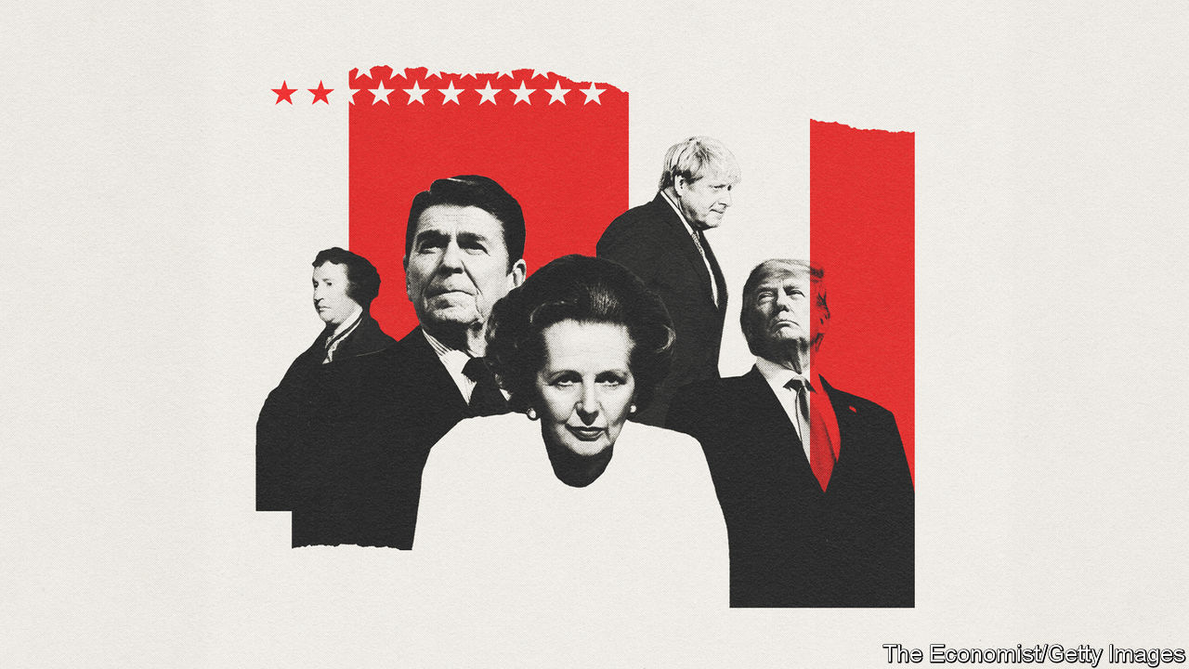

Conservatism. By Edmund Fawcett. Princeton University Press; 544 pages; $35 and £30.

IN 1794 TWO British students made a plan to set up a radical Utopia—in Pennsylvania. Samuel Taylor Coleridge and Robert Southey envisaged creating a society governed along the latest Pantisocratic principles, with no private property and plenty of time for art. They would write sonnets while ploughing the soil, criticise poetry while chasing buffalo and discuss metaphysics while chopping down trees. It came to nothing, for the usual reasons: lack of money and disagreement about who would ultimately be in charge. Southey, for example, thought that women should do all the domestic work and the child care. Coleridge disagreed.

As well as writing Romantic verse, both Coleridge and Southey would go on to be prominent conservatives. Coleridge became preoccupied with the need to maintain order. He also worried that democracy would ruin valuable elitist pursuits, such as the composition of lengthy poems about decrepit sailors. Southey went further. Though he became poet laureate, he thought that people who committed libel ought to be transported to Australia. When a cavalry regiment fatally charged into a crowd of protesters in Manchester in 1819, Southey blamed the crowd.

The crossing of boundaries that separate it from radicalism is a theme of Edmund Fawcett’s epic history of conservatism. It begins, as is traditional, with the French revolution. Previous revolutions—1688 in England, 1776 in America—could be seen as defences of ancient liberties, and so as attempts to restore something that had been spoiled by despotism. But 1789 was different; there was nothing ancient or restorative about the guillotine and the basket. In arguments against the French revolution, a conservative tradition was founded. It has been an essential ingredient of Western democracy ever since.

Throughout its first 200 years, conservatism has contained an unresolvable tension. Robert Peel, the Tory prime minister who created London’s Metropolitan Police, thought his party’s governing philosophy ought to be to oppose unneeded social change wherever possible, but to accept it where necessary. Writing much later, Samuel Huntington, an American academic, thought that in this regard all conservatism was “situational”. But how to tell the difference between unnecessary change and the unavoidable sort?

## Bend or break

Subordinate to that big question are several other conservative puzzles. Is democracy good, because it is generally a source of order, or bad, because it can pose a threat to established ways of doing things? Is capitalism too disruptive a force for conservatives to embrace? Are the masses possessed of plain common sense, or should complex matters of state be left to an enlightened (conservative) elite? Is modern architecture mostly harmless, or should it all be bulldozed and replaced by something with a nice portico?

Previously the author of a penetrating history of liberalism, Mr Fawcett—who also wrote for The Economist for 30 years, from London, Paris, Berlin and Washington, until he retired in 2003—traces these tensions through a multistorey pantheon of thinkers in Britain, France, Germany and America. Almost all are men; each is put briefly into historical context, with sketches of the politics of their time. The result is more guidebook than essay, but to the extent that Mr Fawcett has a unifying thesis it is that liberal democracies flourish when conservatives feel safe in them, and are prone to collapse when they do not. Or, to put the proposition in reverse: compromising conservatism is a vital part of a healthy democracy; the uncompromising kind is a threat to liberty.

Practical, compromising conservatism of the sort pursued in the past by prime ministers and presidents has sought to embrace its contradictions rather than take sides. By doing so it became the dominant force in Western governance. Despite initially setting themselves up as an opposition force in the countries covered here, conservatives have exercised more power than liberals or socialists combined. They also have a decent record in the kind of social reforms that liberals like to think are their turf. The extension of the franchise in Britain is a good example of compromising conservatism: British Tories spent much of the 19th century arguing for restrictions on the right to vote, before doubling the size of the electorate in 1867—and proceeding to win six of the next ten general elections under the new rules.

Uncompromising conservatism has a darker history. In Mr Fawcett’s telling it runs from Joseph de Maistre and his counter-revolutionaries in the French-speaking world; to the pro-slavery arguments made by John C. Calhoun in America’s Senate; and on to the 20th-century conservatives in France and Germany who failed to defend democracy, a failure which allowed jackbooted fascists to march through Europe in the 1930s. Chastened by that experience, and aided by the foreclosing of radical options that had tempted some of its adherents before the second world war, conservatism then enjoyed its greatest period—from 1945 until very recently.

Now conservatism is in trouble again. Most of its front-rank thinkers in America feel orphaned by a movement they helped create, as conservatism as a political brand has been seized by people like Viktor Orban, Marine Le Pen and Donald Trump. Defeat for Mr Trump, though, would offer another chance for this flexible ideology’s renewal. The way out, so the past couple of centuries suggest, is to think hard about what is worth hanging on to and what must be abandoned. And then to compromise. ■

John Prideaux: We identify the reviewers of books connected to The Economist or its staff. John Prideaux is the paper’s United States editor.

This article was downloaded by calibre from <https://www.economist.com/books-and-arts/2020/10/31/conservatism-works-best-when-it-compromises>

|  |  |  |  |
| --- | --- | --- | --- |
|  | Articles | Sections | Next |

|  |  |  |  |
| --- | --- | --- | --- |
| Previous | Articles | Sections | Next |

#### Windows of opportunity

# Matisse’s windows offer glimpses of another life

A delayed show at the Centre Pompidou captures and alleviates the lockdown mood

Oct 31st 2020 | PARIS

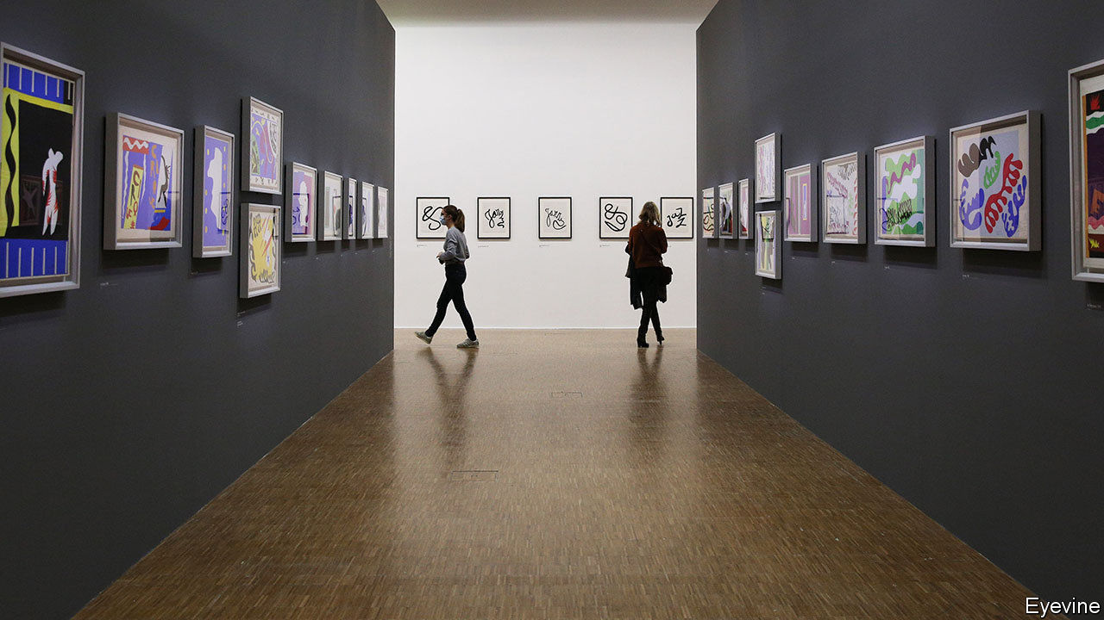

A DOUBLE FRENCH window flung open to reveal a glimpse of headland and sea. The distant peach-pink glow over a Paris bridge, framed by the dark inky-blue walls of an apartment’s interior. The quiet contemplation of a violinist as he practises before a closed upper-floor window. One of the more unexpected sensations prompted by the Centre Pompidou’s major new exhibition, “Matisse, like a novel”, is that the artist inadvertently captures life in lockdown: the confined angular indoor spaces, the teasing promise of open windows, the glimpse of a brighter life beyond.

In 1908 Henri Matisse wrote of his own work: “What I dream of is an art of balance, of purity and serenity, devoid of troubling or depressing subject matter…a soothing, calming influence on the mind.” His association with decorative art, and his defiant use of vibrant colour, earned him a reputation as a painter of bonheur. The chance to see “Interior with aubergines” (1911), for example, a vast canvas that vibrates with floral motifs and fabrics and disrupts space and dimension, lent for the exhibition by the Museum of Grenoble, is indeed a sheer delight. As are the original, vivacious “Jazz” cut-outs (1943-46) or “Red interior, still life on a blue table” (1947), one of Matisse’s last works in oil, on loan from Dusseldorf.

Looking at his paintings at a time of pandemic, though, is a reminder of how much more there is to him. The Pompidou had to postpone the exhibition, which marks the 150th anniversary of Matisse’s birth, from May this year because of covid-19 (it finally opened last week). It has reduced the number of tickets sold each day to meet health rules, and closes early to conform with the nightly curfew in Paris. Over 230 works are on display, although none from Russia or private American collections. In a nod to the title of Louis Aragon’s work “Matisse, a novel”, exhibits are organised around the thoughts of nine writers on the painter, and the interplay between his art and the written word.

It is the windows, though, that seize the lockdown eye. Unlike the English-style vertical-sliding sash version, French double casement windows seem designed to be thrown wide open, to blur the interior and exterior worlds. Raised in northern France, Matisse was enchanted by the Mediterranean light, and brought it in to fuse inside and out. “Red interior, still life on a blue table” boldly blends both perspectives in a profusion of red and gold. “Interior with goldfish”, painted from his fourth-floor Paris studio on the Quai Saint-Michel in 1914, on the eve of war, speaks more of solitude. A translucent wash of light on the Ile de la Cité beckons through the window, framed by the sombre greys and Prussian blues of walls and furniture. Two goldfish swim in a bowl, confined.

Matisse’s windows are playful, childlike, enticing, deceptive, but also on occasion darker, a hint at the unknown that may lurk beyond the comfort of home. In “French window at Collioure” (1914), it is the shutters that Matisse has given colour, while a black wash obscures the view. Aurélie Verdier, the exhibition’s curator, stresses that Matisse “can also be read in the light of a certain anxiety”.

Art was his way to work through it. In 1916, as the first world war raged on, the painter said that he had begun “to use black as a colour of light and not as a colour of darkness”. As lockdowns tighten again, this ambiguity, and the uplifting moments of insouciance that the Matisse exhibition offers, are unusually powerful. ■

“Matisse, like a novel” will be at Centre Pompidou, Paris until February 22nd 2021. Image: “Celestial Jerusalem” © Succession H. Matisse

This article was downloaded by calibre from <https://www.economist.com/books-and-arts/2020/10/31/matisses-windows-offer-glimpses-of-another-life>

|  |  |  |  |
| --- | --- | --- | --- |
| Previous | Articles | Sections | Next |

|  |  |  |  |
| --- | --- | --- | --- |
| Previous | Articles | Sections | Next |

#### Bumps in the night

# Exorcism has a long and spooky history

Demand surged after the release of “The Exorcist” in 1973

Oct 31st 2020 |



The Penguin Book of Exorcisms. Edited by Joseph Laycock.Penguin Classics; 336 pages; $17.

WITH DISARMING banality, in April 2012 Father Michael Maginot, a Catholic priest in Indiana, wrote to his bishop about a recent event. During his weekly Bible class, he had “received a call…to perform an exorcism on a boy witnessed by many as walking backwards up a wall.”

The boy was the son of Latoya Ammons, the haunting of whose house and the apparently supernatural possession of whose offspring became the subject of intense media coverage and, later, a film. The priest’s request for permission to conduct the ritual makes suitably chilling reading for Halloween. Among other things, Ms Ammons’s children were said to break into a “demonic chant, where one would stop and the other would pick up where [the first] left off”.

In his commentary on this letter, Joseph Laycock of Texas State University—author of “Speak of the Devil” and “Vampires Today”—does not mention that the family’s doctor thought the whole thing was a hoax, nor that previous and subsequent tenants of Ms Ammons’s house did not experience paranormal activity. His anthology of writings about exorcism, including eyewitness accounts, is short on scepticism (though not wholly lacking in it). But the book shows in illuminating detail how the belief in demonic possession stretches back more than 2,500 years.

An early presumed victim was Princess Bentresh, the daughter of a potentate in what today is Turkey. Her resident demon was said, in a later inscription, to have fled at the sight of a statue of Khonsu, the Egyptian lunar god. Mr Laycock surmises that Bentresh may actually have been throwing a tantrum because the pharaoh Rameses II had married her sister rather than her.

Demons able to take possession of people feature in virtually all the world’s main religious traditions: bhuts in the Indian subcontinent, fox spirits in China and Japan, zar in parts of Africa and the Middle East. A hadith (a text recounting a saying of the Prophet) has Muhammad driving a demon from the body of a young boy. He “opened the boy’s mouth and blew into it three times, and he said, ‘In the name of God—I am the servant of God—Go away, O enemy of God!’”

Many Muslims are nevertheless sceptical of demonic possession, and the leaders of the more established Christian churches had until recently come to see exorcism as something between a superstition and an embarrassment. Yet today it is in greater demand in the Christian world than at any time since the febrile witch-hunting days of the 17th century. William Friedkin’s cult film of 1973, “The Exorcist” (see picture), prompted a huge uptick in America, while the global spread of Pentecostal and evangelical Christianity has propagated a rebranded version of exorcism as “deliverance ministry”.

Some believers will doubtless see this as the result of a rise in genuine demonic activity. Others may side with a character in one of the “Colloquies” of that dogged old sceptic, Erasmus, who argued that “many Things that have been printed and published, as true Relations, were only by Artifice and Imposture, Impositions upon credulous Persons.” ■

This article was downloaded by calibre from <https://www.economist.com/books-and-arts/2020/10/31/exorcism-has-a-long-and-spooky-history>

|  |  |  |  |
| --- | --- | --- | --- |
| Previous | Articles | Sections | Next |

|  |  |  |  |
| --- | --- | --- | --- |
| Previous | Articles | Sections | Next |

#### Kenyan fiction

# Sisters and suitors battle ogres in “The Perfect Nine”

At 82, Ngugi wa Thiong’o has written a delightful novel in verse

Oct 31st 2020 |

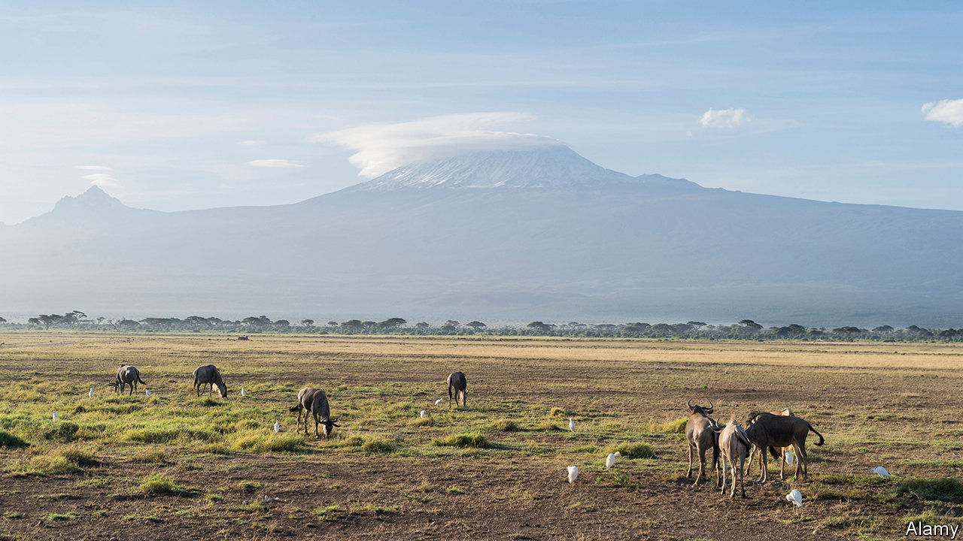

The Perfect Nine. By Ngugi wa Thiong’o. New Press; 240 pages; $23.99. Harvill Secker; £12.

AMONG THE most exciting new writing of the past few decades has been the reimagining of foundation myths by authors across the globe: Derek Walcott breathing fresh life into Homer in St Lucia; Murray Bail reinventing the princess-in-the-tower fable among Australia’s ever-varied eucalyptus forests; Gabriela Cabezón Cámara subversively turning a famous gaucho narrative from the macho Argentina of the 1870s into a gay feminist story, published in English earlier this year as “The Adventures of China Iron”.

Now comes Ngugi wa Thiong’o, an 82-year-old Kenyan novelist and playwright, with an experimental epic written in blank verse—originally in his native tongue and translated into English by the author himself. It tells of the very first Kikuyu and their passionate attachment to Mount Kenya, the home of their god, Ngai.

Early in their marriage, fleeing war and starvation, Gikuyu and Mumbi, his “partner in everything”, settle in the mountain’s foothills. They bring up a family of famously beautiful, self-reliant girls; the youngest, Warigia, is an ace with the bow and arrow, although disabled from birth and unable to walk. When 99 suitors turn up one day in search of brides, Gikuyu and Mumbi urge their daughters to test the men first and then choose, but above all to choose wisely.

“Warigia is my last born,” Mumbi explained.  
“She makes up the Perfect Nine.  
Her eyes can see a long way, and her ears hear sounds from afar.  
Her legs are the only organs that remained those of a child.  
The rest of the body is a grown woman, and she does things her own way.”

Mr wa Thiong’o’s writing is rich with Kikuyu folklore and observations about this mountain of tropical forests and icy peaks, and his verse has a galloping intensity that gives the narrative momentum. The men are instructed that they must first build new homes, each named after one of the daughters. Then the suitors must bring back the cure for Warigia’s disability, which, they are told, is a single hair that can be found only on the tongue of an ogre.

The sisters take the men up the mountain, trying their courage and devotion. Some get eaten by crocodiles, others sink in the mud or are bitten by snakes. Many run away. And then on the upper slopes they encounter the ogres, among them the Ogre of Endless Tears and the Ogre that Shat Without Stopping, around whom the air “smelled of pure rot”. The posse:

feared that the rot might pollute the rivers.  
Polluting air and water is poisoning life.  
We chased the ogre with the sweet smell of fresh flowers.

Gifted, ingenious and brave, the older sisters have a generosity of spirit that is well conveyed in the book’s lolloping rhythms. But it is Warigia’s story—with its challenges, uncertainties and bittersweet ending—that gives this tale its deep humanity. Most writers lose their energy and inventiveness as they grow old. Not Mr wa Thiong’o. “The Perfect Nine” is one of the year’s great discoveries. ■

This article was downloaded by calibre from <https://www.economist.com/books-and-arts/2020/10/31/sisters-and-suitors-battle-ogres-in-the-perfect-nine>

|  |  |  |  |
| --- | --- | --- | --- |
| Previous | Articles | Sections | Next |

|  |  |  |  |
| --- | --- | --- | --- |
| Previous | Articles | Sections | Next |

#### Johnson

# A tantalising book of puzzles is a gateway to linguistics

How do you say “nine cucumbers” in Japanese?

Oct 31st 2020 |

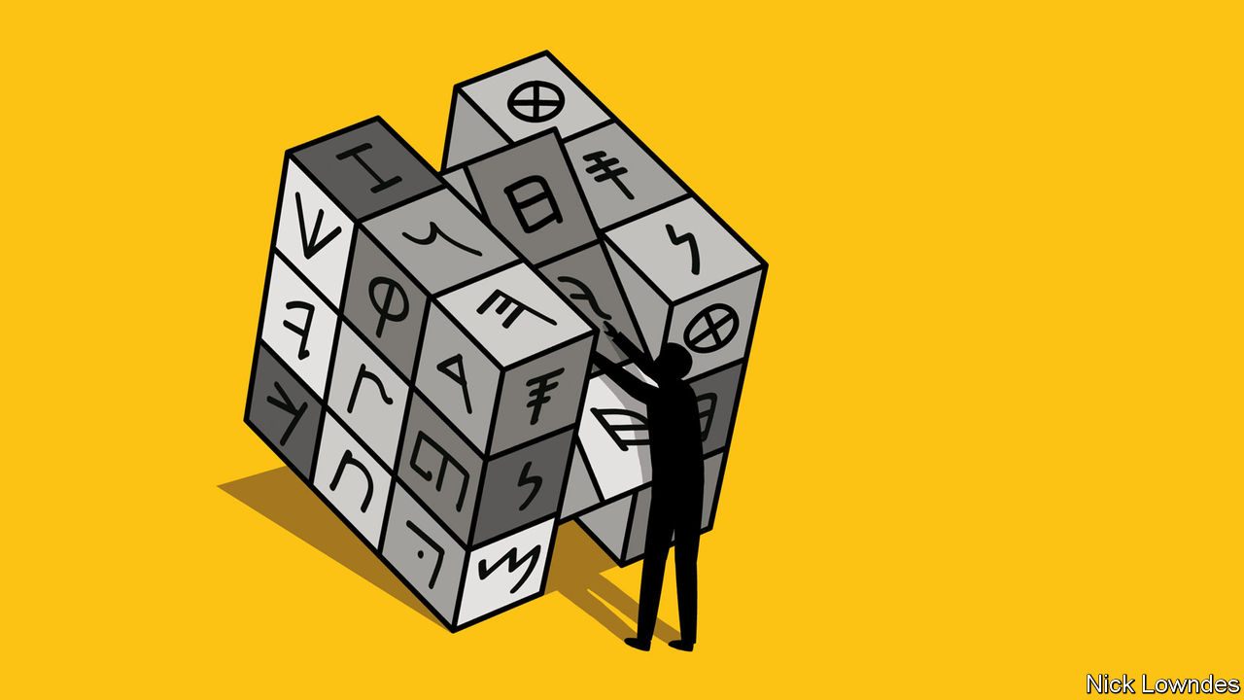

YOU HAVE a candle, a box of matches and some tacks. How do you affix the candle to the wall so the wax won’t drip on a table below? It is a classic problem first devised in the 1930s. Most people struggle with it. The easiest solution: pour out the matches, and use the tacks and part of the matchbox to make a little shelf, which the candle can sit on. The reason people struggle is “fixedness”: the association of candles with the matches themselves is so strong as to blot out the container. The idea that the box is more important simply doesn’t occur.

Now consider this problem, derived from these Japanese phrases: boru niko (two balls), tsuna nihon (two ropes), uma nito (two horses), kami nimai (two sheets of paper), ashi gohon (five legs), ringo goko (five apples), sara gomai (five plates) and kaba goto (five hippos). How do you say “nine cucumbers”? Kyuri kyuhon, kyuri kyuko, kyuri kyuhiki or kyuri kyuto?

If that fires you up, you are probably not only a language-lover but a puzzle-solver, with the type of intellect that thrills not only to cryptic crosswords but to sudoku or brainteasers like the matchbox riddle. And Alex Bellos, who has the delightful job of “puzzle columnist” at the Guardian, has a book for you: “The Language Lover’s Puzzle Book”. It begins with the Japanese conundrum above (a hint at the answer is at the end of this column), and takes readers through a host of linguistic games that will stretch their minds in ways most were not aware they could be stretched.

Mr Bellos was inspired by the Linguistics Olympiad, a competition for students that gives them problems like the Japanese one. It requires no knowledge of Japanese; questions are intentionally drawn from languages that the contestants won’t know. The point is to piece together the answer using barely sufficient evidence, some common sense and some uncommon reasoning.

Uncommon, at least, to non-speakers of the languages involved. Languages pay attention to different things: a famous formulation of this idea, by Roman Jakobson, a Russian-American linguist, is that languages differ not in what they can say, but what they must. English-speakers take note of the distinction between “a man” and “the man”, which many languages could not care less about; when others learn English they have to force themselves to grapple with details that seem to them trivial. Mr Bellos’s book is not just a puzzle collection, but an introduction to the science of distilling regularities from the weird ways in which languages behave.

History buffs will enjoy a chapter that focuses on decoding ancient tongues. Some of the challenges are just simple enough to impart a sense of confidence (such as matching runic inscriptions to Norse words and the names of gods). Some are so hard as to inspire awe for those who cracked them, like the deciphering of a passage of Old Persian in cuneiform script, starting with impossibly little information. Mr Bellos provides short narratives about such feats, and how they in turn inspired others—in this case, the interpretation of cuneiform writings from Babylon and Sumer.

Along the way, the seemingly exotic becomes familiar. In a simplified but realistic example, readers can reconstruct proto-Germanic, spoken 2,000 years ago but never written down, by figuring out patterns of difference in the daughter languages of German, Icelandic and English. Suddenly Icelandic looks like English’s cousin, which it is. But the familiar also becomes exotic. The Tok Pisin creole of Papua New Guinea may be based on English, but few will guess that gras bilong dok is “the grass that belongs to the dog”, or fur.

Many people think academic linguistics is either something to do with working out “correct” grammar (it isn’t), or with learning to speak a dozen languages (most linguists do not). It is really about the kind of problem-solving that can help a field linguist translate an isolated unknown language, a historical linguist reconstruct a never-written tongue, or a computational linguist code a computerised translation system. Many beginners, after the buzz of Mr Bellos’s puzzles, may also fall in love with the joys of this misunderstood discipline.

About those Japanese cucumbers. Unless you know a language that behaves similarly, like Chinese, you may not have thought to consider the shape of the objects being counted. In Japanese this is integrated into the numbers themselves. Once you’ve found the solution, and those to many other comparable problems, it will become second nature to think outside the matchbox.

This article was downloaded by calibre from <https://www.economist.com/books-and-arts/2020/10/31/a-tantalising-book-of-puzzles-is-a-gateway-to-linguistics>

|  |  |  |  |
| --- | --- | --- | --- |
| Previous | Articles | Sections | Next |

|  |  |  |
| --- | --- | --- |
| Books & arts | Sections | Graphic detail |

Economic & financial indicators

Economic data, commodities and markets

.

|  |  |  |
| --- | --- | --- |
| Books & arts | Sections | Graphic detail |

|  |  |  |  |
| --- | --- | --- | --- |
|  | Articles | Sections | Next |

# Economic data, commodities and markets

Oct 31st 2020 |

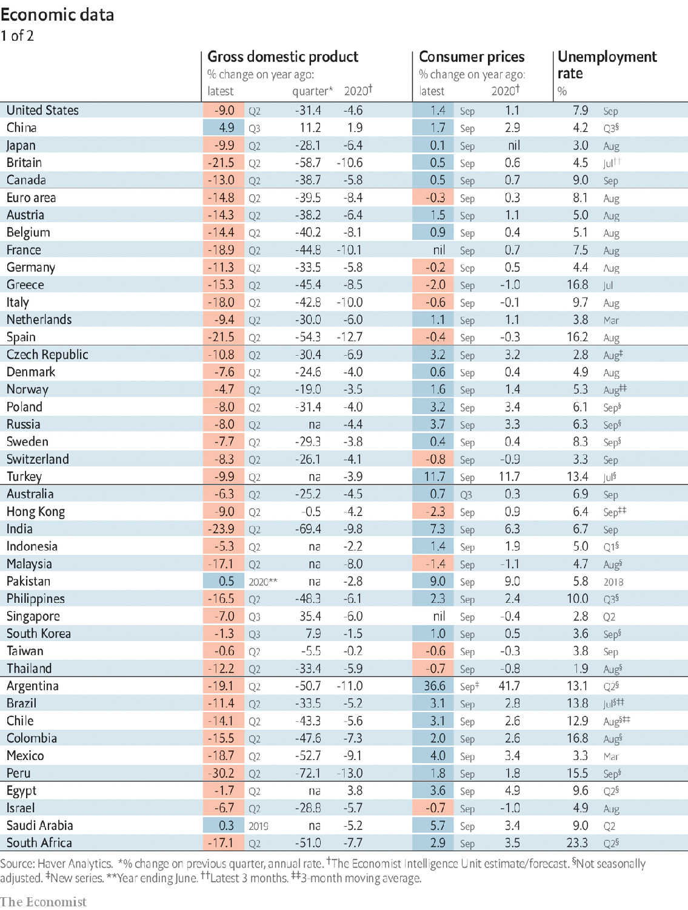

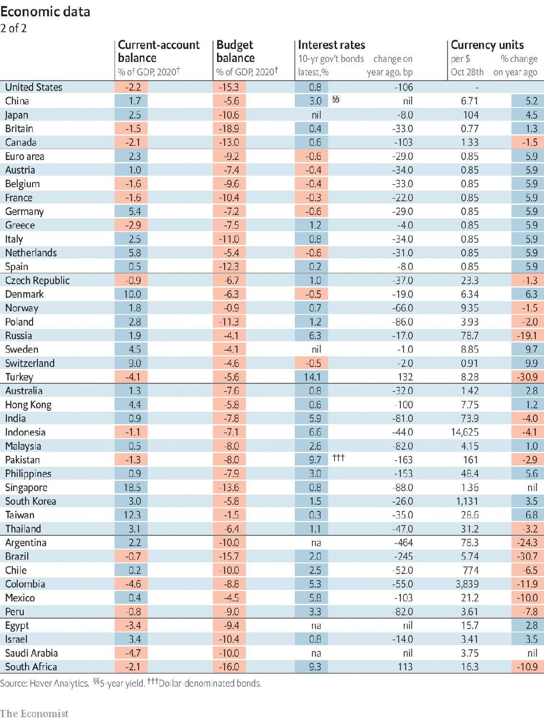

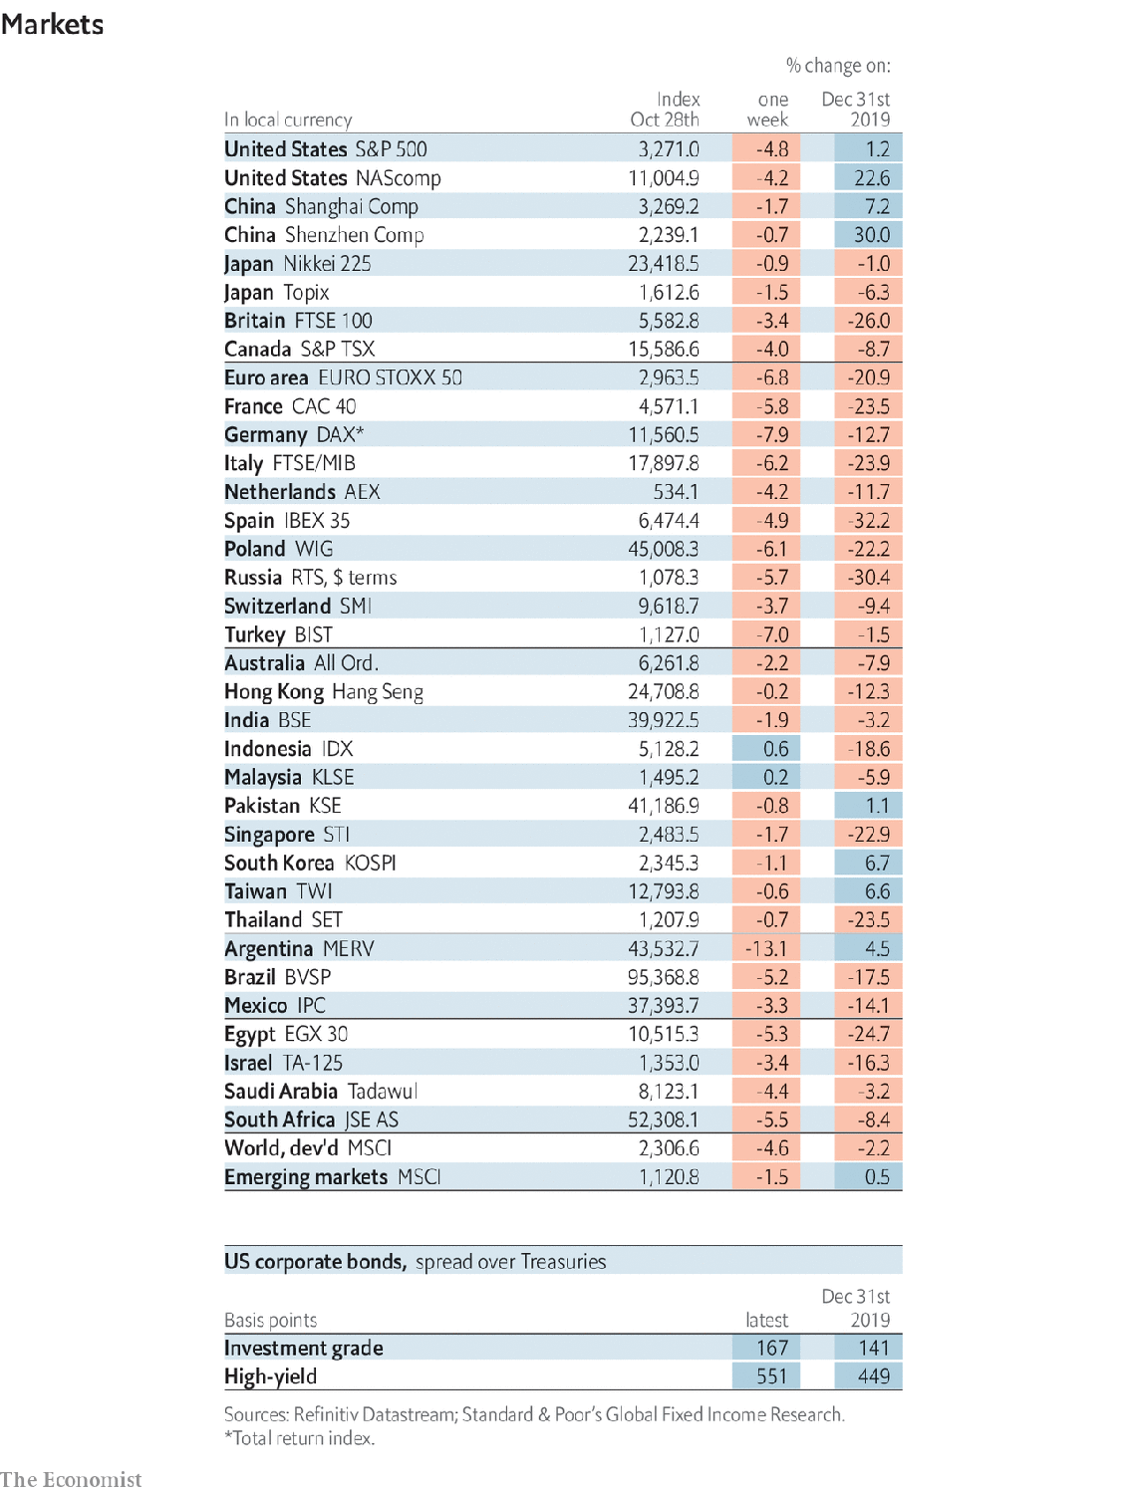

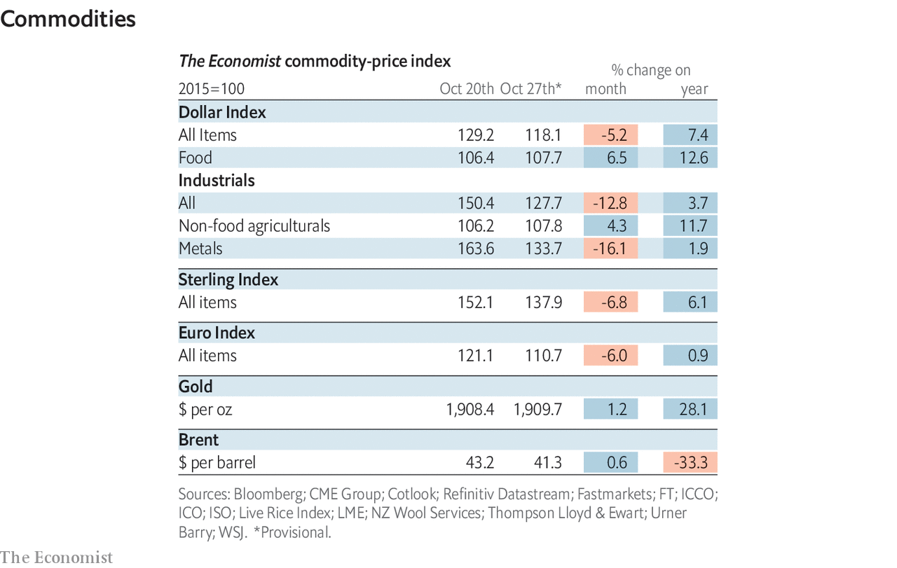

This article was downloaded by calibre from <https://www.economist.com/economic-and-financial-indicators/2020/10/31/economic-data-commodities-and-markets>

|  |  |  |  |
| --- | --- | --- | --- |
|  | Articles | Sections | Next |

|  |  |  |
| --- | --- | --- |
| Economic & ... | Sections | Obituary |

Graphic detail

Immunity to covid-19: The valleys of the shadow of death

.

|  |  |  |
| --- | --- | --- |
| Economic & ... | Sections | Obituary |

|  |  |  |  |
| --- | --- | --- | --- |
|  | Articles | Sections | Next |

#### The valleys of the shadow of death

# Italian towns hit hardest by covid-19 are doing better now

Municipal data reveal signs of partial population-level immunity

Oct 31st 2020 |

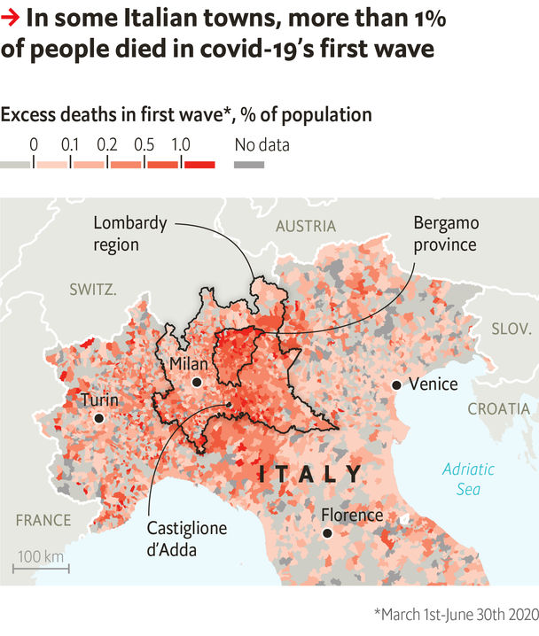

ONE OF THE most pressing questions about covid-19 is how achievable “herd immunity” may be. Holding other factors constant, the more people have protective antibodies, the slower the virus spreads. If enough people become and remain immune, further outbreaks are prevented.

Some experts have advised letting the young and healthy get covid-19, in order to approach such herd immunity. European data suggest this goal remains distant: within countries, the regions with the most cases in the spring also tend to have the biggest outbreaks now. Yet broad averages can obscure local variation. And new Italian data show that the worst-hit places do now enjoy some degree of immunity.

Like a tornado, covid-19 has walloped some towns while sparing others. In Lombardy, the heart of Italy’s first wave, 83% more people died of all causes from March to June than the historical average, an excess representing 0.3% of the population. Yet some pockets of the region were hit disproportionately. The rate was 0.6% of the population in Bergamo province, and more than 1% in 30 of Bergamo’s 243 municipalities. If anywhere has enough antibodies to restrain covid-19, it would be these towns.

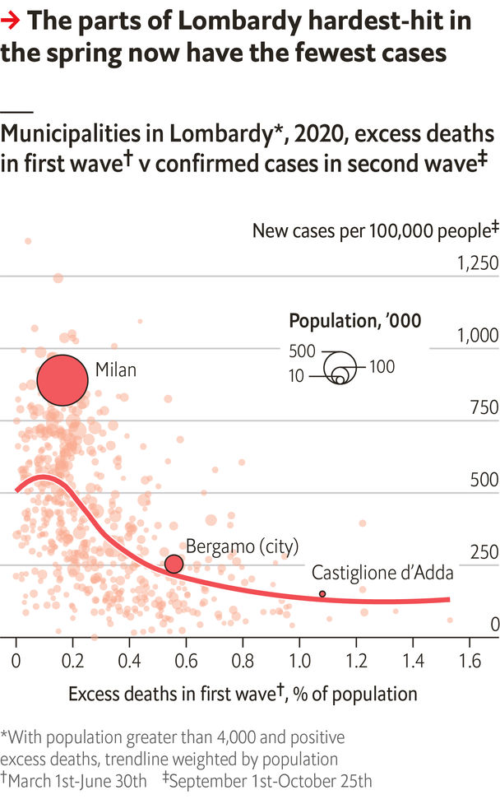

Lombardy’s government does not share case counts for every area. But Isaia Invernizzi, a journalist, has gained access to its internal data, which show that the hardest-hit towns are doing unusually well today. Since September 1st, municipalities with first-wave excess deaths of at least 0.5% of the population have tallied 216 cases per 100,000 people—one-third as many as in areas with excess deaths around 0.1%.

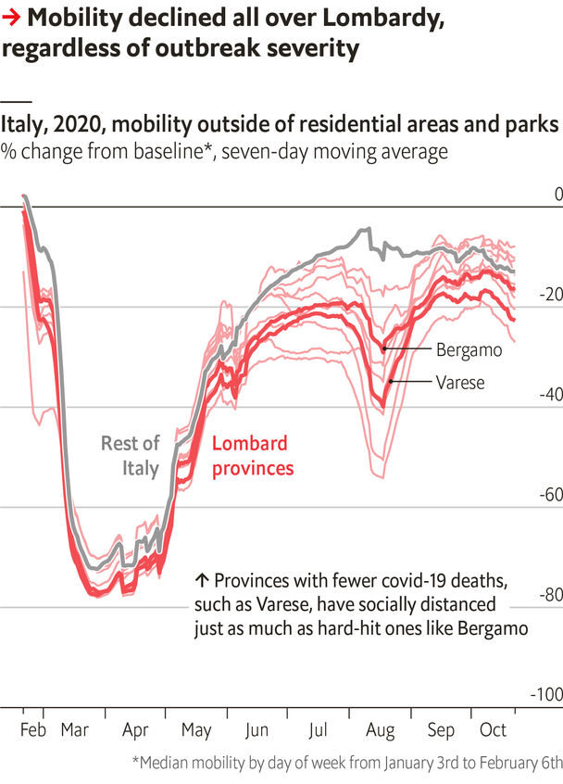

Social distancing has also slowed the virus. According to Google, Lombards moved around 24% less in July than in January, the steepest drop in Italy. But this decline has been similar in all of Lombardy. That leaves immunity as the best explanation for differences in case counts within the region.

These data do not prove the case for seeking herd immunity. Without a vaccine, the cost of gaining even mild resistance is grim. No national study has found a share of people with antibodies even one-third as high as the 24% seen in Bergamo in July. And Europe’s highest national excess death rate, in Spain, is just a fifth of Bergamo’s.

Yet for beleaguered Bergamasques, the data are good news. Serosurveys show that antibodies there are not only common, but especially so among the old and health-care workers, who need them most. ■

Sources: ISTAT; Isaia Invernizzi; Google; The Economist

This article was downloaded by calibre from <https://www.economist.com/graphic-detail/2020/10/31/italian-towns-hit-hardest-by-covid-19-are-doing-better-now>

|  |  |  |  |
| --- | --- | --- | --- |
|  | Articles | Sections | Next |

|  |  |  |
| --- | --- | --- |
| Graphic detail | Sections |  |

Obituary

Hawa Abdi: It takes a village

.

|  |  |  |
| --- | --- | --- |
| Graphic detail | Sections |  |

|  |  |  |  |
| --- | --- | --- | --- |
|  | Articles | Sections | Next |

#### It takes a village

# Hawa Abdi died on August 5th

The doctor who dreamed of rebuilding Somalia was 73

Oct 31st 2020 |

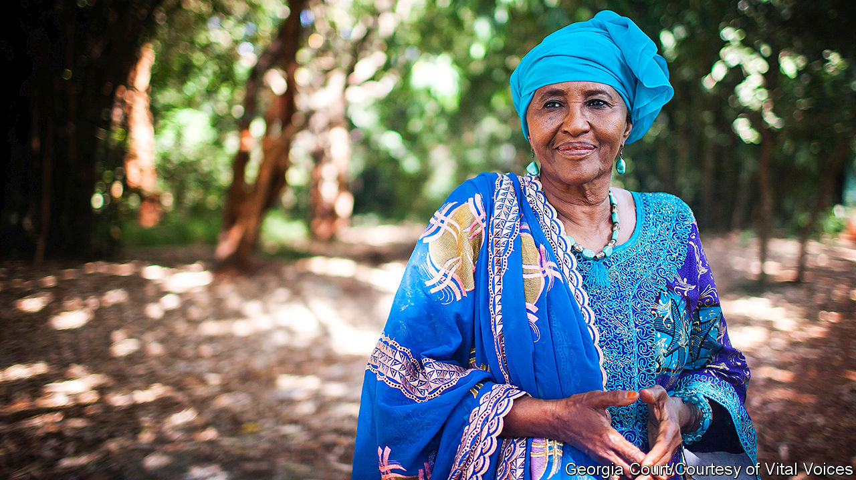

AFTER HER morning prayer and before she had eaten breakfast, the sun barely up, Hawa Abdi liked to walk around the village. First she would go to the communal farm to start the generators and check the crops: sorghum, maize, bananas, beans. Then she would go past the villagers’ dwellings, just stirring. When she had bought this land, in the Lower Shebelle west of Mogadishu, the capital, trees stretched to the horizon. Many remained, but now thousands of people sheltered among them, in a haven that had come to be called Hawa Abdi, after her. “Where are you going?” one dusty, desperate traveller might ask another in the years of Somalia’s civil wars, and the frequent answer was: “To Hawa.”

Her name was not only on it, but she ran it, sorting out problems with the village elders in the shade of the mango grove she had planted. She guided its growth over three decades from a one-room rural maternity clinic, built in 1983 with some family gold she had put by, into a 400-bed hospital with three operating theatres, a school for 850 children and seven feeding centres. Eventually the village was home to 90,000 people. She was chief doctor and surgeon, farm manager, strategist, fundraiser and spokesman for the place. When the rest of the world forgot about Somalia, or turned away, she kept going at a furious pace. “Sitting is empty,” her grandmother taught her, “but working is plenty.”

This was a village of the poor and needy. Its houses were shacks of sticks and woven grass, or bubble-tents rainproofed with plastic sheets. New arrivals often slept in the open, lining up each morning to see her and ask to stay. Many would be women, heavily pregnant, seeking a safe place to give birth where care was free. Some people came to find jobs; she trained a band of sharp-eared boys to be security guards and put men to work at building and farming. In the 1990s, when the hospital overflowed with injured soldiers and refugees who stumbled out of the bush, she became skilled, well beyond her expertise in obstetrics and gynaecology, at taking bullets and shrapnel out of them. When famine struck, especially the dreadful hunger of 2011, people came simply to be fed. At times she could not think how to help so many, but gave them whatever she had: sorghum chapatis every other day, a little donated rice cooked up in oil drums, cool water from the wells, a place to sleep.

The residents of her village were mostly women and children. Their men had gone: killed, away fighting, or working in some other land. This gave her a fine chance to empower women, and she set to it. She knew how little they counted in Somali society, where boys were kings. When she was a child her mother had died before her eyes after a miscarriage, the blood pooling out of her robe; she decided then to become a doctor, to save the lives of other mothers. At seven she had been cut and stitched, which made the birth of her first child, at 13 after a forced marriage, wretchedly hard. The sickly little girl died, but happily her husband divorced her, and at 17 she leaped into studying: medical training in Kyiv on a Soviet scholarship, then a law degree in her spare time. Devoutly Muslim though she was, she dressed as she liked, and hotly disputed the parts of sharia law that offended her. In her village, equal rights were meant to prevail. Men were not allowed to beat their wives, and were locked in a storeroom if they did. Women were taught to sew and read in a special centre. Girls packed the school, smiling shyly in their uniform yellow hijabs alongside the boys. Her two daughters by her second, free, marriage, Amina and Deqo, set the example by becoming doctors and working with her.

As for her, she could hold her own against anyone. Her body might be weak, but her tongue could defend against a thousand. She refused to tolerate the clan identities that made men fight each other, forbidding clan politics in the village and hanging white sheets round the boundaries to show it was a neutral place. That did not stop the Islamist militants, however. They routinely blocked food shipments and barged several times into the village, most violently in 2010 when teenage fighters ransacked the hospital, smashed the four incubators that were the only ones in the country, drove out the patients and tore up their records. She shouldn’t be in charge of anything, one gunman sneered, because she was old, and a woman. Well, she shouted back, he was young, and a man; he had two testes; but so did a goat. She was doing something to help her country. What exactly was he doing? She demanded a written apology. To her great satisfaction, it came.

As their staff were increasingly attacked and killed, the international aid agencies left one by one. She had mixed feelings about that. People should work, not get handouts; it was better to train Somalis, many of them nomadic herders, to fend for themselves by farming or fishing. She gave the villagers patches of land and a small fleet of boats to encourage them. But she also needed big infusions of money and willing hands. In 2010 her three-year partnership with Médecins Sans Frontières, which had helped run large parts of the hospital, came to an end; in 2013 MSF left Somalia. The UN World Food Programme suspended aid too, and the Italian company that had subsidised the farm no longer dared send ships to buy its bananas. Trips to America from 2010 brought her welcome publicity and money from the diaspora, but when the foreign NGOs ventured back in later years they still avoided the riskiest areas, like hers. She thought about leaving too, but who would care for her patients then? She sighed and stayed.

Sometimes she was so weary that she could hardly walk. She felt Somalia was lost. What kept her going was a dream of her village as the country in miniature: the Somalia she remembered from childhood as a string of jewels along the Indian Ocean, its fields and tall trees greening miraculously after the rains. This seemed to her to have been a society of diligence, honesty, respect and love. Slowly, she had begun to rebuild it. No sound of gunfire there, just the sing-song of children at their lessons; no one hiding in terror from armed gangs, but women working at crafts and men fishing off the shore. And if a traveller should ask these people where they came from, they would answer: “From Hawa.” ■

This article was downloaded by calibre from <https://www.economist.com/obituary/2020/10/31/hawa-abdi-died-on-august-5th>

|  |  |  |  |
| --- | --- | --- | --- |
|  | Articles | Sections | Next |